New Delhi, India

June 25, 2024



Data Manager GUIDE

*Justice Services Statistical System (JSSS)*

Data Manager GUIDE

*Justice Services Statistical System (JSSS)*

**Revision History**

|  |  |  |  |
| --- | --- | --- | --- |
| Name | Date | Reasons of Changes | Version |
| iTM | 23rd April 2024 | The first draft of Data Manager JSSS. | V1 |
| iTM | 25th June 2024 | The second draft of Data Manager JSSS. | V2 |

Table of Contents

1.0 INTRODUCTION 6

2.0 LOGIN 9

3.0 HOME 10

4.0 SERVICE MANAGEMENT 12

4.1 CCFLU 12

**4.1.1 CCFLU Expungement** 12

**4.1.2 CCFLU Marriage License** 20

4.2 NPCD/CD 28

**4.2.1 NPCP/CD Cases** 28

**4.2.2 NPCD/CD Activity Summary** 36

4.3 RJ 43

**4.3.1 RJ Cases** 43

**4.3.2 RJ Activity Summary** 51

4.4 VSD 58

**4.4.1 VSD Cases** 58

**4.4.2 VSD Activity Summary** 67

4.5 LAC 74

**4.5.1 LAC Cases** 74

**4.5.2 LAC Mobile Unit Cases** 81

**4.5.3 LAC Additional Act** 88

4.6 MEDIATION 95

**4.6.1 Mediation Cases** 95

5.0 FEEDBACK MANAGEMENT 104

5.1 NCDP/CD PROGRAMME EVALUATION 104

**5.1.1. EXPORT** 105

**5.1.2 IMPORT** 106

**5.1.3 ADD** 107

5.2 RJ FEEDBACK 109

**5.2.1. EXPORT** 110

**5.2.2 IMPORT** 111

**5.2.3 ADD** 112

5.3 VSB FEEDBACK 114

**5.3.1. EXPORT** 115

**5.3.2 IMPORT** 116

**5.3.3 ADD** 117

5.4 LAC CUSTOMER SATISFACTION SURVEY 119

**5.4.1. EXPORT** 120

**5.4.2 IMPORT** 121

**5.4.3 ADD** 122

5.5 LAC MOBILE UNIT CLIENT FEEDBACK 124

**5.5.1. EXPORT** 125

**5.5.2 IMPORT** 126

**5.5.3 ADD** 127

5.6 MEDIATION 129

**5.6.1. EXPORT** 130

**5.6.2 IMPORT** 131

**5.6.3 ADD** 132

5.7 CUSTOMER SATISFACTION DETAILS 134

**5.7.1. EXPORT** 135

**5.7.2 IMPORT** 136

**5.7.3 ADD** 137

6.0 INDICATOR MANAGEMENT 139

6.1 INDICATOR 139

**6.1.1 EXPORT** 139

**6.1.2 IMPORT** 142

6.2 INDICATOR METADATA 143

**6.2.1 EXPORT** 143

**6.2.2 IMPORT** 146

**6.2.3 ADD** 147

6.3 INDICATOR DATA 149

**6.3.1 EXPORT** 149

**6.3.2 IMPORT** 152

**6.3.3 ADD** 153

6.4 DATA APPROVE 155

6.5 CALCULATE/AGGREGATE 156

6.6 ANALYSIS 160

7.0 ADMIN 163

7.1 AREA 163

**7.1.1 EXPORT** 164

**7.1.2 IMPORT** 166

**7.1.3 ADD** 167

7.2 FRAMEWORK 168

**7.2.1 EXPORT** 168

**7.2.2 IMPORT** 170

**7.2.3 ADD** 171

7.3 TOPIC AND SUBTOPIC 172

**7.3.1 EXPORT** 172

**7.3.2 IMPORT** 174

**7.3.3 ADD** 175

7.4 IMPORT LOG 176

7.5 AUDIT TRAIL 176

7.6 CLASSIFICATION MANAGEMENT 177

**7.6.1 CLASSIFICATION TYPE** 177

**7.6.2 CLASSIFICATION** 179

7.7 ACCESS CONTROL 183

**7.7.1 ROLE AND PERMISSION** 183

**7.7.2 USER** 185

7.8 RESOURCE 187

7.9 REPORT 189

7.10 CUSTOMIZE 194

**7.10 1 KEY FACTS** 194

# 1.0 INTRODUCTION

The Justice Services Statistical (JSS) System is developed as a centralized information management System that allows to gather data, processes, and protocols for AJS and social justice services, and prepare an inaugural Annual Social Justice Services Statistics Report. The System comprises of two applications – User interface and Data Manager which contains various modules and sub-modules to perform both the user and admin-based tasks. This user manual is developed to help the data administrators to understand the use of Data Manager application and its modules. The data manager application can be accessed by the authorized users having valid login credentials.

The data manager application modules allow the creation and management of the master data and its elements. Below is the list of the module and its submodules -

1. Home
2. Service Management

* CCFLU
  + CCFLU Expungement
  + CCFLU Marriage License
* NCDP/CD
  + NCDP/CD Cases
  + NCDP/CD Activity Summary
* RJ
  + RJ Cases
  + RJ Activity Summary
* VSD
  + VSD Cases
  + VSD Activity Summary
* LAC
  + LAC Cases
  + LAC Mobile Unit Cases
  + LAC Additional Act
* Mediation
  + Mediation Cases

1. Feedback Management

* NCDP/CD Programme Evaluation
* RJ Feedback
* VSD Feedback
* LAC Customer Satisfaction Survey
* LAC Mobile Unit Client Feedback
* Mediation
* Customer Satisfaction Details

1. Indicator Management

* Indicator
* Indicator Metadata
* Indicator Data
* Data Approve
* Calculate/Aggregate
* Analysis

1. Admin

* Area
* Framework
* Topic and Subtopic
* Import Log
* Classification Management
  + Classification Type
  + Classification
* Access Control
  + Role and Permission
  + User
* Resources
* Report
* Customize
  + Key facts

Each of these modules are explained in detail in the following chapters.

# 2.0 LOGIN

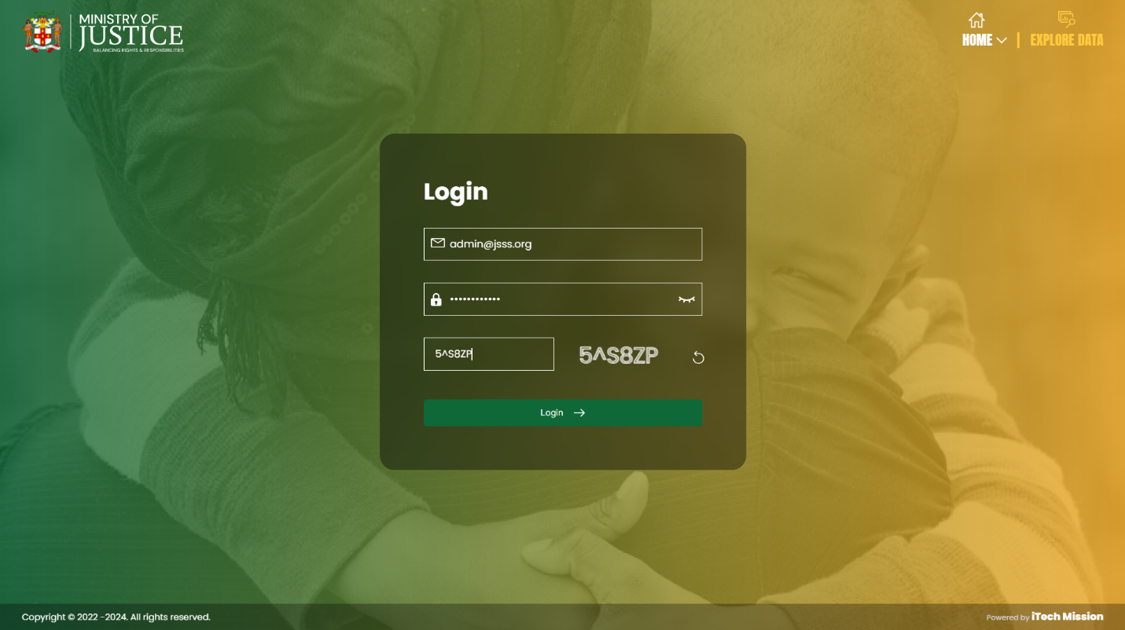The JSSS Data Manager application can be accessed through a web browser (recommended browser - Google Chrome latest version). Enter URL <https://jsss.itechmission.org/datamanager> in the web browser. Enter administrator login credentials and correct captcha. Click on the **Login** button (see figure below).

# 3.0 HOME

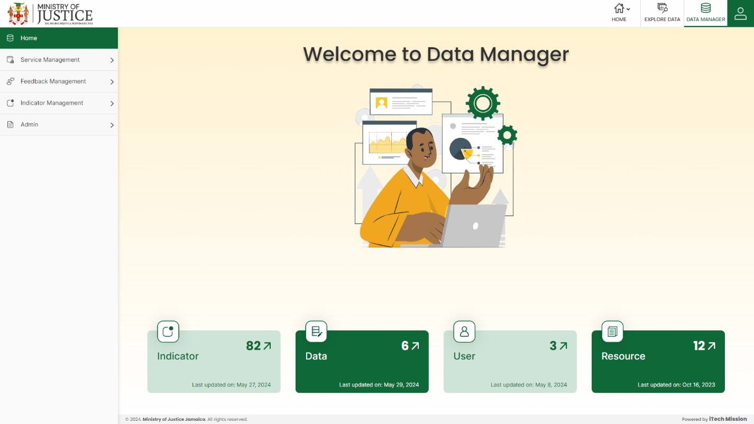The first module after successful login is **Home**. You can also access this module by clicking on the Home menu option in the left panel (see below figure).

This module depicts the following information of the database -

1. **Indicator**

The first box shows the total count of indicators available in the database and the last date/time when the indicator list was entered/updated. There is an arrow button available to navigate to the respective module.

1. **Data**

The second box shows the total count of data values entered against the unique combination of Indicator – Unit – Subgroup (IUS), Area, Time Period and Source along with the last date/time when the data value was entered/updated. There is an arrow button available to navigate to the respective module.

1. **User**

The third box shows the total count of users created in the database and the last date/time when the user details were entered/updated. There is an arrow button available to navigate to the respective module.

1. **Resource**

The fourth and last box shows the total count of resources available in the database and the last date/time when the resources were entered/updated. There is an arrow button available to navigate to the respective module.

# 4.0 SERVICE MANAGEMENT

Click on the **Service Management** menu option from the left panel to access this module. This module has six submodules – CCFLU, NCDP/CD, RJ, VSD, LAC and Mediation. Let us understand these submodules in detail.

## **4.1 CCFLU**

Click on the **CCFLU** from service management menu option from the left panel to access this module. This module has two submodules – CCFLU Expungement and CCFLU Marriage License.

### **4.1.1 CCFLU Expungement**

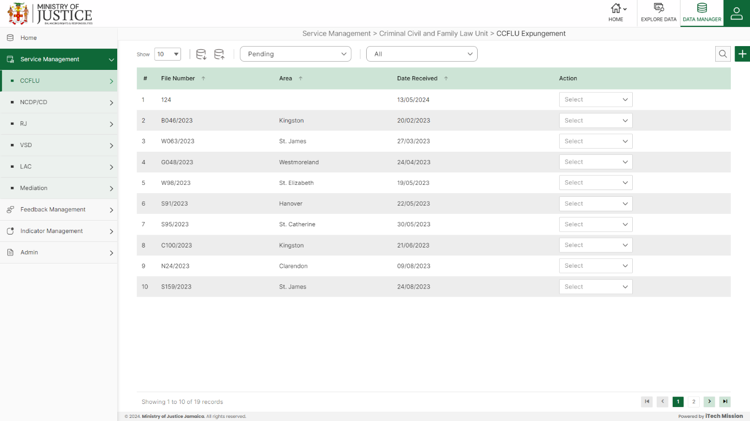Click on **CCFLU Expungement** from the CCFLU menu option available in the left panel to access this module. This module allows to manage the CCFLU expungement master list. You will have options to export or import, add a new element, view the list of existing elements, sort the list, search from the list, edit and delete the existing elements (see below figure).

#### 4.1.1.1 EXPORT

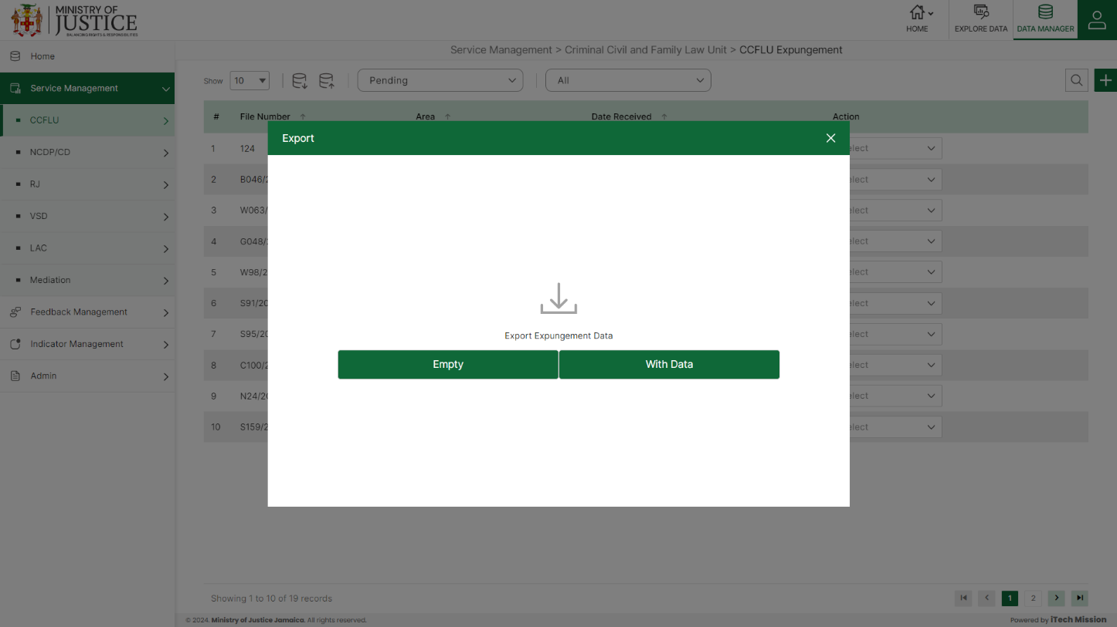****Click on the **Export** button to download the empty template and the master list (see below figure).

Click on the **Empty** option to download an empty template (see below figure). The file is imported and exported in the CSV (Comma Separated Value) file format.

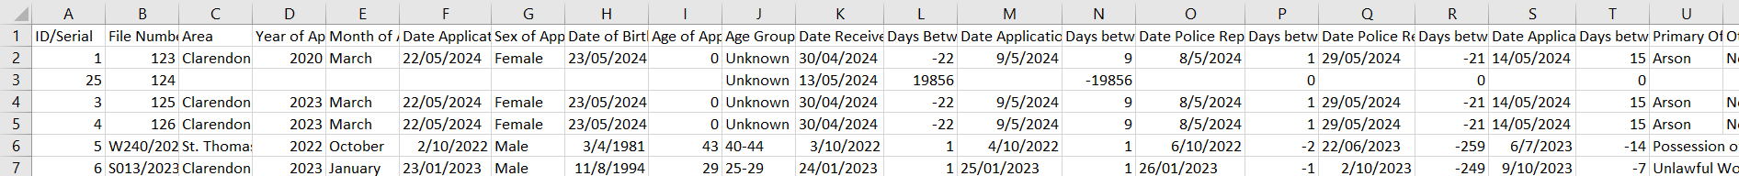Click on the **With Data** option to download the master list (see below figure).

#### 4.1.1.2 IMPORT

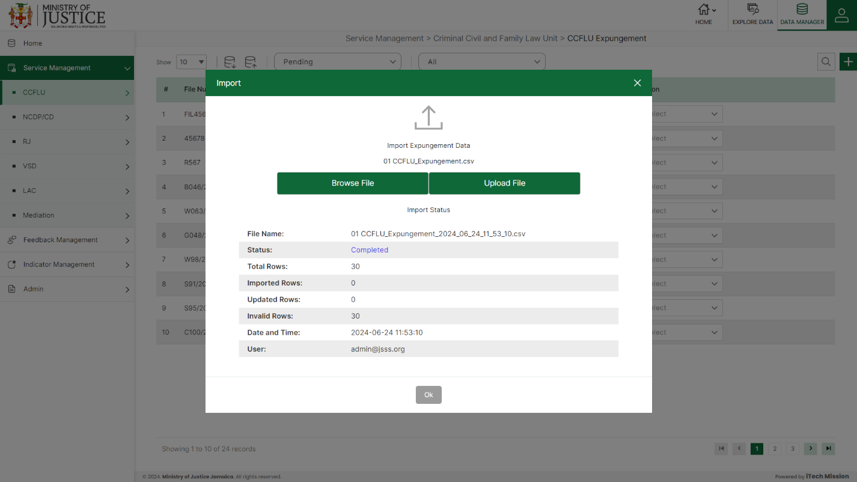Click on the **Import** button to browse the file and upload the master list into the database (see below figure).

To upload the file into the database first enter the structure in the template and then click on the **Browse File** button to select the template. Now, click on the **Upload** button to start the import process. During the import process, the records which contains blank entries, entries with special characters and duplicate entries are not imported in the database.

A Last Upload summary will appear after the import process which provides the count of successfully imported records out of the total records. An error log will be generated to report on unsuccessfully imported records which you can access from **Logs** module.

#### 4.1.1.3 ADD

****Click on the **Plus** button available at the top right corner to add a new record. The Add CCFLU Expungement form is divided into sections namely – **Application Information, Process Details and Broad Summary**

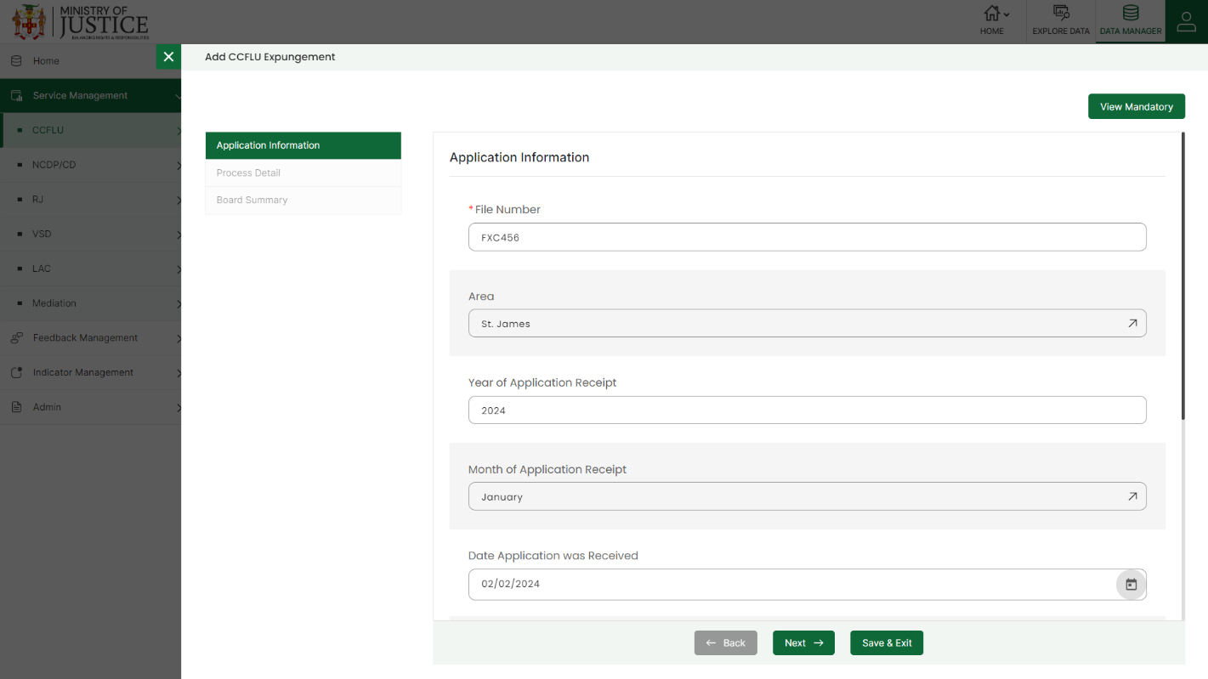Enter the following information to add a new record –

* Enter **File Number**
* Select **Area**
* Enter **Year of Application**
* Select **Month of Application**
* Enter **Date Application was Received**
* Select **Sex of Applicant**
* Enter **Date of Birth**
* Enter **Age of Applicant**
* **Age Group** (*Auto generated based on age of the applicant)*
* Enter **Date Received**
* **Days between Customer receipt and Unit receipt** (*Auto generated)*
* Enter **Date Application was placed in the System** –
* **Days between unit receipt and when application was placed on system** *(Auto generated)*
* Enter **Date Police Report Requested** (CRO)
* **Days between when application was placed on system and Police Report Request** *(Auto generated)*
* Enter **Date Police Report Received (CRO)**
* **Days between Police Report Receipt and Police Report Request** *(Auto generated)*
* Enter **Date Application was sent to Board**
* **Days between Application sent to board and Police Report Receipt** (*Auto generated)*
* Select **Primary Offence**
* Enter **Other Offences**
* Enter **Primary Sentence**
* Enter **Other Sentences**
* Enter **Remarks**
* Enter **Date Board Results are received**
* **Duration (Outside of CRO)** *(Auto generated)*
* **Total Duration** (Auto generated)
* Select **Application Status**
* -Enter **Change in Decision**
* -Enter **Date of Change**

Fields that are mandatory to submit the entry can be viewed using **View Mandatory** button present on the top right side of the add CCFLU Expungement form. Click on the **Save** button to save and confirm. You can now view the new record added in the list.

***NOTE:***

*You can navigate between the sections using the* ***Back*** *and* ***Next*** *button available at the bottom of the page. The* ***Next*** *button will get enabled once the unique field is filled. You can Save the data and Exit anytime using* ***Save & Exit*** *button.* ***Submit*** *button will be enabled when all the mandatory fields are filled.*

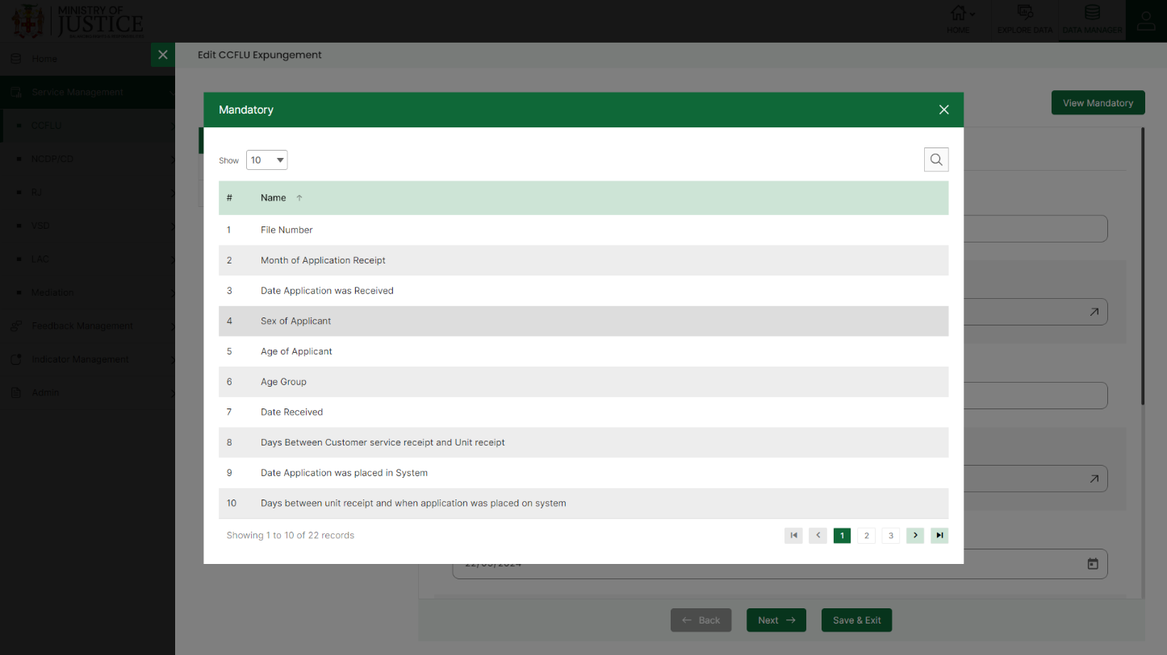You can view the form according to the status i.e. Pending and Approved. If all the mandatory fields of the form are not filled, then it will be saved under **Pending – Incomplete** status.

If all the mandatory fields are filled, then it will be saved under **Pending – Complete** status.

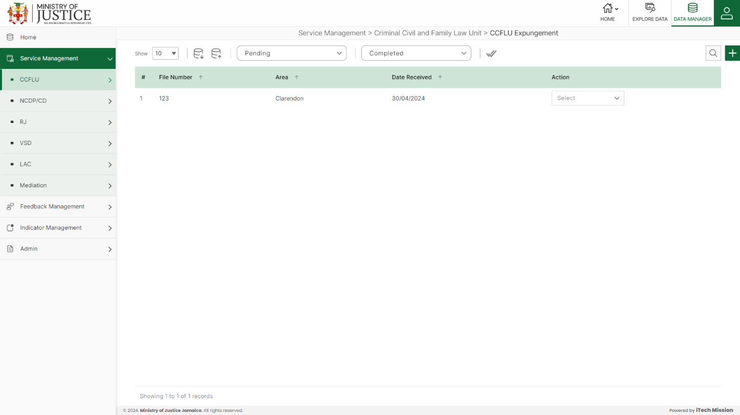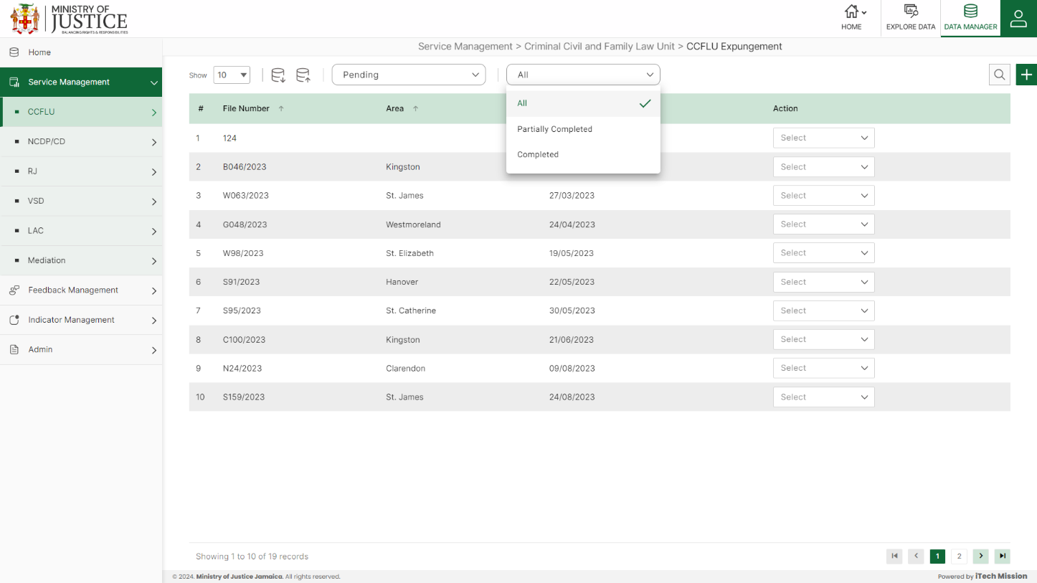Click on the tick icon near status dropdown to **Approve All** the records under pending – complete status.

Select **View** option available in the action dropdown to view the details of the selected element.

Select **Edit** option available in the action dropdown to edit the details of the selected element. Edit the required detail and click on update button to save and confirm.

Select **Delete** option available in the action dropdown to delete the selected element. A confirmation popup appears, click yes to confirm deletion of selected element.

### **4.1.2 CCFLU Marriage License**

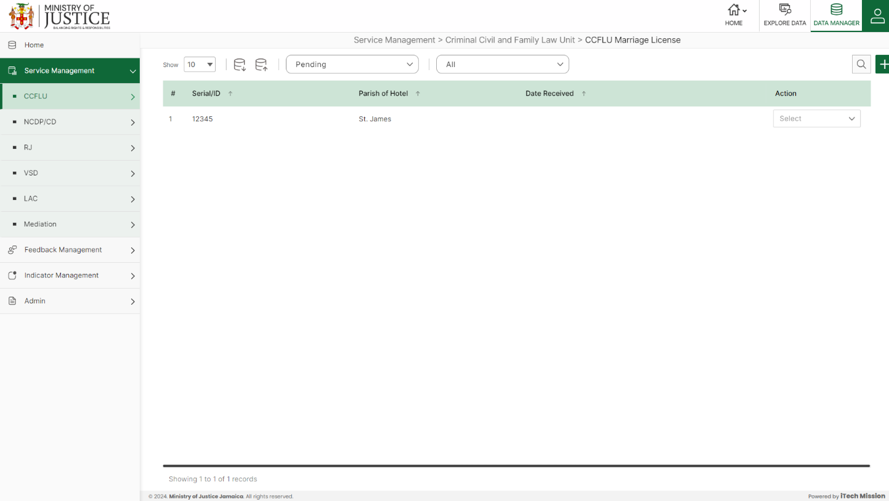Click on **CCFLU Marriage License** from the CCFLU menu option available in the left panel to access this module. This module allows to manage the CCFLU marriage license master list. You will have options to export or import, add a new element, view the list of existing elements, sort the list, search from the list, edit and delete the existing elements (see below figure)

#### 4.1.2.1 EXPORT

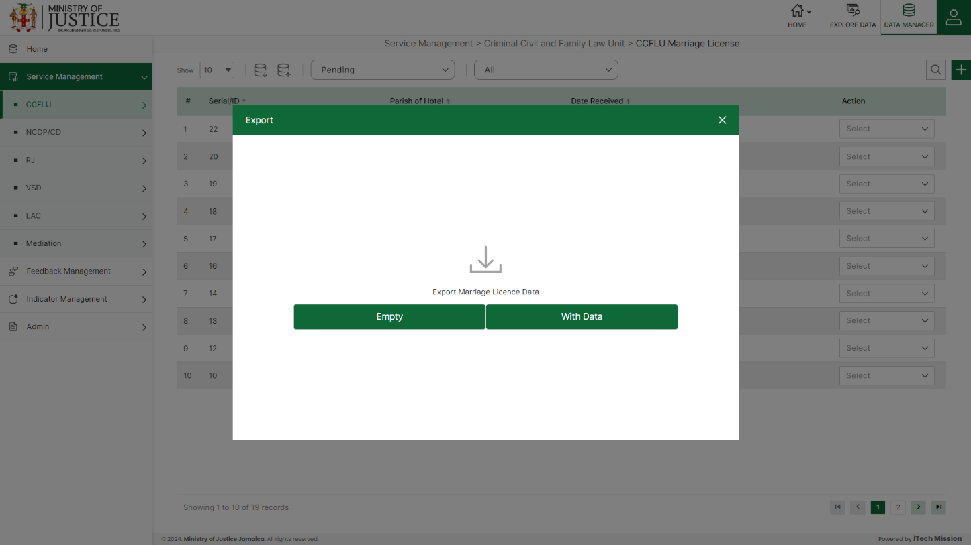****Click on the **Export** button to download the empty template and the master list (see below figure).

Click on the **Empty** option to download an empty template (see below figure). The file is imported and exported in the CSV (Comma Separated Value) file format.

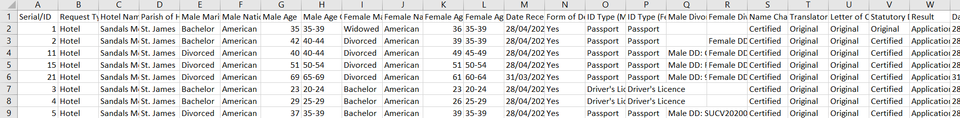Click on the **With Data** option to download the master list (see below figure).

#### 4.1.2.2 IMPORT

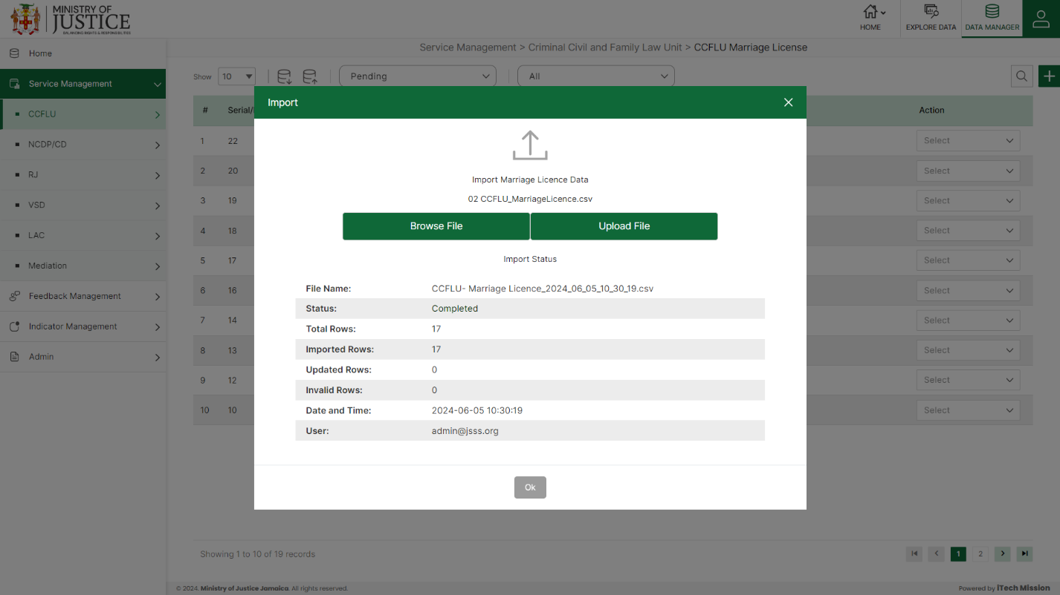Click on the **Import** button to browse the file and upload the master list into the database (see below figure).

To upload the file into the database first enter the structure in the template and then click on the **Browse File** button to select the template. Now, click on the **Upload** button to start the import process. During the import process, the records which contains blank entries, entries with special characters and duplicate entries are not imported in the database.

A Last Upload summary will appear after the import process which provides the count of successfully imported records out of the total records. An error log will be generated to report on unsuccessfully imported records which you can access from **Logs** module.

#### 4.1.2.3 ADD

****Click on the **Plus** button available at the top right corner to add a new record. The Add CCFLU marriage License form is divided into sections namely – **Application Information, Documentation Details and Result Details**

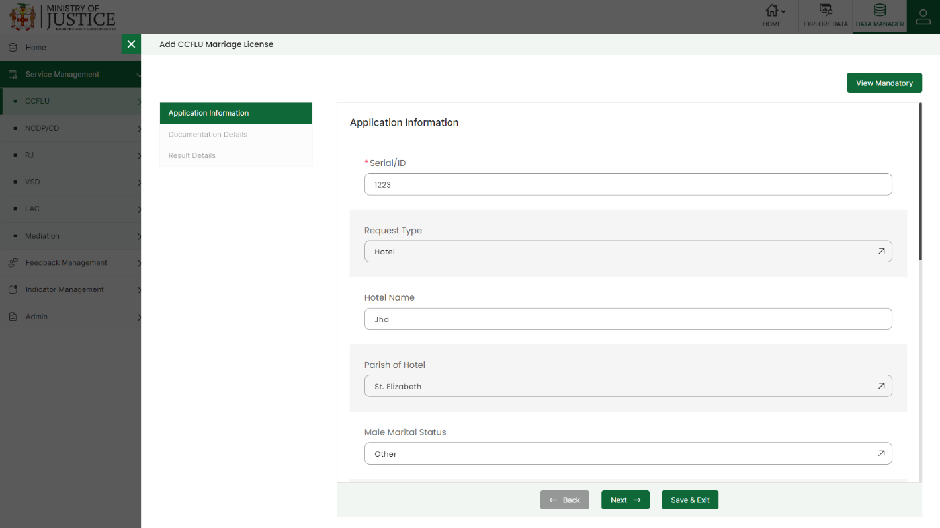Enter the following information to add a new record –

* -Enter **Serial/ID**
* Select **Request Type**
* - Enter **Hotel Name**
* - Select **Parish of Hotel**
* - Select **Male Marital Status**
* - Select **Male Nationality**
* - Enter **Male Age**
* - **Male Age-Group** *(Auto generated)*
* - Select **Female Marital Status**
* - Select **Female Nationality**
* - Enter **Female Age**
* - **Female Age-Group (***Auto generated)*
* - Enter **Date Received**
* - Select **Form of Declaration**
* - Select **ID Type (Male)**
* - Select **ID Type (Female)**
* - Enter **Male Divorce Document**
* - Enter **Female Divorce Document**
* - Select **Name Change**
* - Select **Translators Certificate**
* - Select **Letter of Consent**
* - Select **Statutory Declaration**
* - Select **Results**
* - Enter **Date of Result**
* - Enter **Date Typed**
* - **Days between date typed and date received** (*Auto generated*)
* - Enter **Date dispatched to customers**
* - **Days between date typed and date dispatched** *(Auto generated*)
* - Enter **Total Duration** *(Auto generated)*
* - Select **Application Status**

Fields that are mandatory to submit the entry can be viewed using **View Mandatory** button present on the top right side of the add CCFLU Expungement form. Click on the **Save** button to save and confirm. You can now view the new record added in the list.

***NOTE:***

*You can navigate between the sections using the* ***Back*** *and* ***Next*** *button available at the bottom of the page. The* ***Next*** *button will get enabled once the unique field is filled. You can Save the data and Exit anytime using* ***Save & Exit*** *button.* ***Submit*** *button will be enabled when all the mandatory fields are filled.*

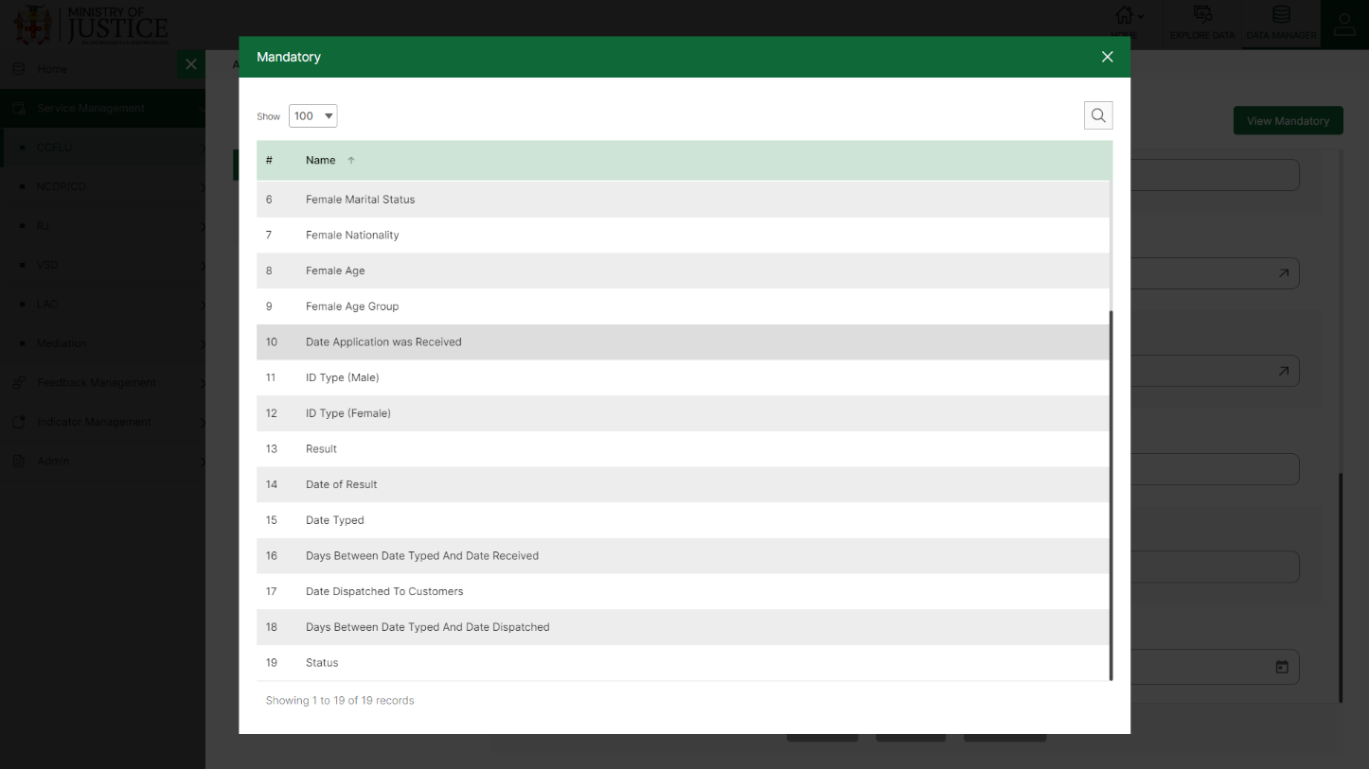You can view the form according to the status i.e. Pending and Approved. If all the mandatory fields of the form are not filled, then it will be saved under **Pending – Incomplete** status.

If all the mandatory fields are filled, then it will be saved under **Pending – Complete** status.

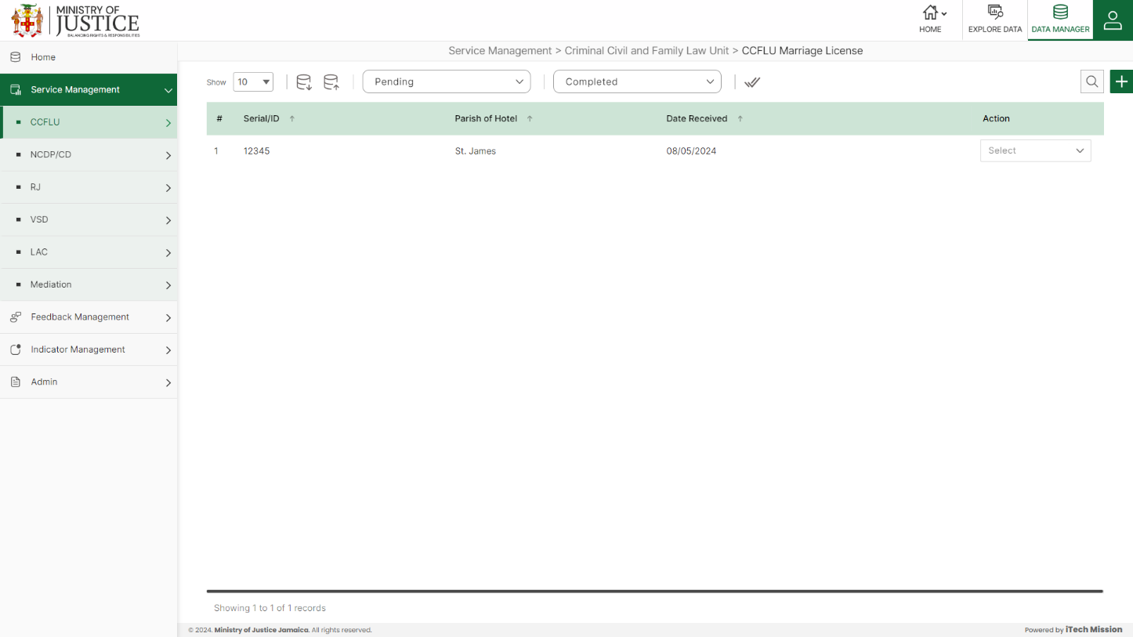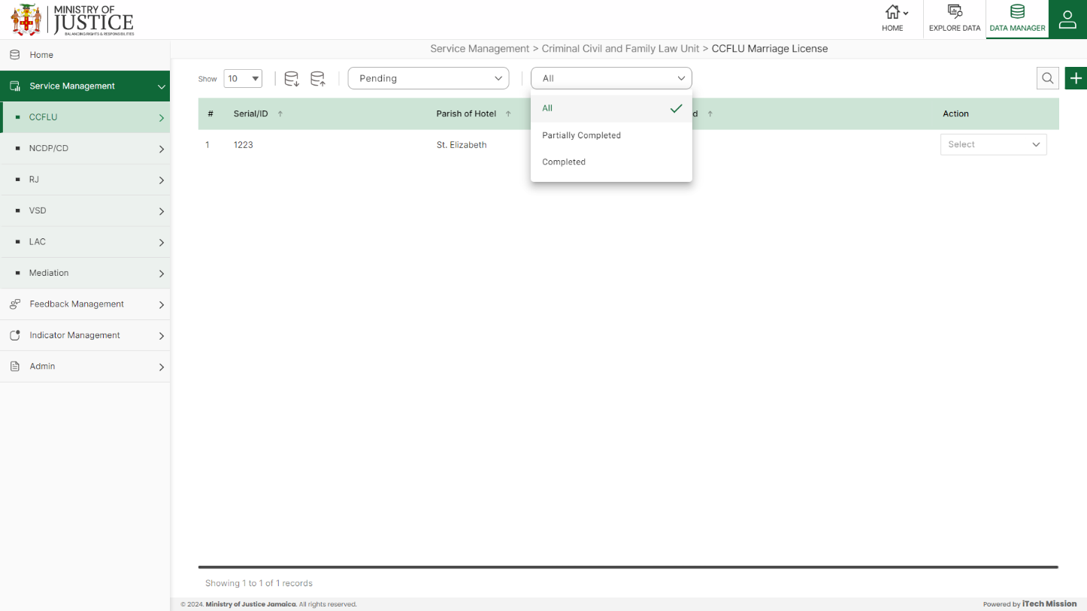Click on the tick icon near status dropdown to **Approve All** the records under pending – complete status.

Select **View** option available in the action dropdown to view the details of the selected element.

Select **Edit** option available in the action dropdown to edit the details of the selected element. Edit the required detail and click on update button to save and confirm.

Select **Delete** option available in the action dropdown to delete the selected element. A confirmation popup appears, click yes to confirm deletion of selected element.

## **4.2 NPCD/CD**

Click on the **NPCD/CD** from service management menu option from the left panel to access this module. This module has two submodules – NPCD/CD Cases and NPCD/CD Activity Summary Let us understand these submodules in detail.

### **4.2.1 NPCP/CD Cases**

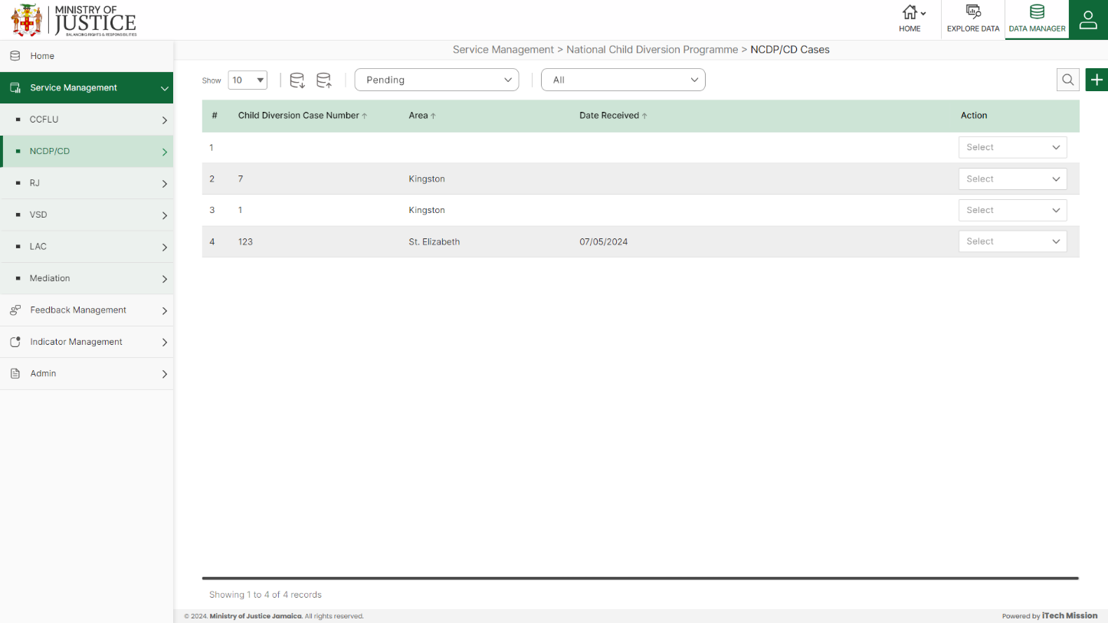Click on **NPCD/CD Cases** from the NPCD/CD menu option available in the left panel to access this module. This module allows to manage the NPCD/CD cases master list. You will have options to export or import, add a new element, view the list of existing elements, sort the list, search from the list, edit and delete the existing elements (see below figure)

#### 4.2.1.1 EXPORT

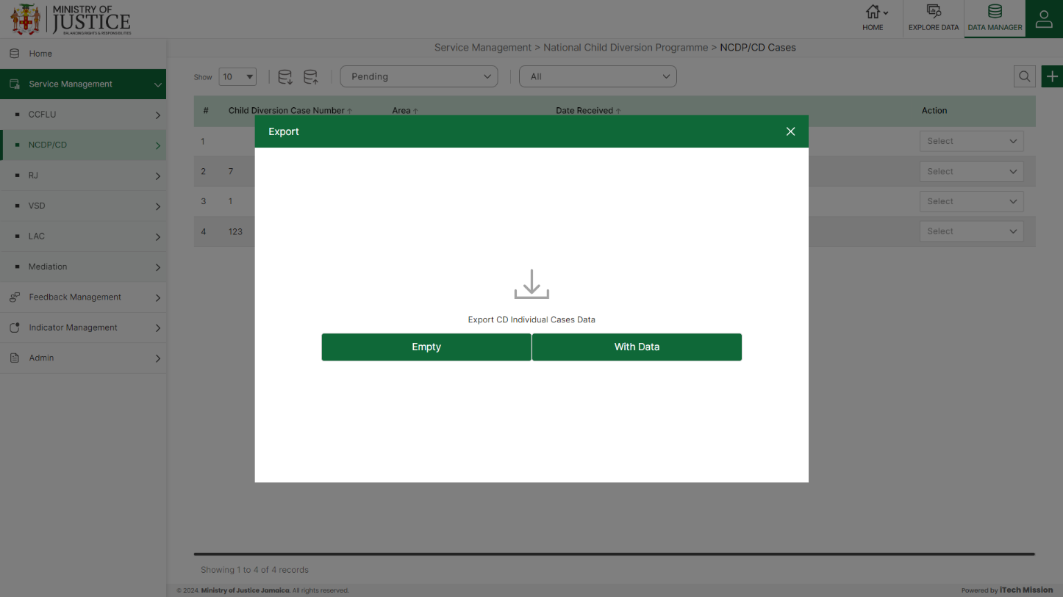****Click on the **Export** button to download the empty template and the master list (see below figure).

Click on the **Empty** option to download an empty template (see below figure). The file is imported and exported in the CSV (Comma Separated Value) file format.

Click on the **With Data** option to download the master list (see below figure).

#### 4.2.1.2 IMPORT

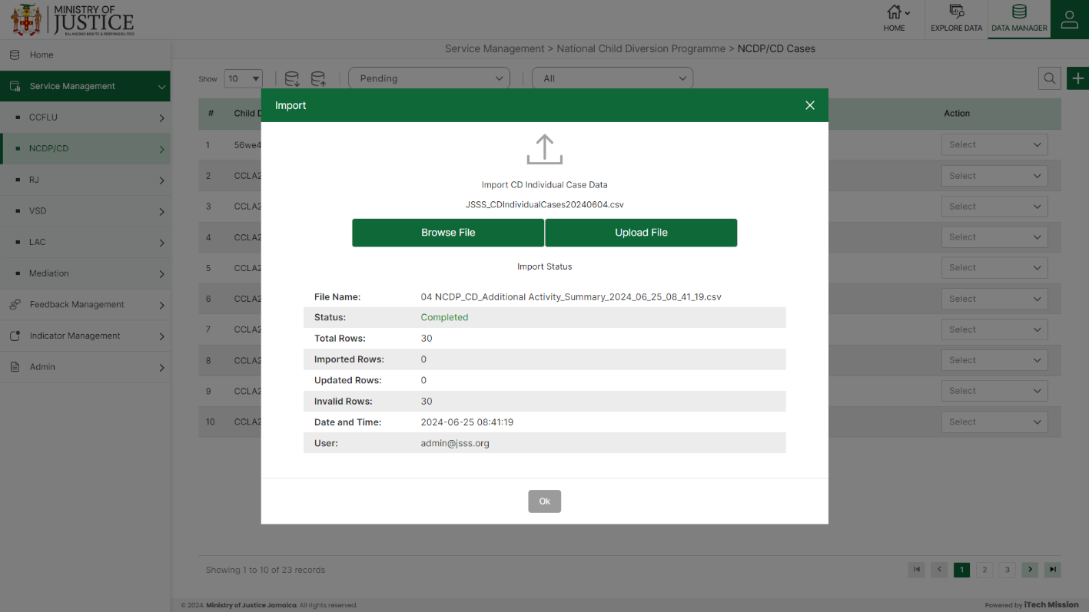Click on the **Import** button to browse the file and upload the master list into the database (see below figure).

To upload the file into the database first enter the structure in the template and then click on the **Browse File** button to select the template. Now, click on the **Upload** button to start the import process. During the import process, the records which contains blank entries, entries with special characters and duplicate entries are not imported in the database.

A Last Upload summary will appear after the import process which provides the count of successfully imported records out of the total records. An error log will be generated to report on unsuccessfully imported records which you can access from **Logs** module.

#### 4.2.1.3 ADD

****Click on the **Plus** button available at the top right corner to add a new record. The Add NPCD/CD Cases form is divided into sections namely – **Centre Details, Client Information, Offender Details, Referral Summary, Treatment Summary and Case Closure Details.**

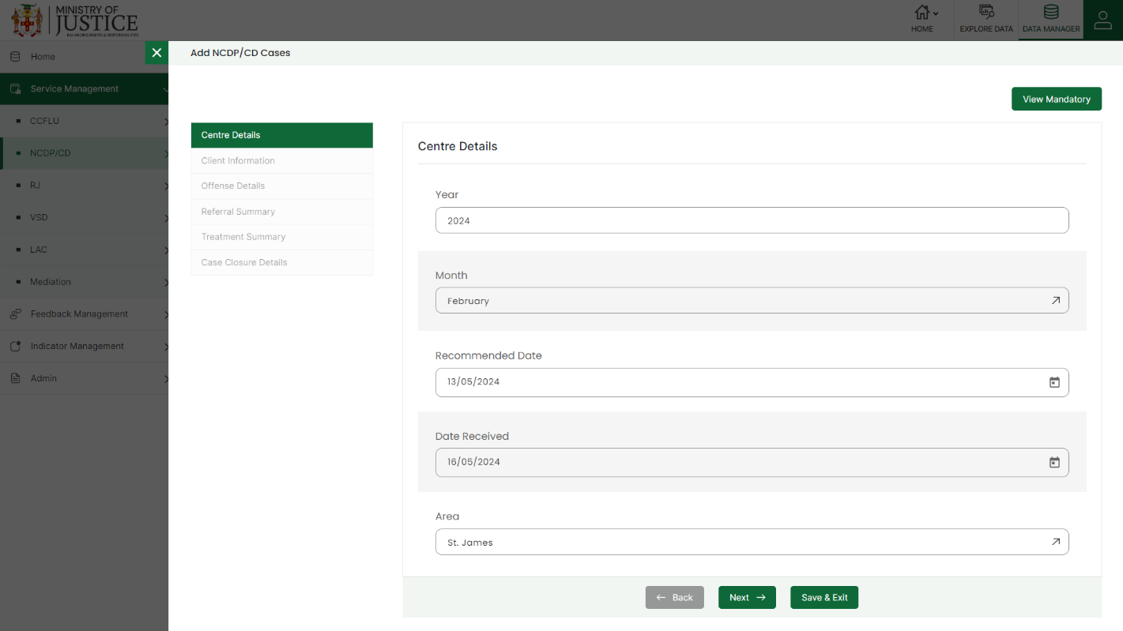Enter the following information to add a new record –

* - Select **Year**
* - Select **Month**
* - Enter **Recommended Date**
* - Enter **Date Received**
* Select **Area**
* - Enter **Child Diversion Case Number**
* - Select **Sex**
* - Enter **Age**
* - **Age-Group** *(Auto generated)*
* - Enter **Community of Offender**
* - Enter **Parish of Offenders**
* - Select **Area of Residence**
* - Select **Is client apart of vulnerable group?**
* - Select **If so, Specify**
* - Enter **Specify Other.**
* - Select **Prior Referral(s) To Child Diversion**
* - Select **Prior convictions**
* - Enter **Details of prior convictions**
* - Select **Primary Offense**
* - Enter **Specify Other**
* - Select **Secondary Offense**
* - Enter **Specify Other (2)**
* - Enter **Additional Offenses**
* - Enter **Community Offense took place**
* - Enter **Date of Offense**
* - Enter **Number of Victims**
* - Select **Referral Source**
* - Select **Received from another center?**
* - Enter **Parish (Transfer was received from)**
* - Select **Transferred to another Office**
* - Enter **Parish (Transferred to)**
* - Select **Intake Assessment Completed**
* - Enter **Intake Date**
* - Select **Risk Level**
* - Select **Treatment Plan Developed**
* - Select **Mental Health Diagnosis/diagnosis impression**
* - Select **Mentorship Assigned**
* - Select **Provided with counselling sessions (Mental Health)**
* - Select **Receiving substance abuse treatment services (NCDA)**
* - Select **Receiving sexual and reproductive education and counselling (WCJF)**
* - Select **Receiving Restorative Justice**
* - Select **Receiving Victim Services**
* - Select **Referred to HEART**
* - Enter **Any other service provider child was diverted to**
* - Select **IDP Signed**
* - Enter **Date IDP was Signed**
* - Enter **Child Diversion Committee Meeting Date**
* - Select **Child Diversion Committee Recommendation**
* - Enter **Proposed IDP Duration of IDP Intervention**
* - Enter **Commencement date of IDP**
* - Enter **Termination date of IDP**
* - Select **Case File Status**
* - Enter **Remarks/Comments**

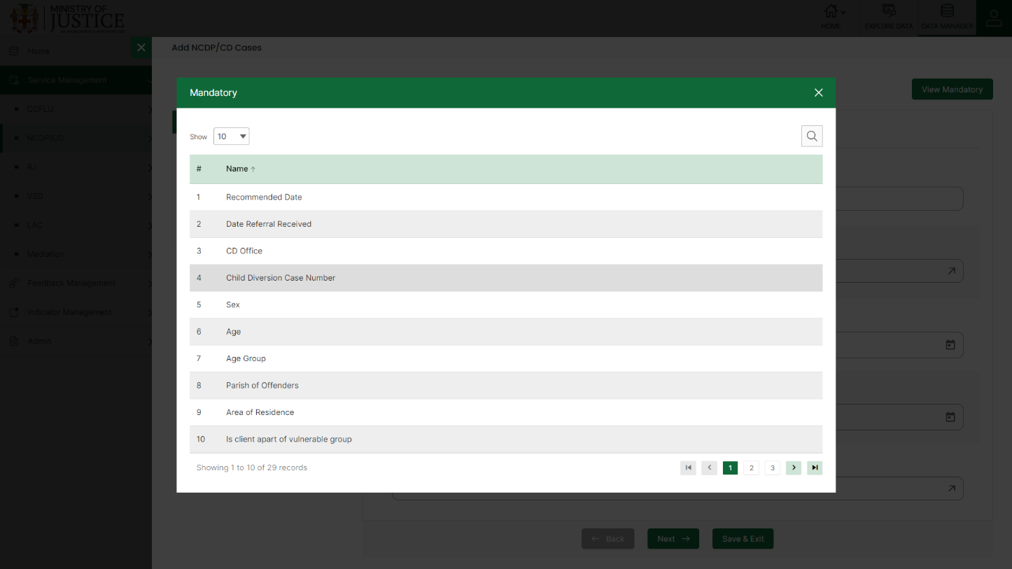Fields that are mandatory to submit the entry can be viewed using **View Mandatory** button present on the top right side of the add CCFLU Expungement form. Click on the **Save** button to save and confirm. You can now view the new record added in the list.

***NOTE:***

*You can navigate between the sections using the* ***Back*** *and* ***Next*** *button available at the bottom of the page. The* ***Next*** *button will get enabled once the unique field is filled. You can Save the data and Exit anytime using* ***Save & Exit*** *button.* ***Submit*** *button will be enabled when all the mandatory fields are filled.*

You can view the form according to the status i.e. Pending and Approved. If all the mandatory fields of the form are not filled, then it will be saved under **Pending – Incomplete** status.

If all the mandatory fields are filled, then it will be saved under **Pending – Complete** status.

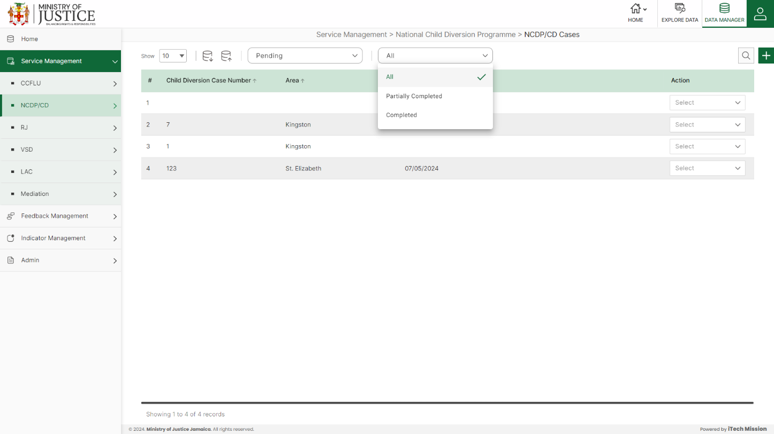Click on the tick icon near status dropdown to **Approve All** the records under pending – complete status.

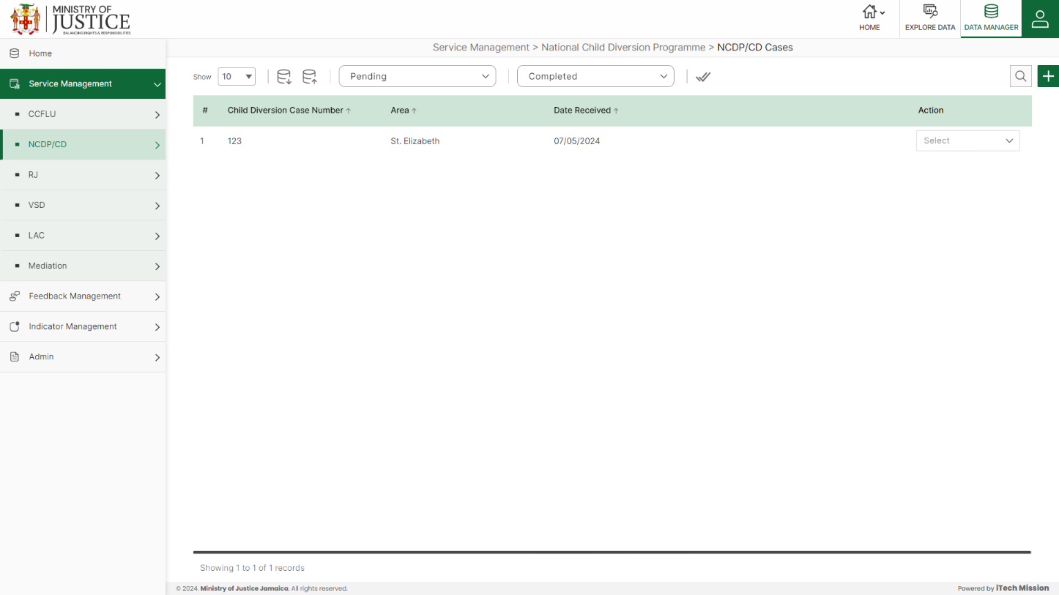Select **Edit** option available in the action dropdown to edit the details of the selected element. Edit the required detail and click on update button to save and confirm.

Select **Delete** option available in the action dropdown to delete the selected element. A confirmation popup appears, click yes to confirm deletion of selected element.

Select **View** option available in the action dropdown to view the details of the selected element.

### **4.2.2 NPCD/CD Activity Summary**

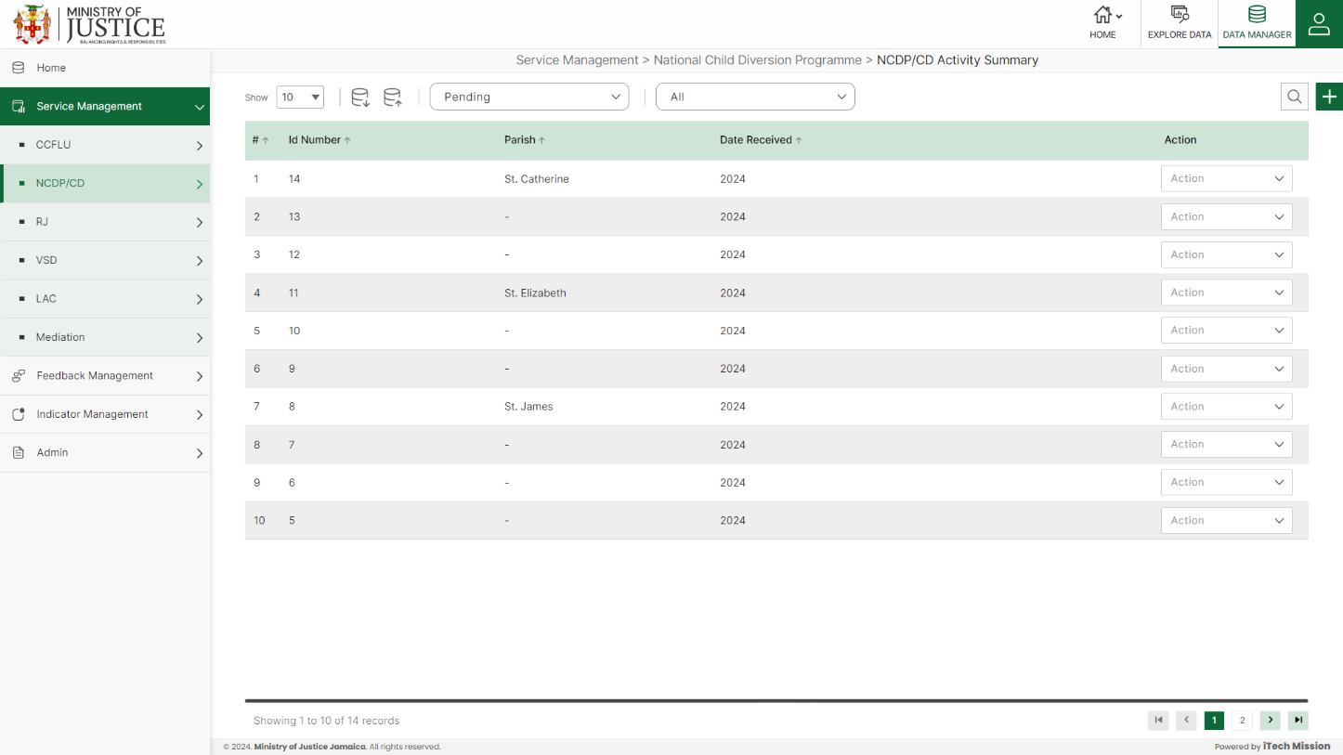Click on **NPCD/CD Activity Summary** from the NPCD/CD menu option available in the left panel to access this module. This module allows to manage the NPCD/CD activity summary master list. You will have options to export or import, add a new element, view the list of existing elements, sort the list, search from the list, edit and delete the existing elements (see below figure).

#### 4.2.2.1 EXPORT

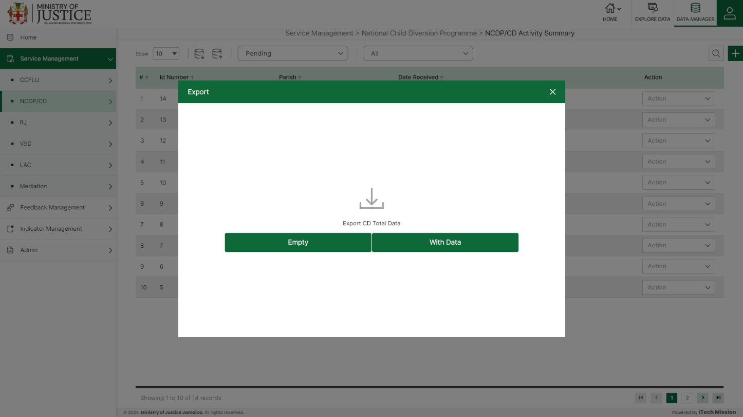****Click on the **Export** button to download the empty template and the master list (see below figure).

Click on the **Empty** option to download an empty template (see below figure). The file is imported and exported in the CSV (Comma Separated Value) file format.

Click on the **With Data** option to download the master list (see below figure).

#### 4.2.2.2 IMPORT

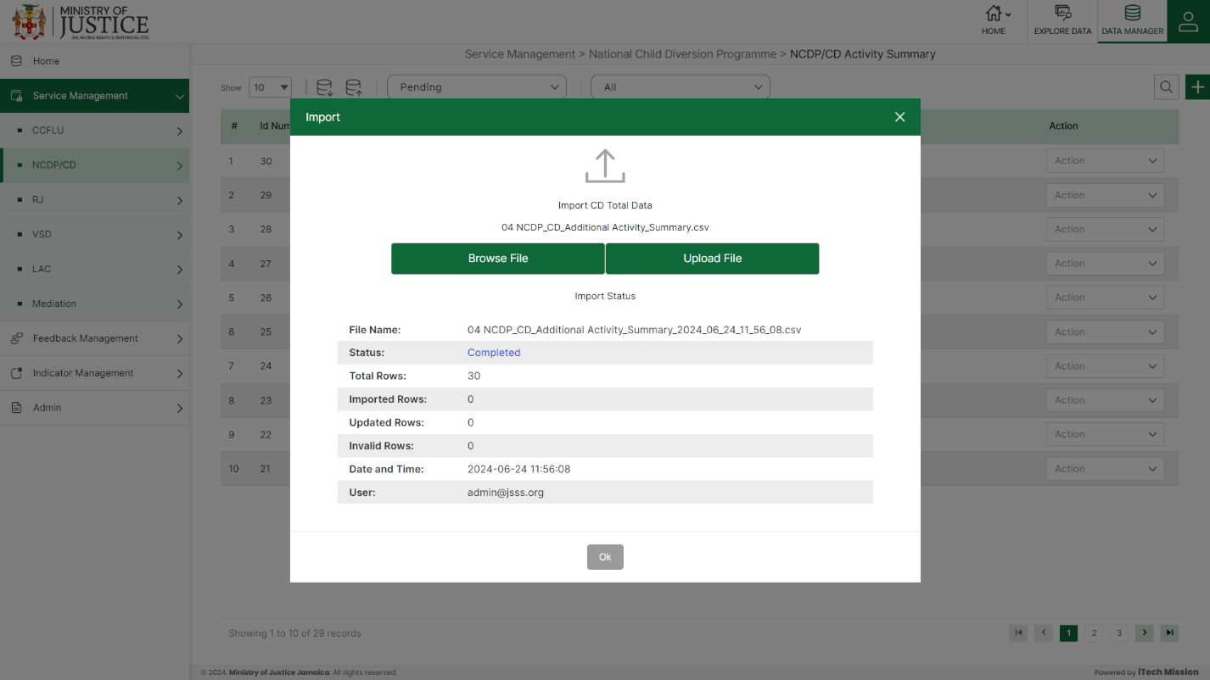Click on the **Import** button to browse the file and upload the master list into the database (see below figure).

To upload the file into the database first enter the structure in the template and then click on the **Browse File** button to select the template. Now, click on the **Upload** button to start the import process. During the import process, the records which contains blank entries, entries with special characters and duplicate entries are not imported in the database.

A Last Upload summary will appear after the import process which provides the count of successfully imported records out of the total records. An error log will be generated to report on unsuccessfully imported records which you can access from **Logs** module.

#### 4.2.2.3 ADD

****Click on the **Plus** button available at the top right corner to add a new record. The Add NPCD/CD Activity Summary form have only one sections namely – **Additional Child Diversion Activities**

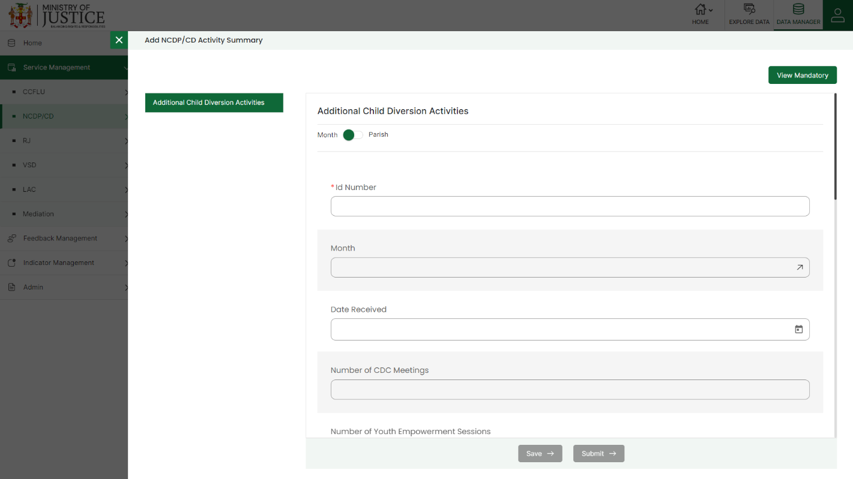Enter the following information to add a new record –

* - Enter **ID Number**
* - Select **Month**
* - Select **Date Received**
* - Enter **Number of CDC Meetings Total**
* - Enter **Number of Youth Empowerment sessions**
* - Enter **Number of Parent Empowerment sessions**
* - Enter **Number of Mentors trained**
* - Enter **Number of sensitization sessions conducted**
* **- Number of persons reached from sessions conducted Total** *(Auto generated)*
* - Enter **Number of persons reached from sessions conducted Male**
* - Enter **Number of persons reached from sessions conducted Female**
* **- Number of medium/high risk children Total** (*Auto generated)*
* - Enter **Number of medium/high risk children in Programme for the month Male**
* - Enter **Number of medium/high risk children Female**
* - **Number of medium/high risk assigned a mentor Total** (Auto generated)
* - Enter **Number of medium/high risk assigned a mentor Male**
* - Enter **Number of medium/high risk assigned a mentor Female**

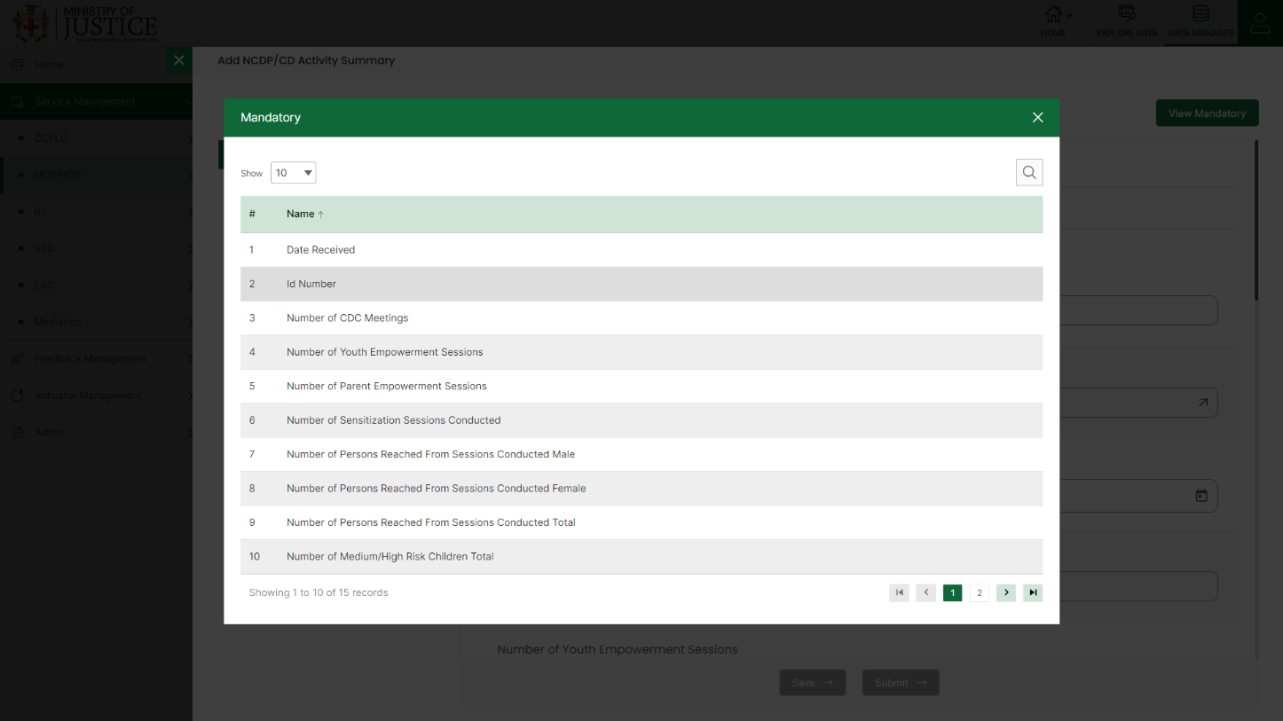Fields that are mandatory to submit the entry can be viewed using **View Mandatory** button present on the top right side of the add CCFLU Expungement form. Click on the **Save** button to save and confirm. You can now view the new record added in the list.

***NOTE:***

*You can navigate between the sections using the* ***Back*** *and* ***Next*** *button available at the bottom of the page. The* ***Next*** *button will get enabled once the unique field is filled. You can Save the data and Exit anytime using* ***Save & Exit*** *button.* ***Submit*** *button will be enabled when all the mandatory fields are filled.*

You can view the form according to the status i.e. Pending and Approved. If all the mandatory fields of the form are not filled, then it will be saved under **Pending – Incomplete** status.

If all the mandatory fields are filled, then it will be saved under **Pending – Complete** status.

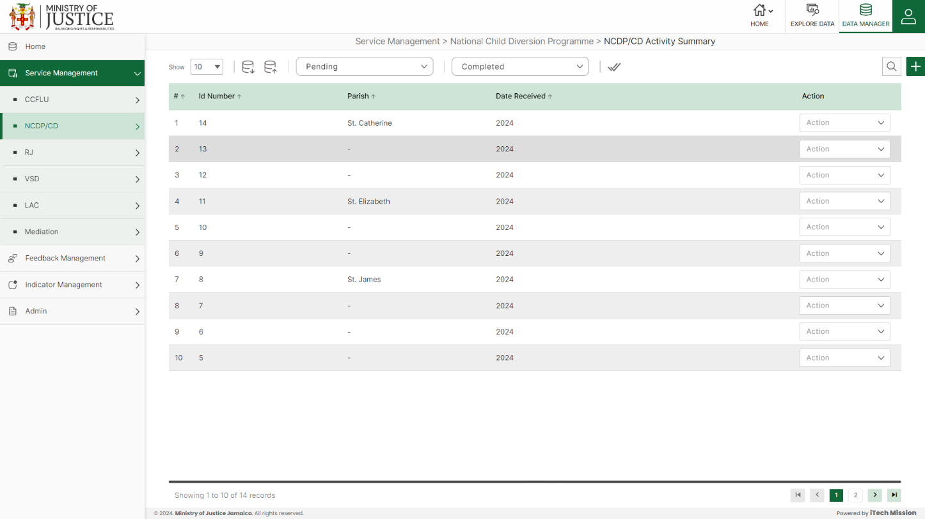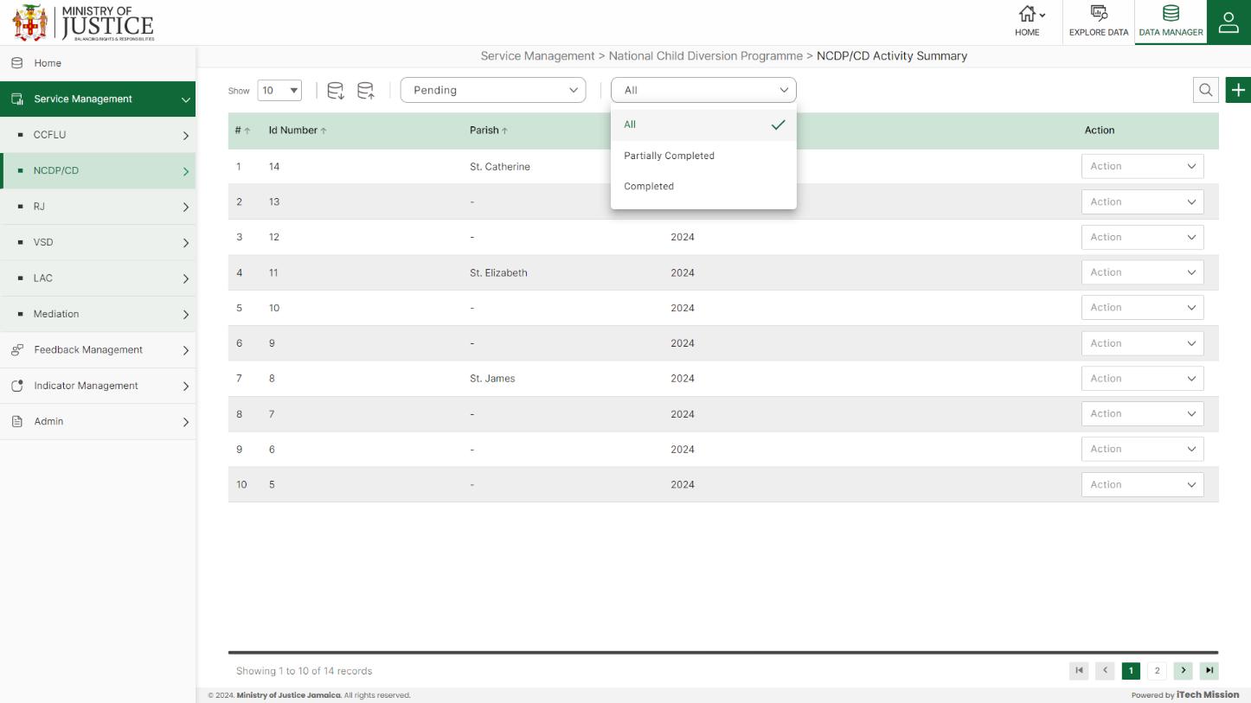Click on the tick icon near status dropdown to **Approve All** the records under pending – complete status.

Select **View** option available in the action dropdown to view the details of the selected element.

Select **Edit** option available in the action dropdown to edit the details of the selected element. Edit the required detail and click on update button to save and confirm.

Select **Delete** option available in the action dropdown to delete the selected element. A confirmation popup appears, click yes to confirm deletion of selected element.

## **4.3 RJ**

Click on the **RJ** from service management menu option from the left panel to access this module. This module has two submodules – RJ Cases and RJ Activity Summary Let us understand these submodules in detail.

### **4.3.1 RJ Cases**

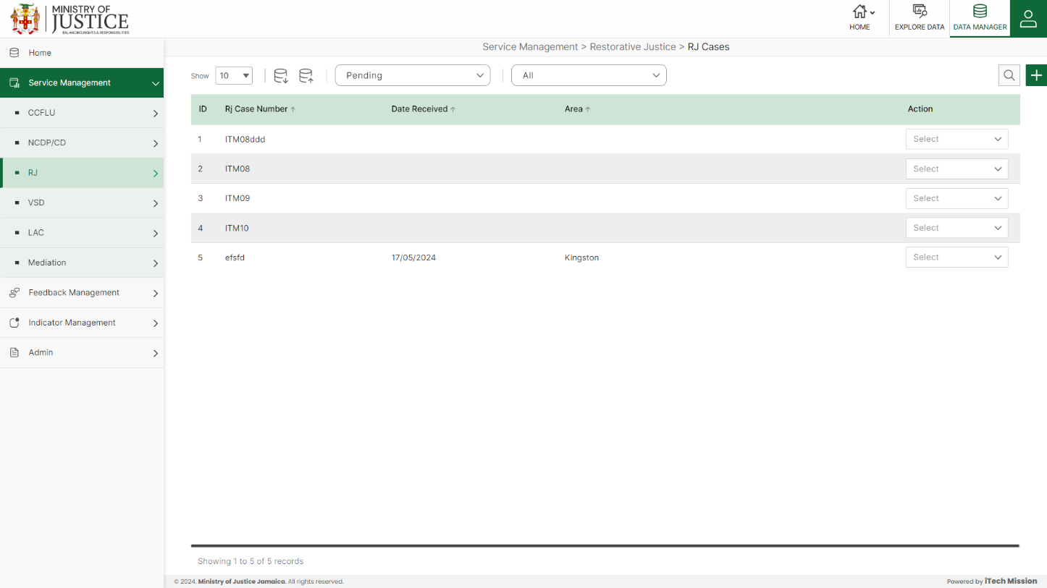Click on **RJ Cases** from the RJ menu option available in the left panel to access this module. This module allows to manage the RJ cases master list. You will have options to export or import, add a new element, view the list of existing elements, sort the list, search from the list, edit and delete the existing elements (see below figure)

#### 4.3.1.1 EXPORT

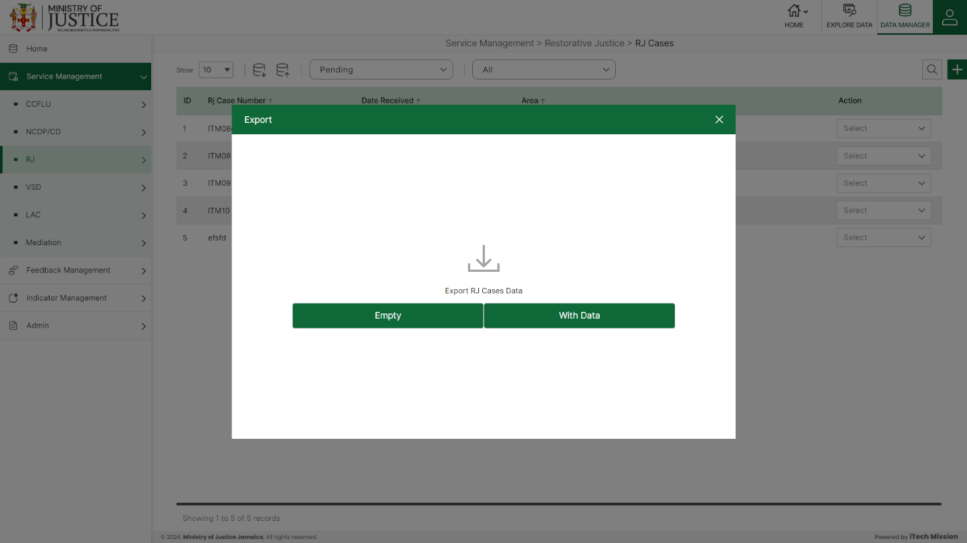****Click on the **Export** button to download the empty template and the master list (see below figure).

Click on the **Empty** option to download an empty template (see below figure). The file is imported and exported in the CSV (Comma Separated Value) file format.

Click on the **With Data** option to download the master list (see below figure).

#### 4.3.1.2 IMPORT

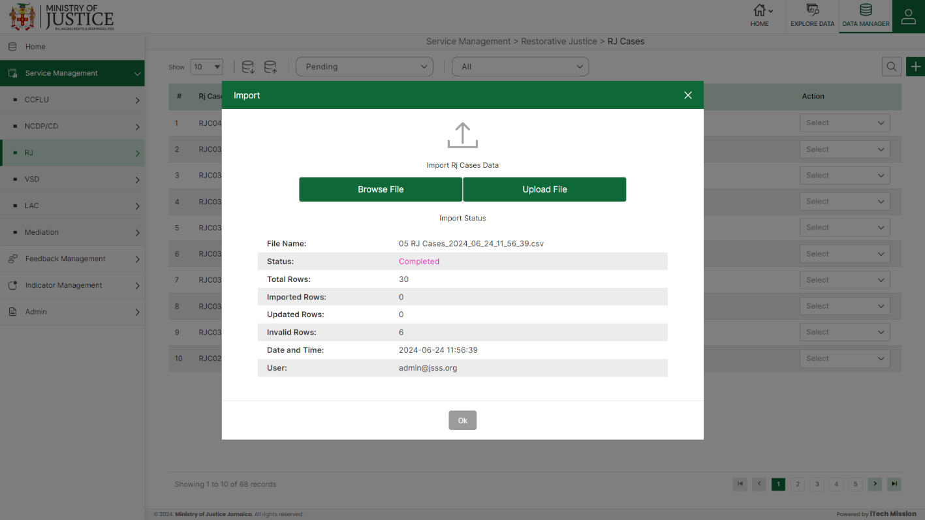Click on the **Import** button to browse the file and upload the master list into the database (see below figure).

To upload the file into the database first enter the structure in the template and then click on the **Browse File** button to select the template. Now, click on the **Upload** button to start the import process. During the import process, the records which contains blank entries, entries with special characters and duplicate entries are not imported in the database.

A Last Upload summary will appear after the import process which provides the count of successfully imported records out of the total records. An error log will be generated to report on unsuccessfully imported records which you can access from **Logs** module.

#### 4.3.1.3 ADD

****Click on the **Plus** button available at the top right corner to add a new record. The Add RJ Cases form is divided into sections namely – **Case Information, Offender Details, Victim Details, Case Details and Settlement Details.**

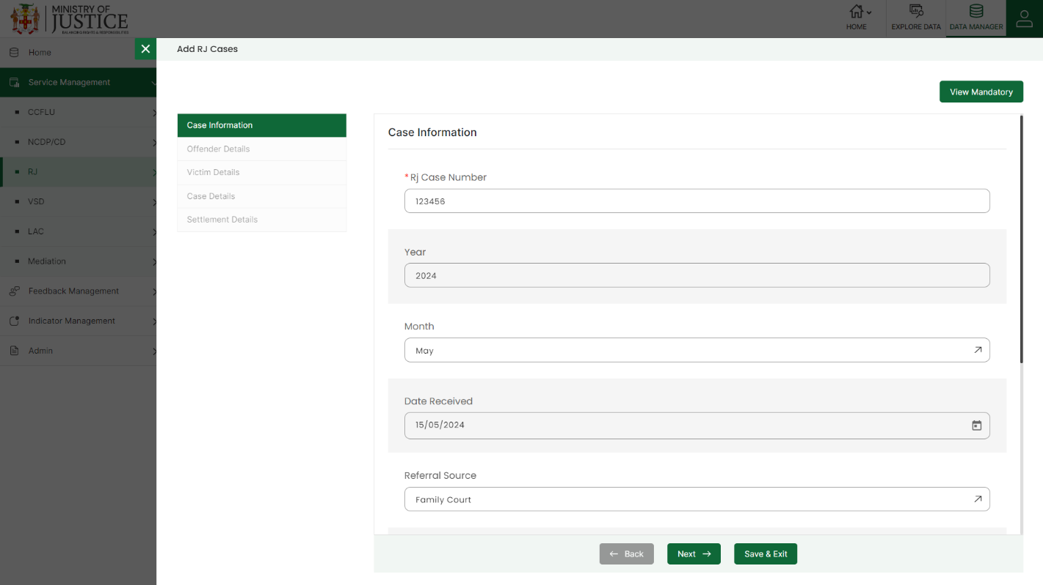Enter the following information to add a new record –

* - Enter **RJ Case Number**
* - Enter **Year**
* - Select **Month**
* - Enter **Date Received**
* - Select **Referral Source**
* - Enter **Specify Other**
* - Enter **Court Referral Number**
* - Select **Area**
* - Enter **RJ Centre**
* - Enter **Number of Offenders**
* - Select **Sex of Offenders**
* - Enter **Age of Offenders**
* - **Age-Group** *(Auto Generated)*
* - Enter **Offender Community of Residence**
* - Enter **Community Code**
* - Select **Area of Residence**
* - Enter **Offender's Parish**
* - Select **Does Offender Have a Lawyer**
* - Select **Is Offender Apart of Vulnerable Group?**
* - Select **If So, Specify Offender’s vulnerable subgroup**
* - Enter **Specify Offender’s Other vulnerable subgroup.**
* - Enter **Pre Meeting Date (Offender)**
* - Enter **Number of Victims**
* - Select **Sex of Victim**
* - Enter **Age of Victim**
* - **Age-Group** *(Auto Generated)*
* - Enter **Victim Community of Residence**
* - Enter **Community Code**
* - Enter **Area of Residence**
* - Enter **Victim's Parish**
* - Select **Does Victim Have a Lawyer**
* - Select **Is Victim Apart of Vulnerable Group?**
* - Select **If So, Specify Victim’s vulnerable subgroup**
* - Enter **Specify Victim’s Other vulnerable subgroup**.
* - Enter **Pre Meeting Date (Victim)**
* - Select **Primary Offence/Harm Type**
* - Enter **Specify Other**
* - Enter **Any Other Offences/Harm Type**
* - Select **Victim's Relation to Offender(S)**
* - Enter **Specify Other Relation**
* - Enter **Community of Harm**
* - Enter **Community Code**
* **-** Enter **Pre Meeting Date**
* **-**Select **Cross Case**
* **-** Enter **Conference Date**
* **-** Select **Agreement Reached**
* **-** Enter **Agreement Date**
* **-** Enter **Date Agreement Returned to Court**
* **-** Enter **Date of Next Court Hearing**
* **-** Enter **If Compensation, How Much Was Agreed? (Specify Currency)**
* **-** Select **Compensation - Was It Paid in Full**
* **-** Enter **Agreement Status**
* - Enter **Follow Up 1 Date**
* **-** Enter **Follow Up 2 Date**
* **-** Enter **Follow Up 3 Date**
* **-** Enter **Follow Up 4 Date**
* **-** Select **Case Status**
* **-** Enter **Remarks**

Fields that are mandatory to submit the entry can be viewed using **View Mandatory** button present on the top right side of the add CCFLU Expungement form. Click on the **Save** button to save and confirm. You can now view the new record added in the list.

***NOTE:***

*You can navigate between the sections using the* ***Back*** *and* ***Next*** *button available at the bottom of the page. The* ***Next*** *button will get enabled once the unique field is filled. You can Save the data and Exit anytime using* ***Save & Exit*** *button.* ***Submit*** *button will be enabled when all the mandatory fields are filled.*

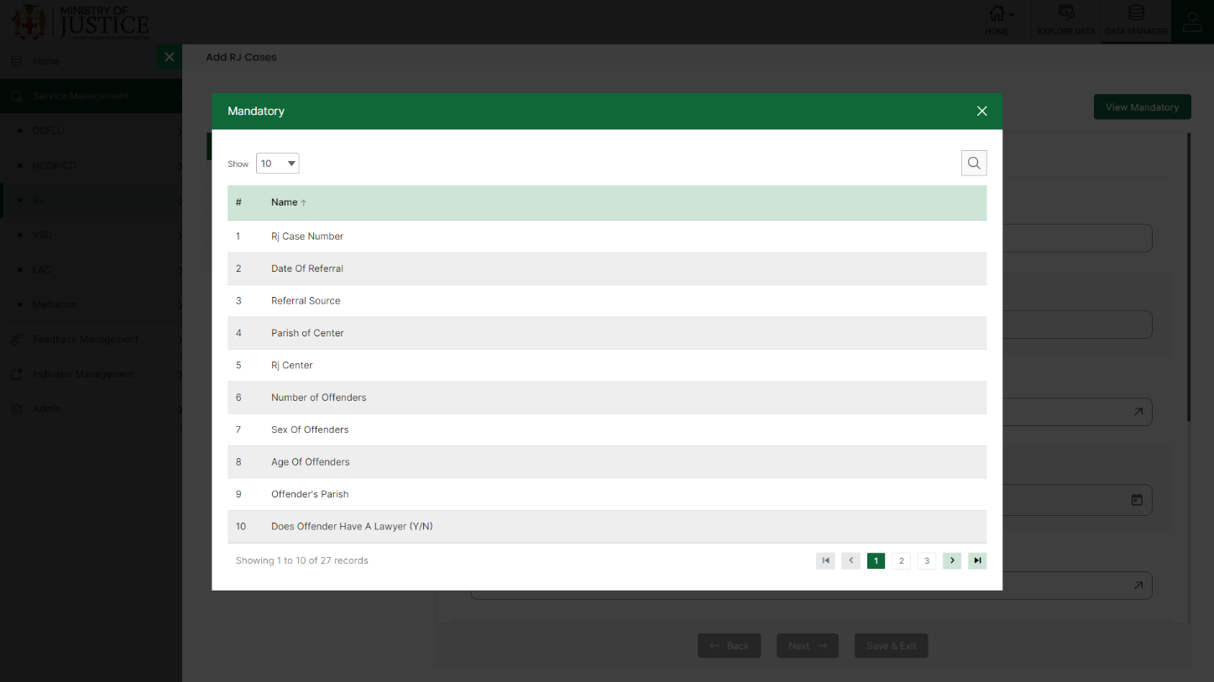You can view the form according to the status i.e. Pending and Approved. If all the mandatory fields of the form are not filled, then it will be saved under **Pending – Incomplete** status.

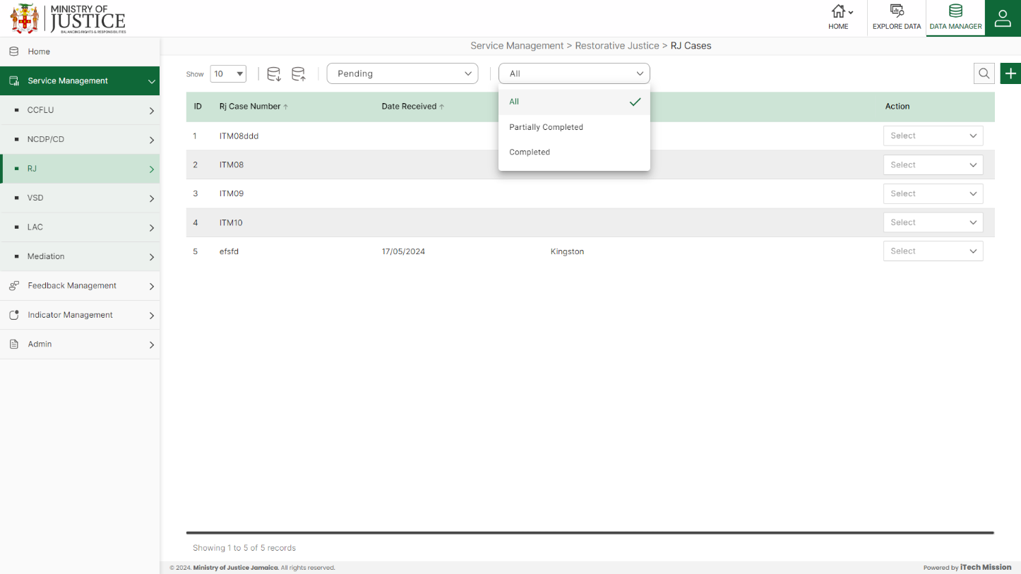If all the mandatory fields are filled, then it will be saved under **Pending – Complete** status.

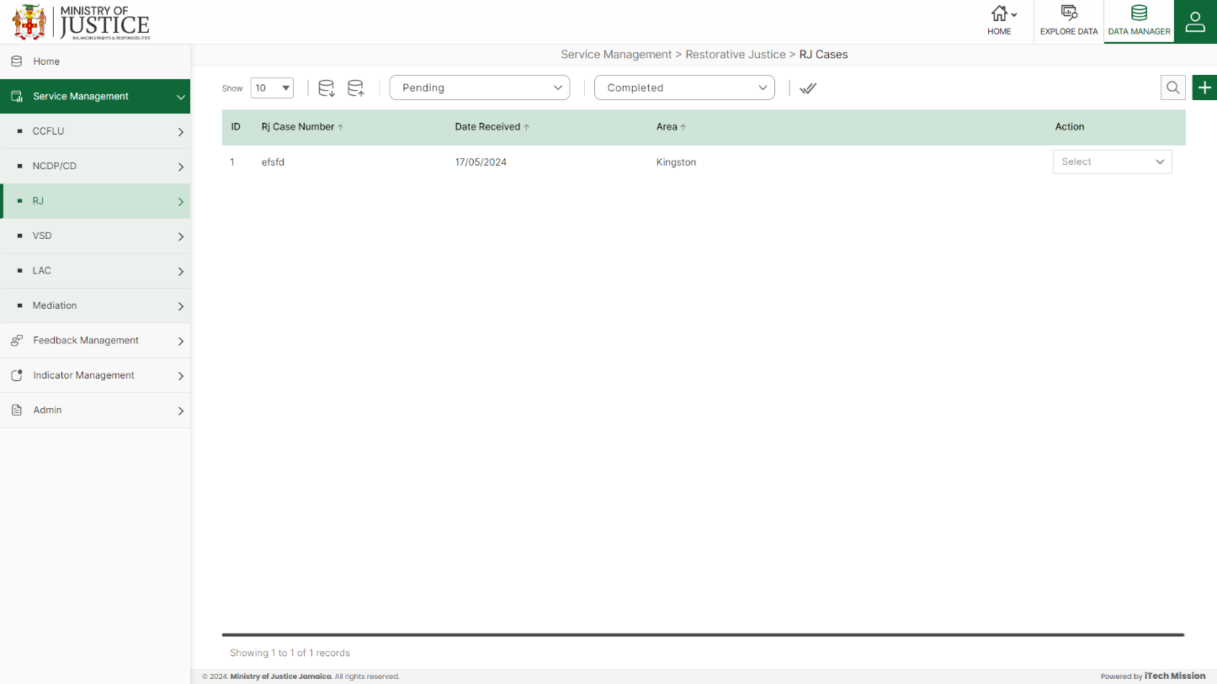Click on the tick icon near status dropdown to **Approve All** the records under pending – complete status.

Select **View** option available in the action dropdown to view the details of the selected element.

Select **Edit** option available in the action dropdown to edit the details of the selected element. Edit the required detail and click on update button to save and confirm.

Select **Delete** option available in the action dropdown to delete the selected element. A confirmation popup appears, click yes to confirm deletion of selected element.

### **4.3.2 RJ Activity Summary**

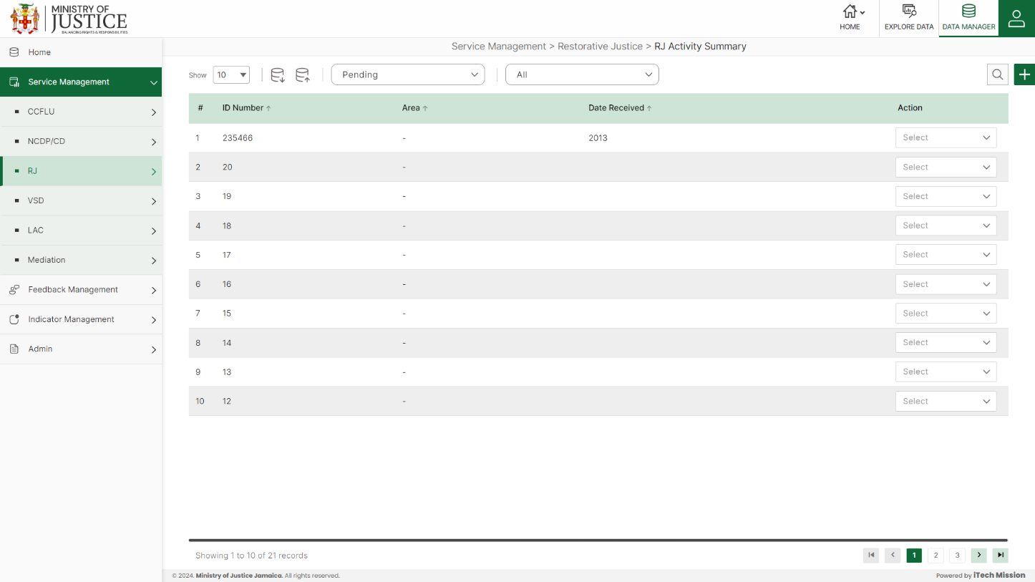Click on **RJ Activity Summary** from the RJ menu option available in the left panel to access this module. This module allows to manage the RJ activity summary master list. You will have options to export or import, add a new element, view the list of existing elements, sort the list, search from the list, edit and delete the existing elements (see below figure).

#### 4.3.2.1 EXPORT

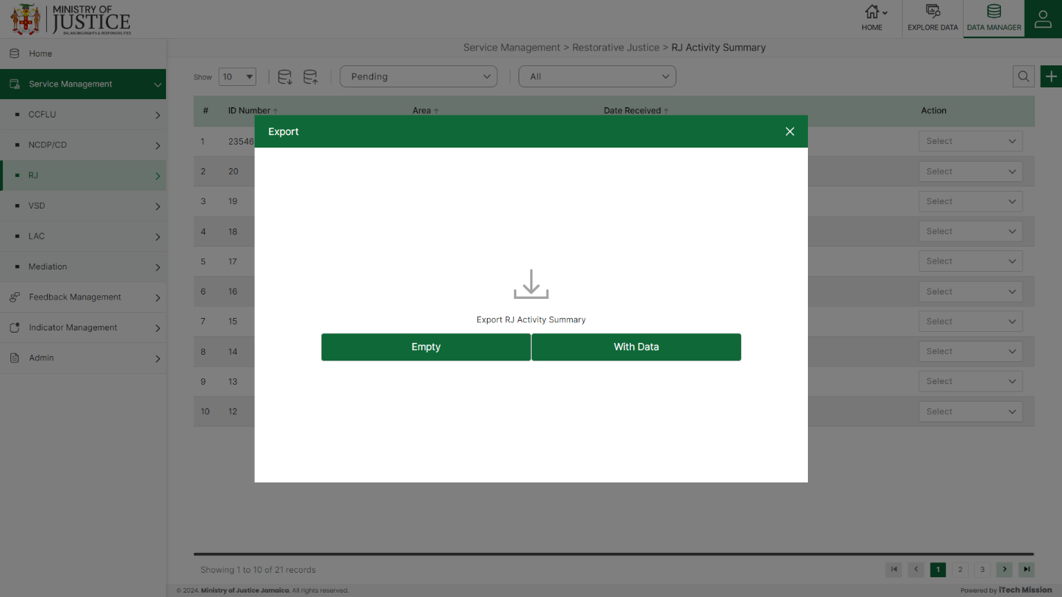****Click on the **Export** button to download the empty template and the master list (see below figure).

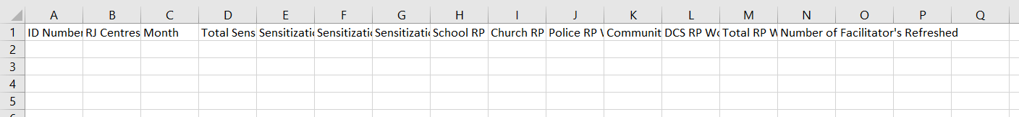Click on the **Empty** option to download an empty template (see below figure). The file is imported and exported in the CSV (Comma Separated Value) file format.

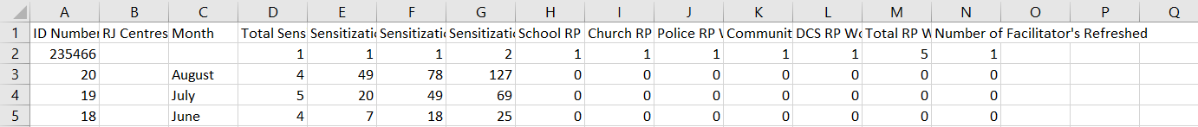Click on the **With Data** option to download the master list (see below figure).

#### 4.3.2.2 IMPORT

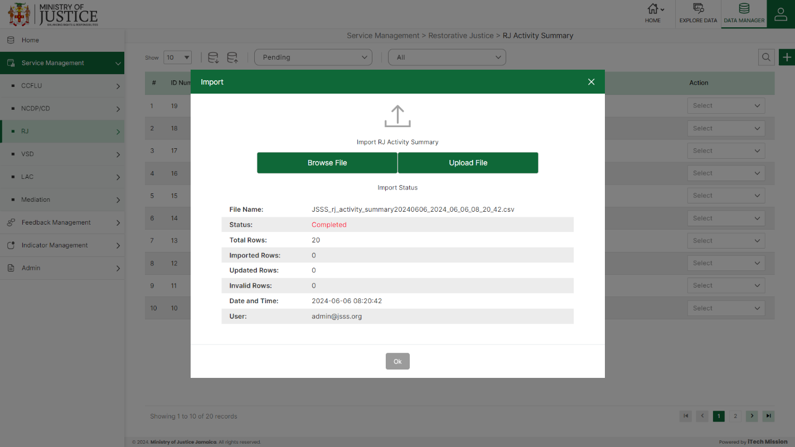Click on the **Import** button to browse the file and upload the master list into the database (see below figure).

To upload the file into the database first enter the structure in the template and then click on the **Browse File** button to select the template. Now, click on the **Upload** button to start the import process. During the import process, the records which contains blank entries, entries with special characters and duplicate entries are not imported in the database.

A Last Upload summary will appear after the import process which provides the count of successfully imported records out of the total records. An error log will be generated to report on unsuccessfully imported records which you can access from **Logs** module.

#### 4.3.2.3 ADD

****Click on the **Plus** button available at the top right corner to add a new record. The Add RJ Activity Summary form is divided into sections namely –  **Referral and Intake Data, Sensitizations Summary, Restorative Practices Workshops**

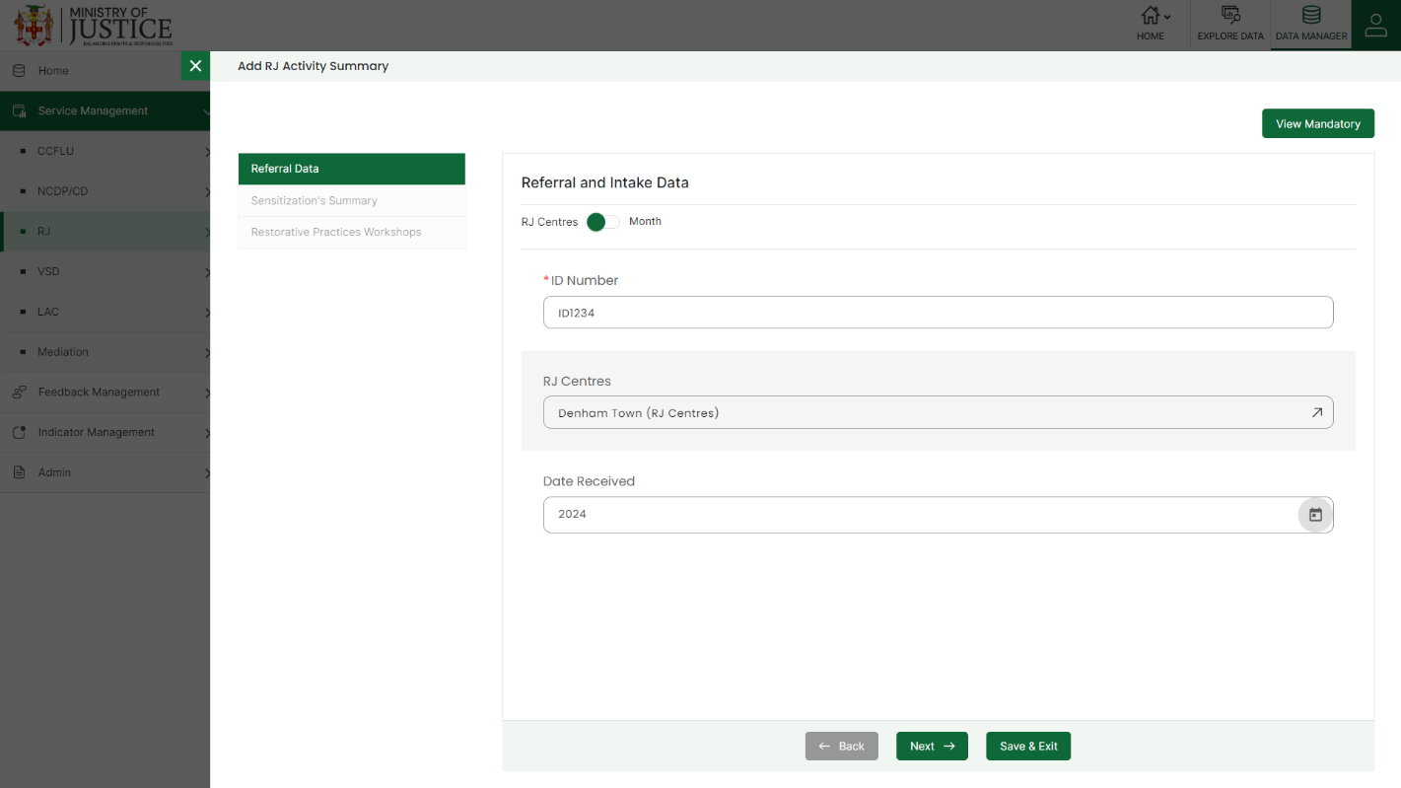Enter the following information to add a new record –

* - Enter **ID Number**
* - Enter **RJ Centre/Month**
* - Select **Date Received**
* - Enter **Total Sensitization Sessions**
* - Enter **Sensitization Beneficiaries Males**
* - Enter **Sensitization Beneficiaries Females**
* - Enter **Sensitization Beneficiaries Total**
* - Enter **School RP Workshop**
* - Enter **Church RP Workshop**
* - Enter **Police RP Workshop**
* - Enter **Community RP Workshop**
* - Enter **DCS RP Workshop**
* - Enter **Total RP Workshop**
* - Enter **Number of Facilitator's Refreshed**

Fields that are mandatory to submit the entry can be viewed using **View Mandatory** button present on the top right side of the add CCFLU Expungement form. Click on the **Save** button to save and confirm. You can now view the new record added in the list.

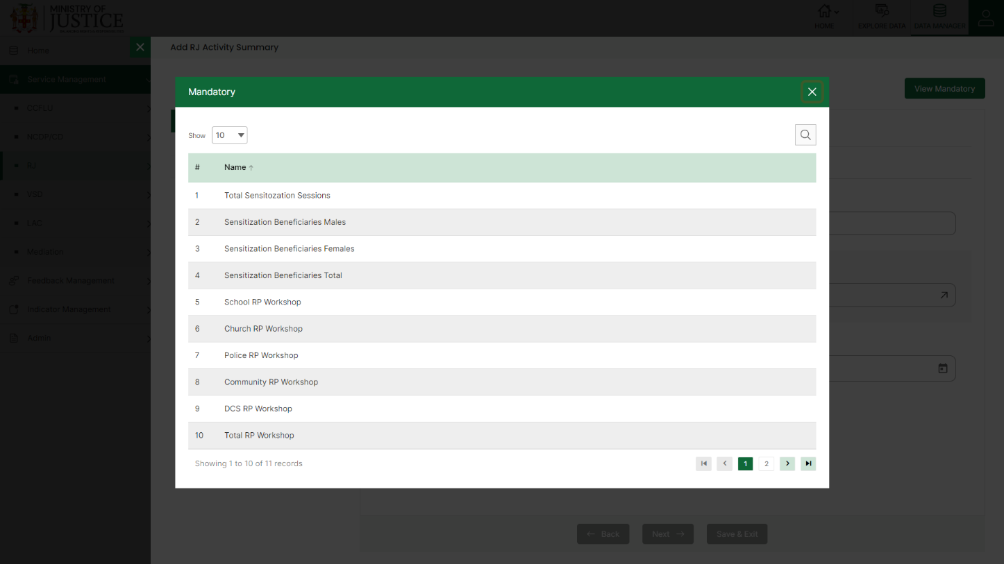You can view the form according to the status i.e. Pending and Approved. If all the mandatory fields of the form are not filled, then it will be saved under **Pending – Incomplete** status.

***NOTE:***

*You can navigate between the sections using the* ***Back*** *and* ***Next*** *button available at the bottom of the page. The* ***Next*** *button will get enabled once the unique field is filled. You can Save the data and Exit anytime using* ***Save & Exit*** *button.* ***Submit*** *button will be enabled when all the mandatory fields are filled.*

If all the mandatory fields are filled, then it will be saved under **Pending – Complete** status.

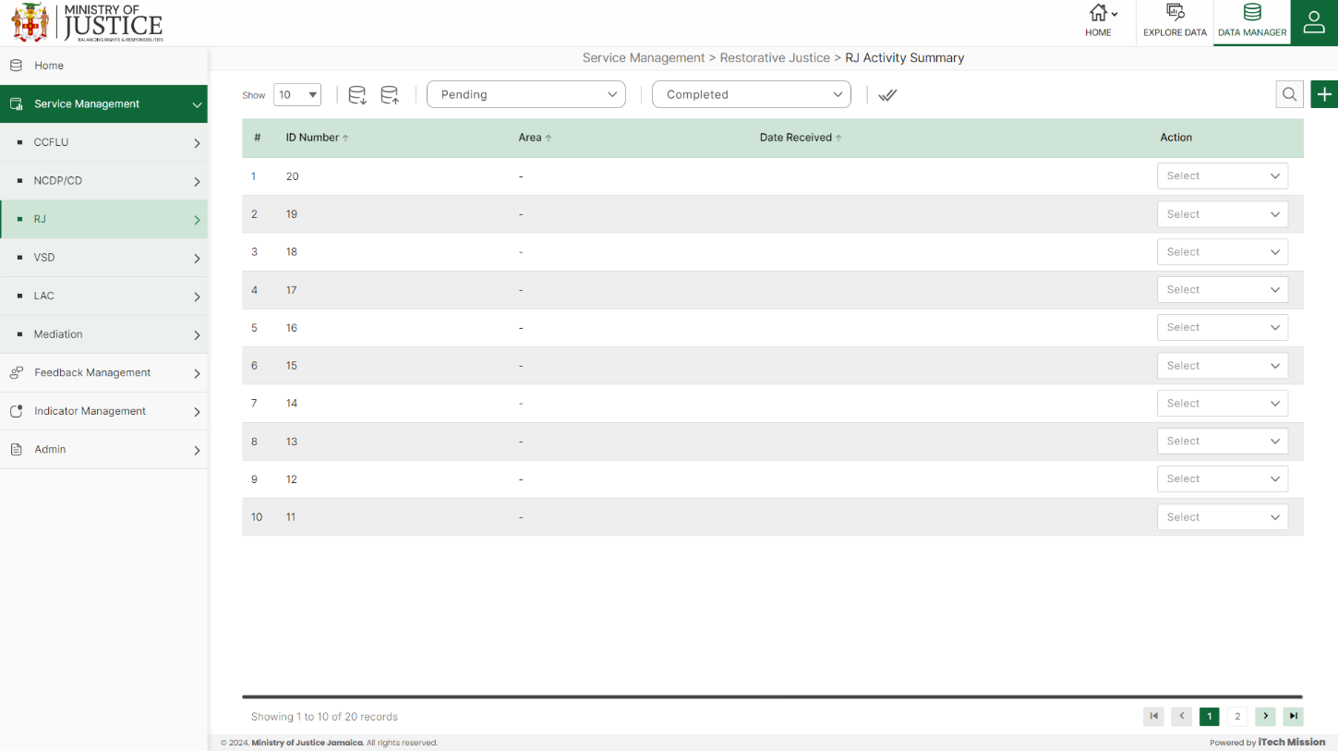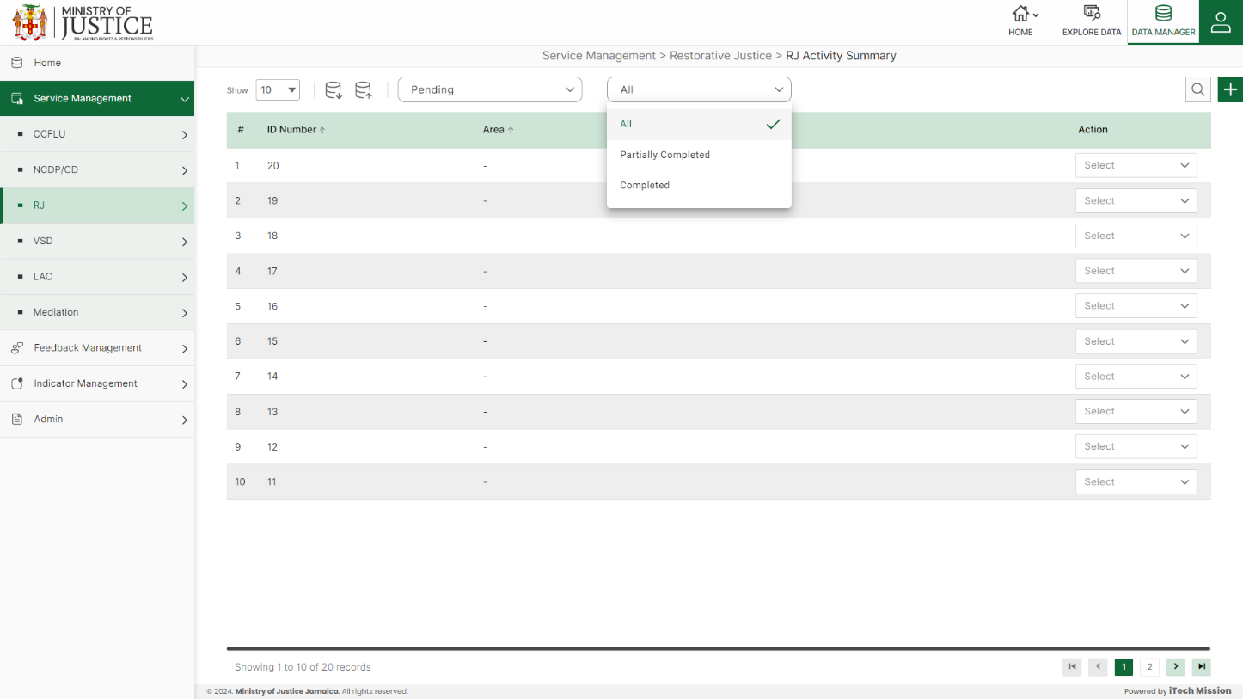Click on the tick icon near status dropdown to **Approve All** the records under pending – complete status.

Select **View** option available in the action dropdown to view the details of the selected element.

Select **Edit** option available in the action dropdown to edit the details of the selected element. Edit the required detail and click on update button to save and confirm.

Select **Delete** option available in the action dropdown to delete the selected element. A confirmation popup appears, click yes to confirm deletion of selected element.

## **4.4 VSD**

Click on the **VSD** from service management menu option from the left panel to access this module. This module has two submodules – VSD Cases and VSD Activity Summary Let us understand these submodules in detail.

### **4.4.1 VSD Cases**

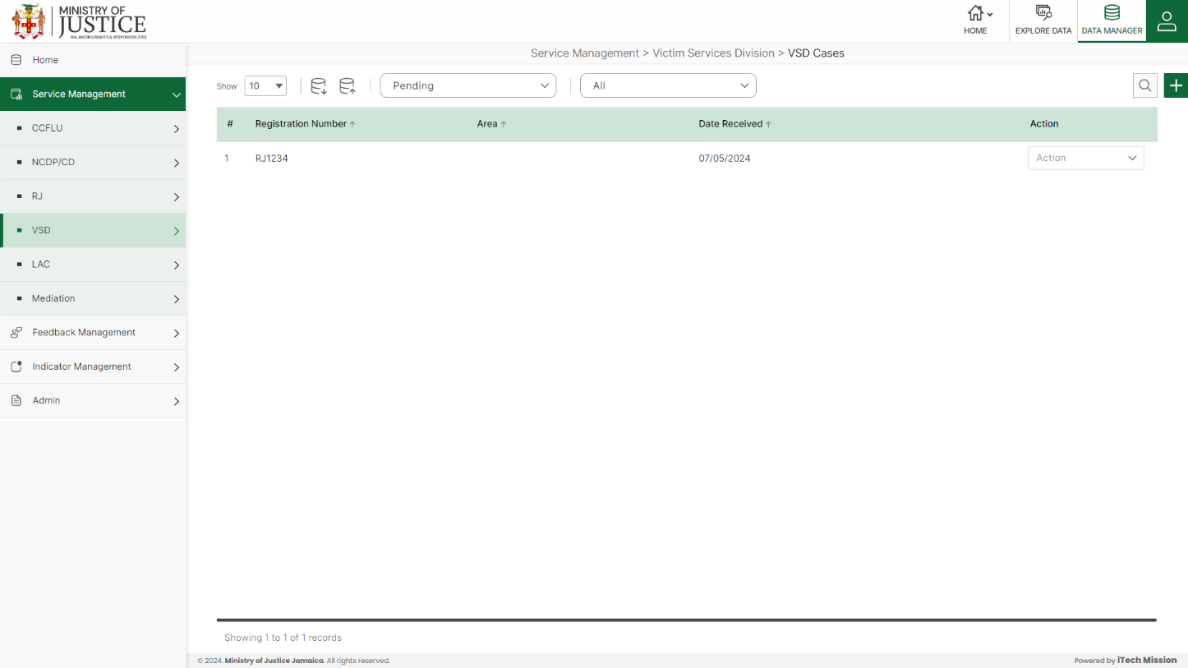Click on **VSD Cases** from the RJ menu option available in the left panel to access this module. This module allows to manage the VSD cases master list. You will have options to export or import, add a new element, view the list of existing elements, sort the list, search from the list, edit and delete the existing elements (see below figure).

#### 4.4.1.1 EXPORT

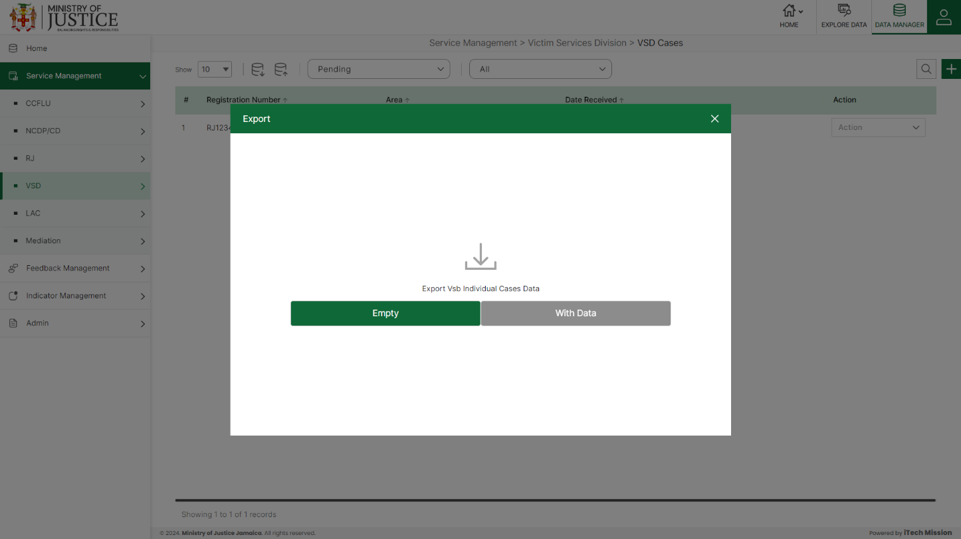****Click on the **Export** button to download the empty template and the master list (see below figure).

Click on the **Empty** option to download an empty template (see below figure). The file is imported and exported in the CSV (Comma Separated Value) file format.

Click on the **With Data** option to download the master list (see below figure).

#### 4.4.1.2 IMPORT

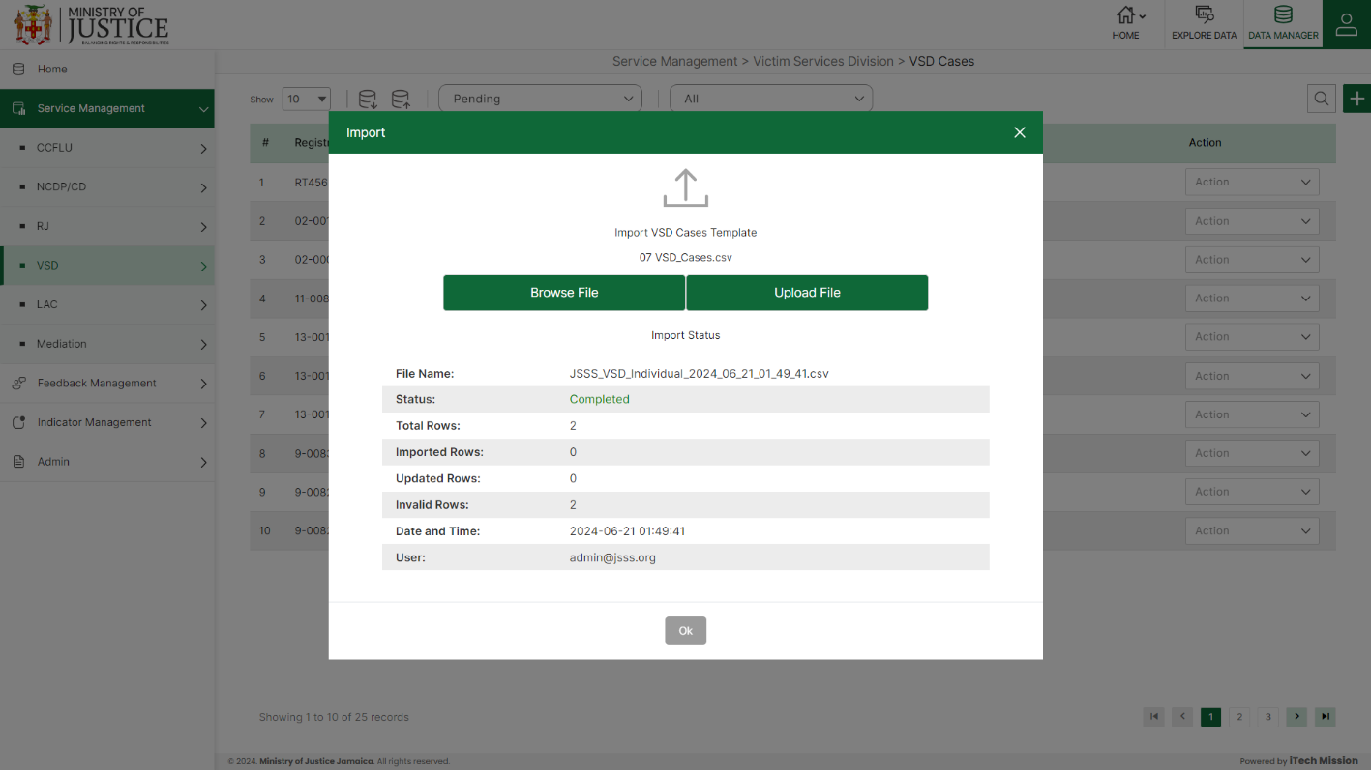Click on the **Import** button to browse the file and upload the master list into the database (see below figure).

To upload the file into the database first enter the structure in the template and then click on the **Browse File** button to select the template. Now, click on the **Upload** button to start the import process. During the import process, the records which contains blank entries, entries with special characters and duplicate entries are not imported in the database.

A Last Upload summary will appear after the import process which provides the count of successfully imported records out of the total records. An error log will be generated to report on unsuccessfully imported records which you can access from **Logs** module.

#### 4.4.1.3 ADD

****Click on the **Plus** button available at the top right corner to add a new record. The Add VSD Cases form is divided into sections namely – **Victim Details, Offense Details, Offender Details and Other court services and follow up.**

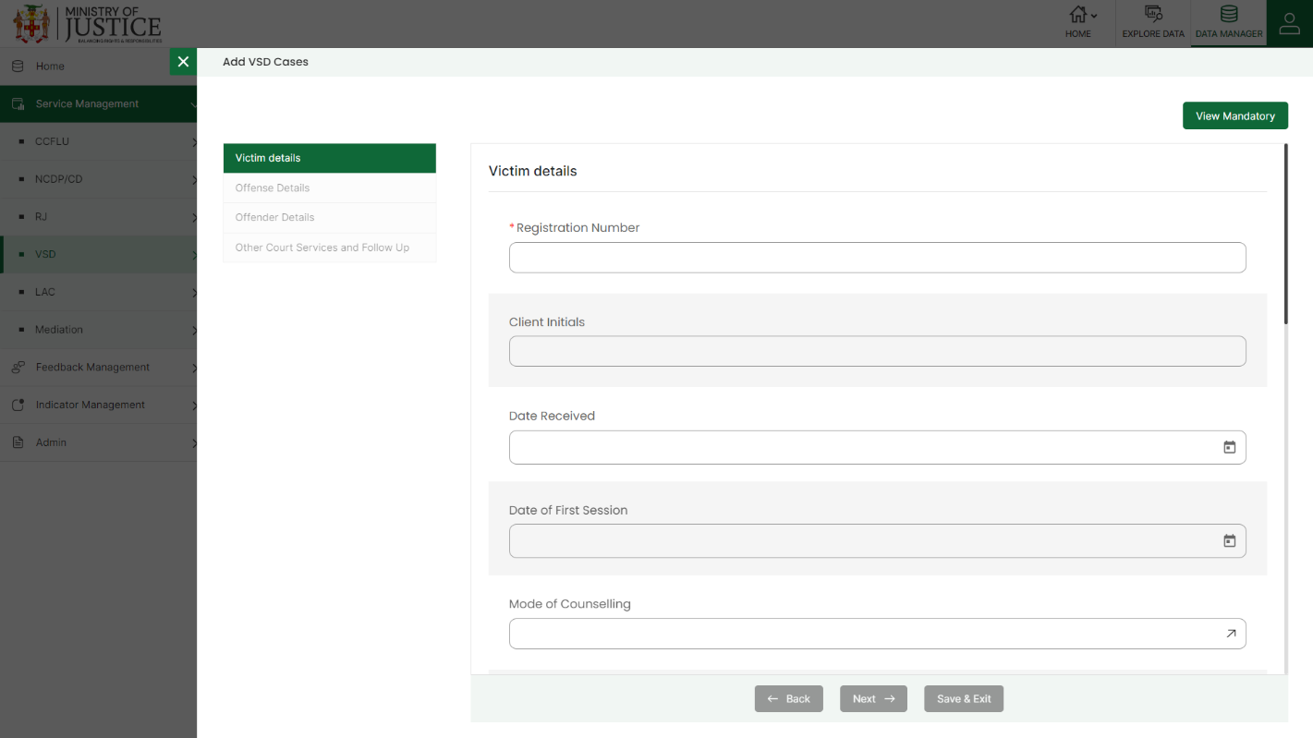Enter the following information to add a new record –

* - Enter **Registration Number**
* - Enter **Client Initials**
* - Enter **Date Received**
* - Enter **Date of First Session**
* - Select **Mode of Counselling**
* - Select **Sex of Client**
* - Enter **Age of Client**
* - Enter **Age-Group**
* - Enter **Client's Community of Residence**
* - Select **Client's Parish of Residence**
* - Select **Area of Residence**
* - Select **Psychoeducation Assessment Administered**
* - Select **Identified as High Risk**
* - Select **Is offender apart of vulnerable group?**
* - Select **If so, Specify**
* - Enter **Specify Other**
* - Select **Area**
* - Enter **Counsellors Initials**
* - Select **Offense**
* - Enter **Specify Other** *(optional)*
* - Select **Offense 2**
* - Enter **Specify Other** *(optional)*
* - Select **Offense 3**
* - Enter **Specify Other** (*optional)*
* - Enter **Offense Date**
* - Enter **Community Offense took place**
* - Select **Referral Source** *(IN)*
* - Enter **Specify Other**
* - Select **Referral Destination** *(OUT)*
* - Enter **Specify Other**
* - Select **1st Offence Against Victim?**
* - Select **Prior Offence**
* - Enter **Prior Offence Details**
* - Select **Relationship of Accused to victim**
* - Enter **Other Relationship to Victim**
* - Select **Sex of Accused**
* - Enter **Community of Accused**
* - Select **Area of Residence**
* - Select **Parish of Accused**
* - Select **Beneficiary of Court Services**
* - Select **Beneficiary of Court Services 2**
* - Select **Beneficiary of Court Services 3**
* - Enter **Follow Up Date 1**
* - Select **Mode of Counselling**
* - Enter **Follow Up Date 2**
* - Select **Mode of Counselling**
* - Enter **Follow Up Date 3**
* - Select **Mode of Counselling**
* - Enter **Follow Up Date 4**
* - Select **Mode of Counselling**
* - Enter **Follow Up Date 5**
* - Select **Mode of Counselling**
* - Enter **Follow Up Date 6**
* - Select **Mode of Counselling**
* - Enter **Follow Up Date 7**
* - Select **Mode of Counselling**
* - Enter **Follow Up Date 8**
* - Select **Mode of Counselling**
* - Enter **Follow Up Date 9**
* - Select **Mode of Counselling**
* - Enter **Follow Up Date 10**
* - Select **Mode of Counselling**

Fields that are mandatory to submit the entry can be viewed using **View Mandatory** button present on the top right side of the add CCFLU Expungement form. Click on the **Save** button to save and confirm. You can now view the new record added in the list.

***NOTE:***

*You can navigate between the sections using the* ***Back*** *and* ***Next*** *button available at the bottom of the page. The* ***Next*** *button will get enabled once the unique field is filled. You can Save the data and Exit anytime using* ***Save & Exit*** *button.* ***Submit*** *button will be enabled when all the mandatory fields are filled.*

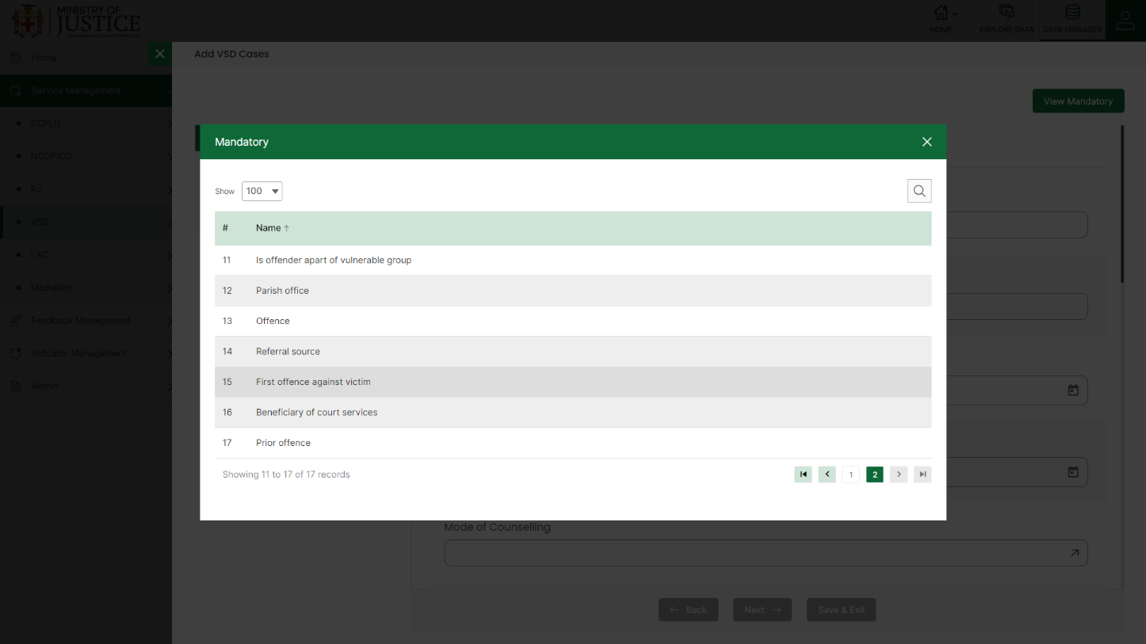You can view the form according to the status i.e. Pending and Approved. If all the mandatory fields of the form are not filled, then it will be saved under **Pending – Incomplete** status.

If all the mandatory fields are filled, then it will be saved under **Pending – Complete** status.

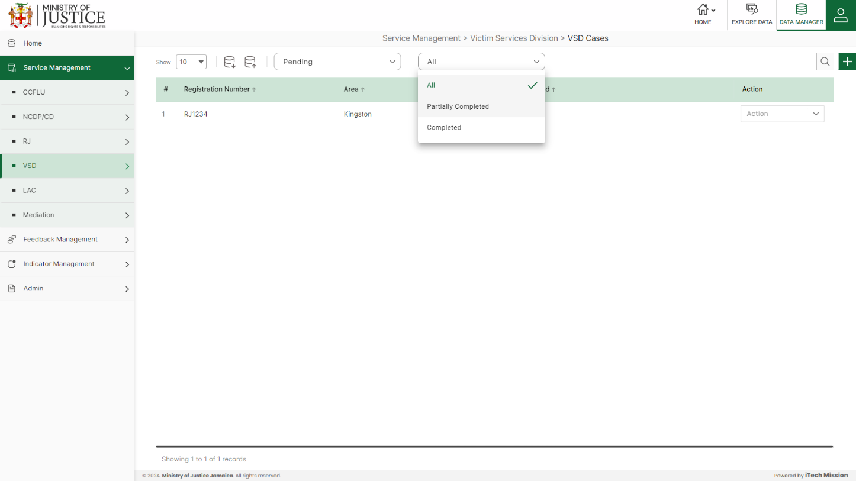Click on the tick icon near status dropdown to **Approve All** the records under pending – complete status.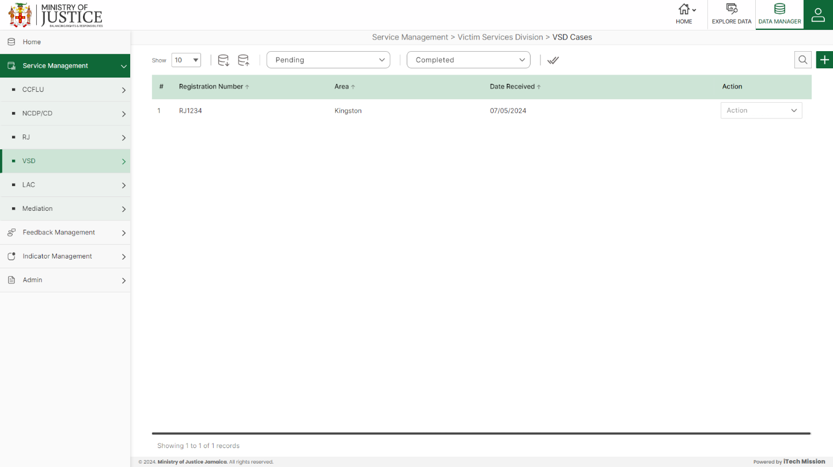

Select **View** option available in the action dropdown to view the details of the selected element.

Select **Edit** option available in the action dropdown to edit the details of the selected element. Edit the required detail and click on update button to save and confirm.

Select **Delete** option available in the action dropdown to delete the selected element. A confirmation popup appears, click yes to confirm deletion of selected element.

### **4.4.2 VSD Activity Summary**

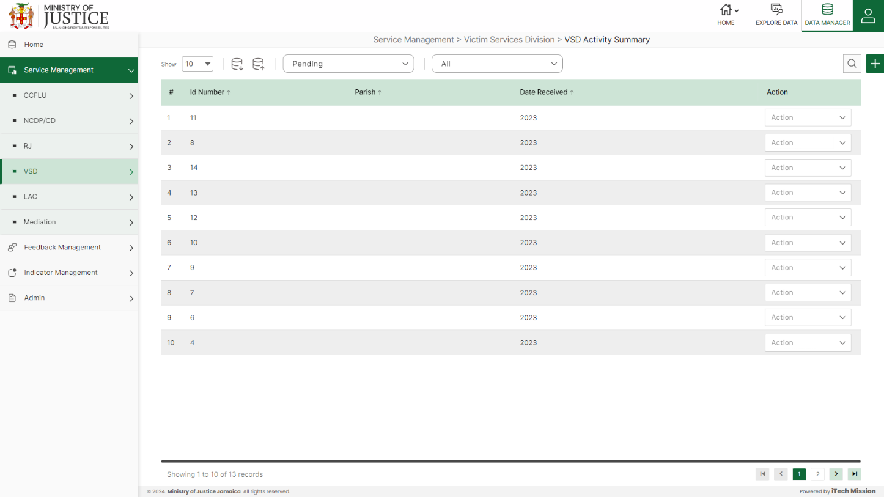Click on **VSD Activity Summary** from the VSD menu option available in the left panel to access this module. This module allows to manage the VSD activity summary master list. You will have options to export or import, add a new element, view the list of existing elements, sort the list, search from the list, edit and delete the existing elements (see below figure).

#### 4.4.2.1 EXPORT

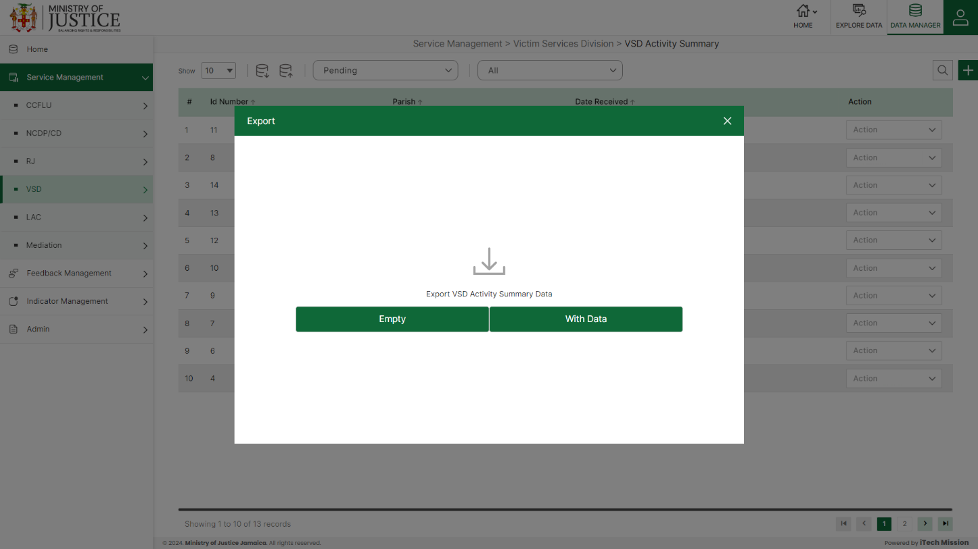****Click on the **Export** button to download the empty template and the master list (see below figure).

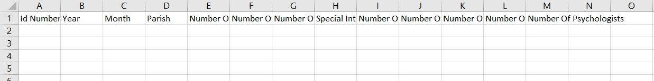Click on the **Empty** option to download an empty template (see below figure). The file is imported and exported in the CSV (Comma Separated Value) file format.

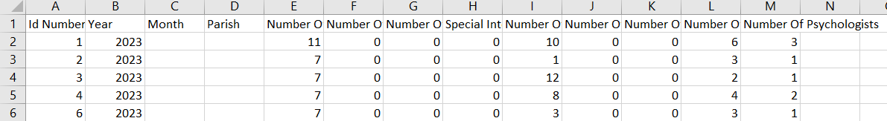Click on the **With Data** option to download the master list (see below figure).

#### 4.4.2.2 IMPORT

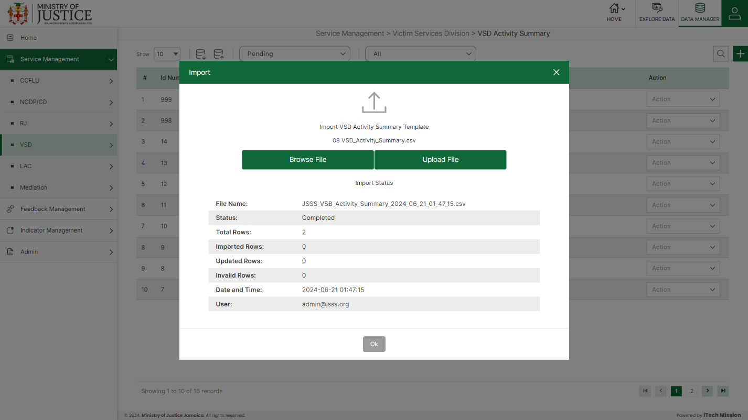Click on the **Import** button to browse the file and upload the master list into the database (see below figure).

To upload the file into the database first enter the structure in the template and then click on the **Browse File** button to select the template. Now, click on the **Upload** button to start the import process. During the import process, the records which contains blank entries, entries with special characters and duplicate entries are not imported in the database.

A Last Upload summary will appear after the import process which provides the count of successfully imported records out of the total records. An error log will be generated to report on unsuccessfully imported records which you can access from **Logs** module.

#### 4.4.2.3 ADD

****Click on the **Plus** button available at the top right corner to add a new record. The Add VSD Activity Summary form have one section namely –  **Activity Details**

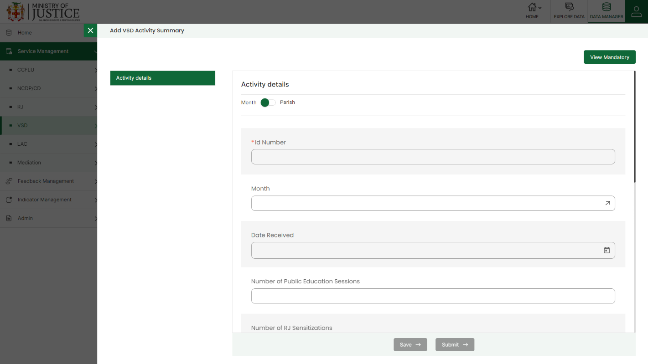Enter the following information to add a new record –

* - Enter **ID Number**
* - Enter **Parish/Month**
* - Select **Date Received**
* - Enter **Number of Public Education Sessions/Promotions**
* - Enter **Number of RJ Sensitizations**
* - Enter **Number of RP training sessions conducted**
* - Enter **Special Intervention Programme Conducted**
* - Enter **Number of Volunteers Deployed**
* - Enter **Number of Group Sessions**
* - Enter **Number of High Risk Children Identified**
* - Enter **Number of Counsellors**
* - Enter **Number of Psychologists**

Fields that are mandatory to submit the entry can be viewed using **View Mandatory** button present on the top right side of the add CCFLU Expungement form. Click on the **Save** button to save and confirm. You can now view the new record added in the list.

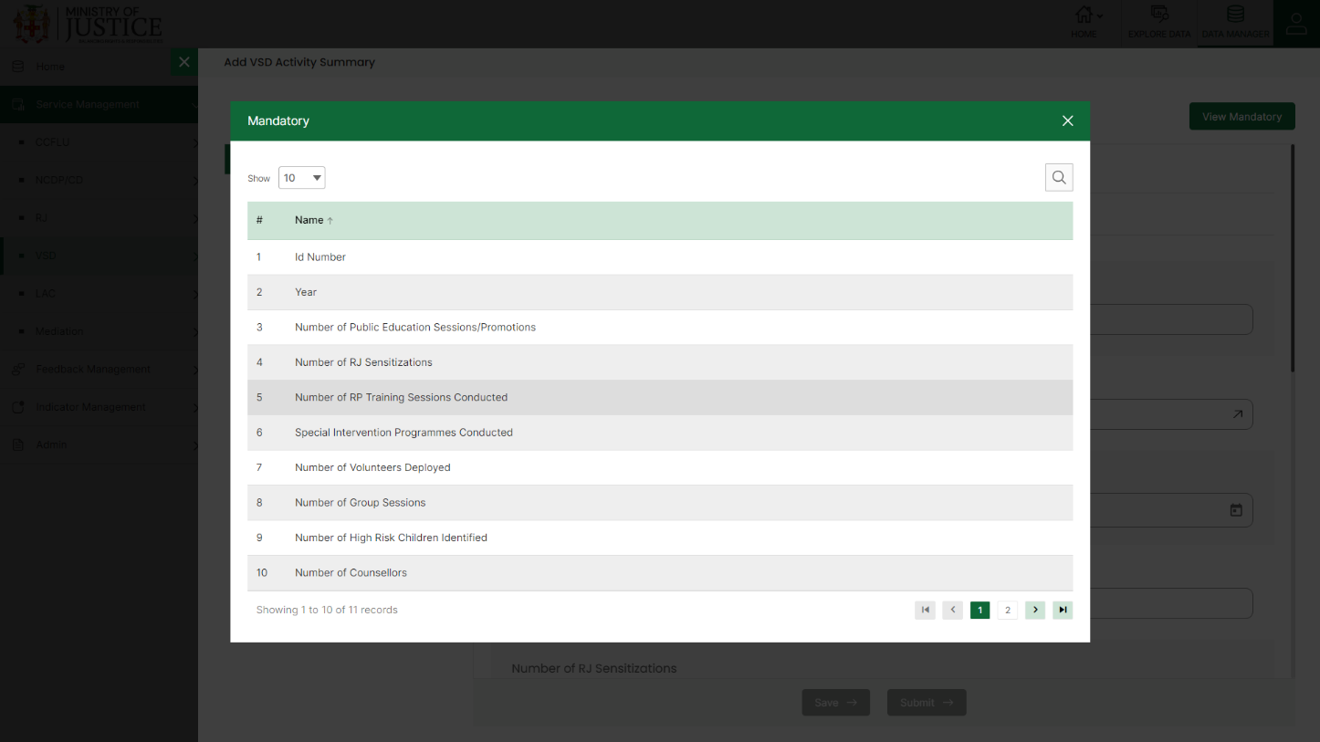You can view the form according to the status i.e. Pending and Approved. If all the mandatory fields of the form are not filled, then it will be saved under **Pending – Incomplete** status.

***NOTE:***

*You can navigate between the sections using the* ***Back*** *and* ***Next*** *button available at the bottom of the page. The* ***Next*** *button will get enabled once the unique field is filled. You can Save the data and Exit anytime using* ***Save & Exit*** *button.* ***Submit*** *button will be enabled when all the mandatory fields are filled.*

If all the mandatory fields are filled, then it will be saved under **Pending – Complete** status.

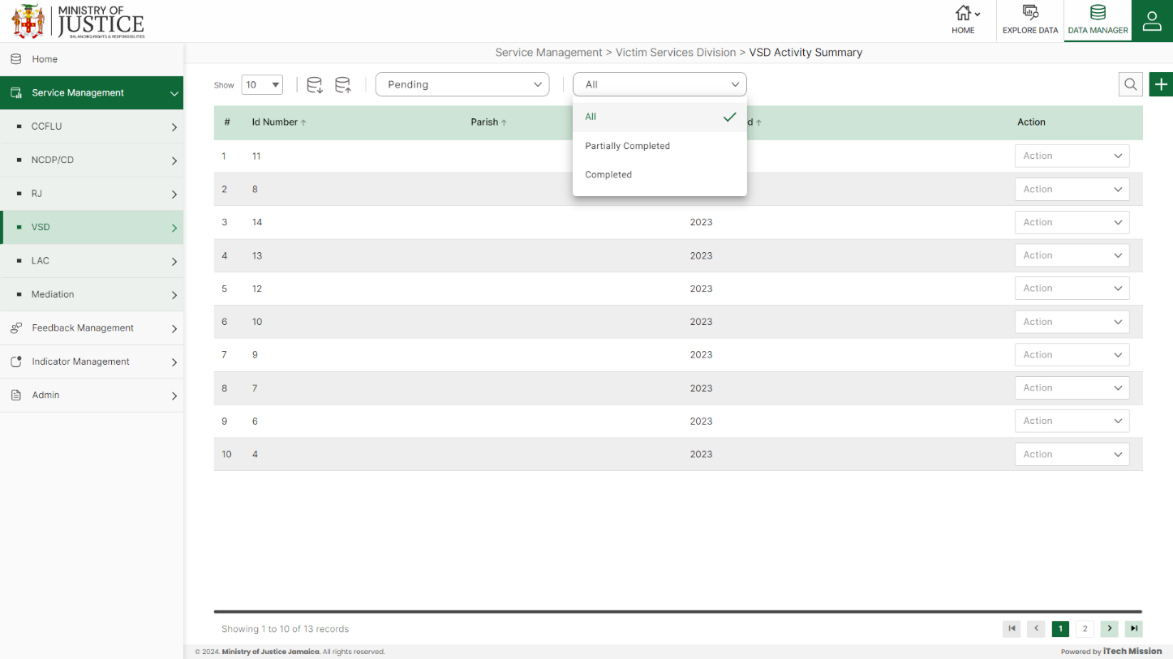Click on the tick icon near status dropdown to **Approve All** the records under pending – complete status.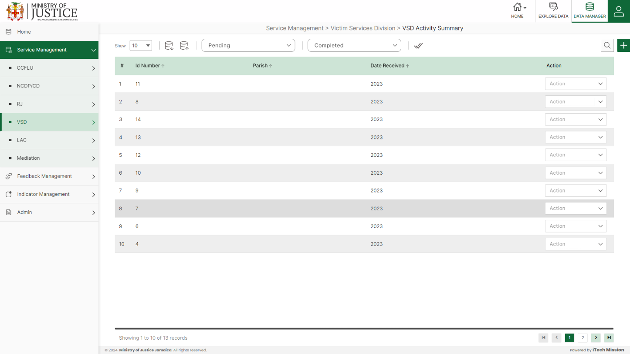

Select **View** option available in the action dropdown to view the details of the selected element.

Select **Edit** option available in the action dropdown to edit the details of the selected element. Edit the required detail and click on update button to save and confirm.

Select **Delete** option available in the action dropdown to delete the selected element. A confirmation popup appears, click yes to confirm deletion of selected element.

## **4.5 LAC**

Click on the **LAC** from service management menu option from the left panel to access this module. This module has three submodules – LAC Cases, LAC Mobile Unit Cases and LAC Additional Act Let us understand these submodules in detail.

### **4.5.1 LAC Cases**

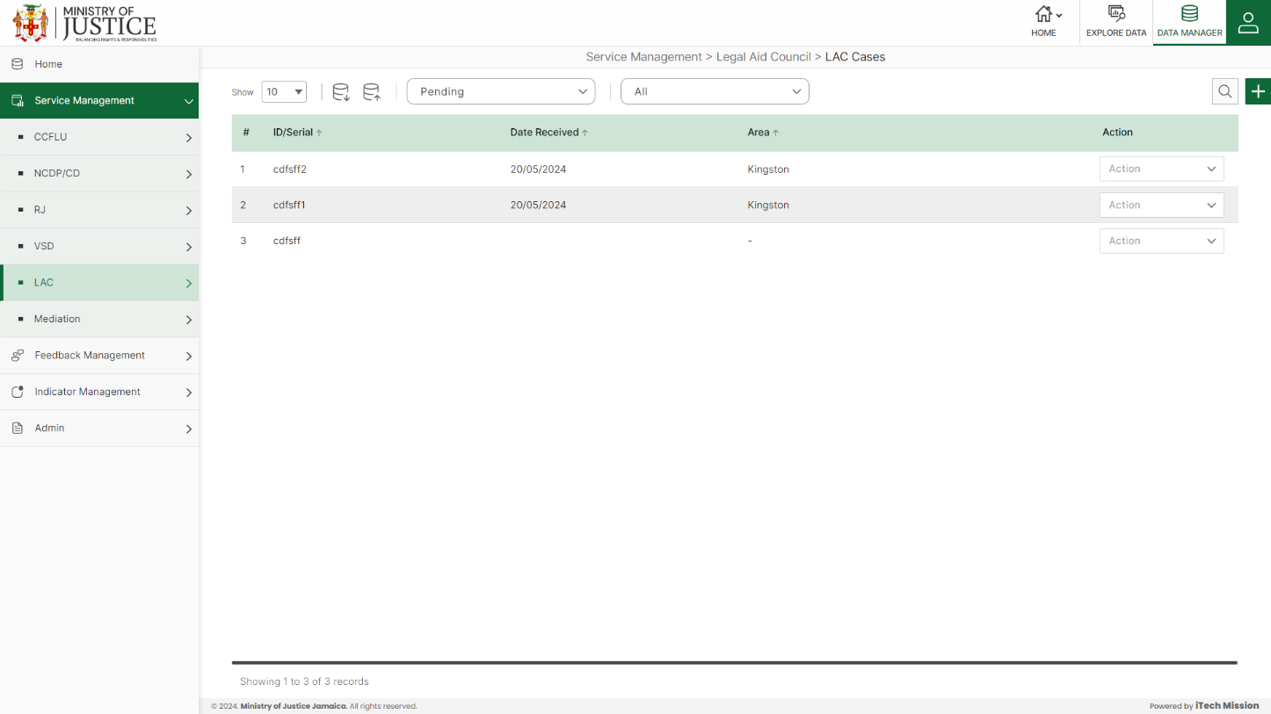Click on **LAC Cases** from the LAC menu option available in the left panel to access this module. This module allows to manage the LAC cases master list. You will have options to export or import, add a new element, view the list of existing elements, sort the list, search from the list, edit and delete the existing elements (see below figure).

#### 4.5.1.1 EXPORT

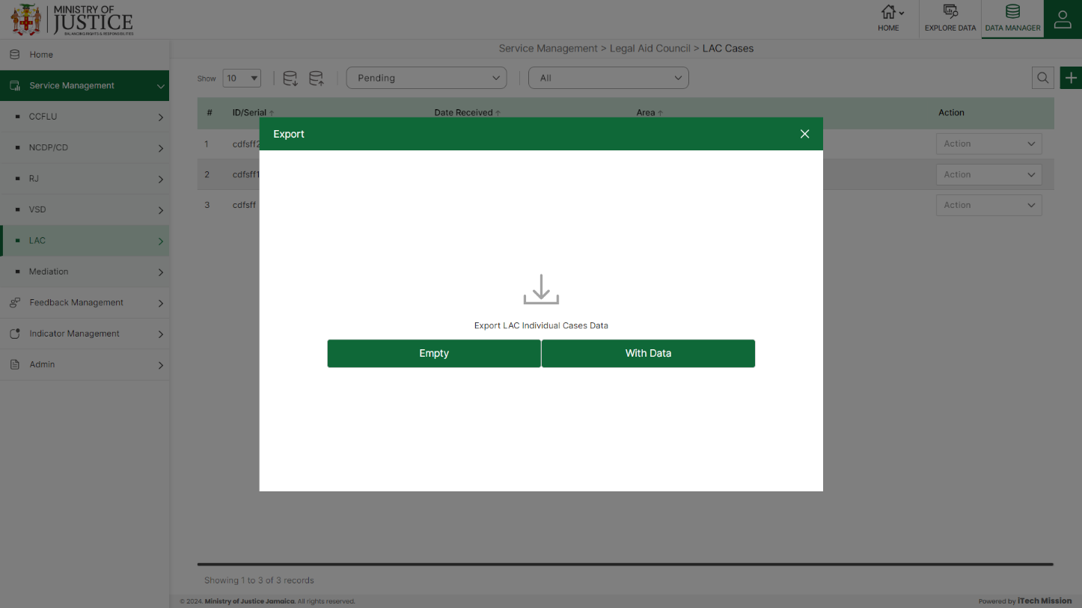****Click on the **Export** button to download the empty template and the master list (see below figure).

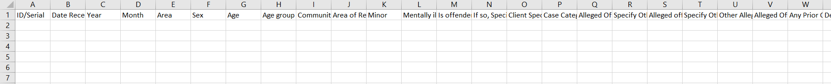Click on the **Empty** option to download an empty template (see below figure). The file is imported and exported in the CSV (Comma Separated Value) file format.

Click on the **With Data** option to download the master list (see below figure).

#### 4.5.1.2 IMPORT

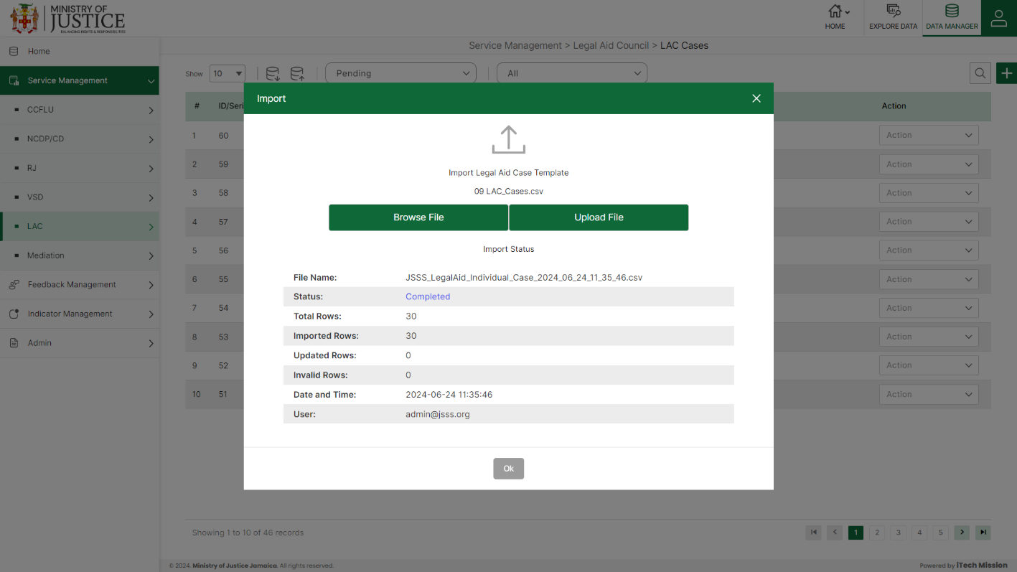Click on the **Import** button to browse the file and upload the master list into the database (see below figure).

To upload the file into the database first enter the structure in the template and then click on the **Browse File** button to select the template. Now, click on the **Upload** button to start the import process. During the import process, the records which contains blank entries, entries with special characters and duplicate entries are not imported in the database.

A Last Upload summary will appear after the import process which provides the count of successfully imported records out of the total records. An error log will be generated to report on unsuccessfully imported records which you can access from **Logs** module.

#### 4.5.1.3 ADD

****Click on the **Plus** button available at the top right corner to add a new record. The Add LAC Cases form is divided into sections namely – **Client Information, Offense Information and Court Proceedings.**

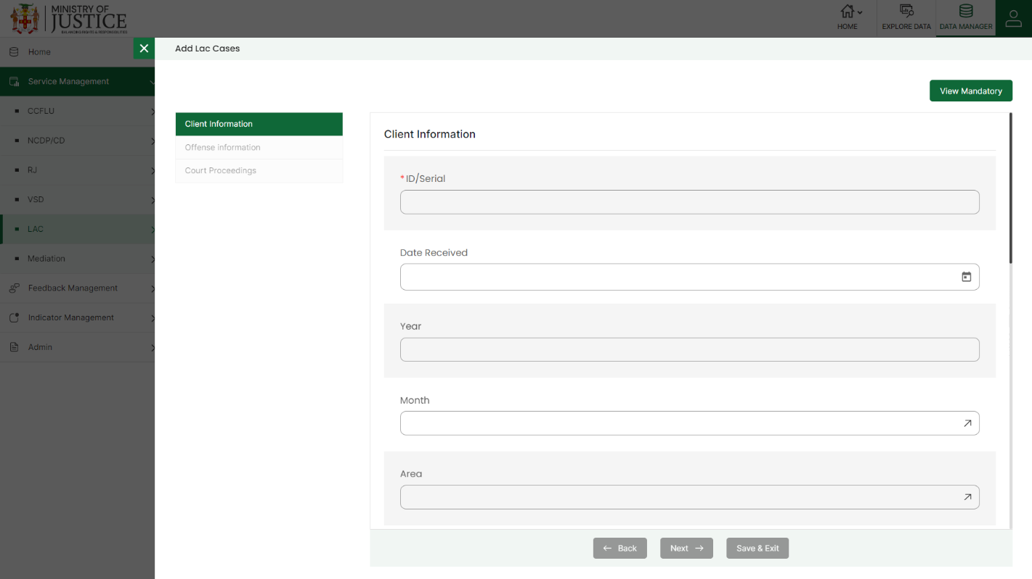Enter the following information to add a new record –

* - Enter **ID/Serial**
* - Select **Date Received**
* - Enter **Year**
* - Select **Month**
* - Select **Area**
* - Select **Sex**
* - Enter **Age**
* - **Age-Group** *(Auto generated)*
* - Enter **Community of Residence**
* - Select **Area of Residence**
* - Select **Minor**
* - Select **Mentally Ill**
* - Select **Is offender apart of vulnerable group?**
* - Select **If so, Specify**
* - Enter **Specify Other**
* - Select **Case Category**
* - Select **Alleged Offense**
* - Enter **Specify Other**
* - Select **Alleged Offense 2**
* - Enter **Specify Other 2**
* - Enter **Other Alleged Offenses**
* - Enter **Alleged Offense Date**
* - Select **Any Prior Offence**
* - Enter **Details of Prior Offence**
* - Select **Attorney Assigned**
* - Enter **Date Assigned**
* - Enter **Contribution**
* - Enter **Next Court Date**
* - Select **Case Status**
* - Enter **Detail of Other**

Fields that are mandatory to submit the entry can be viewed using **View Mandatory** button present on the top right side of the add CCFLU Expungement form. Click on the **Save** button to save and confirm. You can now view the new record added in the list.

***NOTE:***

*You can navigate between the sections using the* ***Back*** *and* ***Next*** *button available at the bottom of the page. The* ***Next*** *button will get enabled once the unique field is filled. You can Save the data and Exit anytime using* ***Save & Exit*** *button.* ***Submit*** *button will be enabled when all the mandatory fields are filled.*

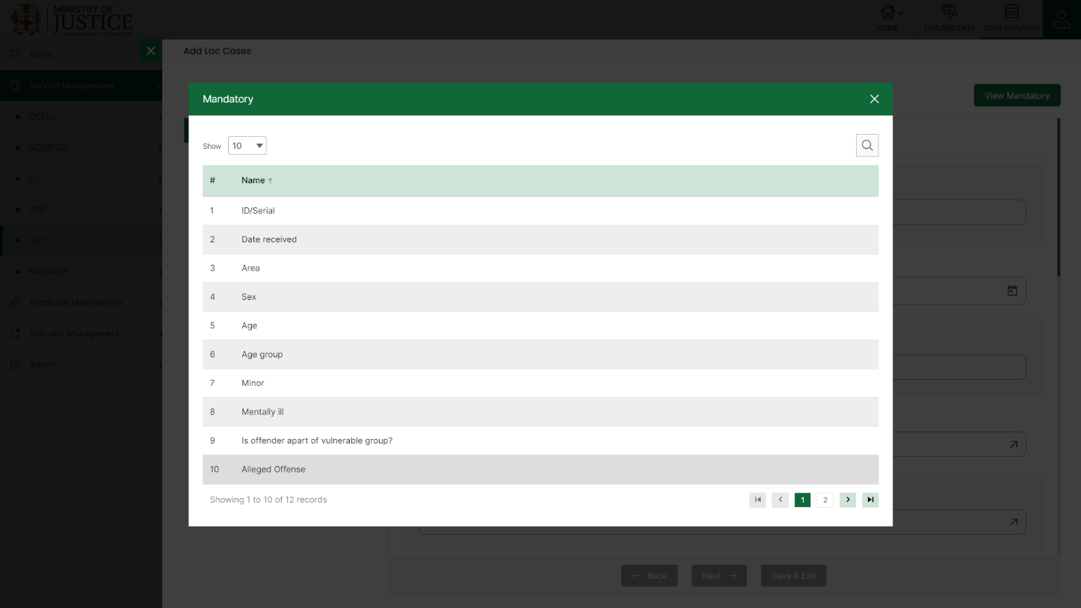You can view the form according to the status i.e. Pending and Approved. If all the mandatory fields of the form are not filled, then it will be saved under **Pending – Incomplete** status.

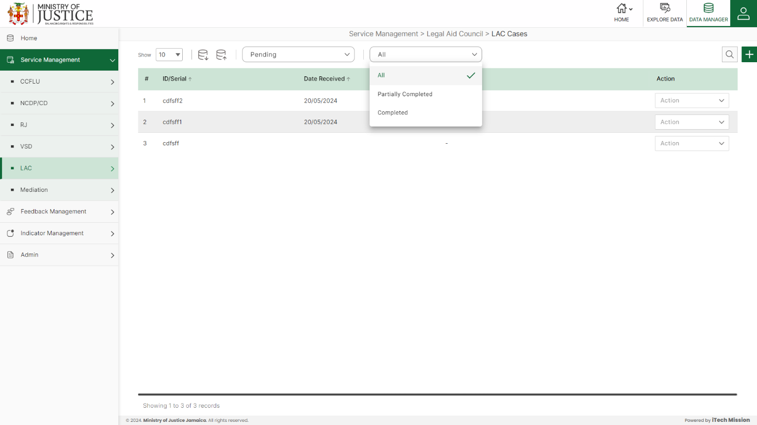If all the mandatory fields are filled, then it will be saved under **Pending – Complete** status.

Click on the tick icon near status dropdown to **Approve All** the records under pending – complete status.

Select **View** option available in the action dropdown to view the details of the selected element.

Select **Edit** option available in the action dropdown to edit the details of the selected element. Edit the required detail and click on update button to save and confirm.

Select **Delete** option available in the action dropdown to delete the selected element. A confirmation popup appears, click yes to confirm deletion of selected element.

### **4.5.2 LAC Mobile Unit Cases**

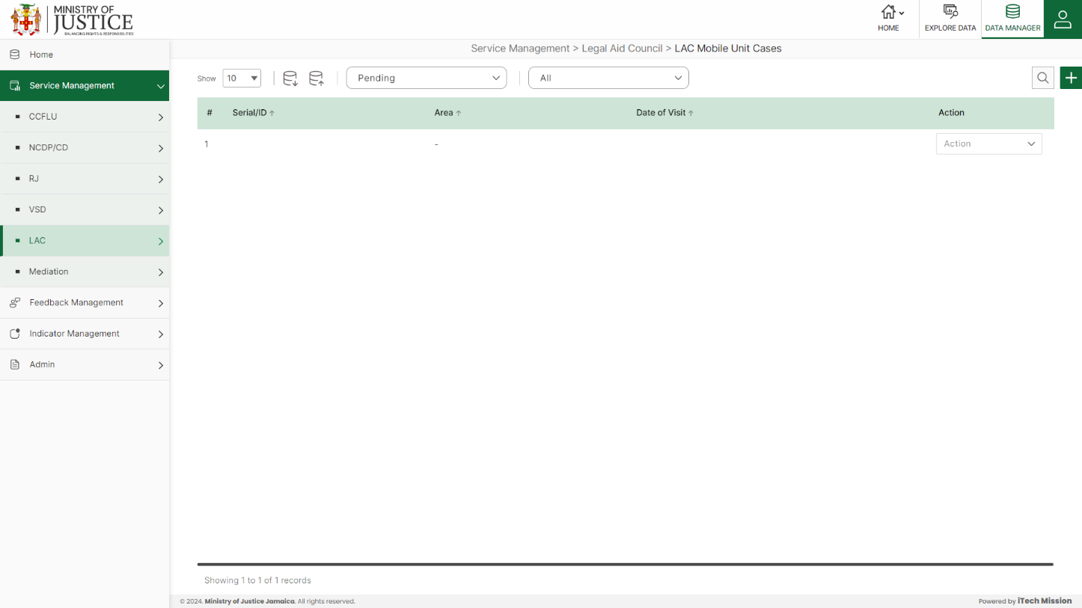Click on **LAC Mobile Unit cases** from the LAC menu option available in the left panel to access this module. This module allows to manage the LAC mobile unit cases master list. You will have options to export or import, add a new element, view the list of existing elements, sort the list, search from the list, edit and delete the existing elements (see below figure).

#### 4.5.2.1 EXPORT

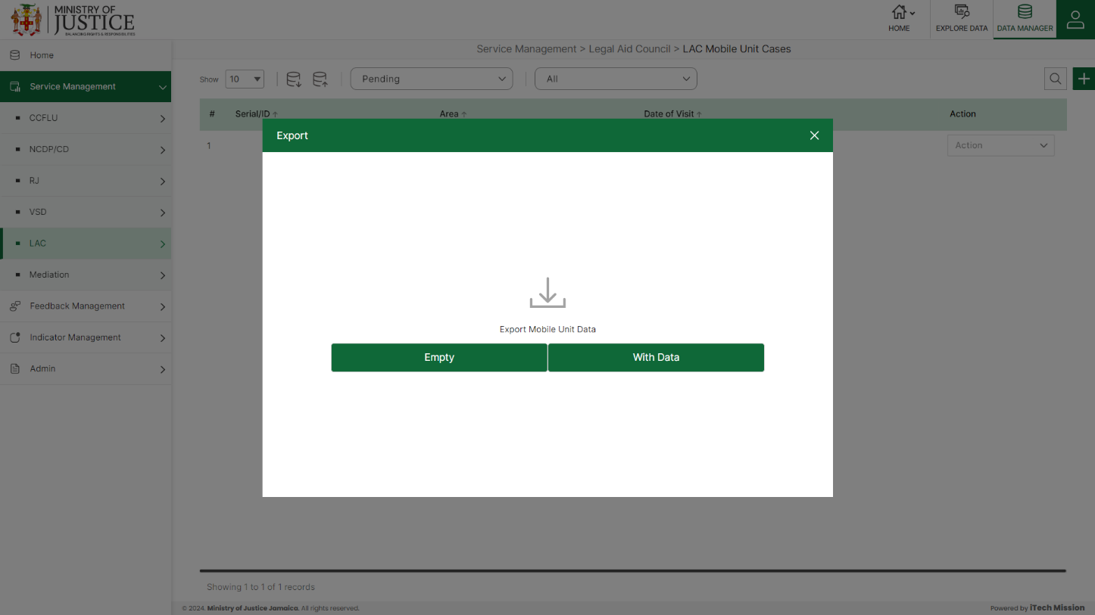****Click on the **Export** button to download the empty template and the master list (see below figure).

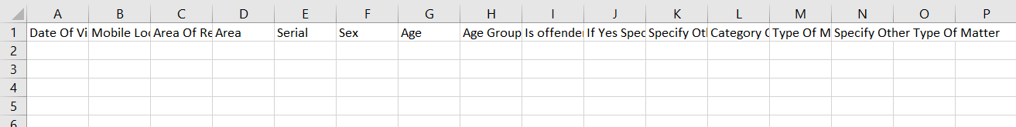Click on the **Empty** option to download an empty template (see below figure). The file is imported and exported in the CSV (Comma Separated Value) file format.

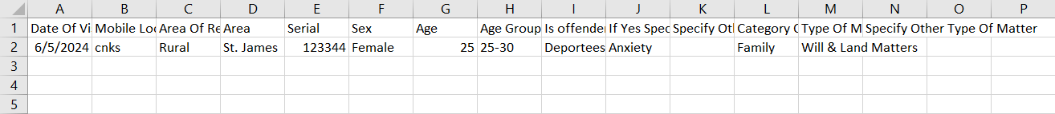Click on the **With Data** option to download the master list (see below figure).

#### 4.5.2.2 IMPORT

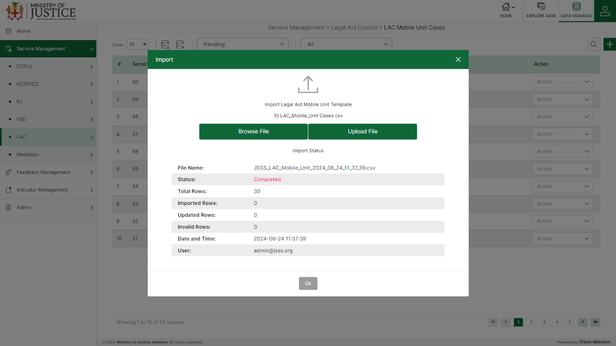Click on the **Import** button to browse the file and upload the master list into the database (see below figure).

To upload the file into the database first enter the structure in the template and then click on the **Browse File** button to select the template. Now, click on the **Upload** button to start the import process. During the import process, the records which contains blank entries, entries with special characters and duplicate entries are not imported in the database.

A Last Upload summary will appear after the import process which provides the count of successfully imported records out of the total records. An error log will be generated to report on unsuccessfully imported records which you can access from **Logs** module.

#### 4.5.2.3 ADD

****Click on the **Plus** button available at the top right corner to add a new record. The Add LAC Mobile Unit Cases is divided into sections namely –  **Mobile Unit Information, Client Details, Type of Matter**

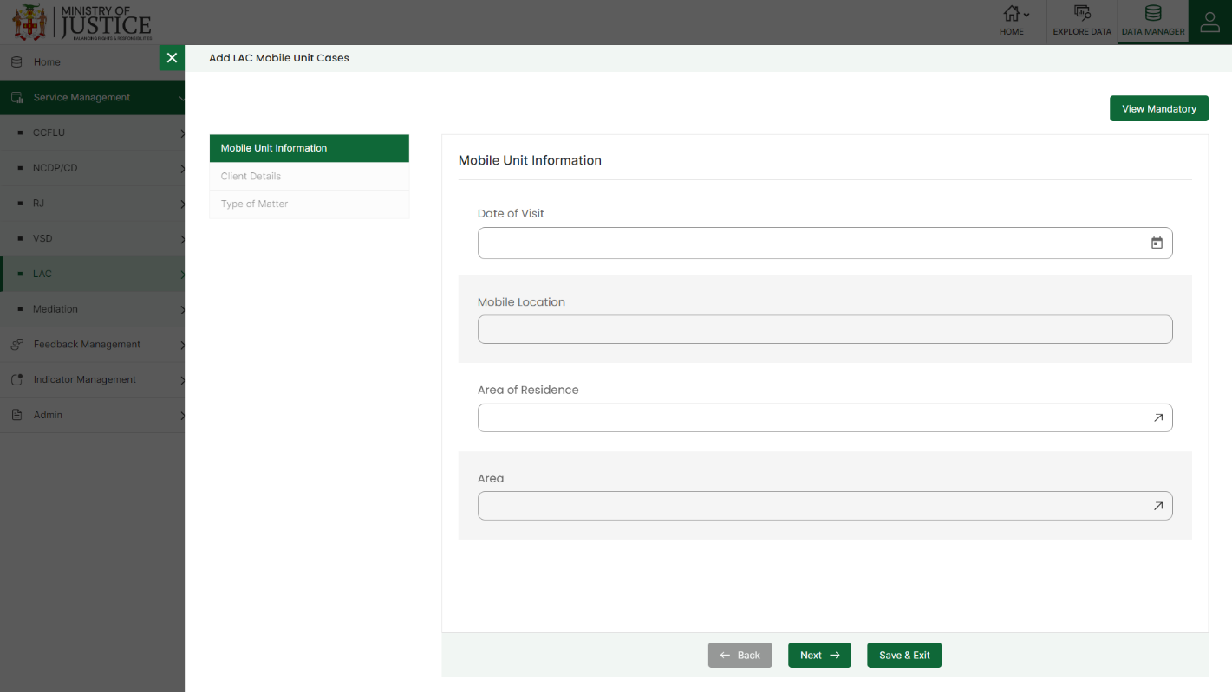Enter the following information to add a new record –

* - Enter **Date of Visit**
* - Enter **Mobile Location**
* - Select **Area of Residence**
* - Enter **Area**
* - Enter **Serial/ID**
* - Select **Sex**
* - Enter **Age**
* - **Age-Group** *(Auto generated*)
* - Select **Is offender apart of vulnerable group?**
* - Select **If so, Specify**
* - Enter **Specify Other**.
* - Enter **Category of Matter**
* - Enter **Type of Matter**
* - Enter **Specify Other**

Fields that are mandatory to submit the entry can be viewed using **View Mandatory** button present on the top right side of the add CCFLU Expungement form. Click on the **Save** button to save and confirm. You can now view the new record added in the list.

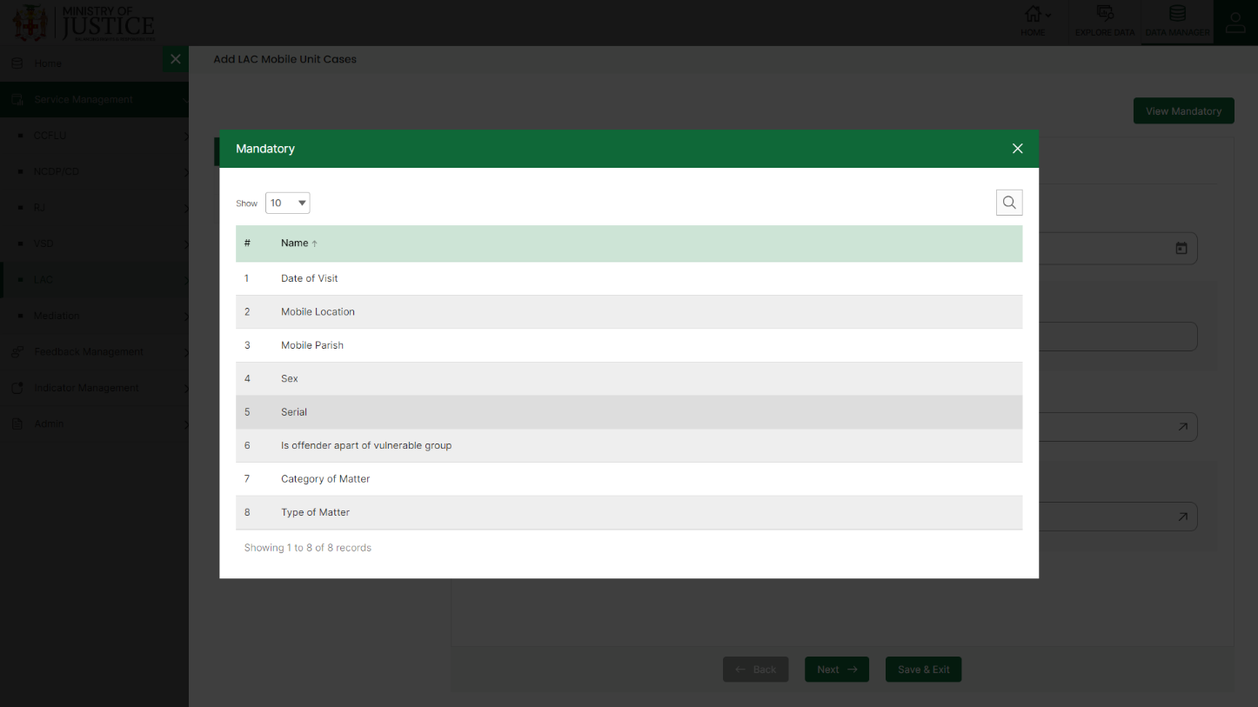You can view the form according to the status i.e. Pending and Approved. If all the mandatory fields of the form are not filled, then it will be saved under **Pending – Incomplete** status.

***NOTE:***

*You can navigate between the sections using the* ***Back*** *and* ***Next*** *button available at the bottom of the page. The* ***Next*** *button will get enabled once the unique field is filled. You can Save the data and Exit anytime using* ***Save & Exit*** *button.* ***Submit*** *button will be enabled when all the mandatory fields are filled.*

If all the mandatory fields are filled, then it will be saved under **Pending – Complete** status.

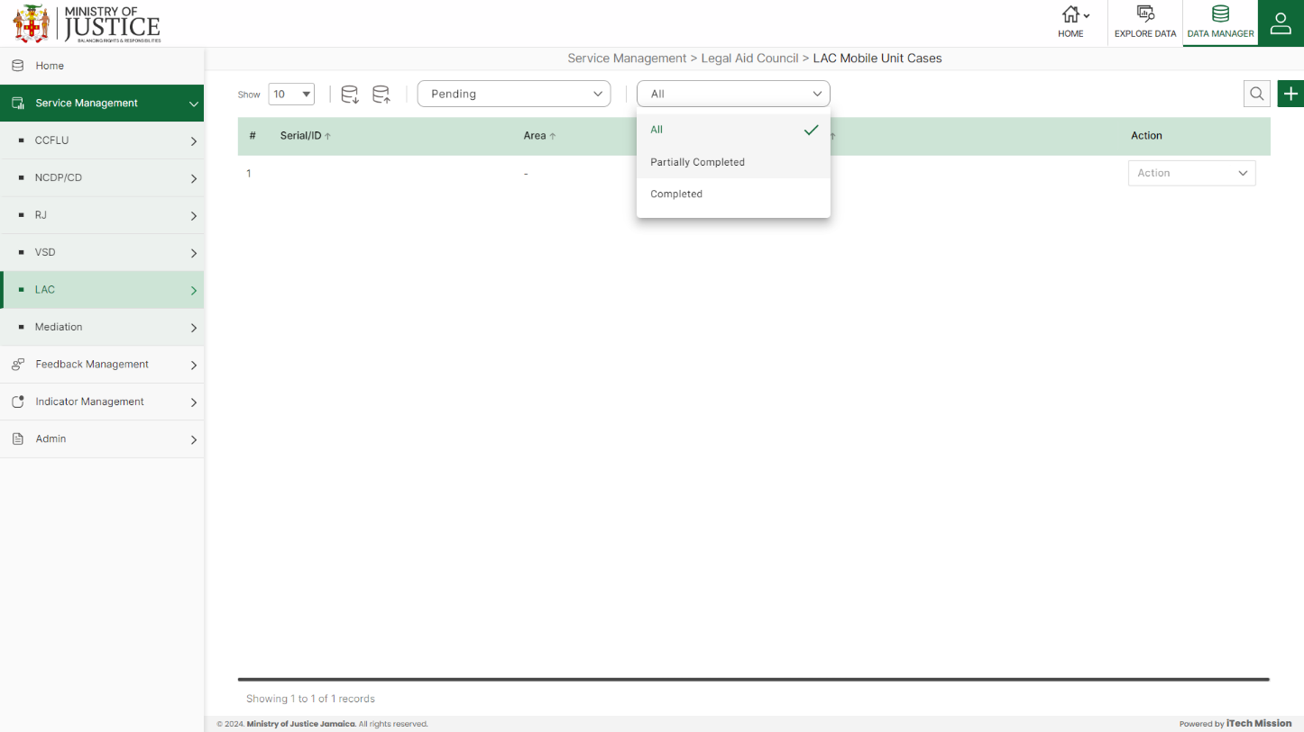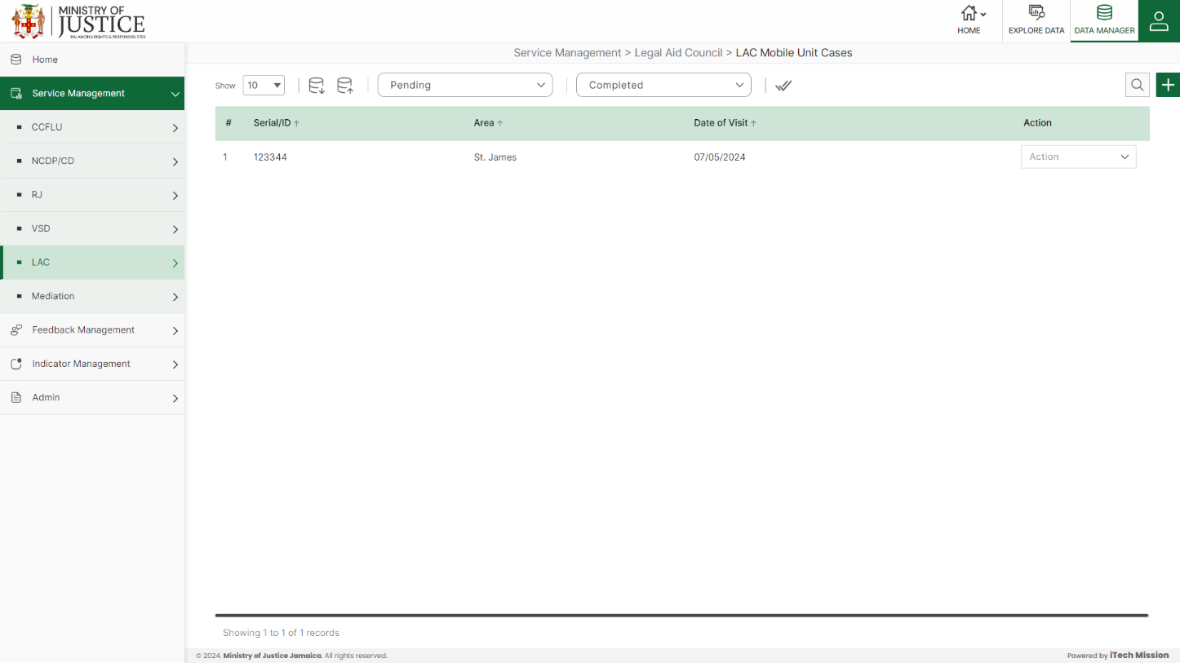Click on the tick icon near status dropdown to **Approve All** the records under pending – complete status.

Select **View** option available in the action dropdown to view the details of the selected element.

Select **Edit** option available in the action dropdown to edit the details of the selected element. Edit the required detail and click on update button to save and confirm.

Select **Delete** option available in the action dropdown to delete the selected element. A confirmation popup appears, click yes to confirm deletion of selected element.

### **4.5.3 LAC Additional Act**

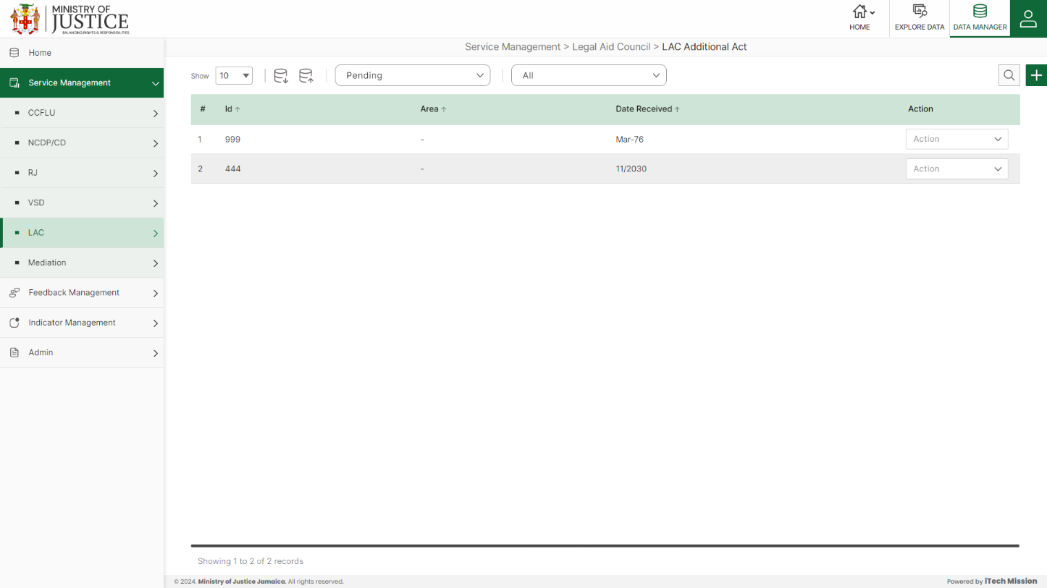Click on **LAC Additional Act** from the LAC menu option available in the left panel to access this module. This module allows to manage the LAC Additional Act master list. You will have options to export or import, add a new element, view the list of existing elements, sort the list, search from the list, edit and delete the existing elements (see below figure).

#### 4.5.3.1 EXPORT

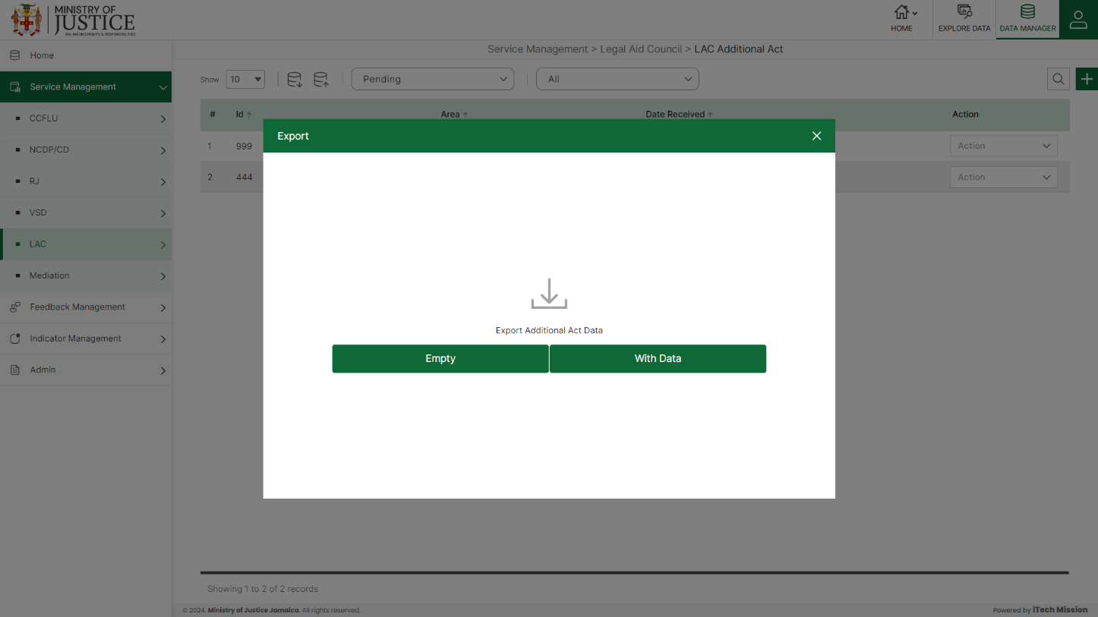****Click on the **Export** button to download the empty template and the master list (see below figure).

Click on the **Empty** option to download an empty template (see below figure). The file is imported and exported in the CSV (Comma Separated Value) file format.

Click on the **With Data** option to download the master list (see below figure).

#### 4.5.3.2 IMPORT

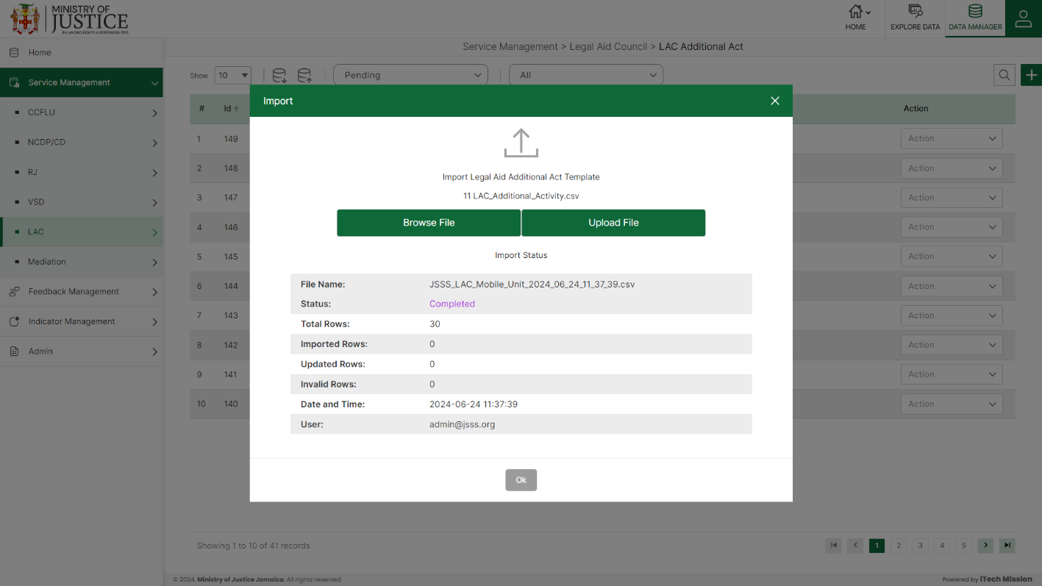Click on the **Import** button to browse the file and upload the master list into the database (see below figure).

To upload the file into the database first enter the structure in the template and then click on the **Browse File** button to select the template. Now, click on the **Upload** button to start the import process. During the import process, the records which contains blank entries, entries with special characters and duplicate entries are not imported in the database.

A Last Upload summary will appear after the import process which provides the count of successfully imported records out of the total records. An error log will be generated to report on unsuccessfully imported records which you can access from **Logs** module.

#### 4.5.3.3 ADD

****Click on the **Plus** button available at the top right corner to add a new record. The Add LAC Additional Act form have one section namely – **Activity Details**

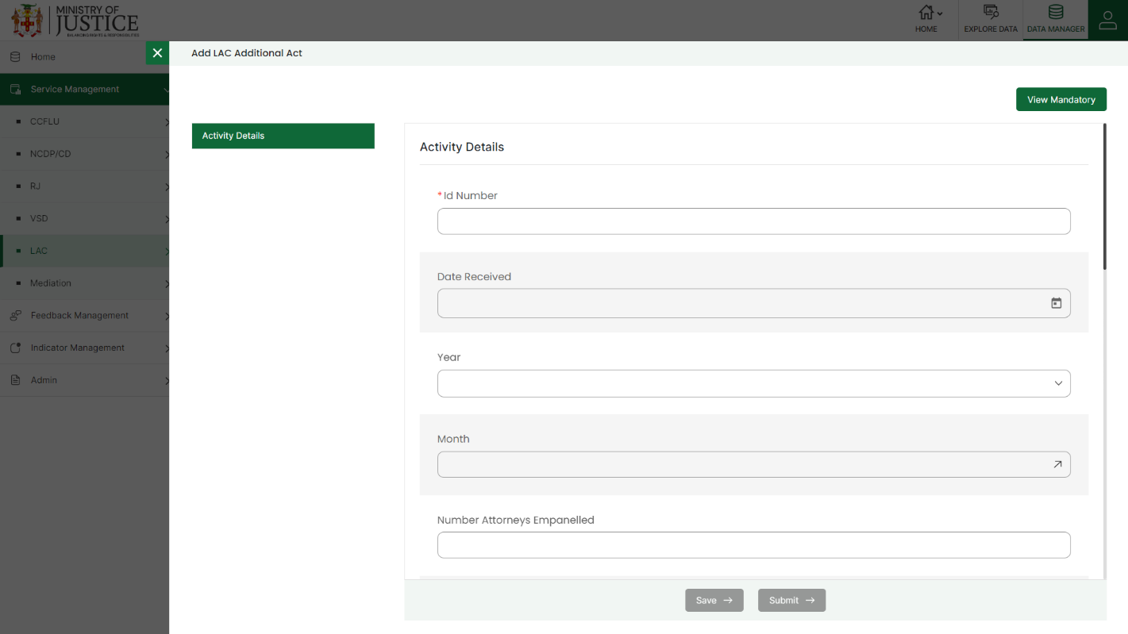Enter the following information to add a new record –

* - Enter **ID Number**
* - Select **Date Received**
* **-** Select **Year**
* - Select **Month**
* - Enter **Number Attorneys Empaneled**
* - Enter **Number of Applicants assigned an Attorney**
* - Enter **Number of Applicants assigned Duty Counsel**
* - Enter **Number of outreach events conducted**
* - Enter **Number of communities visited**
* - Enter **Number of Justice Centers visited**
* - Enter **Number of Virtual Consultations Conducted**
* - Enter **Number of surveys conducted**
* - Enter **Total Number of Matters Completed**
* - Enter **Number of Parish Court Matters Completed**
* - Enter **Number of Circuit Court Matters Completed**
* - Enter **Number of Gun Court Matters Completed**
* - Enter **Number of Appeal Court Matters Completed**

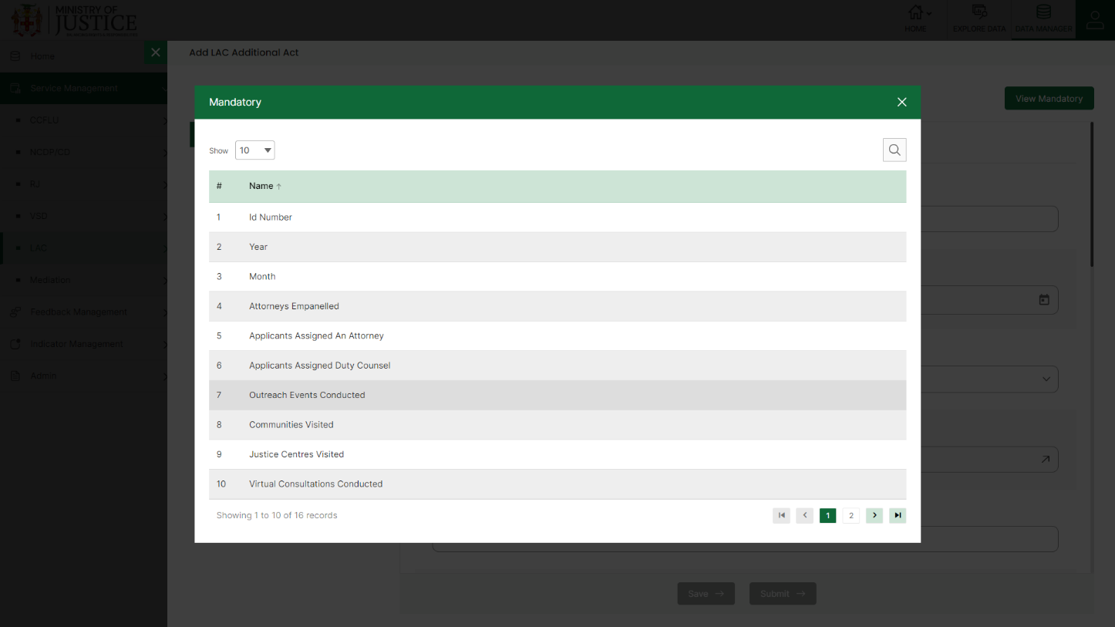Fields that are mandatory to submit the entry can be viewed using **View Mandatory** button present on the top right side of the add CCFLU Expungement form. Click on the **Save** button to save and confirm. You can now view the new record added in the list.

***NOTE:***

*You can navigate between the sections using the* ***Back*** *and* ***Next*** *button available at the bottom of the page. The* ***Next*** *button will get enabled once the unique field is filled. You can Save the data and Exit anytime using* ***Save & Exit*** *button.* ***Submit*** *button will be enabled when all the mandatory fields are filled.*

You can view the form according to the status i.e. Pending and Approved. If all the mandatory fields of the form are not filled, then it will be saved under **Pending – Incomplete** status.

If all the mandatory fields are filled, then it will be saved under **Pending – Complete** status.

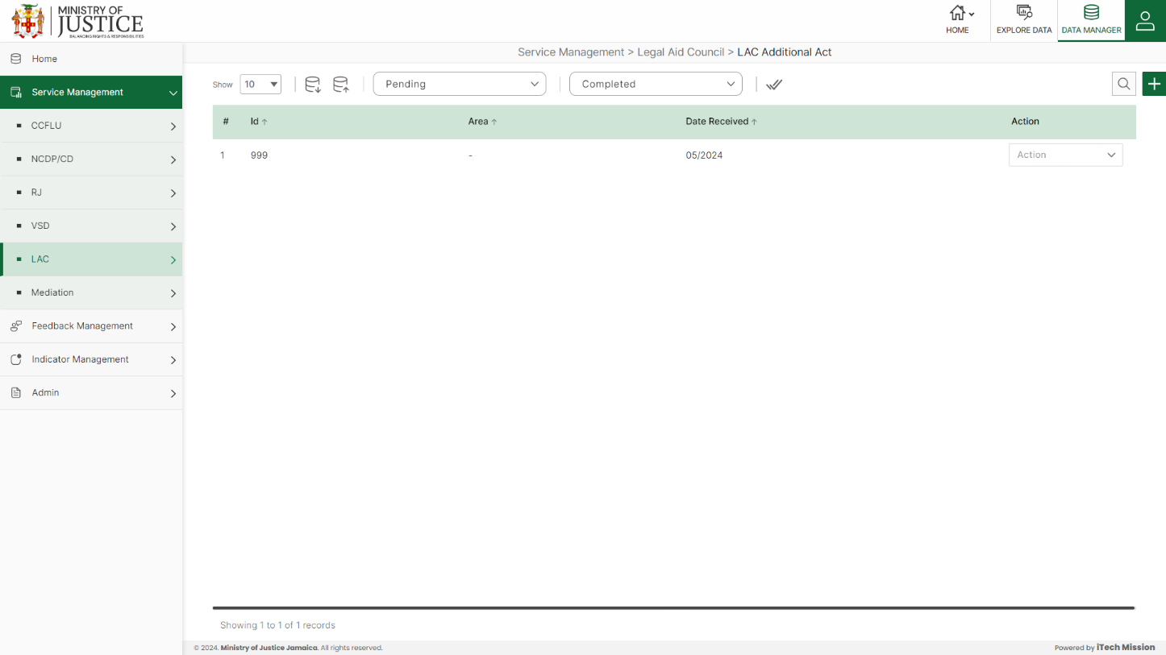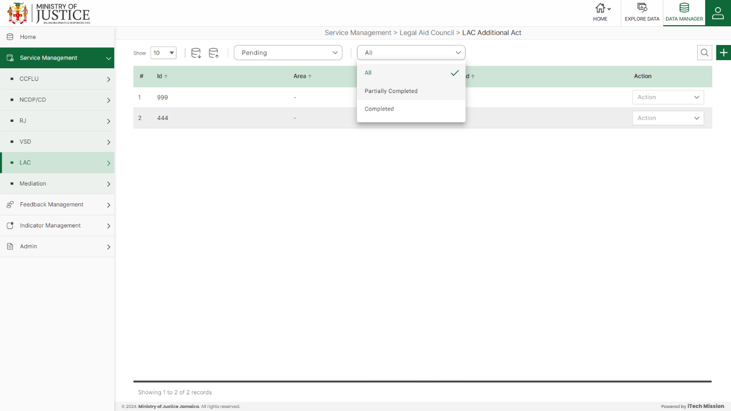Click on the tick icon near status dropdown to **Approve All** the records under pending – complete status.

Select **View** option available in the action dropdown to view the details of the selected element.

Select **Edit** option available in the action dropdown to edit the details of the selected element. Edit the required detail and click on update button to save and confirm.

Select **Delete** option available in the action dropdown to delete the selected element. A confirmation popup appears, click yes to confirm deletion of selected element.

## **4.6 MEDIATION**

Click on the **Mediation** from service management menu option from the left panel to access this module. This module has one submodules –Mediation Cases. Let us understand this submodule in detail.

### **4.6.1 Mediation Cases**

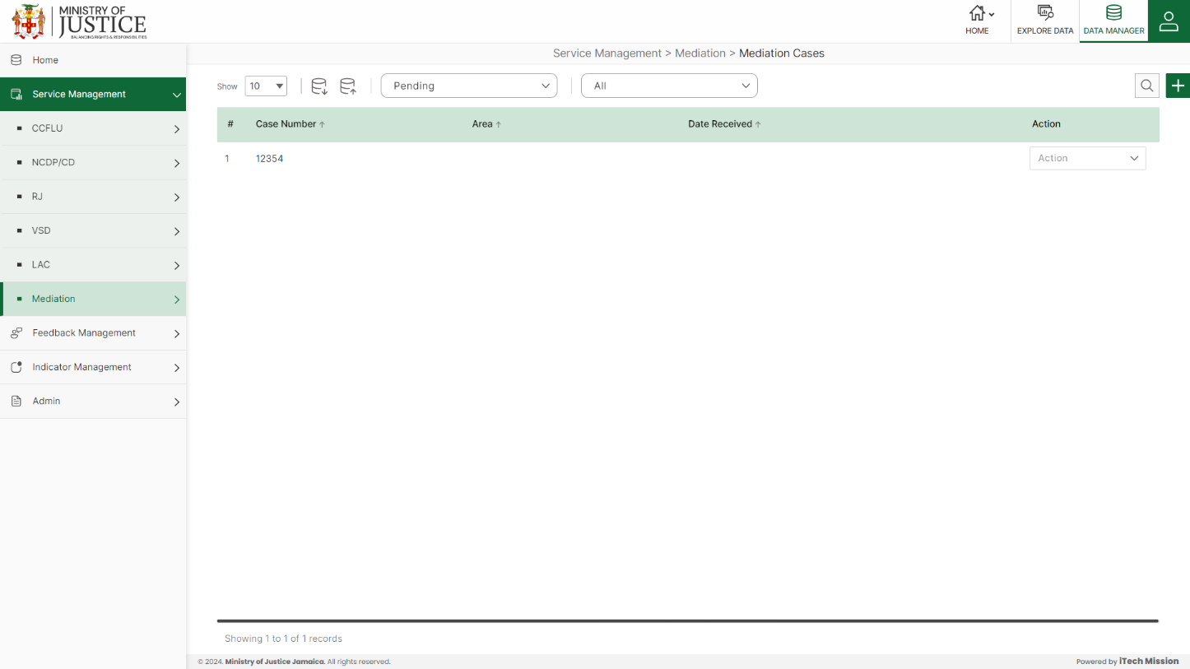Click on **Mediation Cases** from the Mediation menu option available in the left panel to access this module. This module allows to manage the Mediation Cases master list. You will have options to export or import, add a new element, view the list of existing elements, sort the list, search from the list, edit and delete the existing elements (see below figure).

#### 4.6.1.1 EXPORT

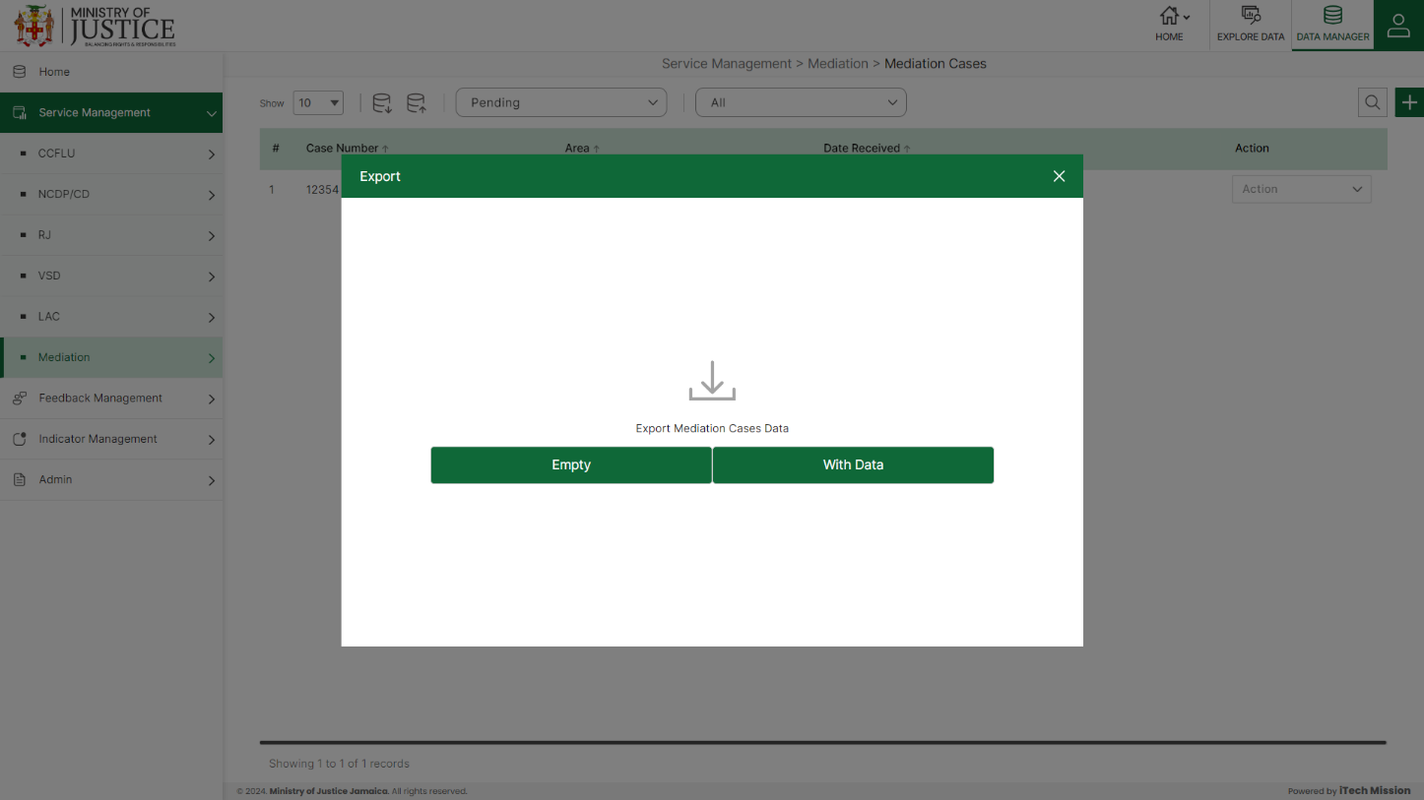****Click on the **Export** button to download the empty template and the master list (see below figure).

Click on the **Empty** option to download an empty template (see below figure). The file is imported and exported in the CSV (Comma Separated Value) file format.

Click on the **With Data** option to download the master list (see below figure).

#### 4.6.1.2 IMPORT

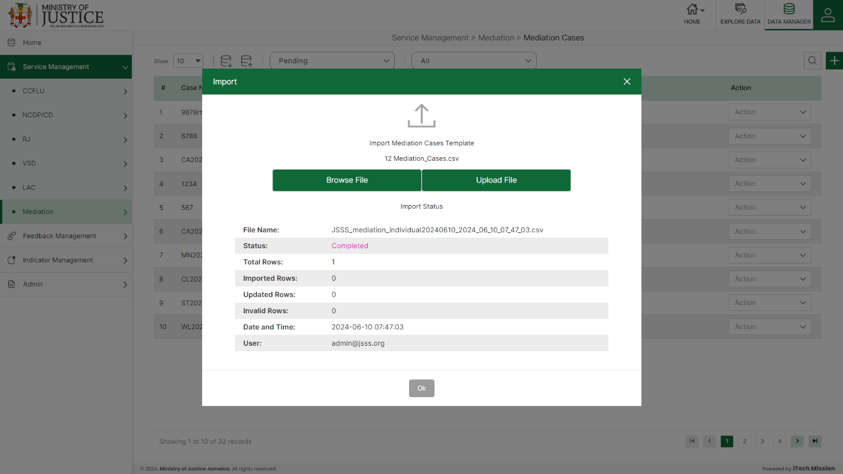Click on the **Import** button to browse the file and upload the master list into the database (see below figure).

To upload the file into the database first enter the structure in the template and then click on the **Browse File** button to select the template. Now, click on the **Upload** button to start the import process. During the import process, the records which contains blank entries, entries with special characters and duplicate entries are not imported in the database.

A Last Upload summary will appear after the import process which provides the count of successfully imported records out of the total records. An error log will be generated to report on unsuccessfully imported records which you can access from **Logs** module.

#### 4.6.1.3 ADD

****Click on the **Plus** button available at the top right corner to add a new record. The Add Mediation Cases form is divided into sections namely – **Case Details, Type of Matter (Offenses) Information, Mediation Information, Claimant 1 Details, Claimant 2 Details, Claimant 3 Details, Respondent 1 Details, , Respondent 2 Details, , Respondent 3 Details, Case Closure**

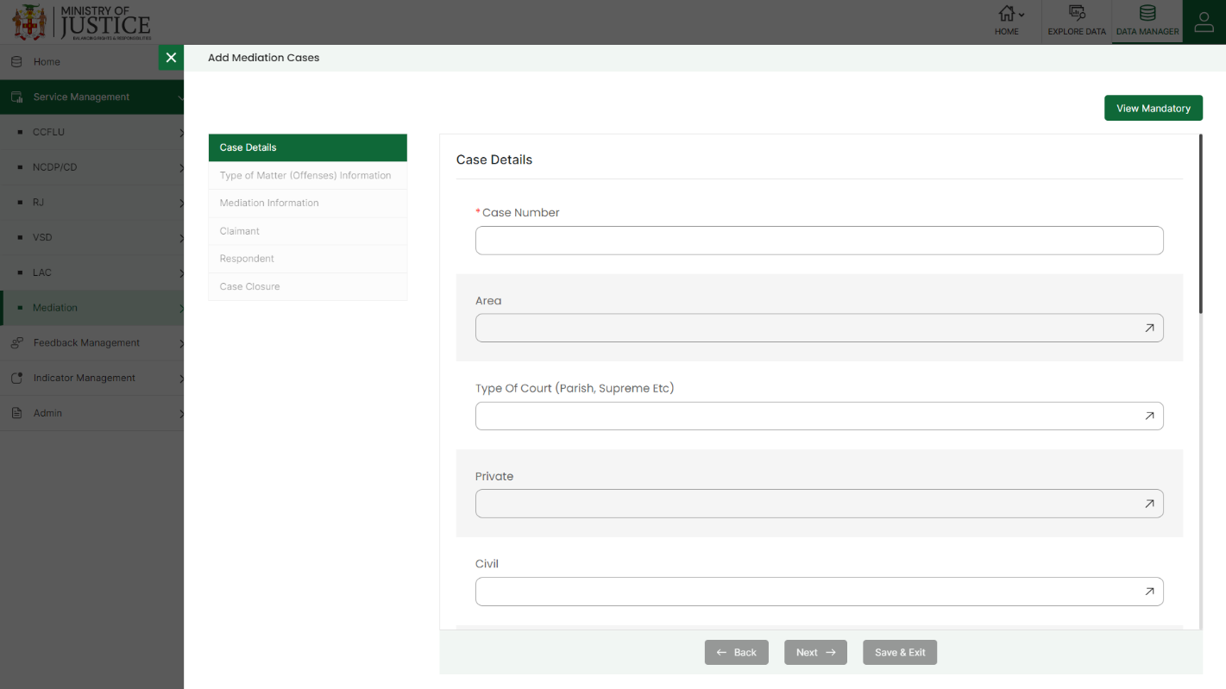Enter the following information to add a new record –

* Select **Case Number**
* Select **Area**
* Select **Type of Court**
* Select **Private**
* Select **Civil**
* Select **Criminal**
* Select **Family Civil**
* Select **Family Criminal**
* Select **Commercial**
* Enter **Referral Date**
* Enter **Date Received**
* Enter **Return Date**
* Select **Referral Point**
* Select **Referral Status**
* Select **Results of Pro Bono Means Test**
* Select **Case Category**
* Enter **Name of Matter**
* Select **Type of Matter 1**
* Enter **Specify Other**
* Select **Type of Matter 2**
* Enter **Specify Other**
* Select **Type of Matter 3**
* Enter **Specify Other**
* Select **Type of Matter 4**
* Enter **Specify Other**
* Enter **Date of Mediation**
* Enter **Time of Mediation**
* Enter **Session Duration**
* Enter **Mediator**
* Select **Prior Continuation**
* Enter **Number of Claimants**
* Select **Claimant Gender 1**
* Enter **Claimant Age 1**
* **Claimant Age Group 1** *(Auto generated)*
* Enter **Telephone Number 1**
* Enter **Relationship to Respondent 1**
* Enter **Community 1**
* Select **Area of Residence 1**
* Select **Parish 1**
* Select **Is Offender Apart of Vulnerable Group?**
* Select **If So, Specify**
* Enter **Specify Other**
* Select **Claimant Gender 2**
* Enter **Claimant Age 2**
* **Claimant Age Group 2***(Auto generated)*
* Enter **Telephone Number 2**
* Enter **Relationship to Respondent 2**
* Enter **Community 2**
* Select **Area of Residence 2**
* Select **Parish 2**
* Select **Is Offender Apart of Vulnerable Group?**
* Select **If So, Specify**
* Enter **Specify Other**
* Select **Claimant Gender 3**
* **Claimant Age 3***(Auto generated)*
* Select **Claimant Age Group 3**
* Enter **Telephone Number 3**
* Enter **Relationship to Respondent 3**
* Enter **Community 3**
* Select **Area of Residence 3**
* Select **Parish 3**
* Select **Is Offender Apart of Vulnerable Group?**
* Select **If So, Specify**
* Enter **Specify Other**
* Enter **Number of Respondents**
* Select **Respondent Gender 1**
* Enter **Respondent Age 1**
* **Respondent Age Group 1***(Auto generated)*
* Enter **Telephone Number 1**
* Enter **Community 1**
* Select **Area of Residence 1**
* Select **Parish 1**
* Select **Is Offender Apart of Vulnerable Group?**
* Select **If So, Specify**
* Enter **Specify Other**
* Select **Respondent Gender 2**
* **Respondent Age 2** *(Auto generated)*
* Select **Respondent Age Group 2**
* Enter **Telephone Number 2**
* Enter **Community 2**
* Select **Area of Residence 2**
* Select **Parish 2**
* Select **Is Offender Apart of Vulnerable Group?**
* Select **If So, Specify**
* Enter **Specify Other**
* Select **Respondent Gender 3**
* Enter **Respondent Age 3**
* **Respondent Age Group 3** *(Auto generated)*
* Enter **Telephone Number 3**
* Enter **Community 3**
* Select **Area of Residence 3**
* Select **Parish 3**
* Select **Is Offender Apart of Vulnerable Group?**
* Select **If So, Specify**
* Enter **Specify Other**
* Enter **Total Charges** *(Total Claim Amount)*
* Enter **Continuation/Reschedule Date**
* Enter **Last Mediation Date**
* Enter **No. Of Sessions Held**
* Enter **Mediation Outcome**
* Enter **Next Court Date**

Fields that are mandatory to submit the entry can be viewed using **View Mandatory** button present on the top right side of the add CCFLU Expungement form. Click on the **Save** button to save and confirm. You can now view the new record added in the list.

***NOTE:***

*You can navigate between the sections using the* ***Back*** *and* ***Next*** *button available at the bottom of the page. The* ***Next*** *button will get enabled once the unique field is filled. You can Save the data and Exit anytime using* ***Save & Exit*** *button.* ***Submit*** *button will be enabled when all the mandatory fields are filled.*

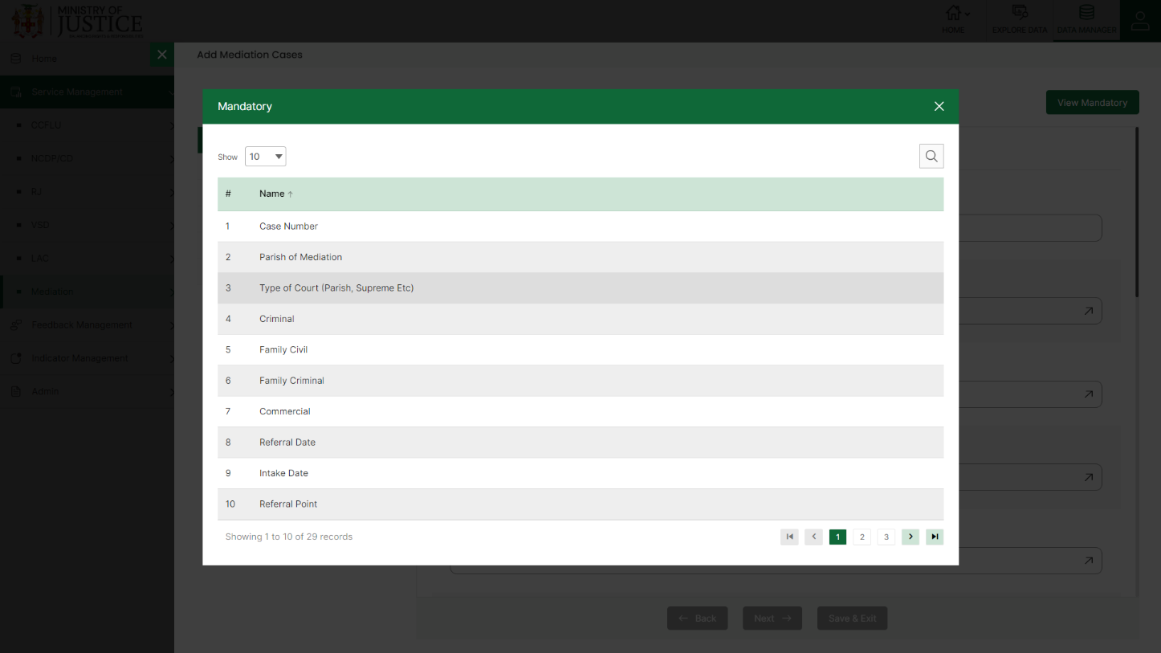You can view the form according to the status i.e. Pending and Approved. If all the mandatory fields of the form are not filled, then it will be saved under **Pending – Incomplete** status.

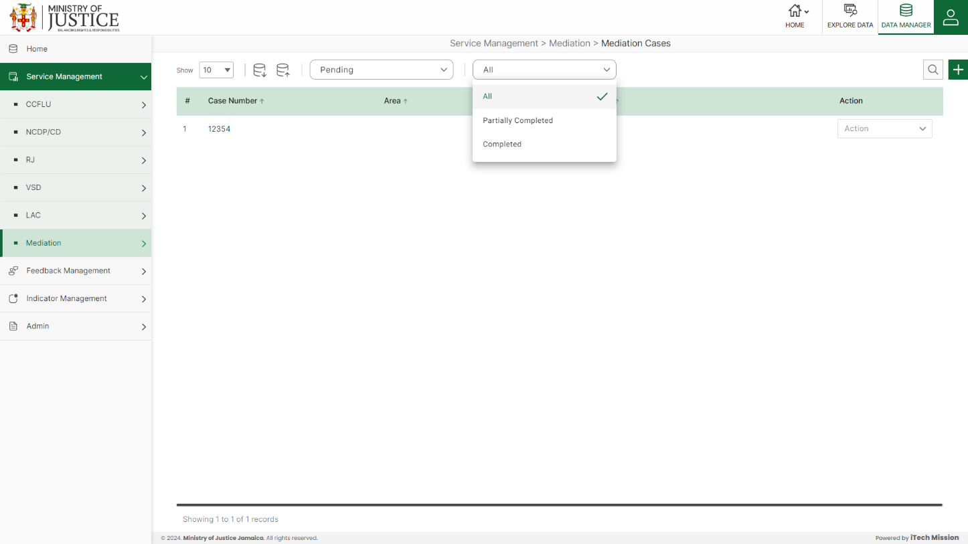If all the mandatory fields are filled, then it will be saved under **Pending – Complete** status.

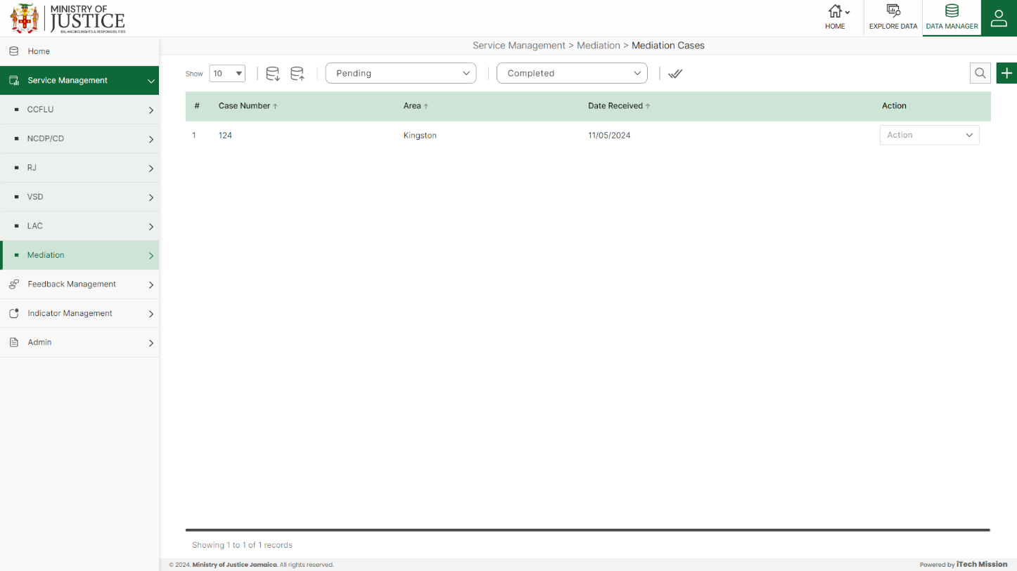Click on the tick icon near status dropdown to **Approve All** the records under pending – complete status.

Select **View** option available in the action dropdown to view the details of the selected element.

Select **Edit** option available in the action dropdown to edit the details of the selected element. Edit the required detail and click on update button to save and confirm.

Select **Delete** option available in the action dropdown to delete the selected element. A confirmation popup appears, click yes to confirm deletion of selected element.

# 5.0 FEEDBACK MANAGEMENT

Click on the **Feedback Management** menu option from the left panel to access this module. This module has seven submodules – NCDP/CD Programme Evaluation, RJ Feedback, VSB Feedback, LAC Customer Satisfaction Survey, Mediation and Customer Satisfaction Details. Let us understand these submodules in detail.

## **5.1 NCDP/CD PROGRAMME EVALUATION**

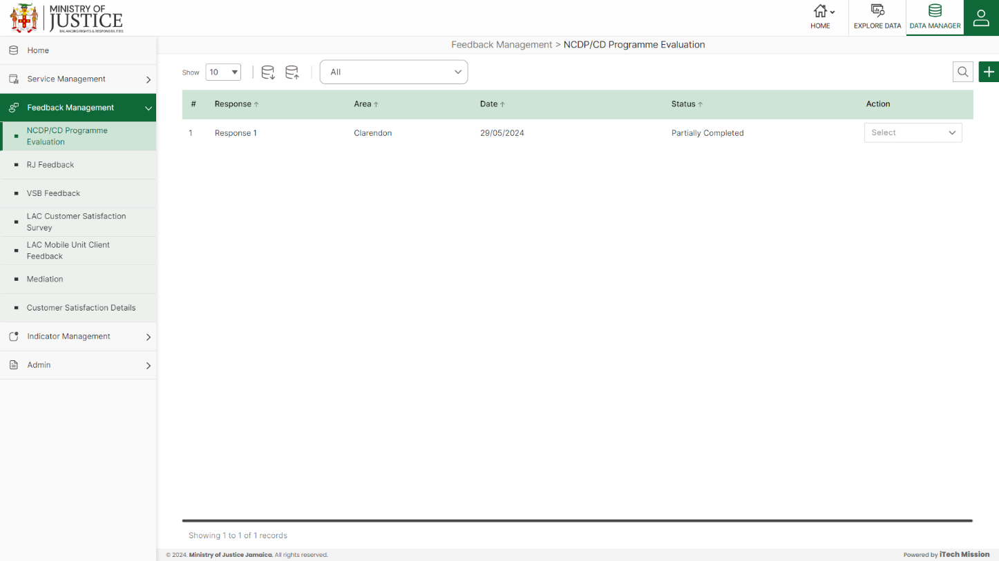Click on **NCDP/CD Programme Evaluation** from the Feedback management menu option available in the left panel to access this module. This module allows to manage the NCDP/CD programme evaluation master list. You will have options to export or import, add a new element, view the list of existing elements, sort the list, search from the list, edit and delete the existing elements (see below figure).

### **5.1.1. EXPORT**

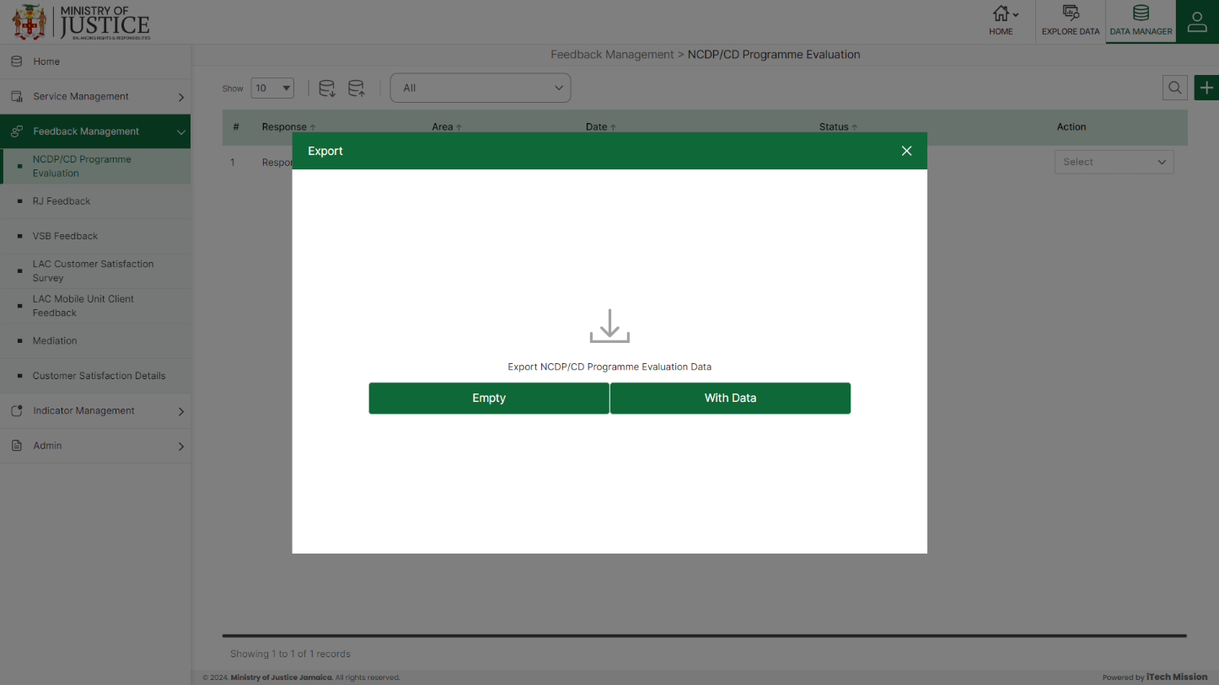****Click on the **Export** button to download the empty template and the master list (see below figure).

Click on the **Empty** option to download an empty template (see below figure). The file is imported and exported in the CSV (Comma Separated Value) file format.

Click on the **With Data** option to download the master list (see below figure).

### **5.1.2 IMPORT**

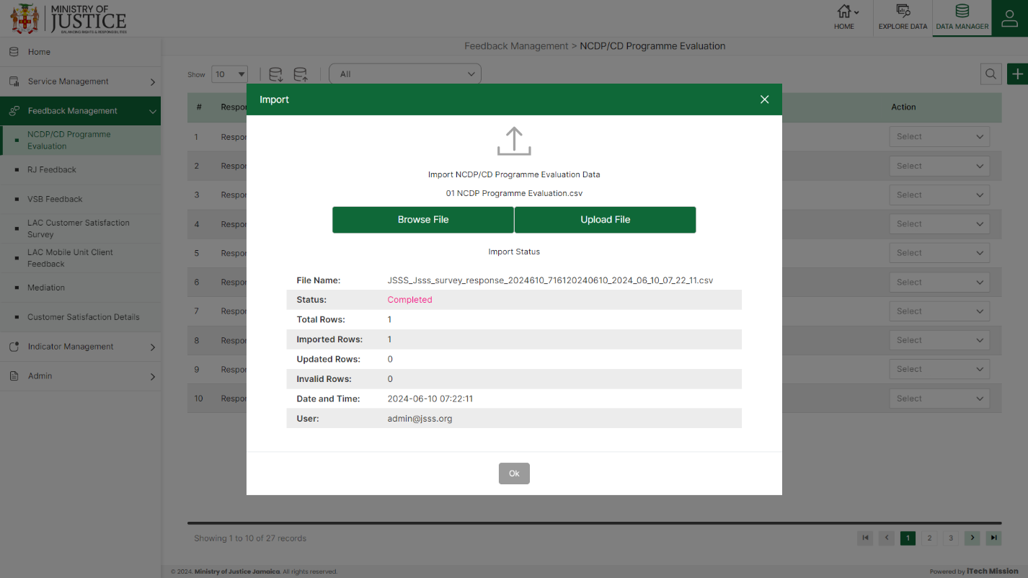Click on the **Import** button to browse the file and upload the master list into the database (see below figure).

To upload the file into the database first enter the structure in the template and then click on the **Browse File** button to select the template. Now, click on the **Upload** button to start the import process. During the import process, the records which contains blank entries, entries with special characters and duplicate entries are not imported in the database.

A Last Upload summary will appear after the import process which provides the count of successfully imported records out of the total records. An error log will be generated to report on unsuccessfully imported records which you can access from **Logs** module.

### **5.1.3 ADD**

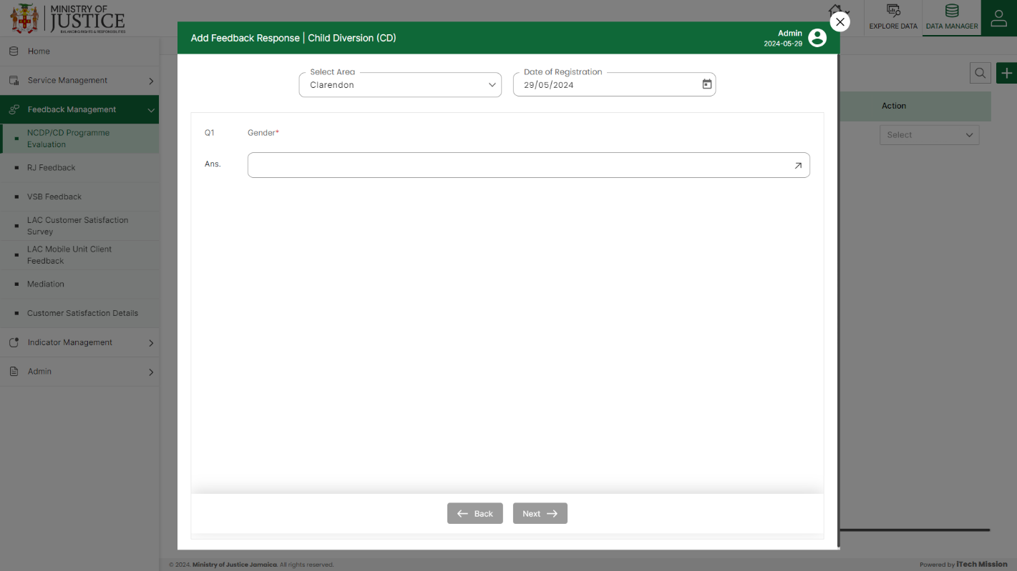****Click on the **Plus** button available at the top right corner to add a new record. Select **Area** and **Date of Registration** and thenenter data in the feedback form.

Click on the **Save** button to save and confirm. You can now view the new record added in the list.

***NOTE:***

*You can navigate between the sections using the* ***Back*** *and* ***Next*** *button available at the bottom of the page.* ***Next*** *button will be enabled when the mandatory field is filled. If all the mandatory fields are filled, then it is categorized as* ***Completed*** *and otherwise it is categorized as* ***Partially Completed****.*

Select **View** option available in the action dropdown to view the details of the selected element.

Select **Edit** option available in the action dropdown to edit the details of the selected element. Edit the required detail and click on update button to save and confirm.

Select **Delete** option available in the action dropdown to delete the selected element. A confirmation popup appears, click yes to confirm deletion of selected element.

## **5.2 RJ FEEDBACK**

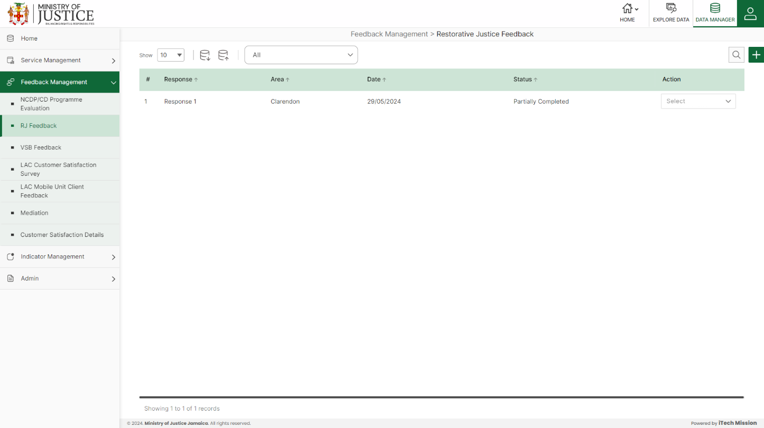Click on **RJ Feedback** from the Feedback management menu option available in the left panel to access this module. This module allows to manage the RJ Feedback master list. You will have options to export or import, add a new element, view the list of existing elements, sort the list, search from the list, edit and delete the existing elements (see below figure).

### **5.2.1. EXPORT**

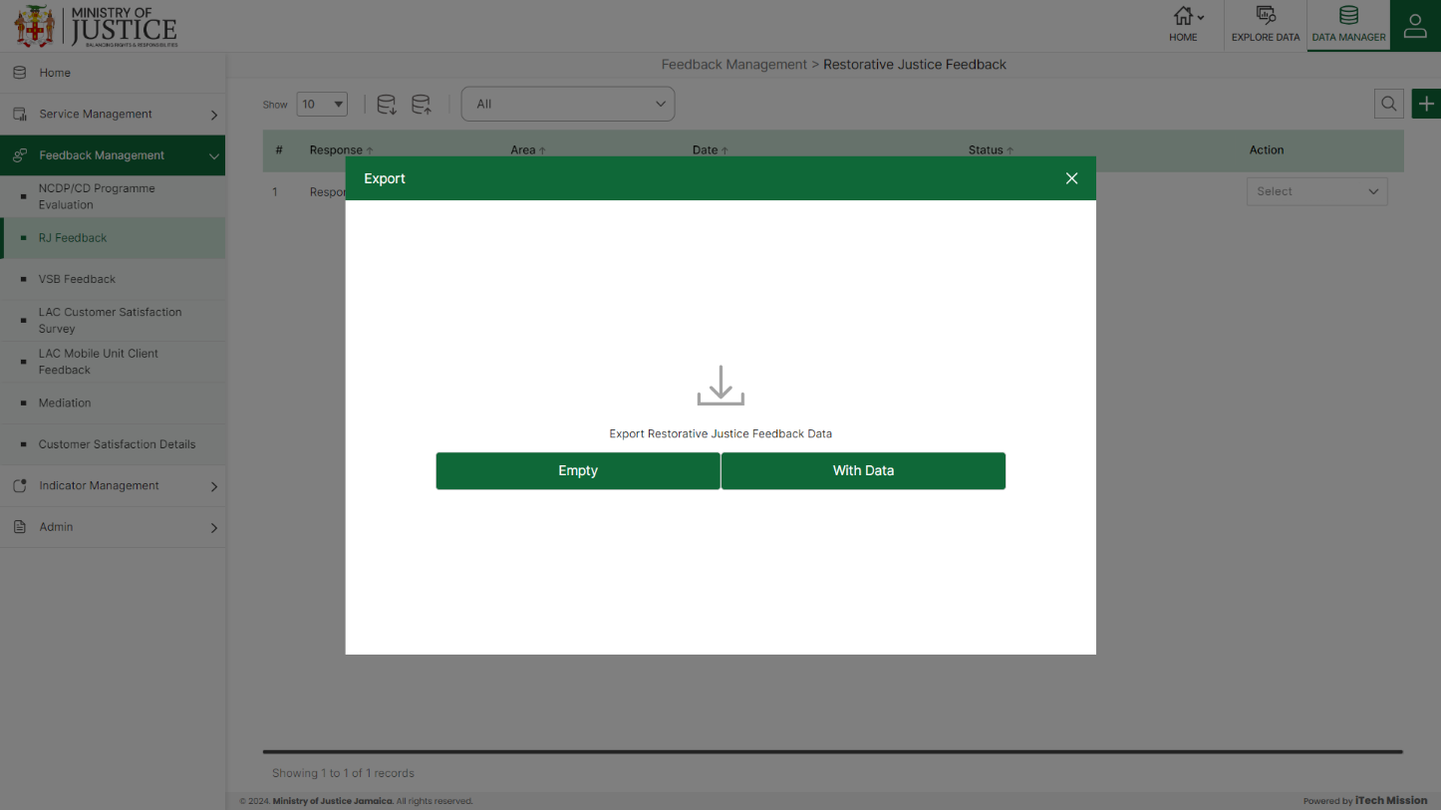****Click on the **Export** button to download the empty template and the master list (see below figure).

Click on the **Empty** option to download an empty template (see below figure). The file is imported and exported in the CSV (Comma Separated Value) file format.

Click on the **With Data** option to download the master list (see below figure).

### **5.2.2 IMPORT**

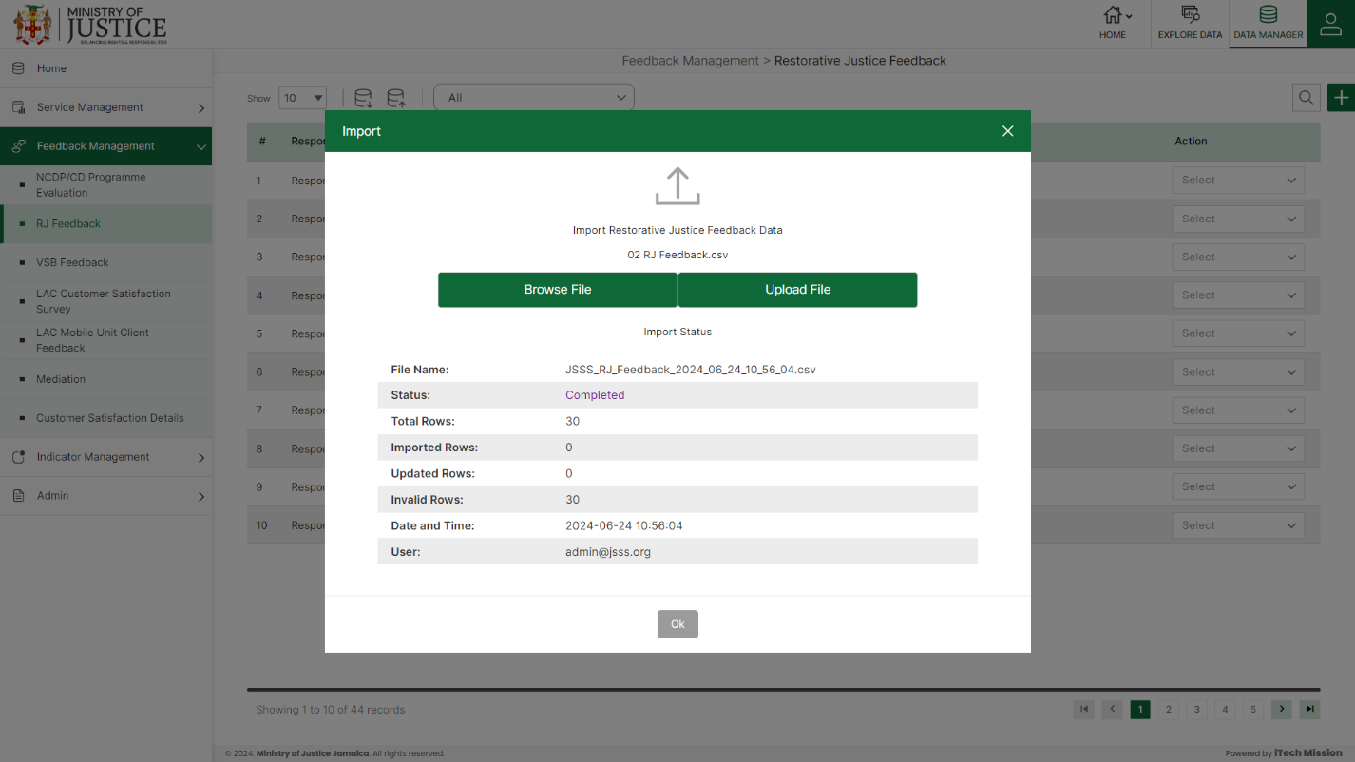Click on the **Import** button to browse the file and upload the master list into the database (see below figure).

To upload the file into the database first enter the structure in the template and then click on the **Browse File** button to select the template. Now, click on the **Upload** button to start the import process. During the import process, the records which contains blank entries, entries with special characters and duplicate entries are not imported in the database.

A Last Upload summary will appear after the import process which provides the count of successfully imported records out of the total records. An error log will be generated to report on unsuccessfully imported records which you can access from **Logs** module.

### **5.2.3 ADD**

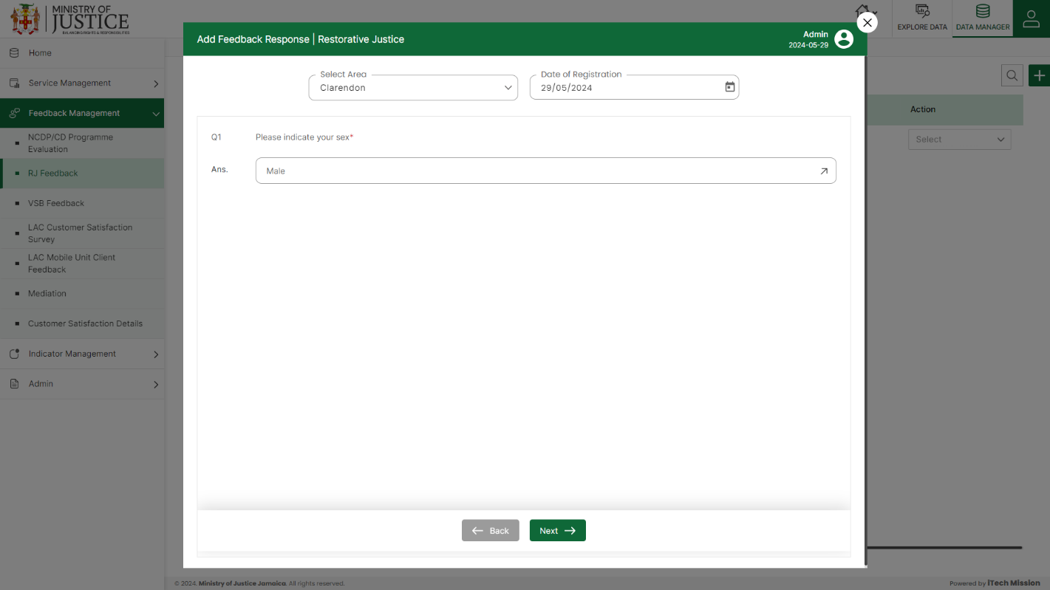****Click on the **Plus** button available at the top right corner to add a new record. Select **Area** and **Date of Registration** and thenenter data in the feedback form.

Click on the **Save** button to save and confirm. You can now view the new record added in the list.

***NOTE:***

*You can navigate between the sections using the* ***Back*** *and* ***Next*** *button available at the bottom of the page.* ***Next*** *button will be enabled when the mandatory field is filled. If all the mandatory fields are filled, then it is categorized as* ***Completed*** *and otherwise it is categorized as* ***Partially Completed****.*

Select **View** option available in the action dropdown to view the details of the selected element.

Select **Edit** option available in the action dropdown to edit the details of the selected element. Edit the required detail and click on update button to save and confirm.

Select **Delete** option available in the action dropdown to delete the selected element. A confirmation popup appears, click yes to confirm deletion of selected element.

## **5.3 VSB FEEDBACK**

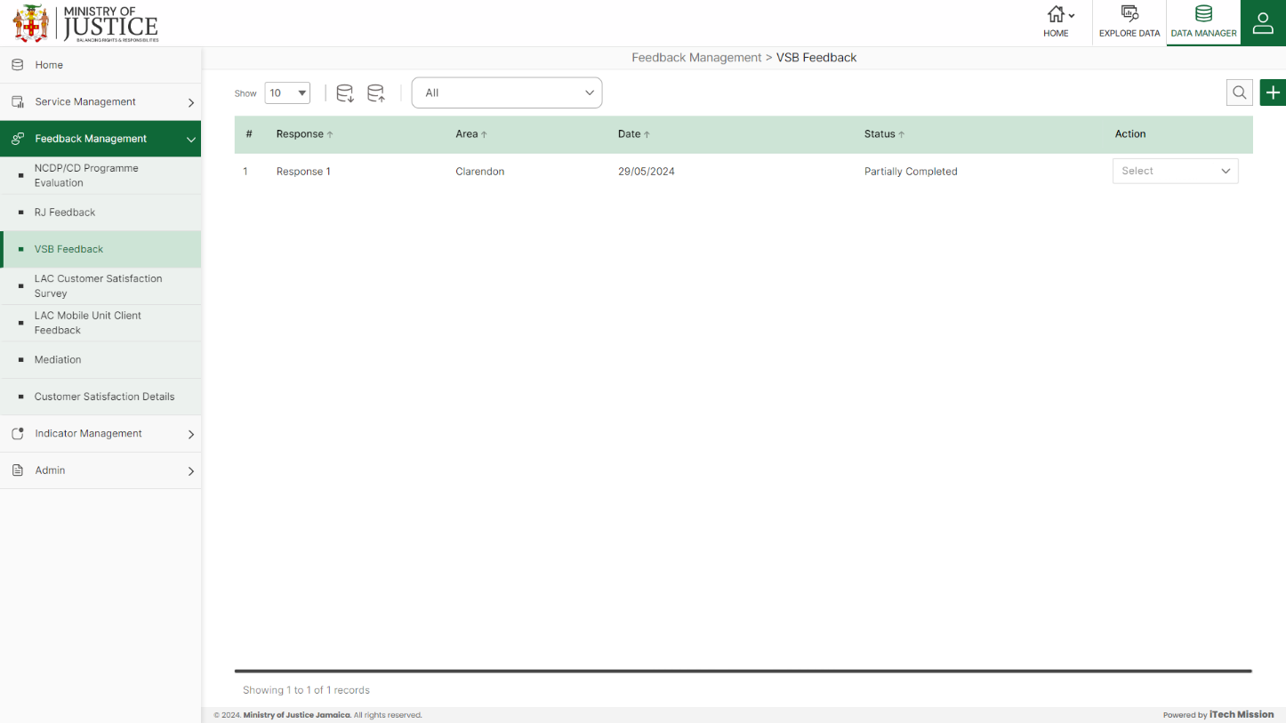Click on **VSB Feedback** from the Feedback management menu option available in the left panel to access this module. This module allows to manage the VSB Feedback master list. You will have options to export or import, add a new element, view the list of existing elements, sort the list, search from the list, edit and delete the existing elements (see below figure).

### **5.3.1. EXPORT**

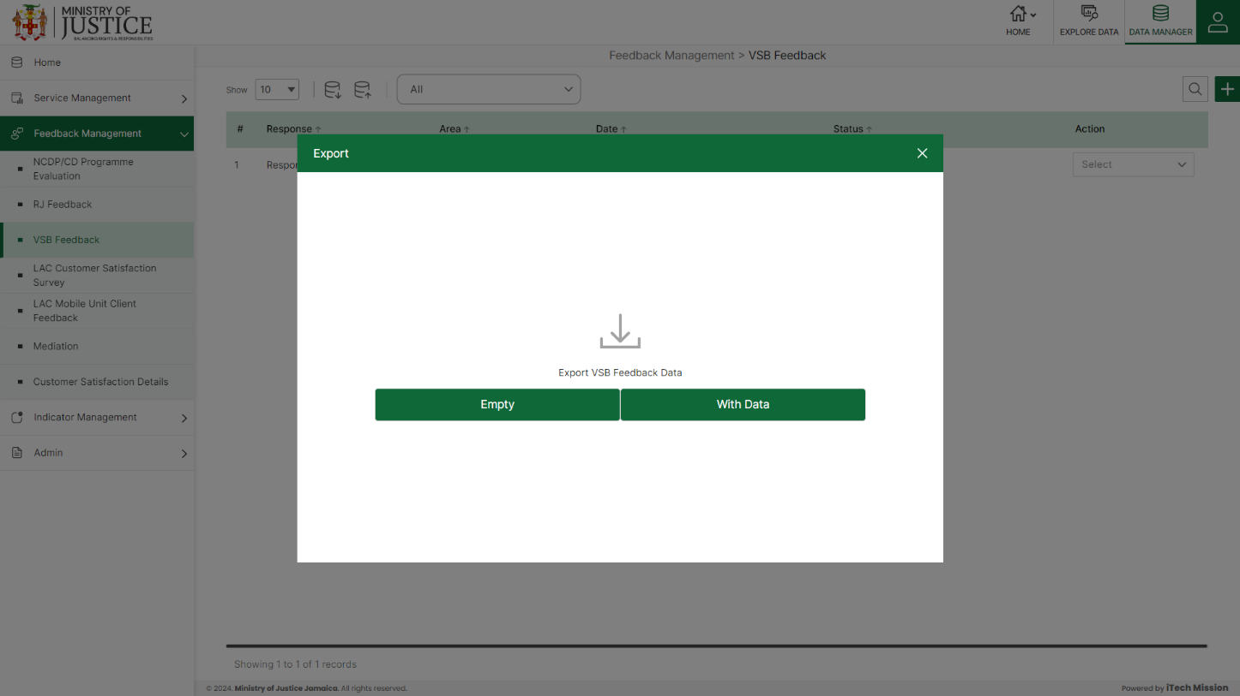****Click on the **Export** button to download the empty template and the master list (see below figure).

Click on the **Empty** option to download an empty template (see below figure). The file is imported and exported in the CSV (Comma Separated Value) file format.

Click on the **With Data** option to download the master list (see below figure).

### **5.3.2 IMPORT**

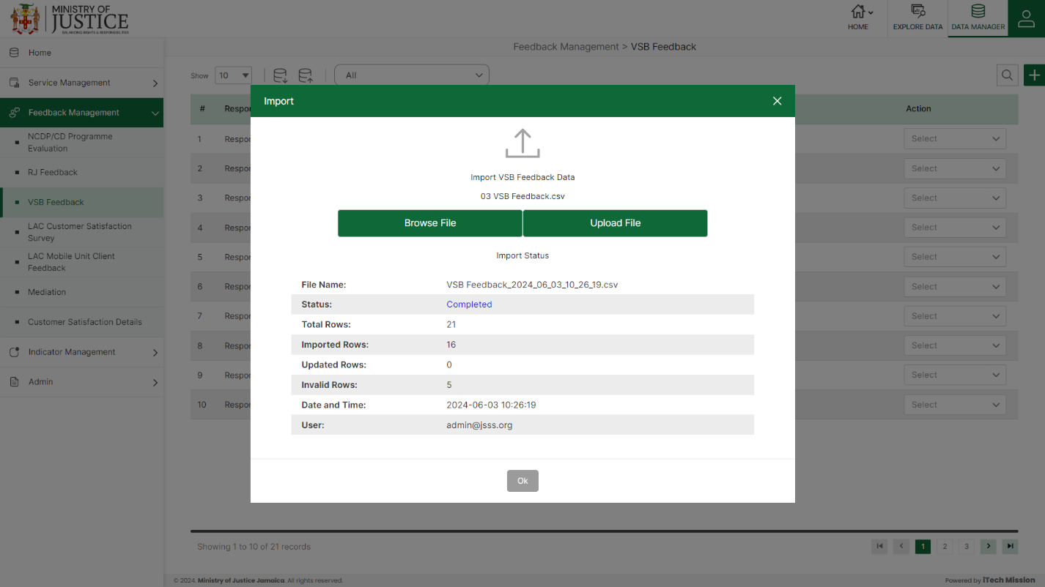Click on the **Import** button to browse the file and upload the master list into the database (see below figure).

To upload the file into the database first enter the structure in the template and then click on the **Browse File** button to select the template. Now, click on the **Upload** button to start the import process. During the import process, the records which contains blank entries, entries with special characters and duplicate entries are not imported in the database.

A Last Upload summary will appear after the import process which provides the count of successfully imported records out of the total records. An error log will be generated to report on unsuccessfully imported records which you can access from **Logs** module.

### **5.3.3 ADD**

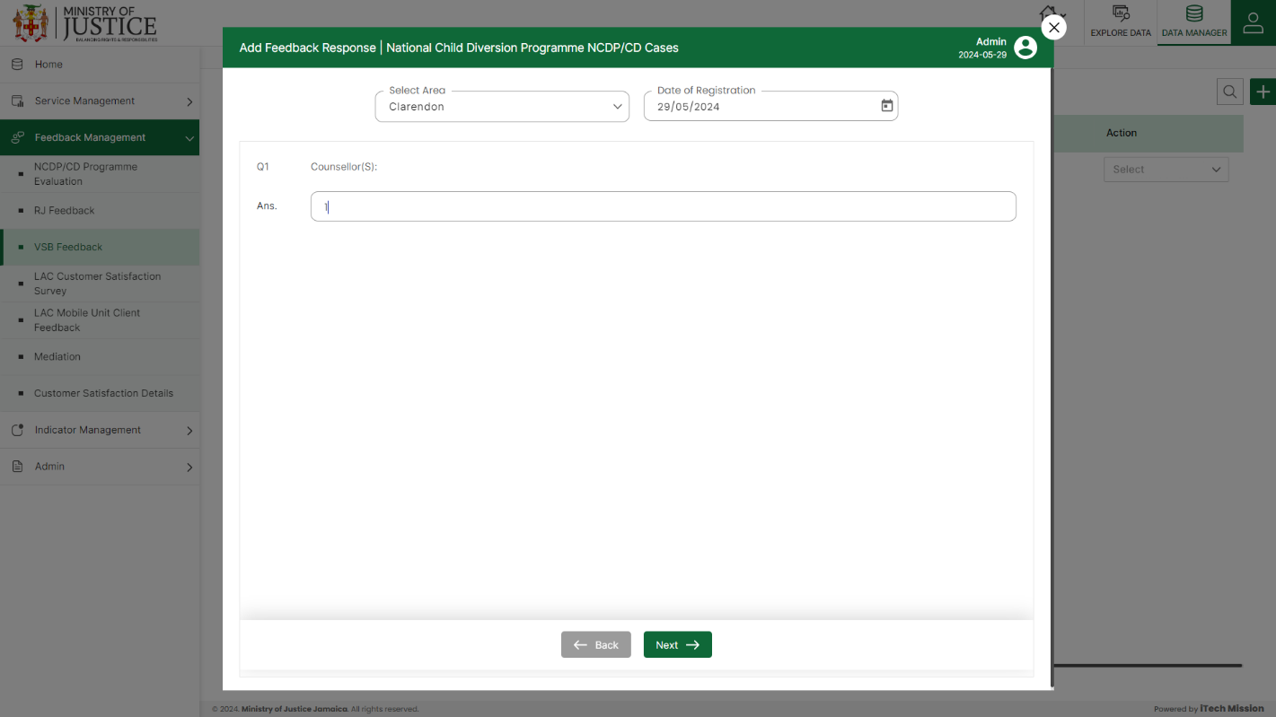****Click on the **Plus** button available at the top right corner to add a new record. Select **Area** and **Date of Registration** and thenenter data in the feedback form.

Click on the **Save** button to save and confirm. You can now view the new record added in the list.

***NOTE:***

*You can navigate between the sections using the* ***Back*** *and* ***Next*** *button available at the bottom of the page.* ***Next*** *button will be enabled when the mandatory field is filled. If all the mandatory fields are filled, then it is categorized as* ***Completed*** *and otherwise it is categorized as* ***Partially Completed****.*

Select **View** option available in the action dropdown to view the details of the selected element.

Select **Edit** option available in the action dropdown to edit the details of the selected element. Edit the required detail and click on update button to save and confirm.

Select **Delete** option available in the action dropdown to delete the selected element. A confirmation popup appears, click yes to confirm deletion of selected element.

## **5.4 LAC CUSTOMER SATISFACTION SURVEY**

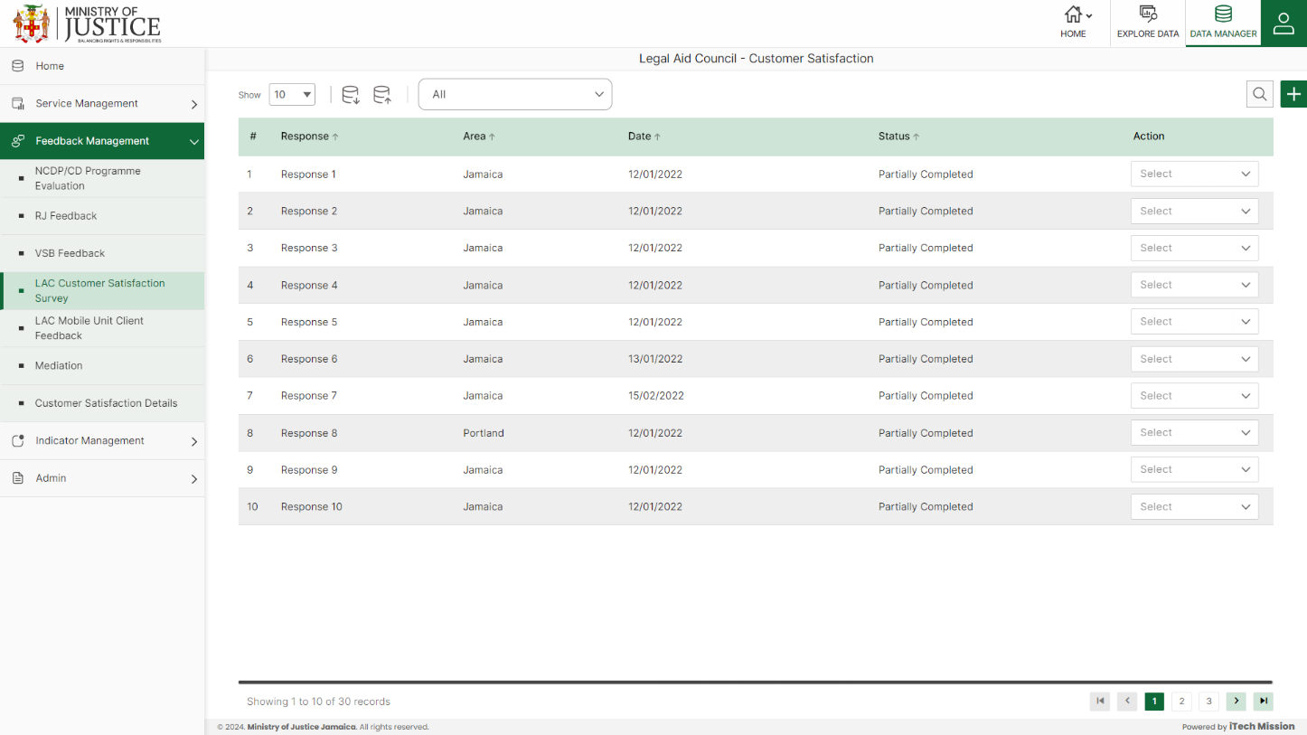Click on **LAC Customer Satisfaction Survey** from the Feedback management menu option available in the left panel to access this module. This module allows to manage the LAC Customer Satisfaction survey master list. You will have options to export or import, add a new element, view the list of existing elements, sort the list, search from the list, edit and delete the existing elements (see below figure).

### **5.4.1. EXPORT**

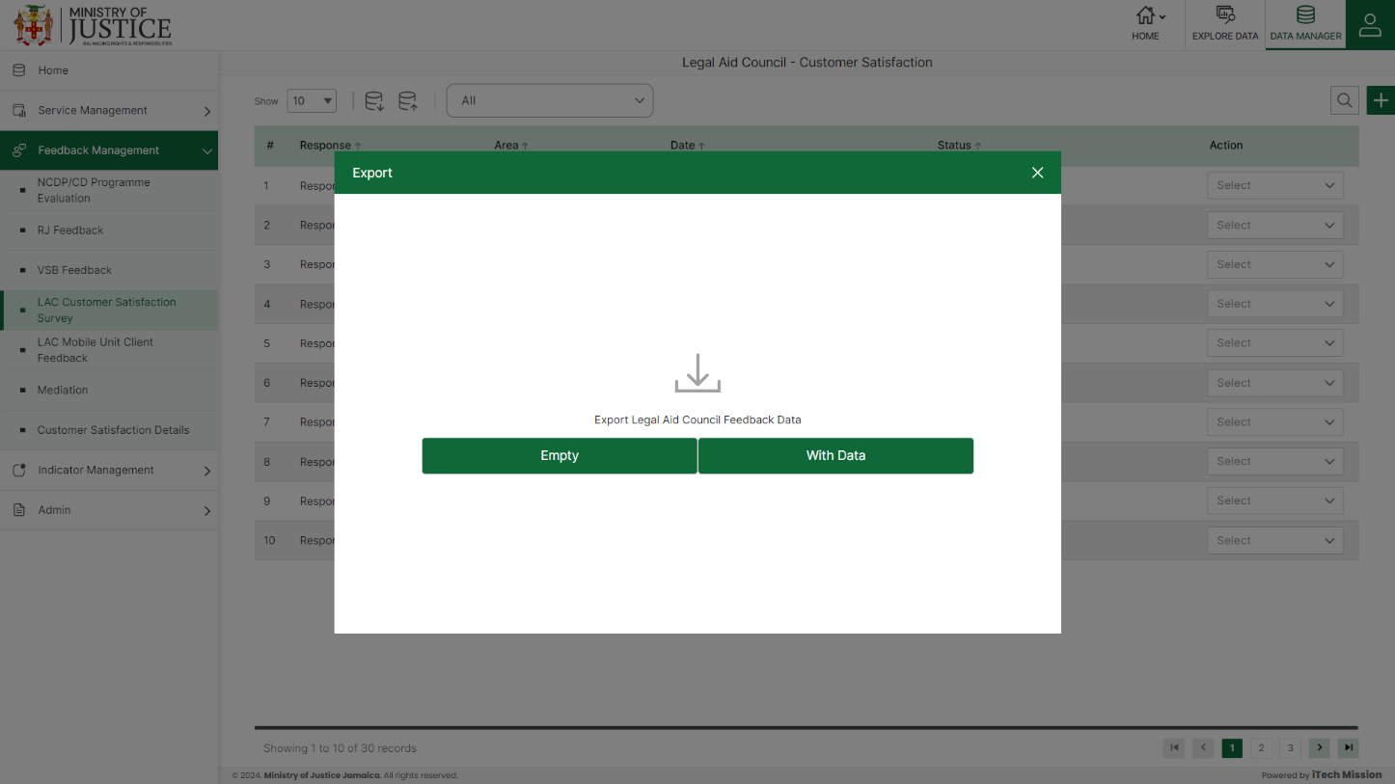****Click on the **Export** button to download the empty template and the master list (see below figure).

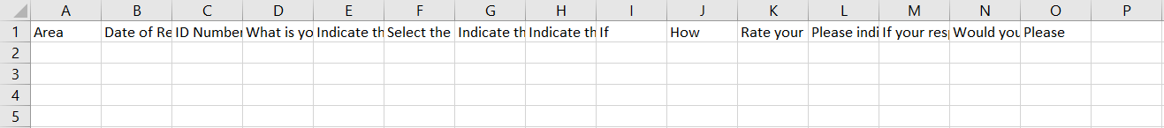Click on the **Empty** option to download an empty template (see below figure). The file is imported and exported in the CSV (Comma Separated Value) file format.

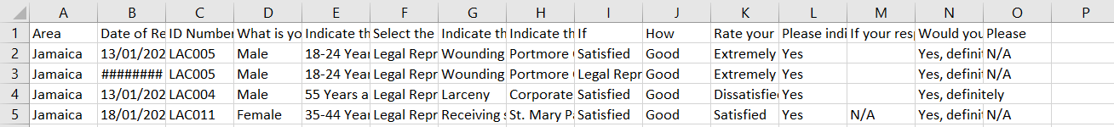Click on the **With Data** option to download the master list (see below figure).

### **5.4.2 IMPORT**

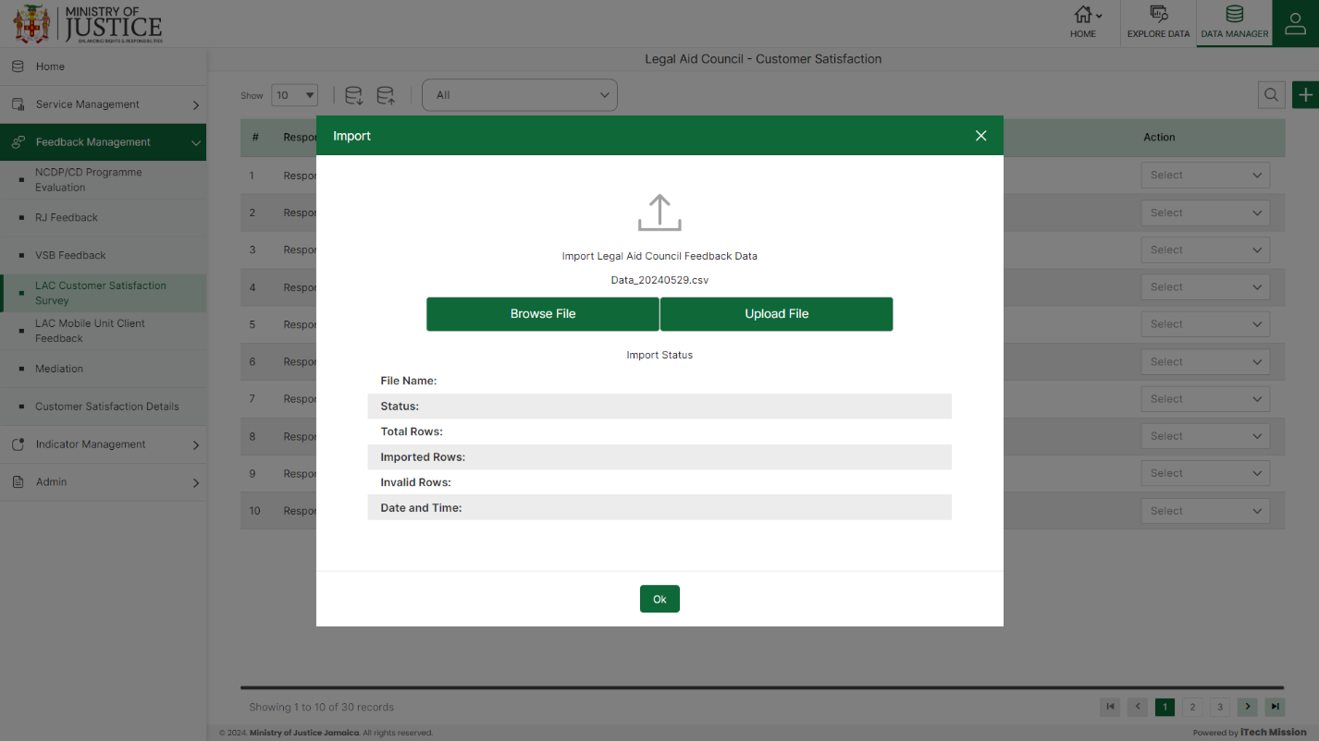Click on the **Import** button to browse the file and upload the master list into the database (see below figure).

To upload the file into the database first enter the structure in the template and then click on the **Browse File** button to select the template. Now, click on the **Upload** button to start the import process. During the import process, the records which contains blank entries, entries with special characters and duplicate entries are not imported in the database.

A Last Upload summary will appear after the import process which provides the count of successfully imported records out of the total records. An error log will be generated to report on unsuccessfully imported records which you can access from **Logs** module.

### **5.4.3 ADD**

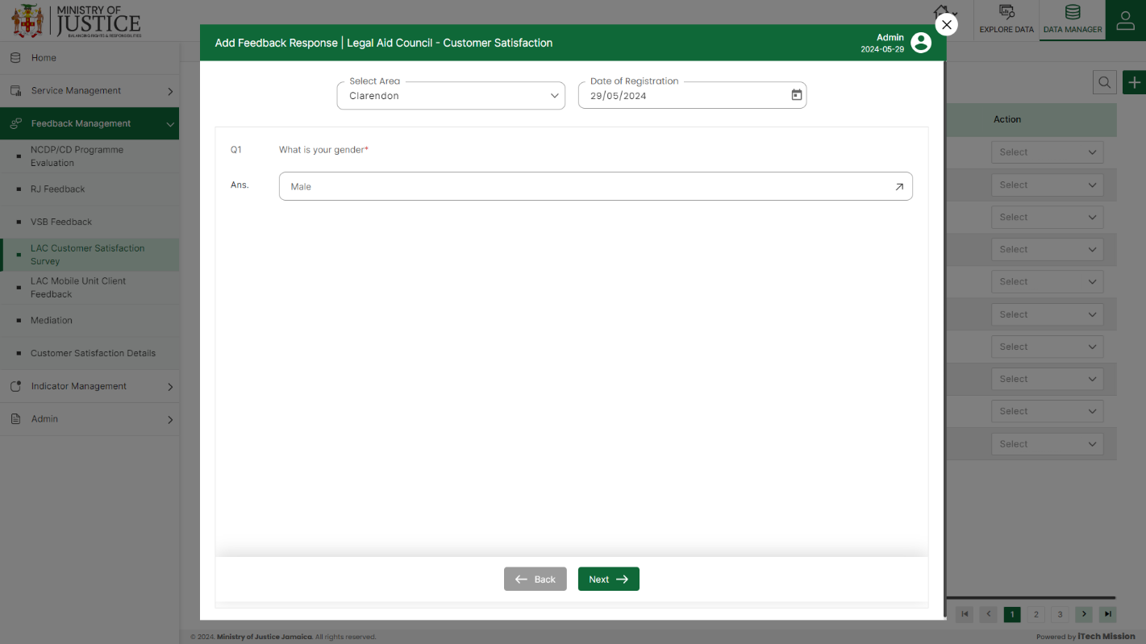****Click on the **Plus** button available at the top right corner to add a new record. Select **Area** and **Date of Registration** and thenenter data in the feedback form.

***NOTE:***

*You can navigate between the sections using the* ***Back*** *and* ***Next*** *button available at the bottom of the page.* ***Next*** *button will be enabled when the mandatory field is filled. If all the mandatory fields are filled, then it is categorized as* ***Completed*** *and otherwise it is categorized as* ***Partially Completed****.*

Click on the **Save** button to save and confirm. You can now view the new record added in the list.

Select **View** option available in the action dropdown to view the details of the selected element.

Select **Edit** option available in the action dropdown to edit the details of the selected element. Edit the required detail and click on update button to save and confirm.

Select **Delete** option available in the action dropdown to delete the selected element. A confirmation popup appears, click yes to confirm deletion of selected element.

## **5.5 LAC MOBILE UNIT CLIENT FEEDBACK**

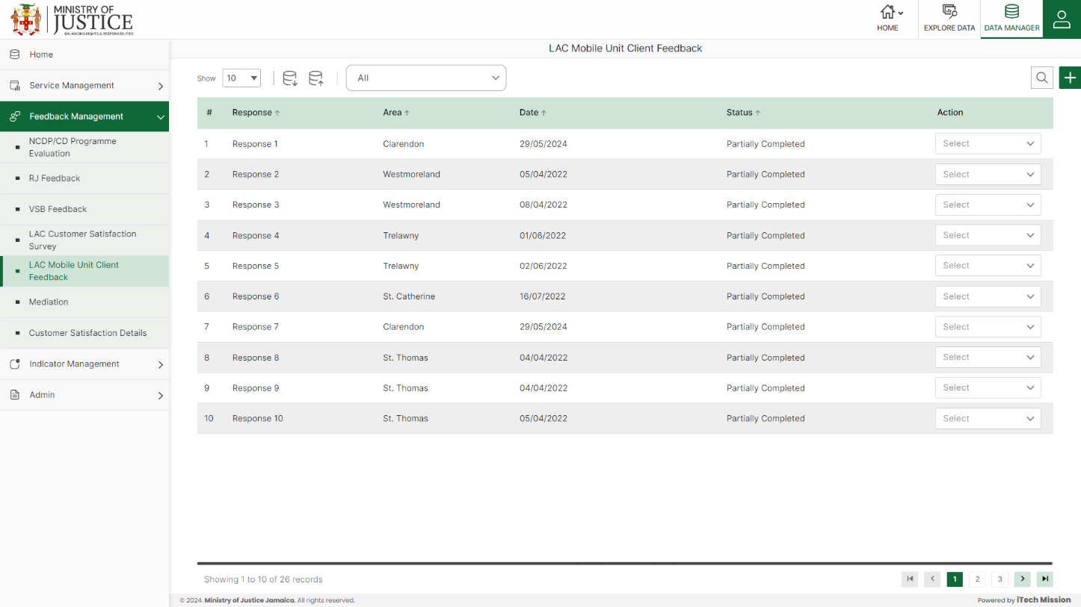Click on **LAC Mobile Unit Client Feedback** from the Feedback management menu option available in the left panel to access this module. This module allows to manage the LAC Mobile Unit Client master list. You will have options to export or import, add a new element, view the list of existing elements, sort the list, search from the list, edit and delete the existing elements (see below figure).

### **5.5.1. EXPORT**

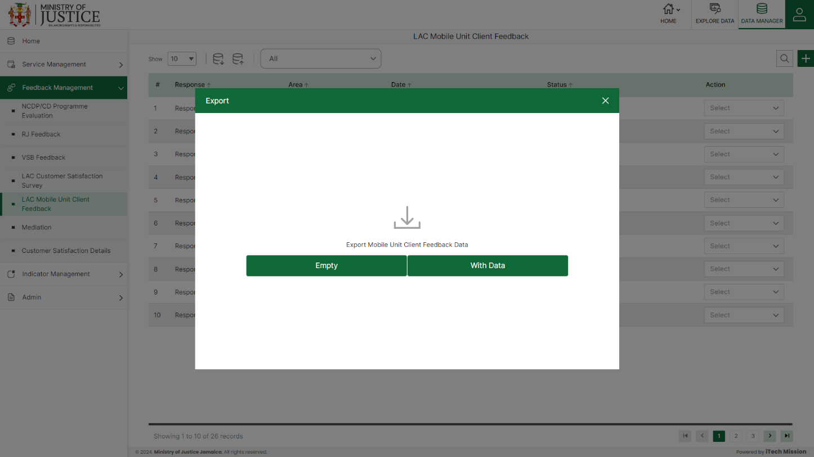****Click on the **Export** button to download the empty template and the master list (see below figure).

Click on the **Empty** option to download an empty template (see below figure). The file is imported and exported in the CSV (Comma Separated Value) file format.

Click on the **With Data** option to download the master list (see below figure).

### **5.5.2 IMPORT**

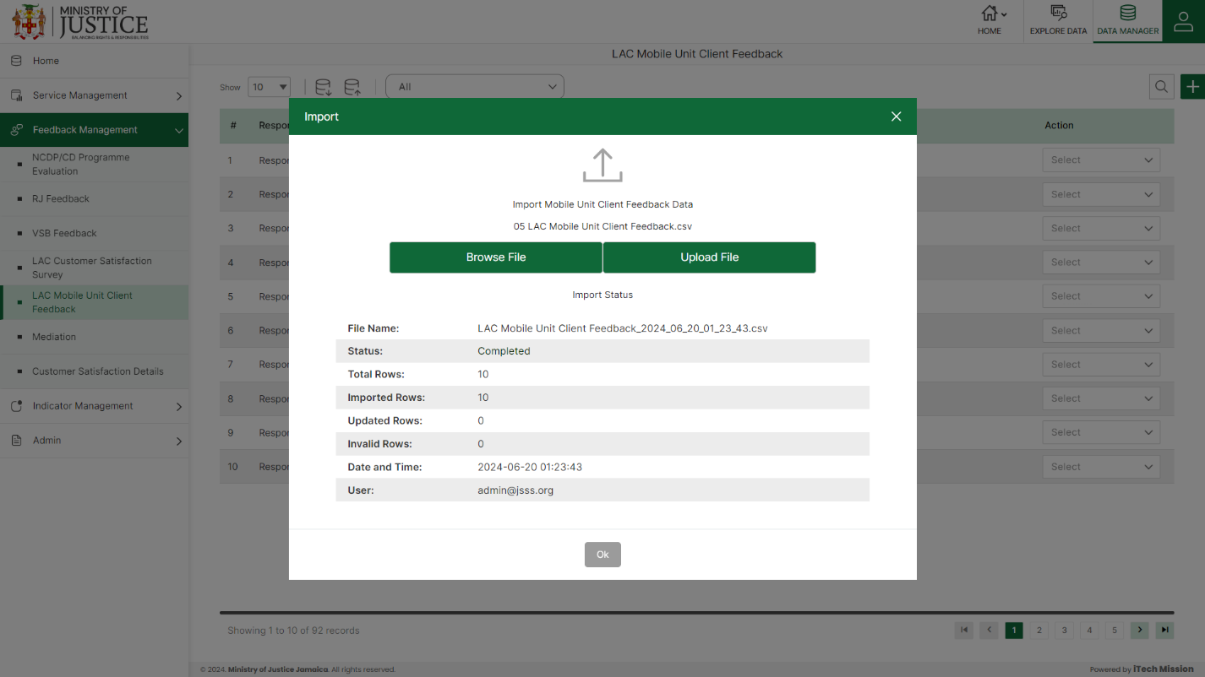Click on the **Import** button to browse the file and upload the master list into the database (see below figure).

To upload the file into the database first enter the structure in the template and then click on the **Browse File** button to select the template. Now, click on the **Upload** button to start the import process. During the import process, the records which contains blank entries, entries with special characters and duplicate entries are not imported in the database.

A Last Upload summary will appear after the import process which provides the count of successfully imported records out of the total records. An error log will be generated to report on unsuccessfully imported records which you can access from **Logs** module.

### **5.5.3 ADD**

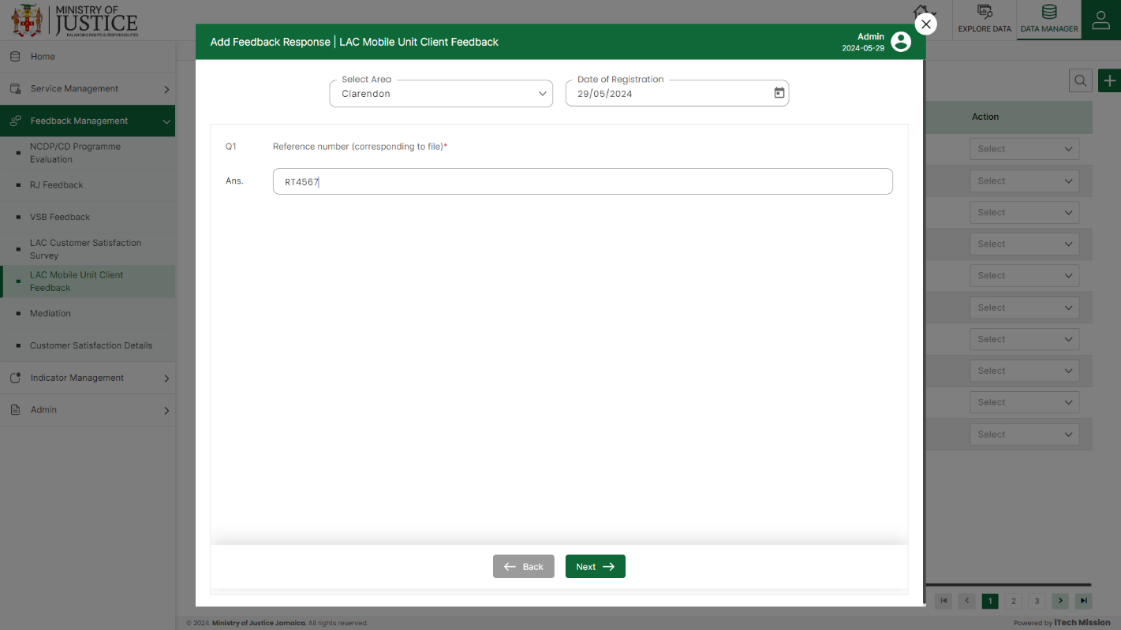****Click on the **Plus** button available at the top right corner to add a new record. Select **Area** and **Date of Registration** and thenenter data in the feedback form.

Click on the **Save** button to save and confirm. You can now view the new record added in the list.

***NOTE:***

*You can navigate between the sections using the* ***Back*** *and* ***Next*** *button available at the bottom of the page.* ***Next*** *button will be enabled when the mandatory field is filled. If all the mandatory fields are filled, then it is categorized as* ***Completed*** *and otherwise it is categorized as* ***Partially Completed****.*

Select **View** option available in the action dropdown to view the details of the selected element.

Select **Edit** option available in the action dropdown to edit the details of the selected element. Edit the required detail and click on update button to save and confirm.

Select **Delete** option available in the action dropdown to delete the selected element. A confirmation popup appears, click yes to confirm deletion of selected element.

## **5.6 MEDIATION**

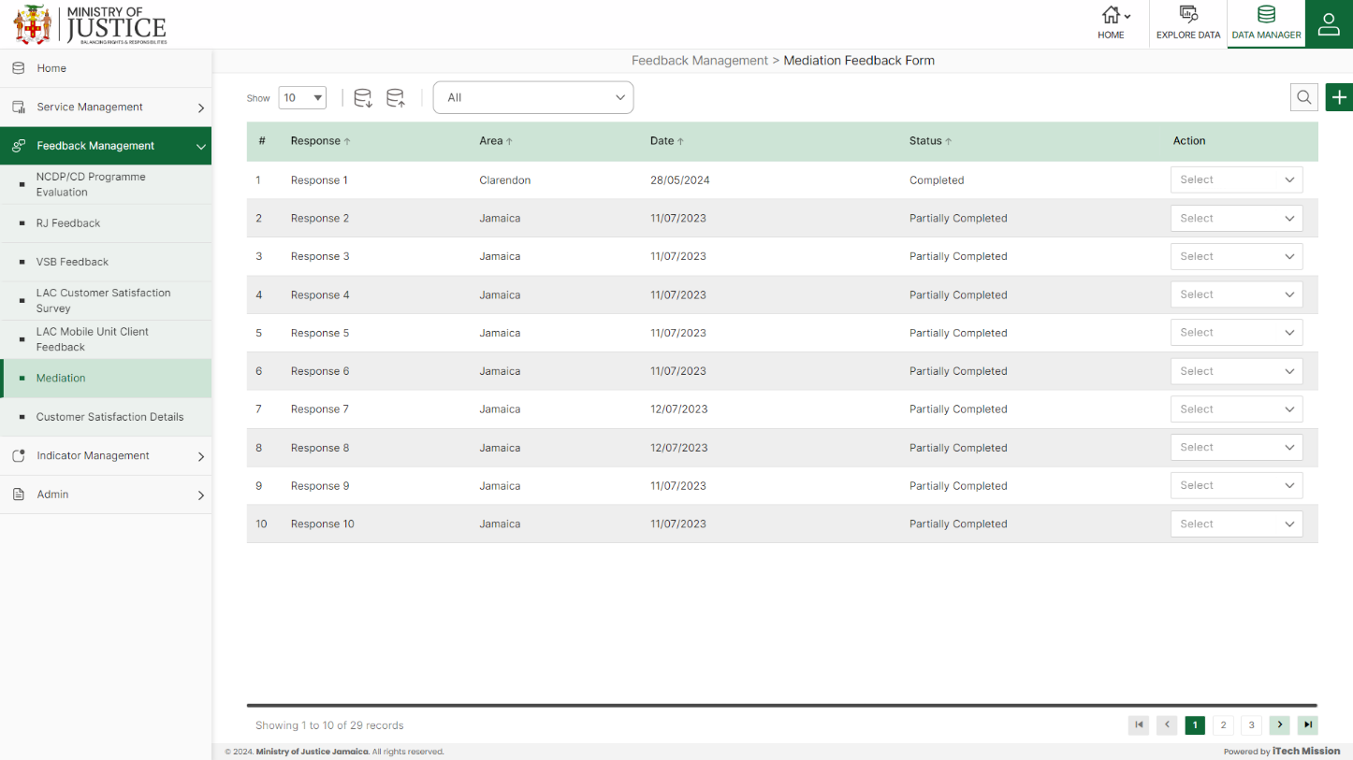Click on **Mediation** from the Feedback management menu option available in the left panel to access this module. This module allows to manage the Mediation master list. You will have options to export or import, add a new element, view the list of existing elements, sort the list, search from the list, edit and delete the existing elements (see below figure).

### **5.6.1. EXPORT**

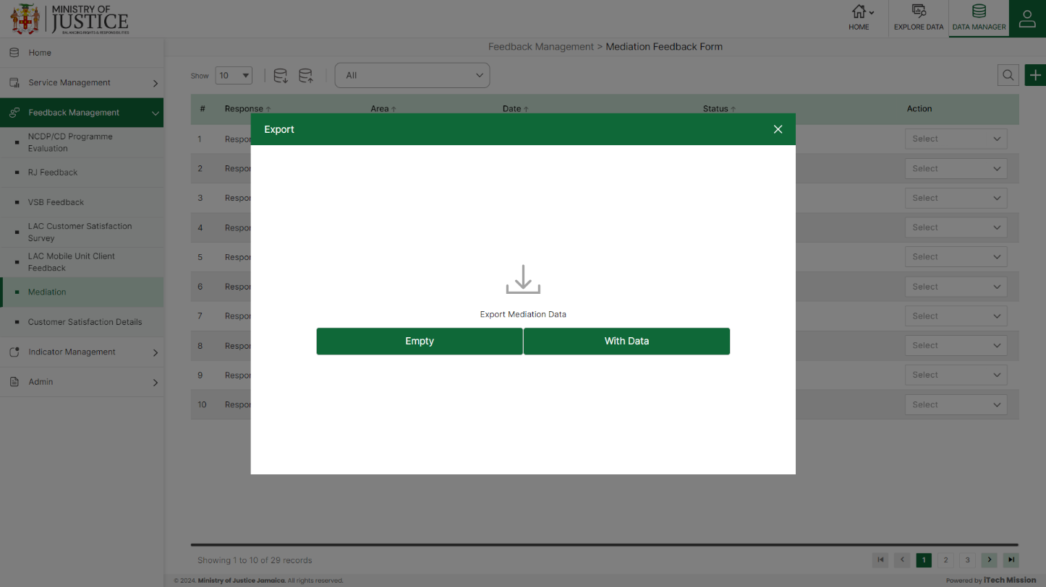****Click on the **Export** button to download the empty template and the master list (see below figure).

Click on the **Empty** option to download an empty template (see below figure). The file is imported and exported in the CSV (Comma Separated Value) file format.

Click on the **With Data** option to download the master list (see below figure).

### **5.6.2 IMPORT**

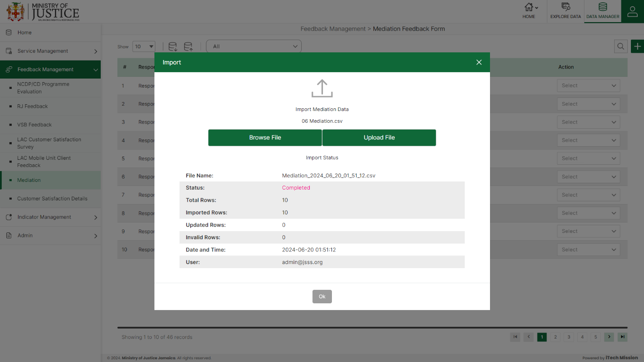Click on the **Import** button to browse the file and upload the master list into the database (see below figure).

To upload the file into the database first enter the structure in the template and then click on the **Browse File** button to select the template. Now, click on the **Upload** button to start the import process. During the import process, the records which contains blank entries, entries with special characters and duplicate entries are not imported in the database.

A Last Upload summary will appear after the import process which provides the count of successfully imported records out of the total records. An error log will be generated to report on unsuccessfully imported records which you can access from **Logs** module.

### **5.6.3 ADD**

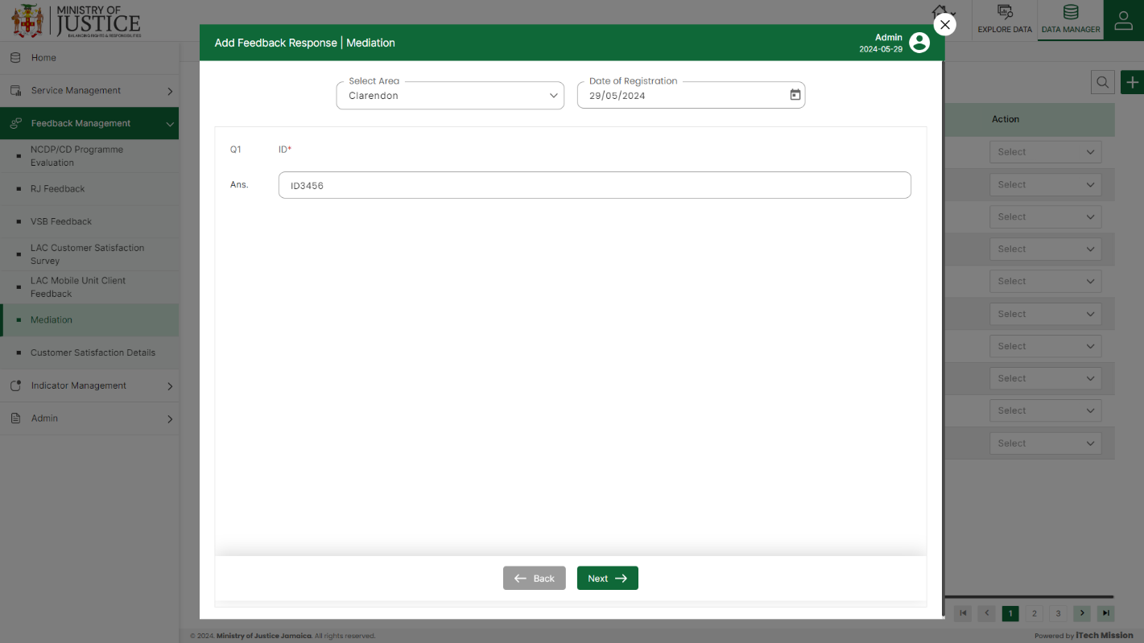****Click on the **Plus** button available at the top right corner to add a new record. Select **Area** and **Date of Registration** and thenenter data in the feedback form.

Click on the **Save** button to save and confirm. You can now view the new record added in the list.

***NOTE:***

*You can navigate between the sections using the* ***Back*** *and* ***Next*** *button available at the bottom of the page.* ***Next*** *button will be enabled when the mandatory field is filled. If all the mandatory fields are filled, then it is categorized as* ***Completed*** *and otherwise it is categorized as* ***Partially Completed****.*

Select **View** option available in the action dropdown to view the details of the selected element.

Select **Edit** option available in the action dropdown to edit the details of the selected element. Edit the required detail and click on update button to save and confirm.

Select **Delete** option available in the action dropdown to delete the selected element. A confirmation popup appears, click yes to confirm deletion of selected element.

## **5.7 CUSTOMER SATISFACTION DETAILS**

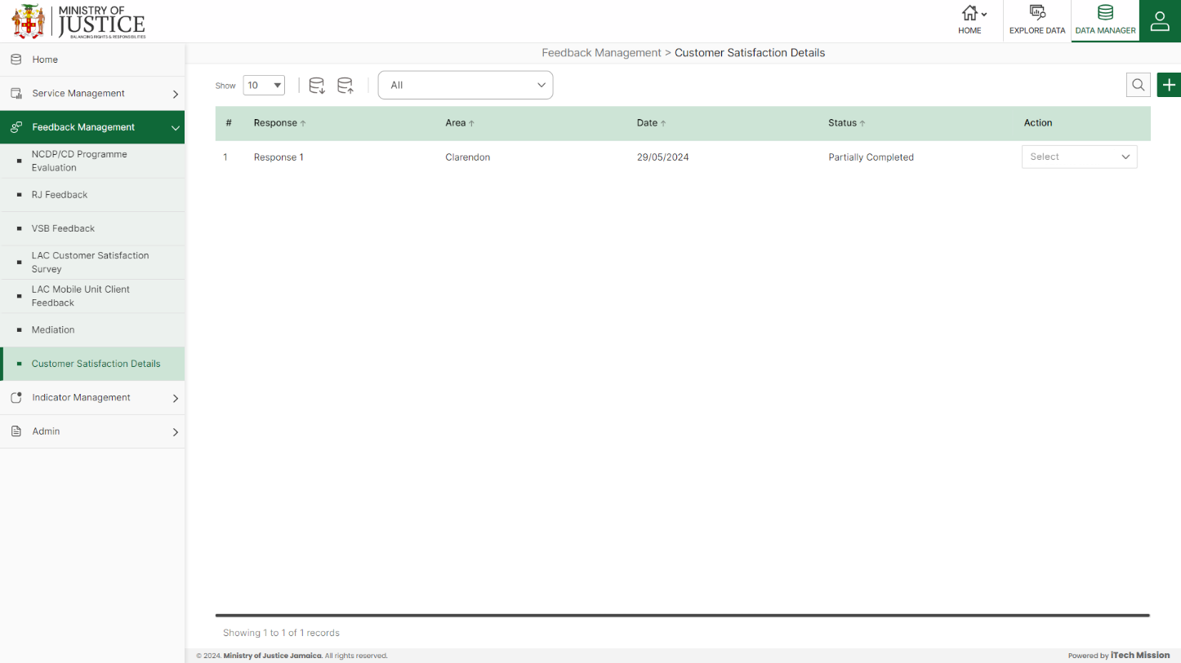Click on **Customer Satisfaction Details** from the Feedback management menu option available in the left panel to access this module. This module allows to manage the Customer Satisfaction Details master list. You will have options to export or import, add a new element, view the list of existing elements, sort the list, search from the list, edit and delete the existing elements (see below figure).

### **5.7.1. EXPORT**

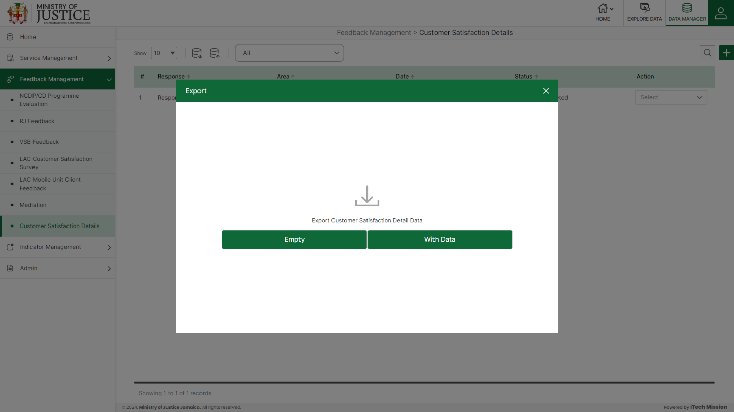****Click on the **Export** button to download the empty template and the master list (see below figure).

Click on the **Empty** option to download an empty template (see below figure). The file is imported and exported in the CSV (Comma Separated Value) file format.

Click on the **With Data** option to download the master list (see below figure).

### **5.7.2 IMPORT**

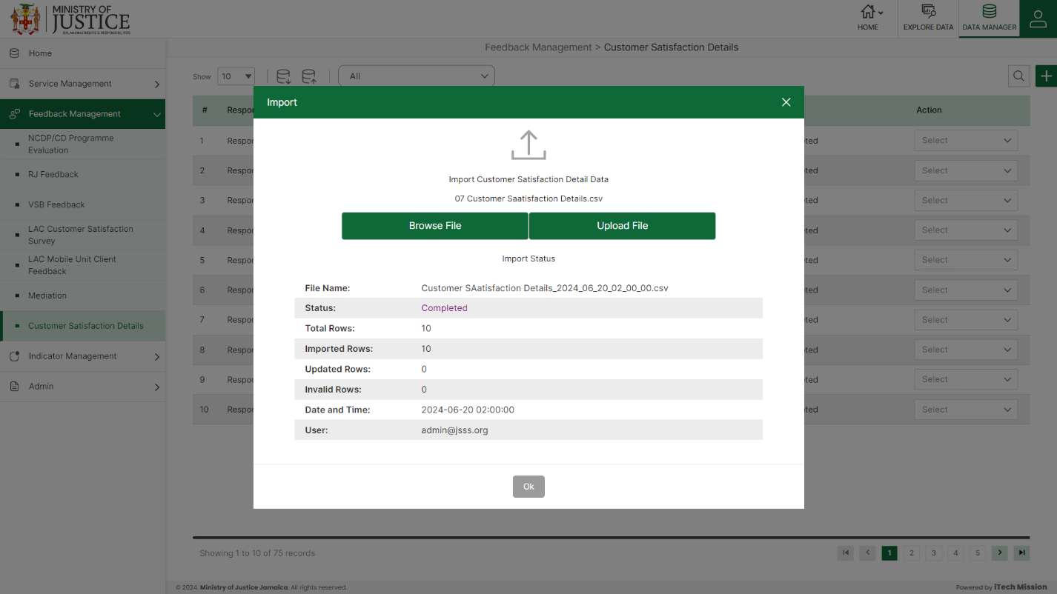Click on the **Import** button to browse the file and upload the master list into the database (see below figure).

To upload the file into the database first enter the structure in the template and then click on the **Browse File** button to select the template. Now, click on the **Upload** button to start the import process. During the import process, the records that contain blank entries, entries with special characters, and duplicate entries are not imported into the database.

A Last Upload summary will appear after the import process which provides the count of successfully imported records out of the total records. An error log will be generated to report on unsuccessfully imported records which you can access from the **Logs** module.

### **5.7.3 ADD**

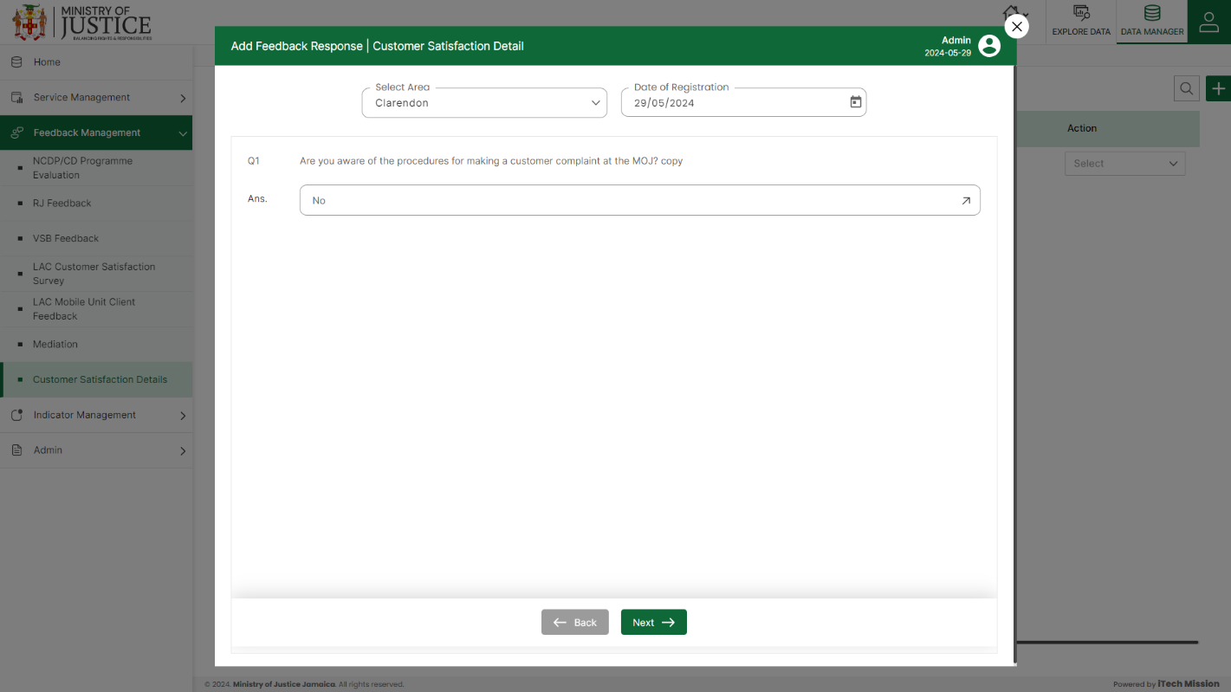****Click on the **Plus** button available at the top right corner to add a new record. Select **Area** and **Date of Registration** and thenenter data in the feedback form.

Click on the **Save** button to save and confirm. You can now view the new record added to the list.

***NOTE:***

*You can navigate between the sections using the* ***Back*** *and* ***Next*** *button available at the bottom of the page.* ***Next*** *button will be enabled when the mandatory field is filled. If all the mandatory fields are filled, then it is categorized as* ***Completed*** *and otherwise it is categorized as* ***Partially Completed****.*

Select **the View** option available in the action dropdown to view the details of the selected element.

Select **the Edit** option available in the action dropdown to edit the details of the selected element. Edit the required detail and click on the update button to save and confirm.

Select **the Delete** option available in the action dropdown to delete the selected element. A confirmation popup appears, click yes to confirm the deletion of the selected element.

# 6.0 INDICATOR MANAGEMENT

Click the **Indicator Management** menu option from the left panel to access this module. This module has six submodules – Indicator, Indicator Metadata, Indicator Data, Data Approve, Calculate/Aggregate and Analysis. Let us understand these submodules in detail.

## **6.1 INDICATOR**

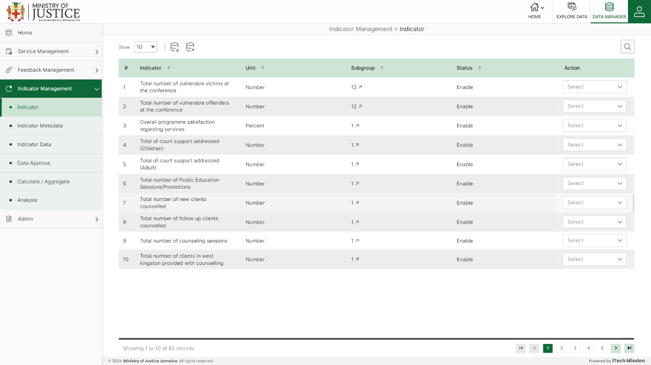Click on **Indicator** from the indicator management menu option available in the left panel to access this module This module allows you to manage the indicator master list. You will have options to export and import indicator templates, add new indicators, view the list of existing indicators, sort the list, search indicators from the list, edit, delete, and enable/disable existing indicators (see below figure)

### **6.1.1 EXPORT**

Click on the **Export** button to download the empty indicator template and the indicator master list (see below figure).

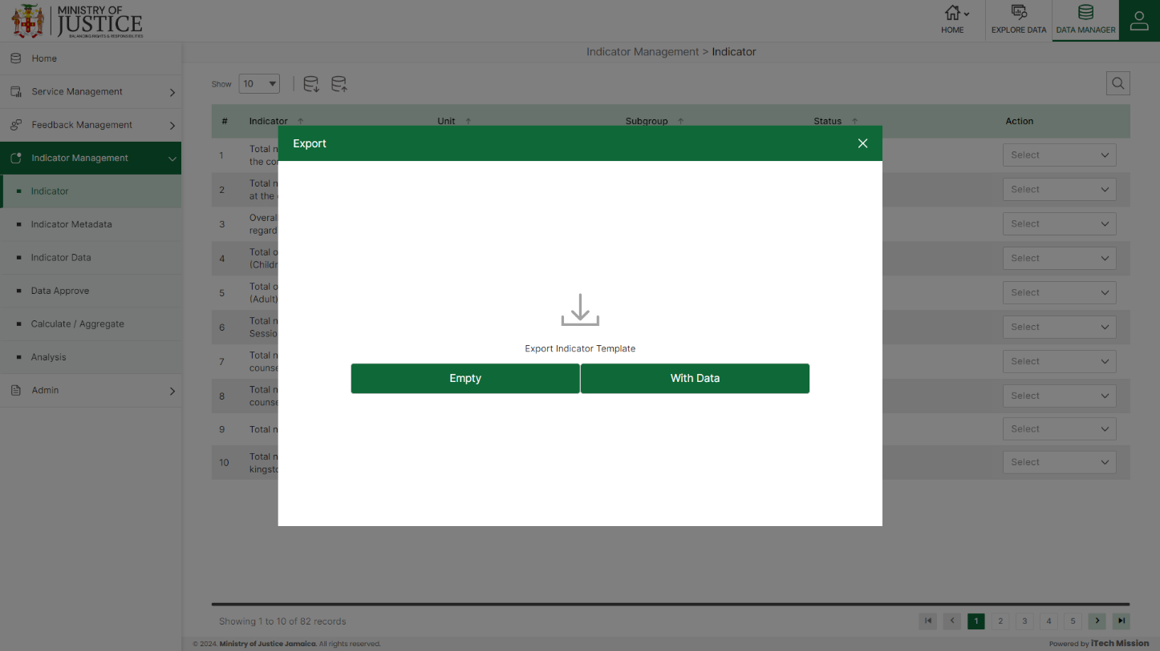You can use this option to create an indicator template structure. Below is the structure that you will find in the indicator empty template.

|  |  |
| --- | --- |
| **Topic** | Topic assigned to the indicator |
| **Subtopic** | Subtopic assigned to the indicator |
| **Pillar** | Pillar of the indicator |
| **Outcome** | The outcome of the indicator |
| **Indicator** | Name assigned to an indicator |
| **Unit** | Measurement unit of indicator |
| **Subgroup Dimension** | Dimension of the subgroup |
| **Subgroup** | Indicator disaggregation |
| **Subgroup Order** | Order of Indicator disaggregation |
| **IsDefaultSubgroup** | Select to store the default subgroups |
| **HighisGood** | Status to represent a good or bad indicator |

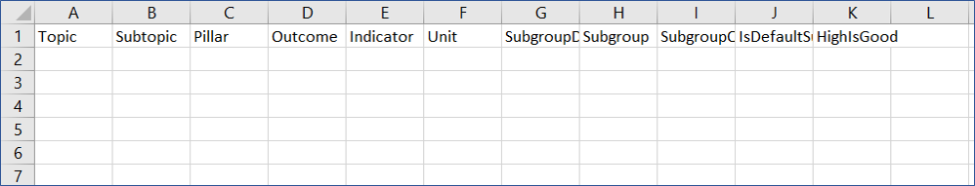Click on the **Empty** option to download an empty indicator template (see below figure). The indicator list is imported and exported in the CSV (Comma Separated Value) file format.

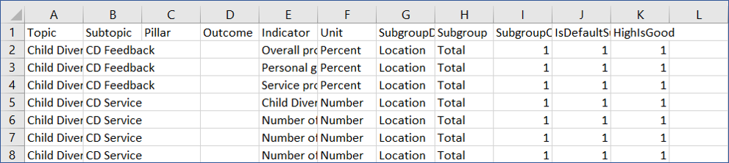Click on the **With Data** option to download the indicator master list (see below figure).

### **6.1.2 IMPORT**

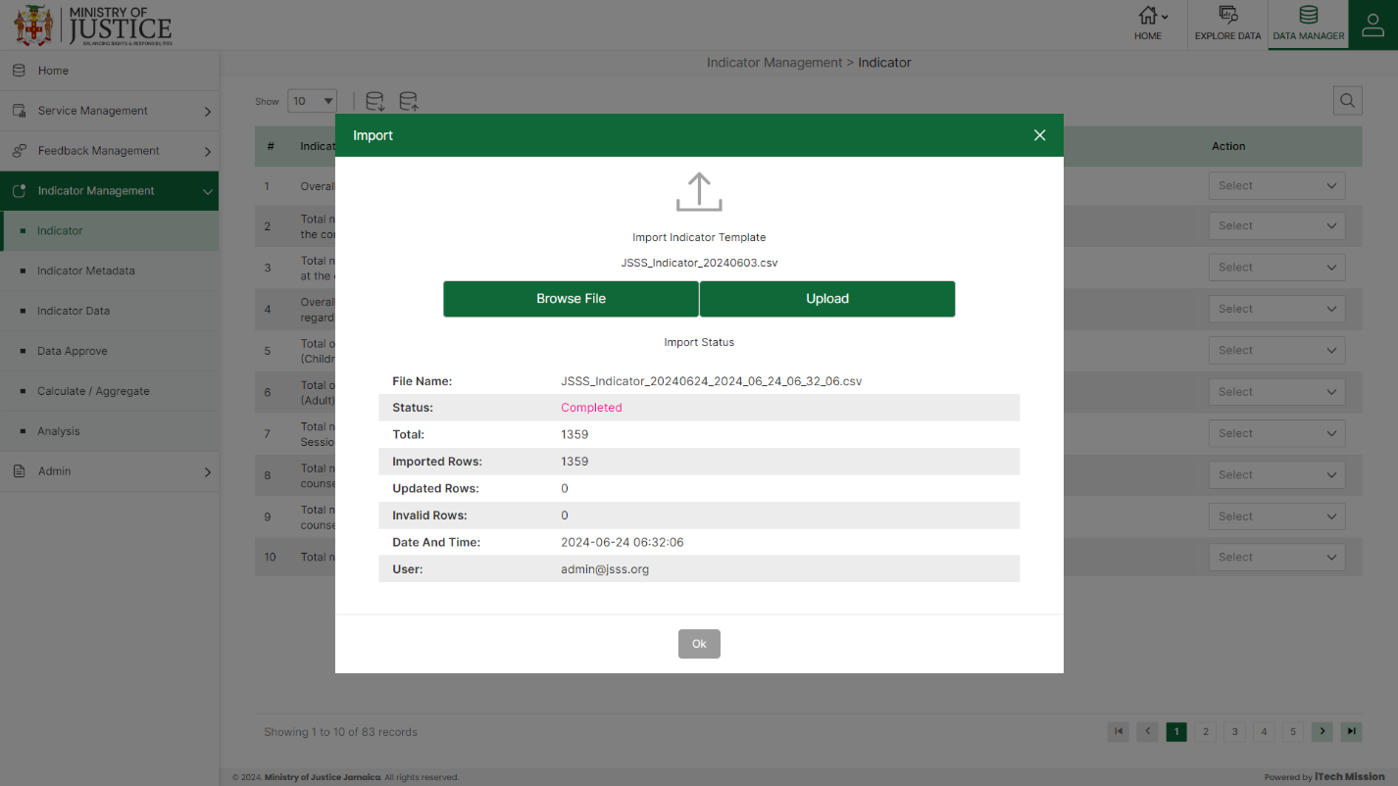Click on the **Import** button to browse the file and upload the indicator master list into the database (see below figure).

To upload the indicator into the database first enter the indicator structure in the template as explained above and then click on the **Browse File** button to select the template. Now, click on the **Upload** button to start the import process. During the import process, the records that contain blank entries, entries with special characters, and duplicate entries are not imported into the database.

A Last Upload summary will appear after the import process which provides the count of successfully imported records out of the total records. An error log will be generated to report on unsuccessfully imported records which you can access from the **Logs** module.

## **6.2 INDICATOR METADATA**

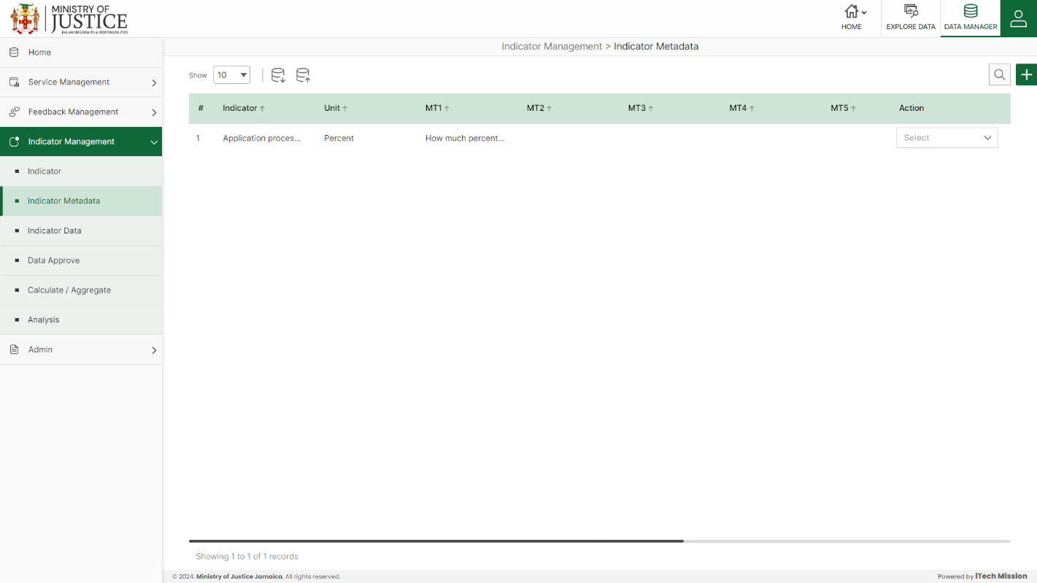Click on **Indicator Metadata** from the indicator management menu option available in the left panel to access this module. This module allows to management indicator’s metadata. You will have options to export and import indicator metadata templates, add new indicators, view the list of existing indicators’ metadata, sort the list, search indicator metadata from the list, edit, delete, and enable/ disable the existing indicators metadata details (see below figure).

### **6.2.1 EXPORT**

Click on the **Export** button to download the empty indicator metadata template and the metadata master list (see below figure).

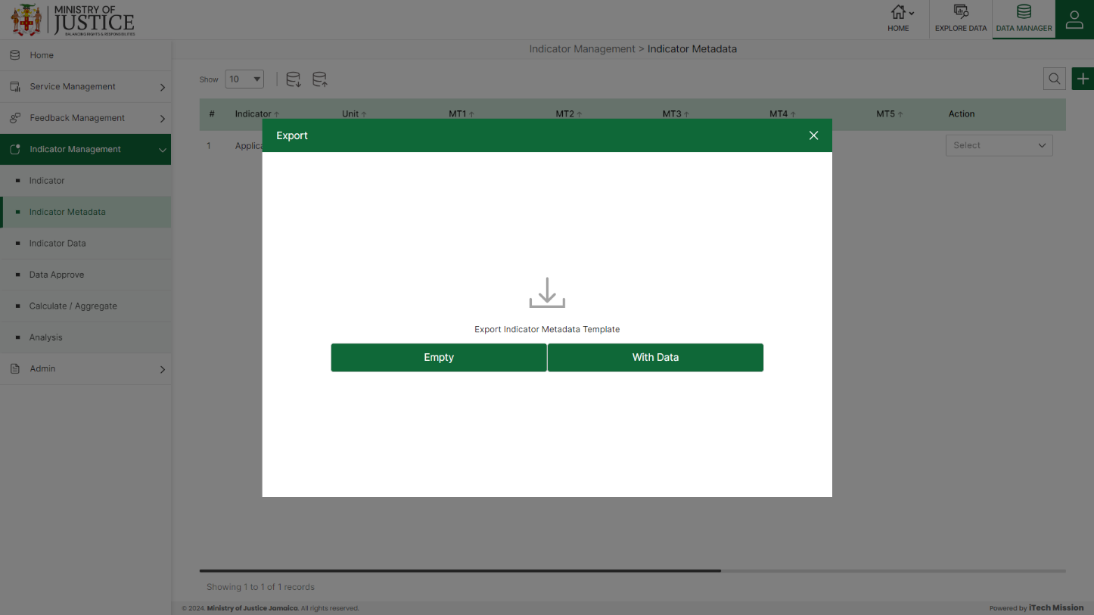You can use this option to create an indicator metadata template structure. Below is the structure that you will find in the indicator metadata empty template.

|  |  |
| --- | --- |
| **Indicator** | Name of the indicator |
| **Unit** | Measurement unit of indicator |
| **MT1** | The definition of the selected indicator |
| **MT2** | The computation description for the indicator |
| **MT3** | The overview of the indicator |
| **MT4** | The comments and limitations of the indicator |
| **MT5** | The detail of data collection for data monitoring |
| **MT6** | The name of the data source of the availability of data. |
| **MT7** | The treatment method for missing values |
| **MT8** | The regional and global estimate of selected Indicator |
| **MT9** | The definition of the selected indicator |

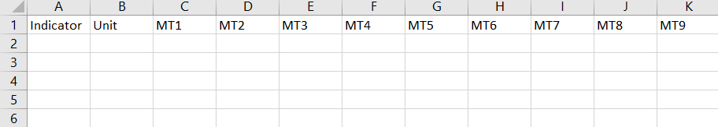Click on the **Empty** option to download an empty indicator metadata template (see below figure). The indicator metadata is imported and exported in the CSV (Comma Separated Value) file format.

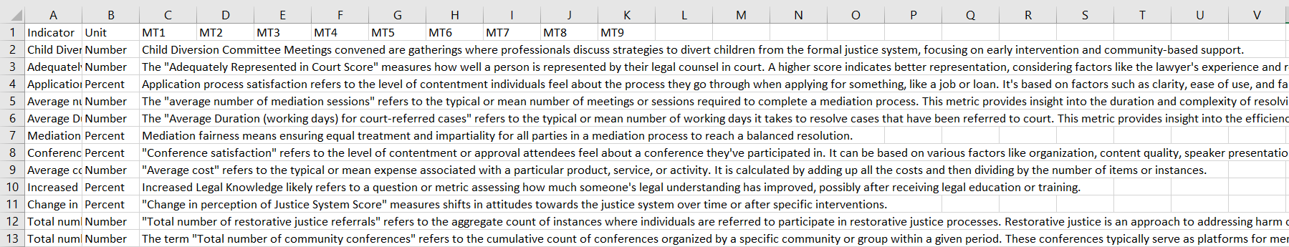Click on the **With Data** option to download the indicator metadata master list.

### **6.2.2 IMPORT**

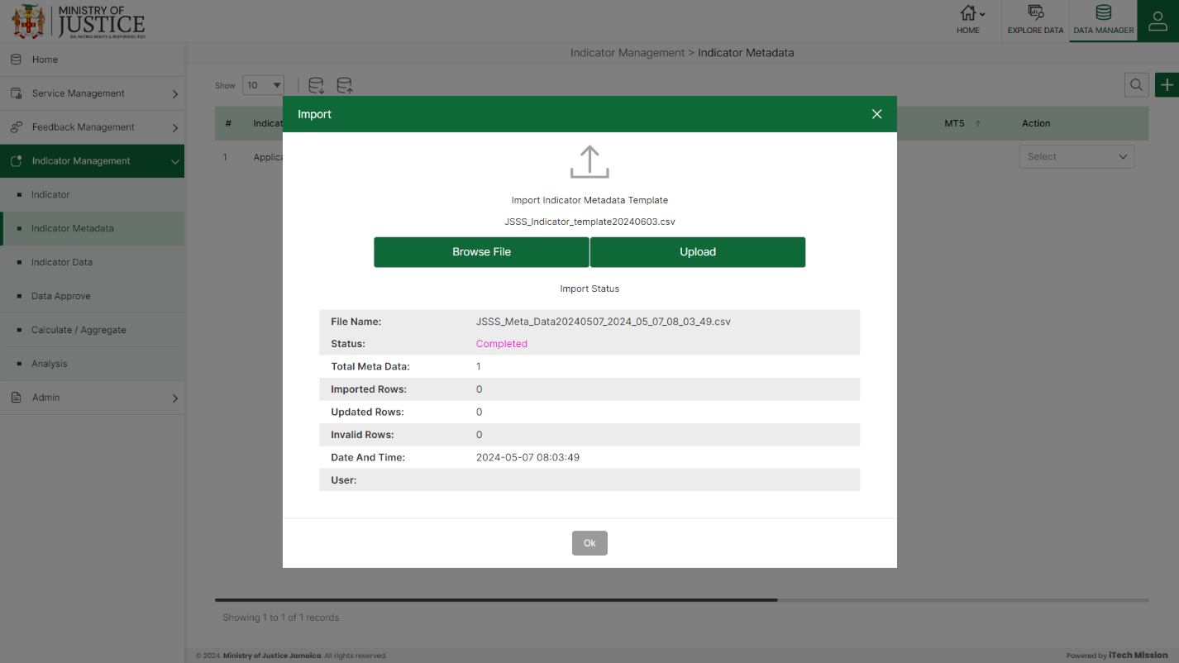Click on the **Import** button to browse the file and upload the indicator metadata master list into the database (see below figure).

To upload the indicator metadata into the database first enter the metadata structure in the template as explained above and then click on the **Browse File** button to select the template. Now, click on the **Upload** button to start the import process. During the import process, the records that contain blank entries, entries with special characters, and duplicate entries are not imported into the database.

A Last Upload summary will appear after the import process which provides the count of successfully imported records out of the total records. An error log will be generated to report on unsuccessfully imported records which you can access from the **Logs** module.

### **6.2.3 ADD**

****Click on the **Plus** button available at the top right corner and enter the following information to add a new indicator metadata.

* Select **Indicator | Unit**
* Enter **Indicator Definition**
* Enter **MT1** (Method of computation)
* Enter **MT2** (Overview of the indicator)
* Enter **MT3** (Comments and Limitations)
* Enter **MT4** (Data source of the availability of data)
* Enter **MT5** (Data collection for data monitoring)
* Enter **MT6** (Treatment method of missing values)
* 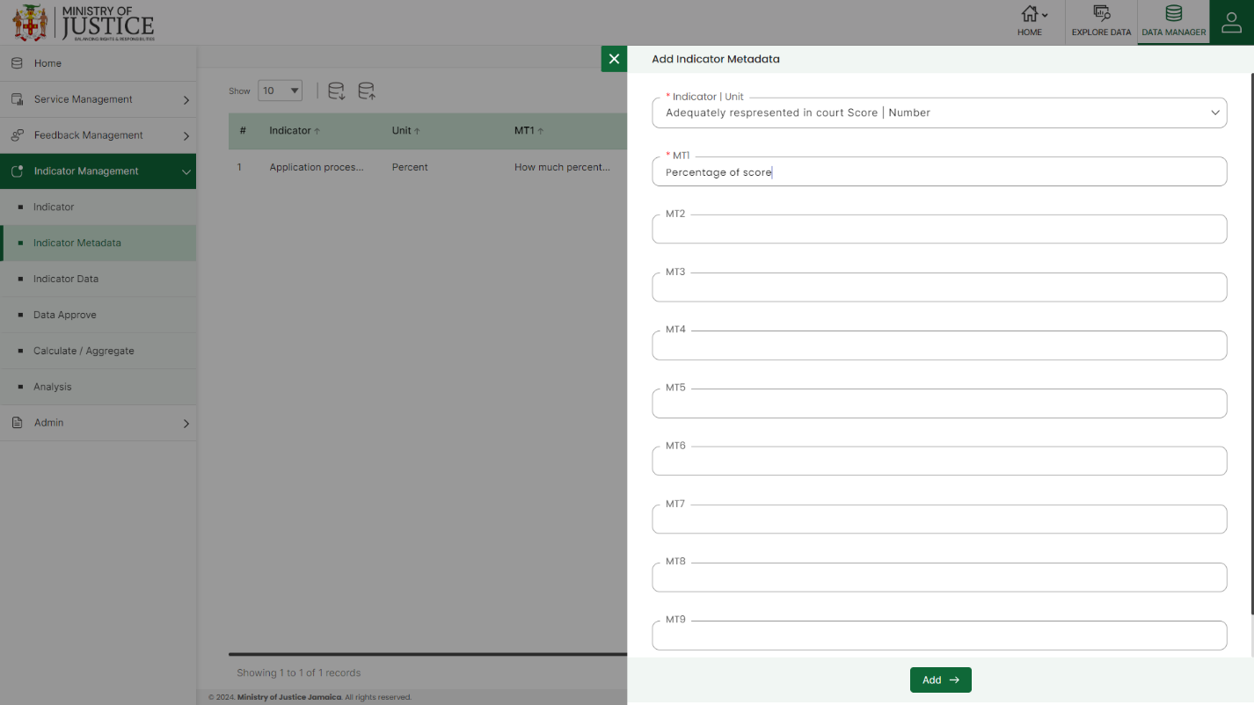Enter **MT7** (Regional and global estimate of selected Indicator)

Starred details are mandatory to be entered. Click on the **Add** button to save and confirm. You can now view the indicator metadata added to the Indicators Metadata list.

Select the **Edit** option available in the dropdown under the Action column to edit the details of the indicator metadata. Edit the required detail and click on the update button to save and confirm.

Select the **Enable/Disable** option available in the action dropdown to show or hide the specific indicator metadata. The hidden element will not be shown in the overall application.

Select the **Delete** option available in the dropdown under the Action column to delete the selected element. A confirmation popup will appear, click yes to confirm the deletion.

## **6.3 INDICATOR DATA**

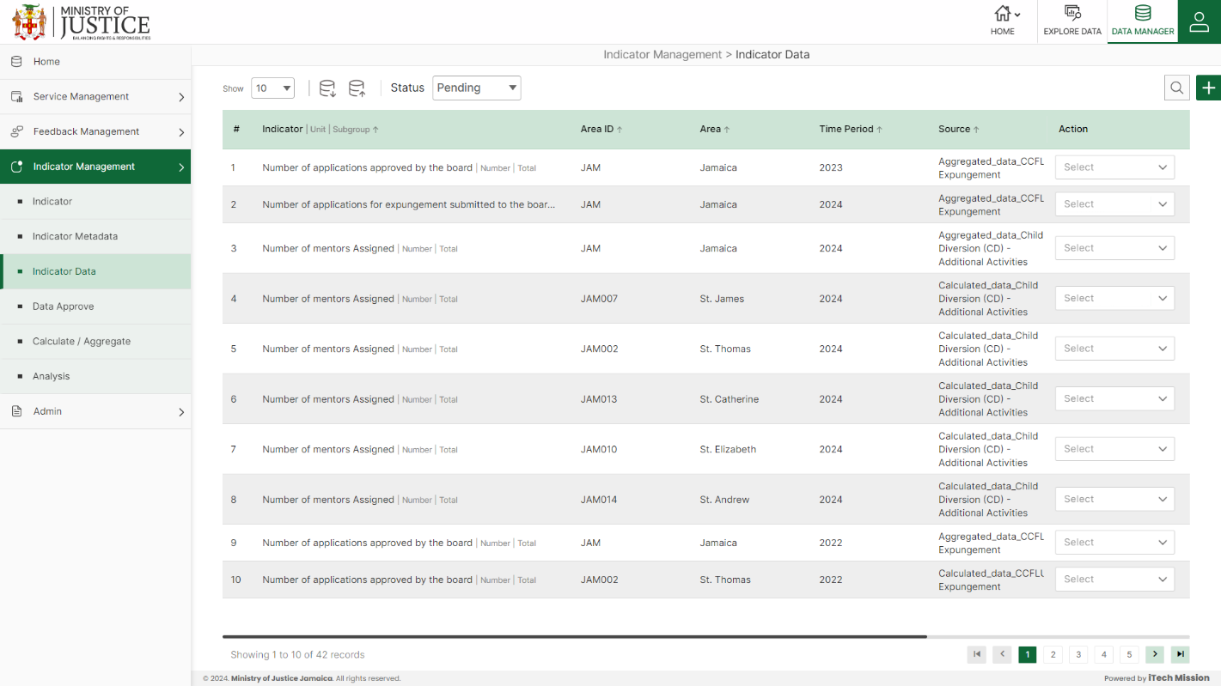Click on **Indicator Data** from the indicator management menuoption available in the left panel to access this module. This module allows to management of the master data. You will have options to export and import data templates, view the list of existing data, and update and delete the existing data (see figure below).

### **6.3.1 EXPORT**

****Click on the **Export button** to download the empty data entry template and the data master list (see below figure).

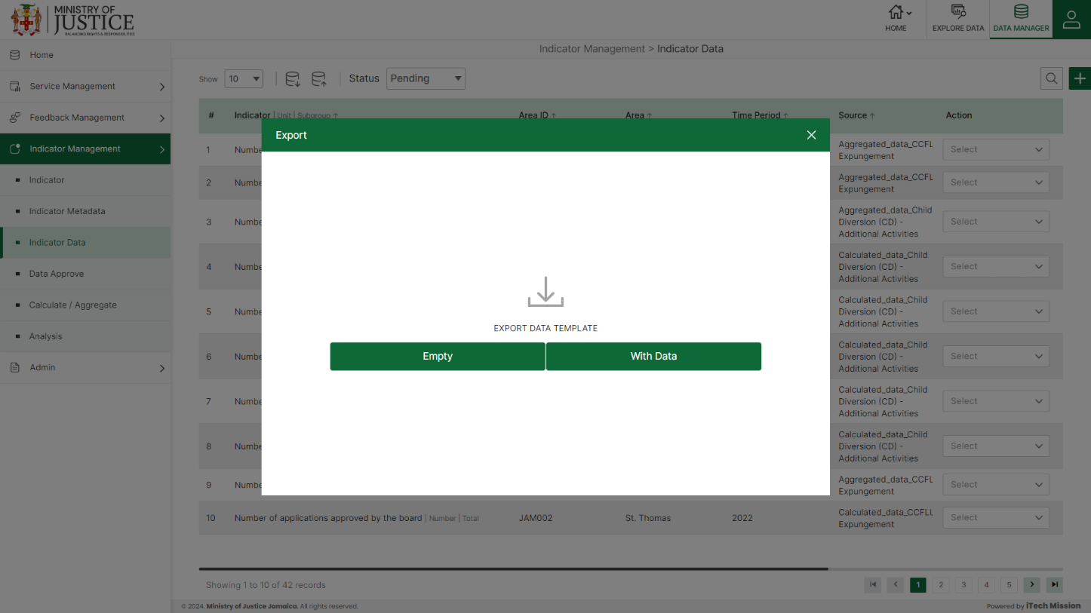You can use this option to create a data template structure. Below is the structure that you will find in the data empty template.

|  |  |
| --- | --- |
| **AreaID** | Area ID of the data |
| **AreaName** | Area Name of the data |
| **Time period** | Data for the selected time period |
| **Source** | Source of the data |
| **Indicator** | Indicator of the data |
| **Unit** | Measurement unit of the indicator selected |
| **Subgroup** | A subgroup of the data |
| **Data Value** | The value assigned to the data |
| **Footnote** | Footnote for the data |

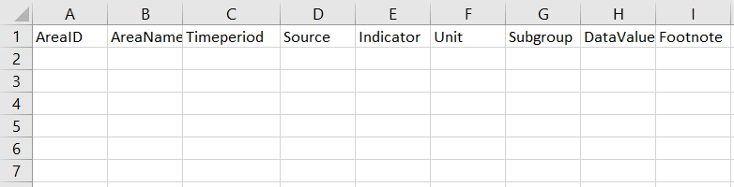Click on the **Empty** option to download an empty data template (see below figure). The indicator data is imported and exported in the CSV (Comma Separated Value) file format.

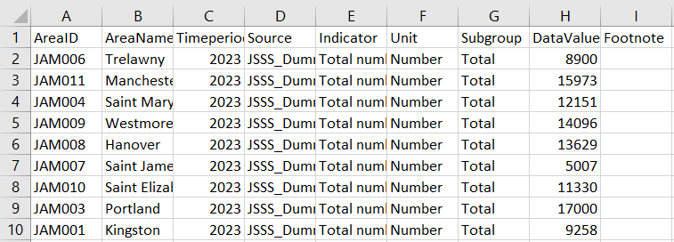Click on the **With Data** option to download the data master list.

### **6.3.2 IMPORT**

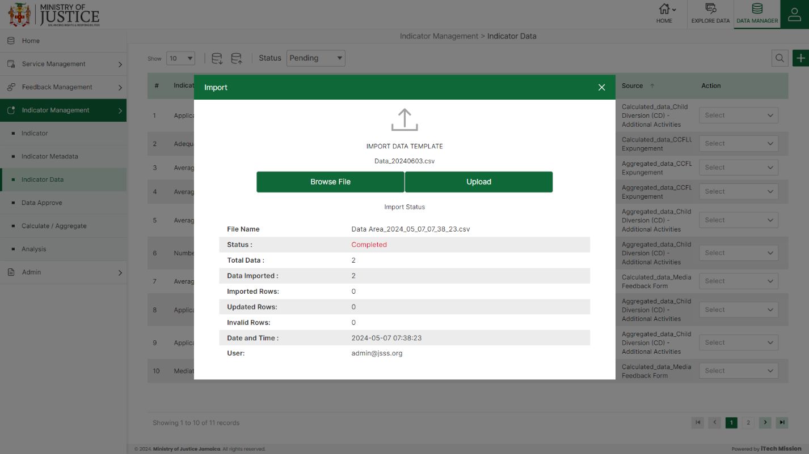Click on the **Import** button to browse the file and upload the data master list into the database (see below figure).

To upload the data into the database first enter the data structure in the template as explained above and then click on the **Browse File** button to select the template. Now, click on the **Upload** button to start the import process. During the import process, the records that contain blank entries, entries with special characters, and duplicate entries are not imported into the database.

A Last Upload summary will appear after the import process which provides the count of successfully imported records out of the total records. An error log will be generated to report on unsuccessfully imported records which you can access from the **Logs** module.

### **6.3.3 ADD**

****Click on the **Plus** button available at the top right corner and enter the following information to add a new data record.

* Select **Indicator I Unit**
* Select **Subgroup**
* Select **Area**
* Enter the **Time period**
* Enter **Sourc**e
* Enter **Data Value**
* 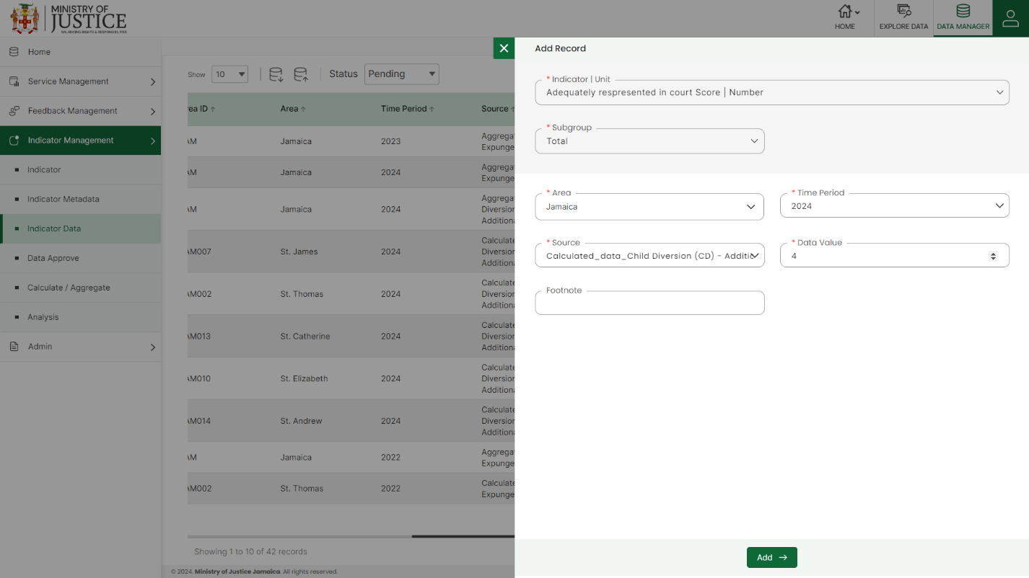Enter **Footnote**

Starred details are mandatory to be entered.

Click on the **Add** button to save and confirm. You can now view the new data record added to the pending list.

Select the **Edit** option available in the action dropdown to edit the details of the selected data record. Edit the required detail and click on the update button to save and confirm.

Select the **Delete** option available in the action dropdown to delete the selected data record. A confirmation popup will appear, click yes to confirm the deletion of the selected data record.

**NOTE:**

The options to edit and delete are only available for the data records which is in Pending state. You can also view the reason for disapproval of the data records by clicking on the **Eye** button available under the remark’s column of each disapproved data.

## **6.4 DATA APPROVE**

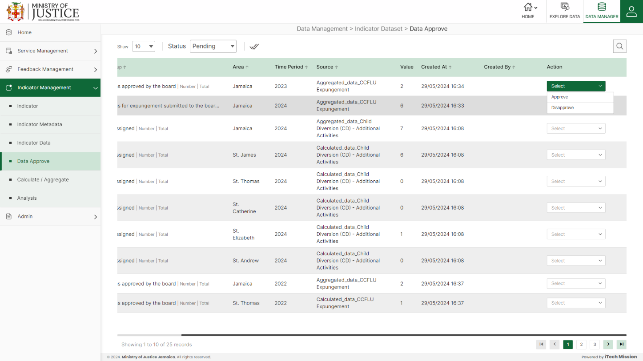Click on the **Data Approve** option from the indicator management menu option in the left panel to access this module. This module allows management approval of the added/updated data records. You will have the option to approve the pending data that has been added or updated using the Indicator Data module

To approve a pending record, click on the **Approve** option available for each pending data record in the action column. The data record will be moved to the approved list and it can now be viewed on the user interface application.

To disapprove a pending record, click on the **Disapprove** option (Cross button) available for each pending data record in the action column. You will be asked to confirm the disapproval and you can also add remarks for disapproval. To approve all data records at once, click on the **Approve All Data** option (Tick Mark button) available at the top left corner of the page.

## **6.5 CALCULATE/AGGREGATE**

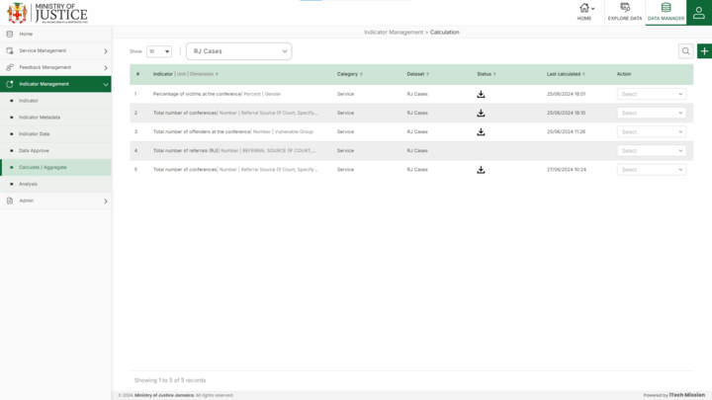Click on **Calculate/Aggregate** from the indicator management menuoption available in the left panel to access this module. This module allows to manage the calculations of the data. You will have options to view the list of existing calculations and execute the existing calculations according to the service or feedback selected from the dropdown. (see figure below).

****Click on the **Plus** button available on the right side of the page to generate a new aggregation.

The first section is **Select**

* Enter **Indicator**
* Enter **Unit**
* Select **Dimension**
* Select **Subgroup**
* Select **Category**
* Select **Service**
* Select the **Column Names** that you want in the calculation

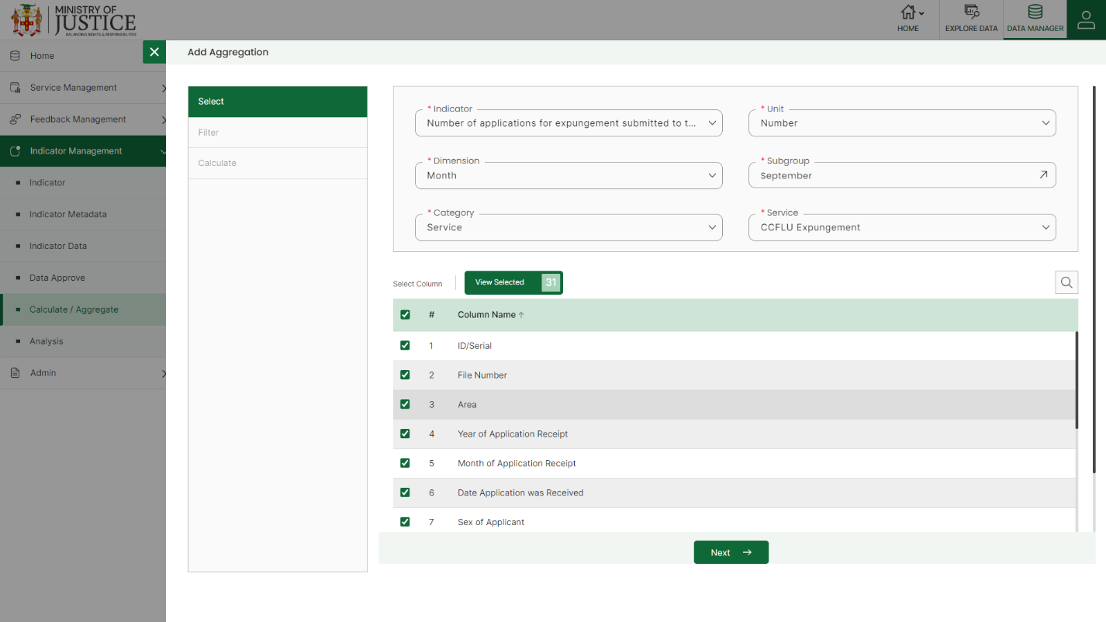Starred details are mandatory to be entered.

Click on the **Next** button to save and move to the next section.

**NOTE:**

You can delete the filter after adding it by clicking on Delete option under action dropdown of the filter and by clicking on the Delete icon all the added filters will be deleted.

The second section is **Filter** (if you want to apply a filter and get filtered data)

* Enter **Filter Name**
* Select **Column**
* Select **Operator**
* Enter **Value**

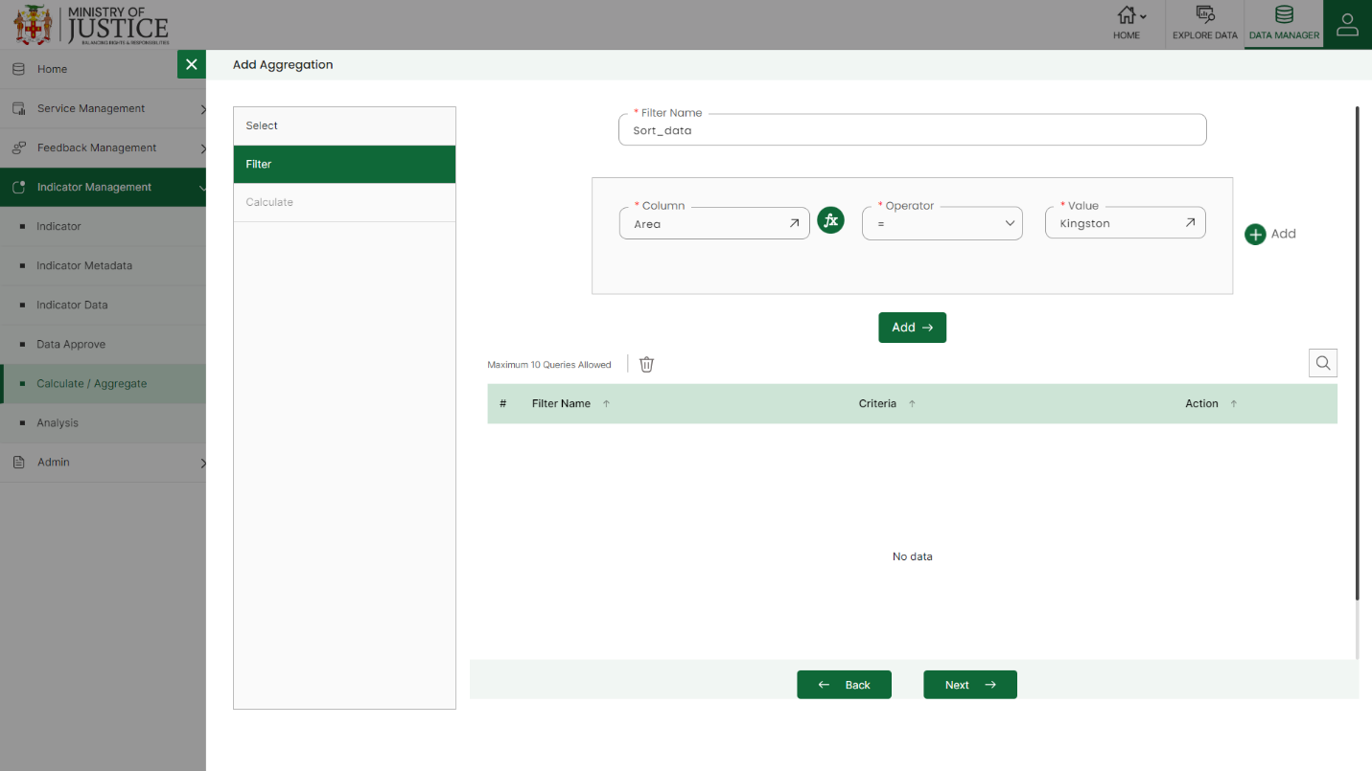Starred details are mandatory to be entered.Click on the **Add** button to save and then click on **Next** to move to the next section.

The third section is **Calculate**

* Enter **Calculation Name**
* Select **Columns** from the left side and Enter **Formula**
* Enter **Decimal Place**
* **Validate** the formula
* Select **Filter**
* Select **Group By**

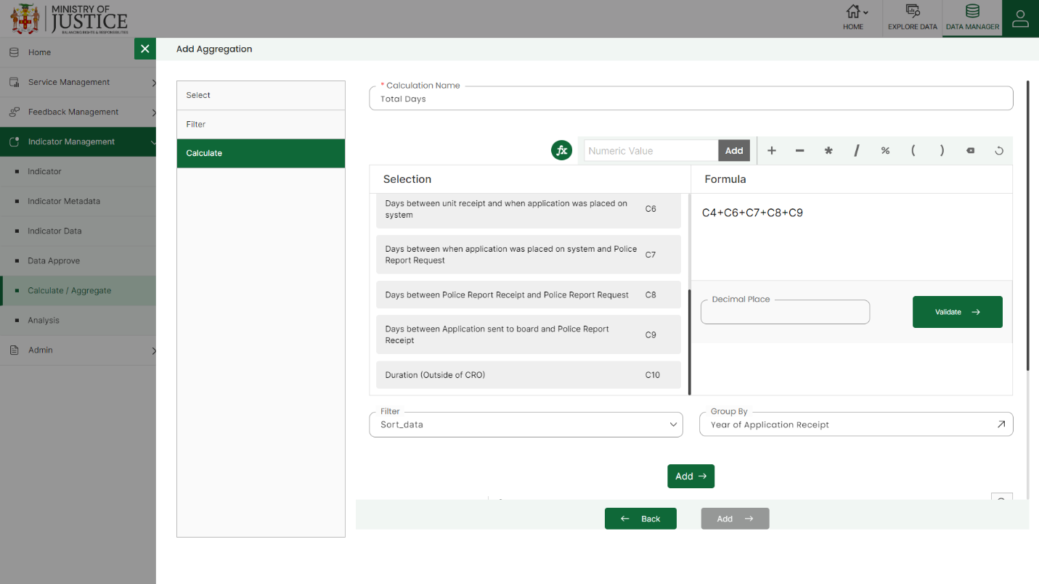 Starred details are mandatory to be entered.

Click on the **Add** button to add the Calculation and again Click on the **Add** button to save the aggregation.

Click to select **the Edit** option available in the action dropdown to edit the details of the selected element. Edit the required detail and click on the update button to save and confirm.

Click to select **the Delete** option available in the action dropdown to delete the selected element. A confirmation popup will appear, click yes to confirm the deletion of the selected element.

Click to select the **Execute** option available in the action dropdown to execute the calculations for a particular time range and then **Download** it using the download icon under the **Status** column.

**NOTE:**

You can delete the calculation after adding it by clicking on Delete option under action dropdown of the calculation and by clicking on the Delete icon all the added calculations will be deleted.

## **6.6 ANALYSIS**

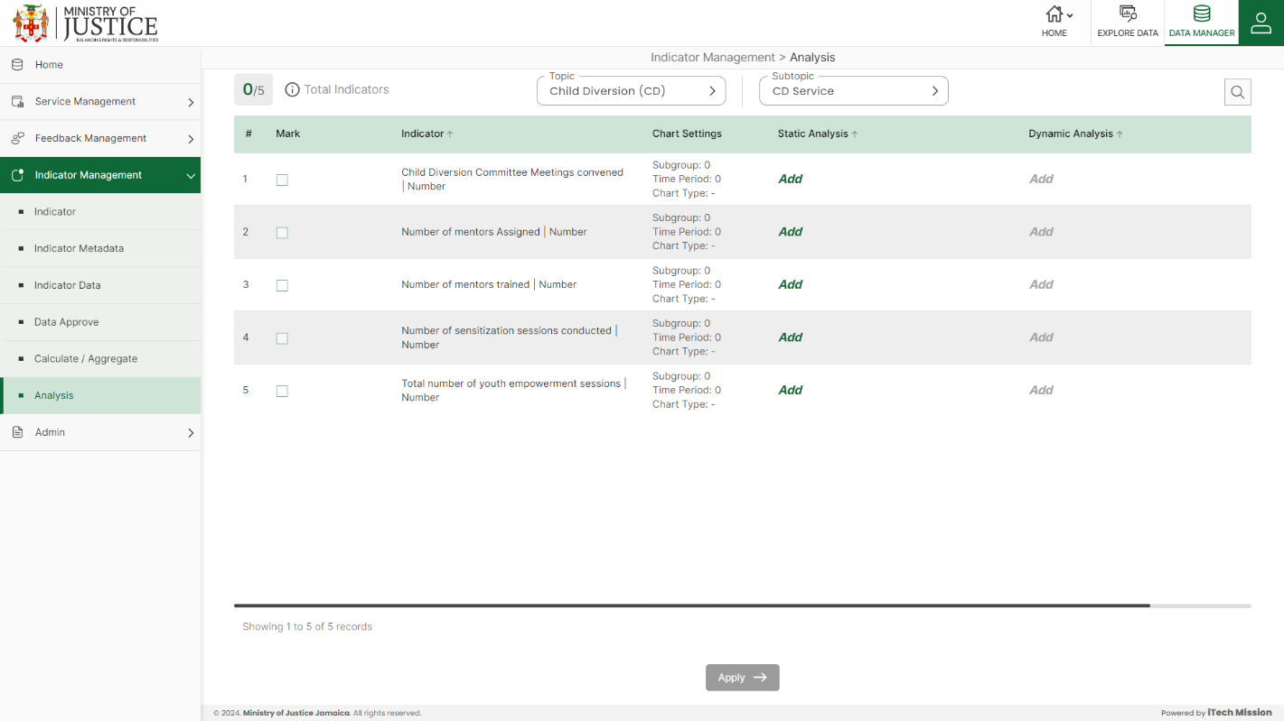Click on **Analysis** from the indicator management menuoption available in the left panel to access this module. This module allows customization of the representation of the Explore Data module in the user interface application. You will have the options to select a topic & subtopic, assign indicator(s) to be displayed for the selected topic & subtopic, and add static and dynamic analysis of the indicators. (see figure below).

Select the **Indicator**. Click on the **Add** option available in the Static Analysis column to add static analysis of the selected indicator. Enter the following details for the same.

* Enter Analysis **Heading**
* Enter Analysis **Description**
* Upload **Infographics**
* Select **Subgroup(s)**
* Select **Time period(s)**
* Select **Chart Type**

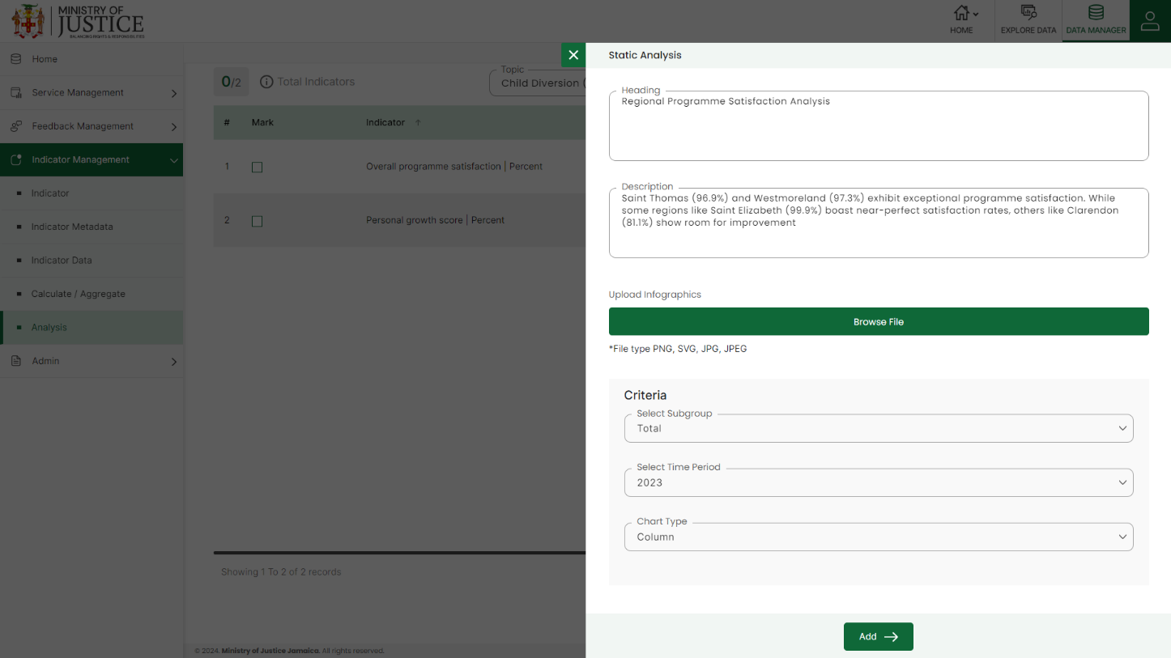Click on the **Add** button to save and confirm. You can now view the static analysis added for the selected indicator in the data by topic module of the user interface application.

Click on the **Add** text available in the Dynamic Analysis column to add dynamic analysis of the selected indicator. Dynamic Analysis will display the change in selected indicator data over time period or for different disaggregation. Therefore, the dynamic analysis statement will have static content as well as arithmetic expression to show dynamic values. Select an element as Text to enter static information of the analysis and select an element as a Variable to enter arithmetic expressions and dynamic variables.

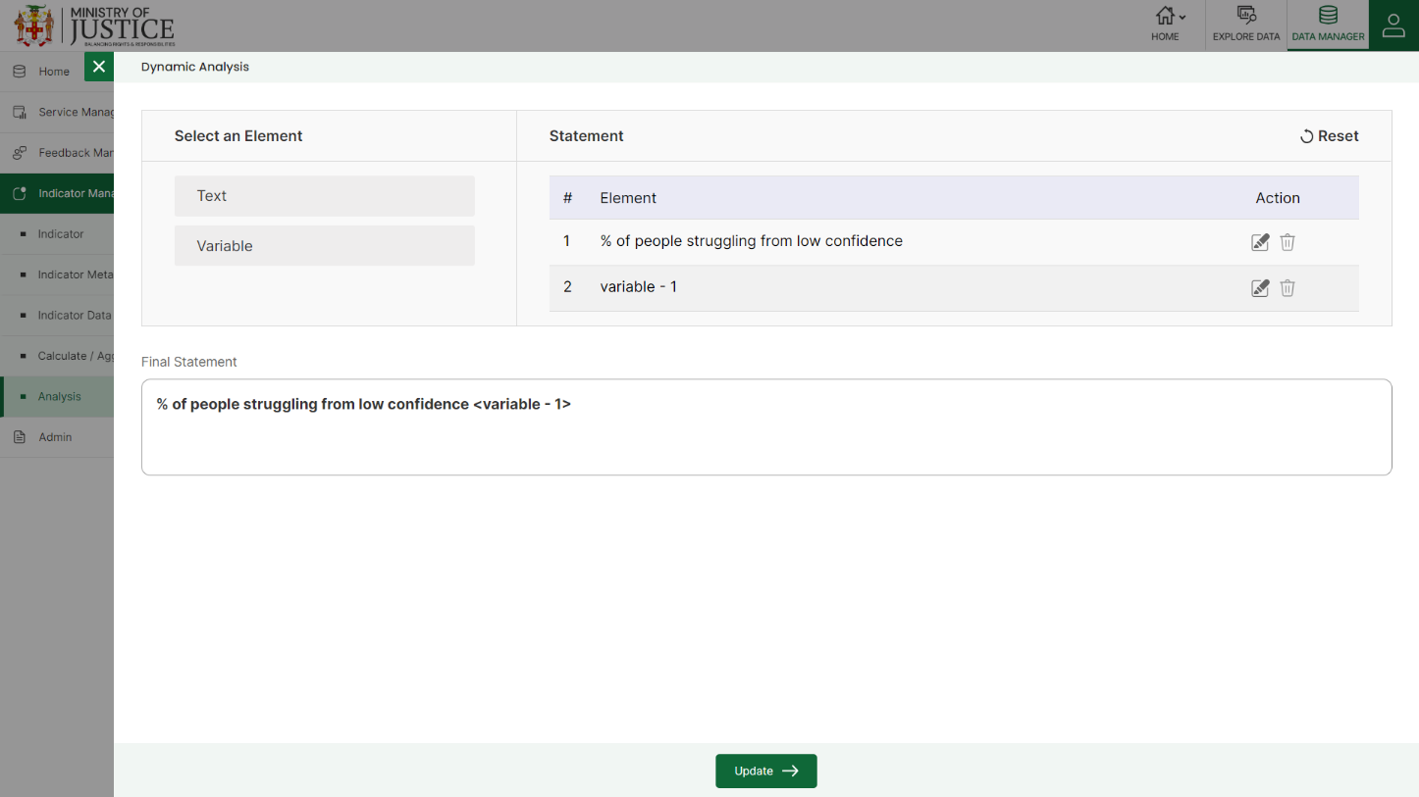Select the Time period option to show dynamic analysis by time period and select Disaggregation to show dynamic analysis by disaggregation. Use arithmetic operators to create an arithmetic expression in the Calculation text area and then Validate the formula. Click **Ok** after validation to save & confirm.

Click on the **Edit** option available for static and dynamic analysis to view and update the selected analysis statement.

# 7.0 ADMIN

Click the **Admin** menu option from the left panel to access this module. This module has ten submodules – Area, Framework, Topic and Subtopic, Import Logs, Audit Trail, Classification Management, Access Control, Resources, Report and Customize.

Let us understand these submodules in detail.

## **7.1 AREA**

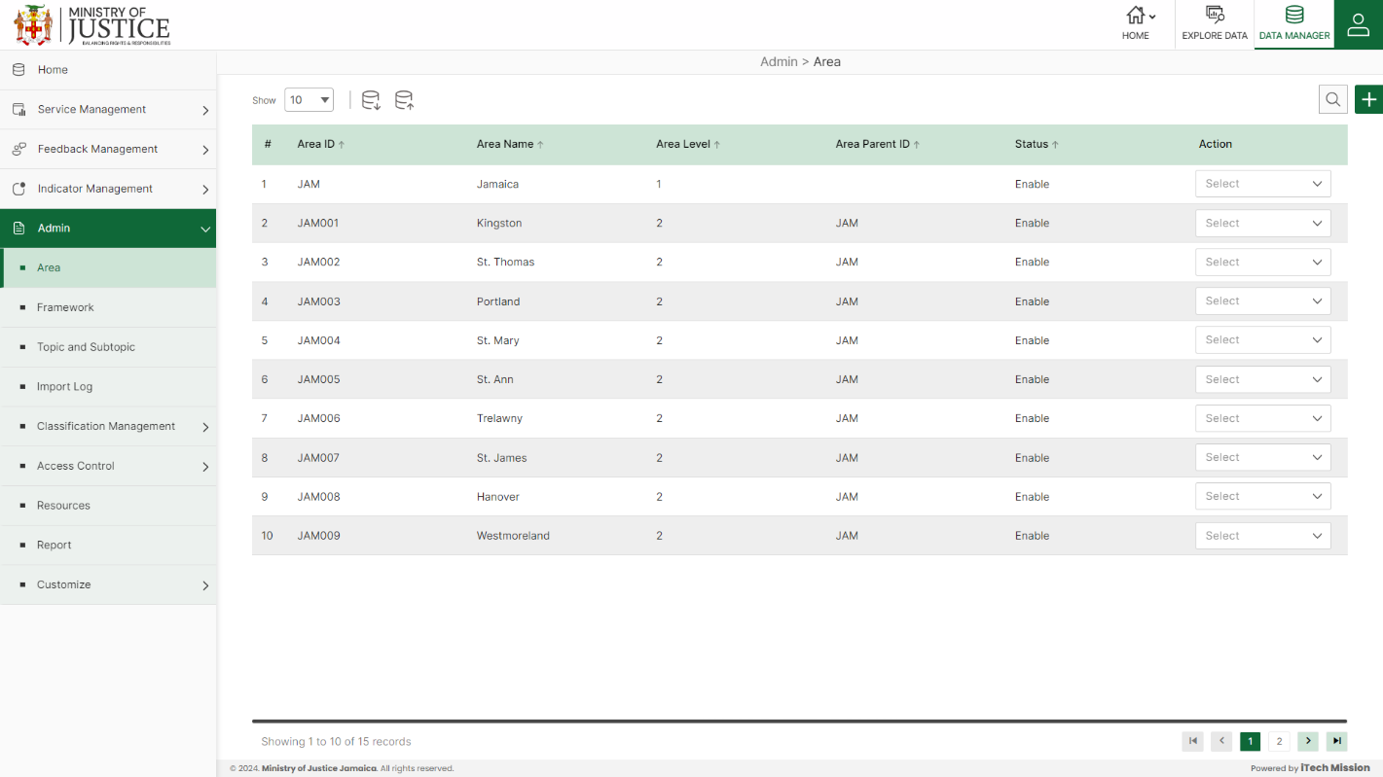Click on **Area** from the admin menu option available in the left panel to access this module. This module allows the management area master list. You will have options to export the area template and data, import data, add a new area, view the list of existing areas, sort the list, search area from the list, edit, delete, and enable/disable existing areas (see figure).

### **7.1.1 EXPORT**

****Click on the **Export** button to download the empty area template and the area master list (see below figure).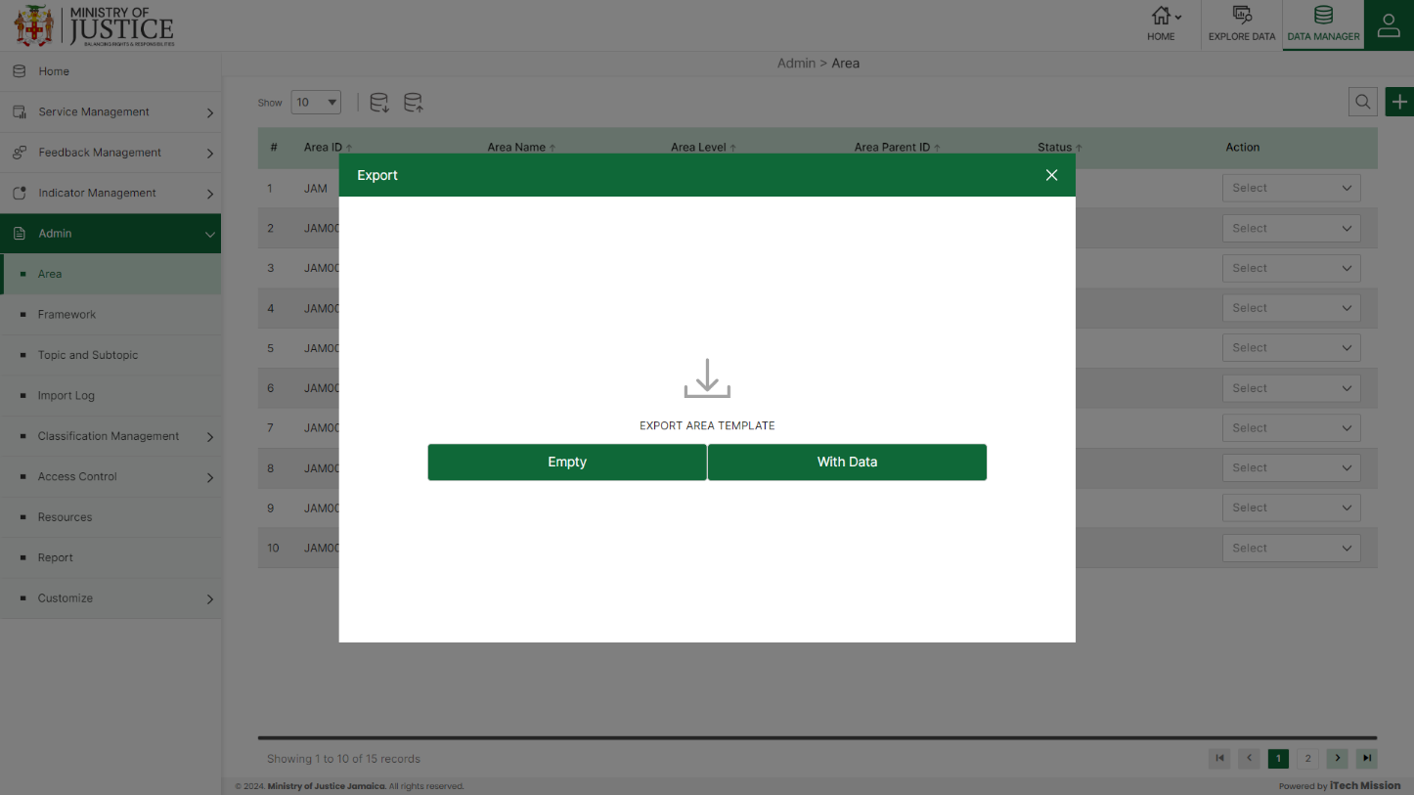

You can use this option to create an area template structure. Below is the structure that you will find in the area empty template.

|  |  |
| --- | --- |
| **Area ID** | A unique area identification that associates the area with its map |
| **Area Name** | Area Name assigned to an area. |
| **Area Level** | The level number is assigned in the area hierarchy. |
| **Area ParentID** | AreaID of the parent area. |
| **Area Group** | Group of the area. |

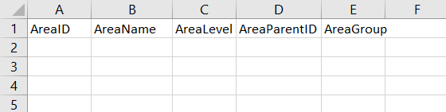Click on the **Empty** option to download an empty area template (see below figure). The area list is imported and exported in the CSV (Comma Separated Value) file format.

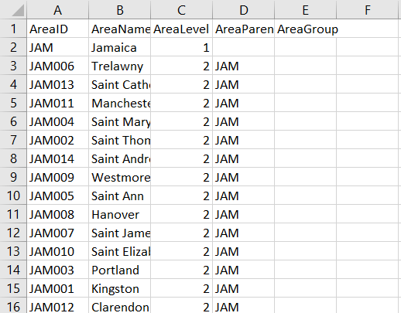Click on the **With Data** option to download the area master list (see below figure).

### **7.1.2 IMPORT**

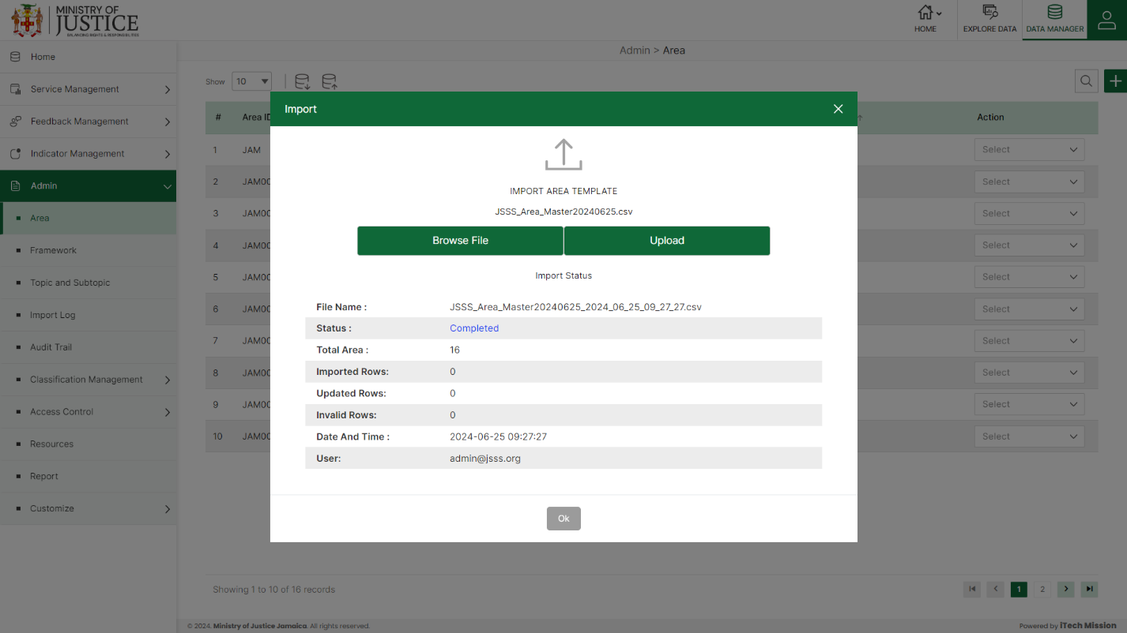Click on the **Import** button to browse the file and upload the area master list into the database (see the below figure).

To upload the area into the database first enter the area structure in the template as explained above and then click on the **Browse File** button to select the template. Now, click on the **Upload** button to start the import process. During the import process, the records that contain blank entries, entries with special characters, and duplicate entries are not imported into the database.

A Last Upload summary will appear after the import process which provides the count of successfully imported records out of the total records. An error log will be generated to report on unsuccessfully imported records which you can access from the **Logs** module.

### **7.1.3 ADD**

****Click on the **Plus** button available at the top right corner and enter the following information to add a new area.

* Select **Parent Area**
* Enter **Area ID**
* 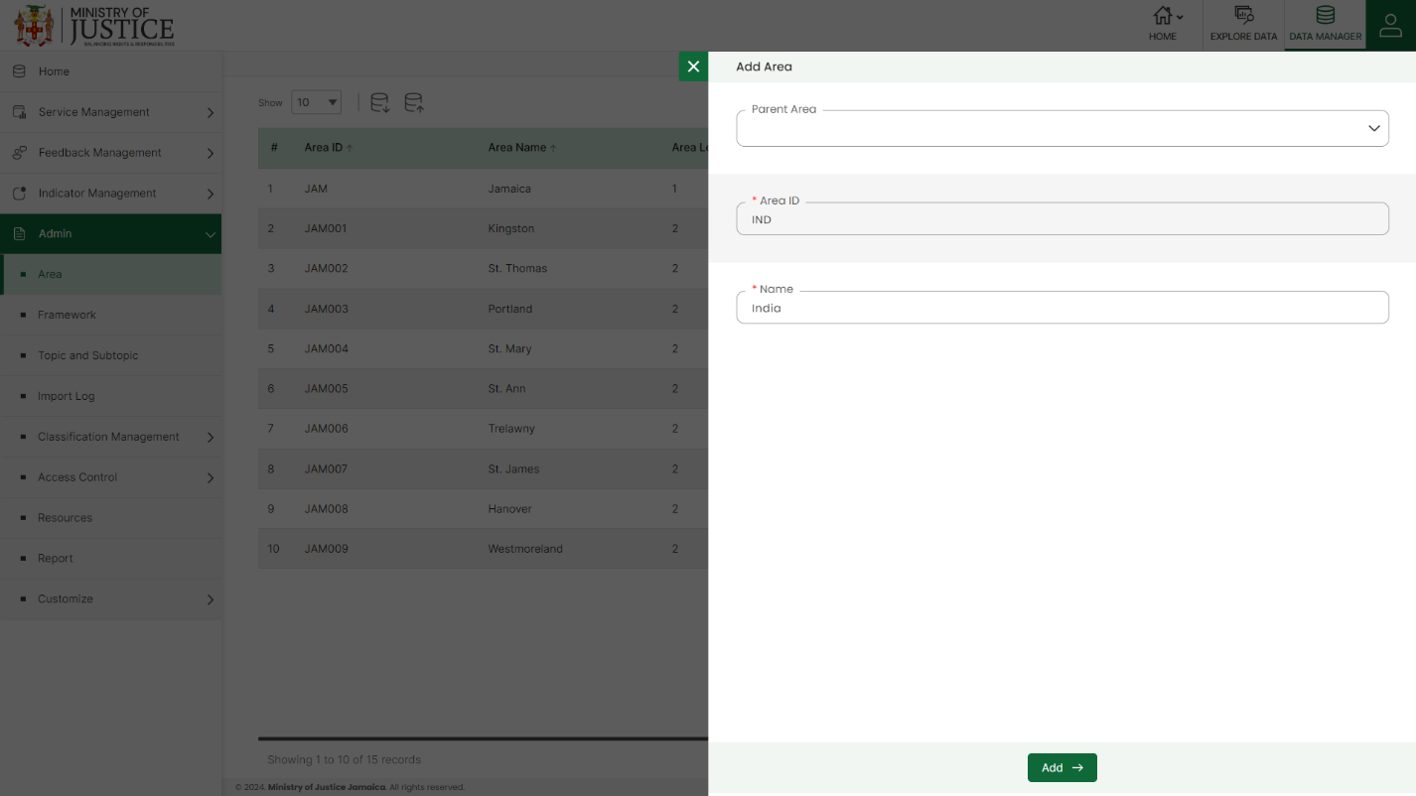Enter area **Name**

Green color details are mandatory to be entered. Click on the **Add** button to save and confirm. You can now view the new area added to the area list.

Select the **Edit** option available in the action dropdown to edit the details of the selected area. Edit the required detail and click on the update button to save and confirm.

Selectthe **Enable/Disable** option available in the action dropdown to show or hide the specific area. The hidden area will not be shown in the overall application.

Selectthe **Delete** option available in the dropdown under the Action column to delete the selected element. A confirmation popup will appear, click yes to confirm the deletion.

## **7.2 FRAMEWORK**

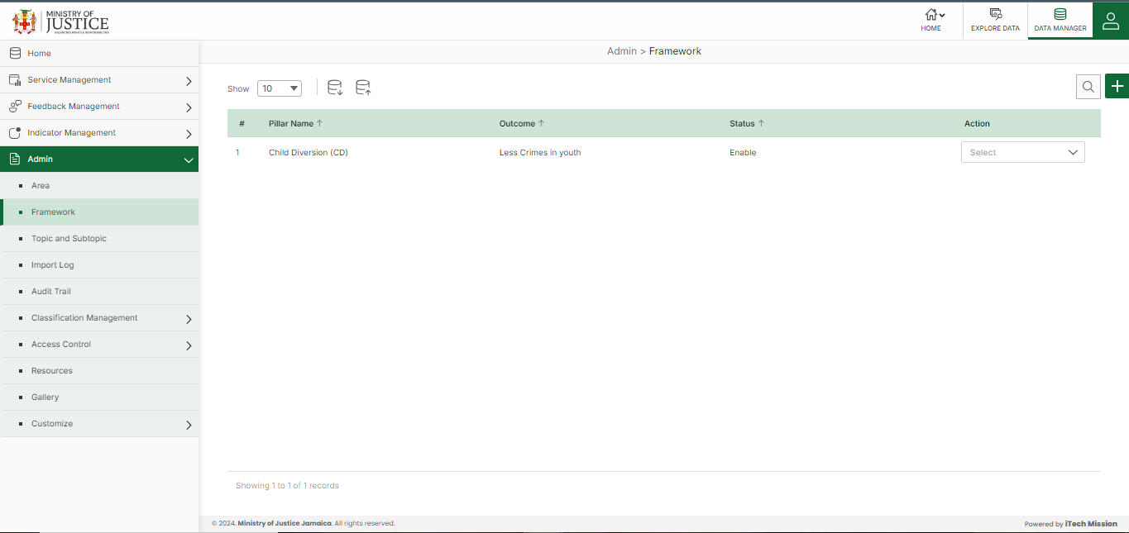Click on **Framework** from the admin menu option available in the left panel to access this module. This module allows to management framework master list. You will have options to export and import a framework template, add a new framework, view the list of existing frameworks, sort the list, search frameworks from the list, edit, delete, and enable/disable existing frameworks (see below figure).

### **7.2.1 EXPORT**

****Click on the **Export** button to download the empty framework template and the framework master list (see below figure).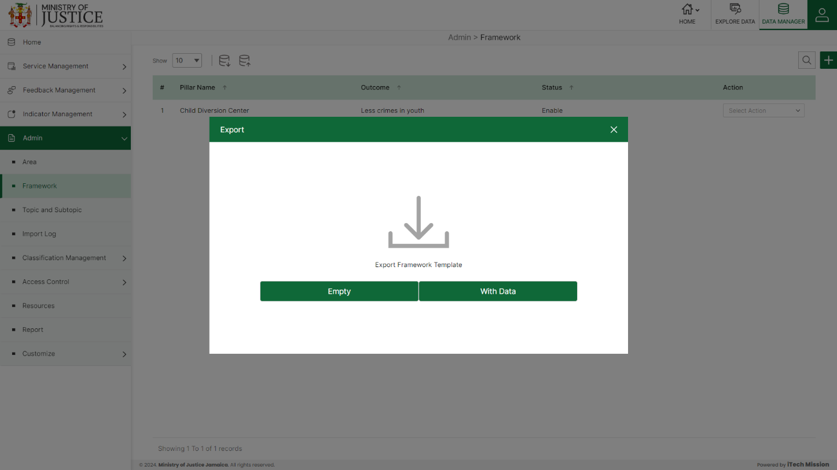

You can use this option to create a framework template structure. Below is the structure that you will find in the framework empty template.

|  |  |
| --- | --- |
| **Pillar** | Pillar of the framework |
| **Outcome** | The outcome of the framework |
| **Description** | Description of the framework |

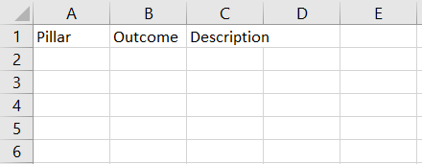Click on the **Empty** option to download an empty framework template (see below figure). The framework list is imported and exported in the CSV (Comma Separated Value) file format.

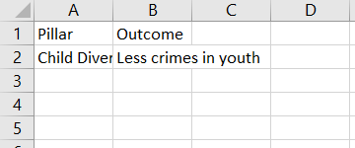Click on the **With Data** option to download the framework master list (see below figure).

### **7.2.2 IMPORT**

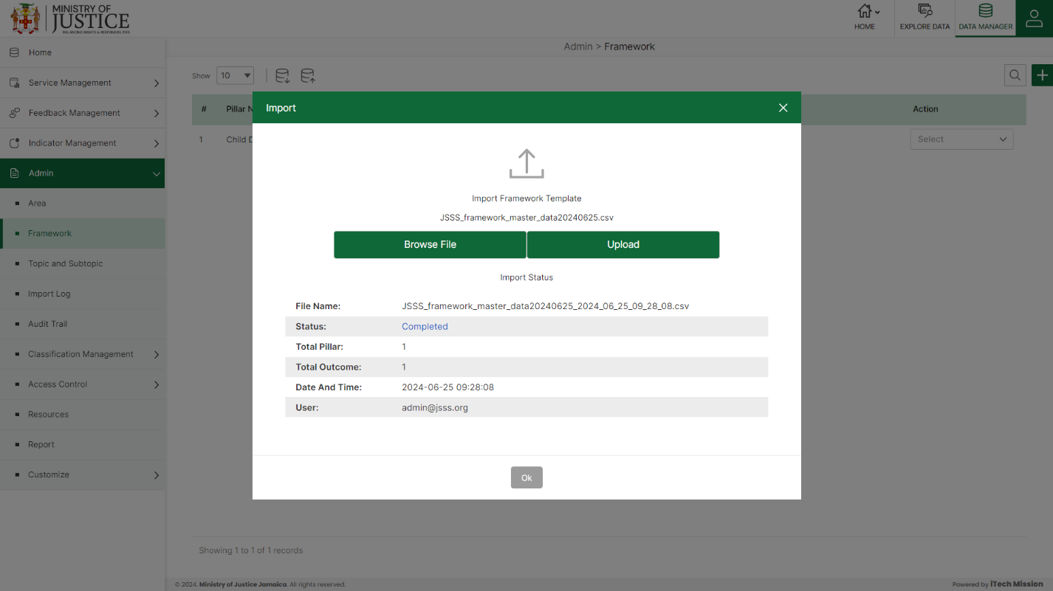Click on the **Import** button to browse the file and upload the framework master list into the database (see below figure).

To upload the framework into the database first enter the structure in the template as explained above and then click on the **Browse File** button to select the template. Now, click on the **Upload** button to start the import process. During the import process, the records that contain blank entries, entries with special characters, and duplicate entries are not imported into the database.

A Last Upload summary will appear after the import process which provides the count of successfully imported records out of the total records. An error log will be generated to report on unsuccessfully imported records which you can access from the **Logs** module.

### **7.2.3 ADD**

****Click on the **Plus** button available at the top right corner and enter the following information to add a new framework.

* Enter **Pillar Name**
* 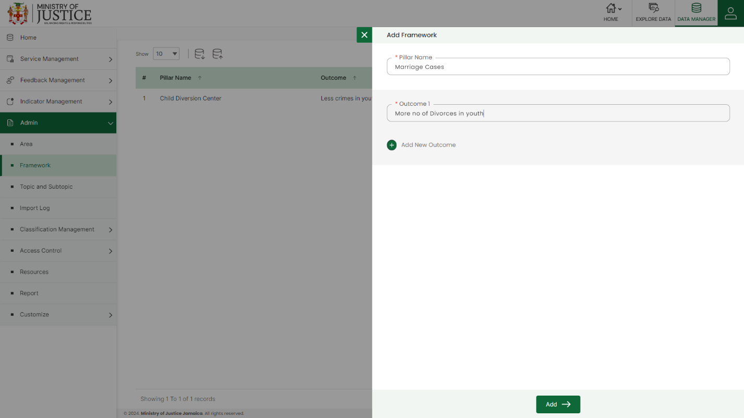Enter **Outcome 1** *(If you want to enter more than 1 outcome, click on Add New Outcome***)**

Starred details are mandatory to be entered. Click on the **Add** button to save and confirm. You can now view the new framework added to the framework list.

Selectthe **Edit** option available in the action dropdown to edit the details of the selected framework. Edit the required detail and click on the update button to save and confirm.

Selectthe **Enable/Disable** option available in the action dropdown to show or hide the specific element. The hidden framework will not be shown in the overall application.

Select the **Delete** option available in the dropdown under the Action column to delete the selected element. A confirmation popup will appear, click yes to confirm the deletion.

## **7.3 TOPIC AND SUBTOPIC**

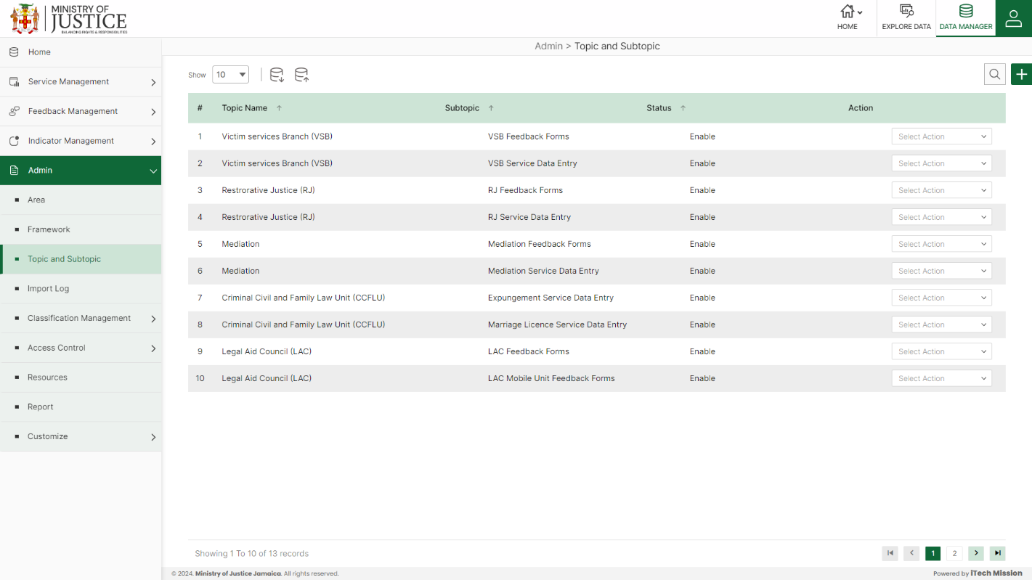Click on **Topic and Subtopic** from the admin menu option available in the left panel to access this module. This module allows one to manage a topic and its subtopic master list. You will have options to export and import a topic template, add a new topic, view the list of existing topics, sort the list, search topics from the list, edit, delete, and enable/disable existing topics (see below figure).

### **7.3.1 EXPORT**

****Click on the **Export** button to download the empty topic template and the topic master list (see below figure).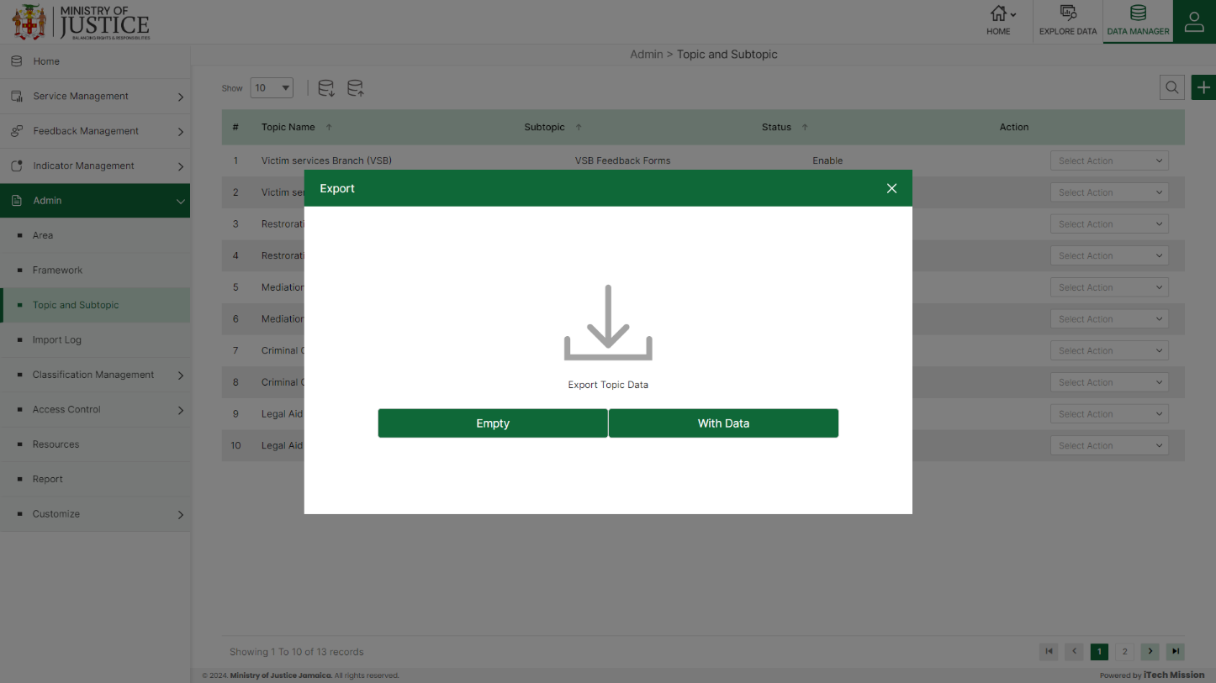

You can use this option to create a topic template structure. Below is the structure that you will find in the topic empty template.

|  |  |
| --- | --- |
| **Topic** | Name of the subtopic |
| **Subtopic** | Name of the subtopic(s) associated with the topic |

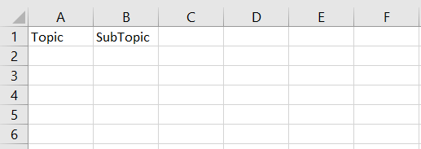Click on the **Empty** option to download an empty topic template (see below figure). The topic and its subtopic list are imported and exported in the CSV (Comma Separated Value) file format.

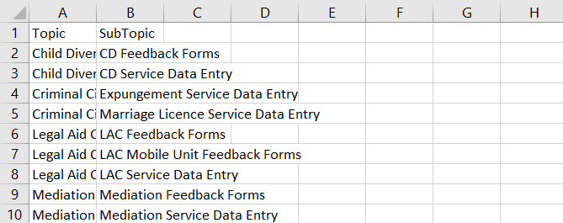Click on the **With Data** option to download the topic master list (see below figure).

### **7.3.2 IMPORT**

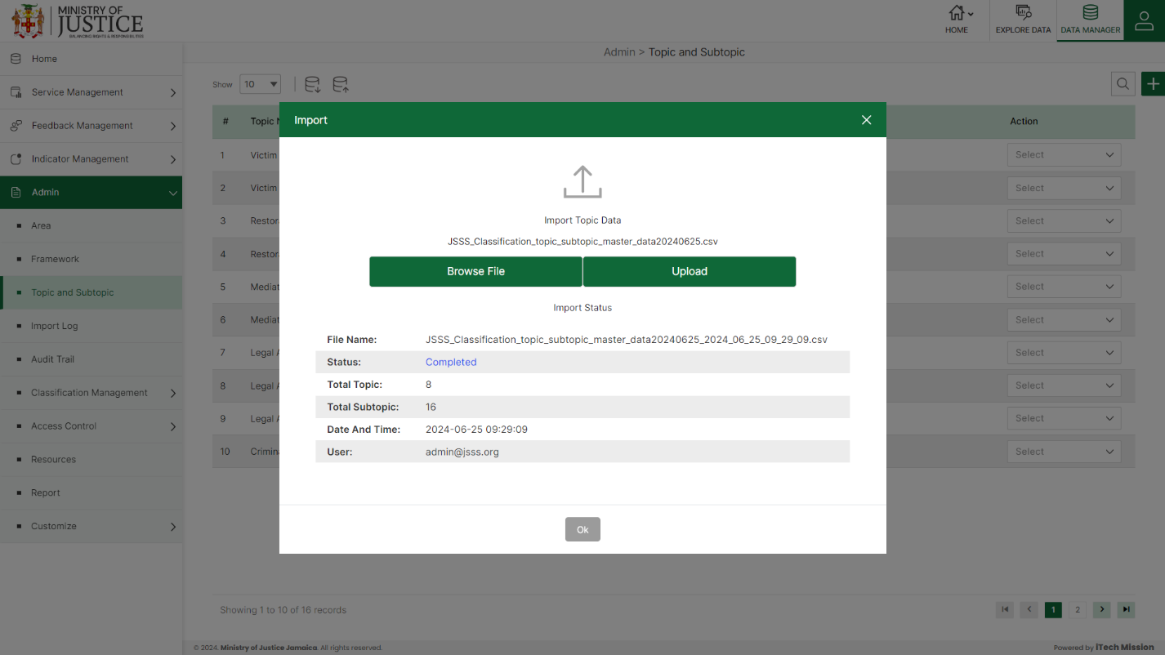Click on the **Import** button to browse the file and upload the topic master list into the database (see below figure).

To upload the topic into the database first enter the structure in the template as explained above and then click on the **Browse File** button to select the template. Now, click on the **Upload** button to start the import process. During the import process, the records that contain blank entries, entries with special characters, and duplicate entries are not imported into the database.

A Last Upload summary will appear after the import process which provides the count of successfully imported records out of the total records. An error log will be generated to report on unsuccessfully imported records which you can access from the **Logs** module.

### **7.3.3 ADD**

****Click on the **Plus** button available at the top right corner and enter the following information to add a new topic.

* Enter **Topic**
* 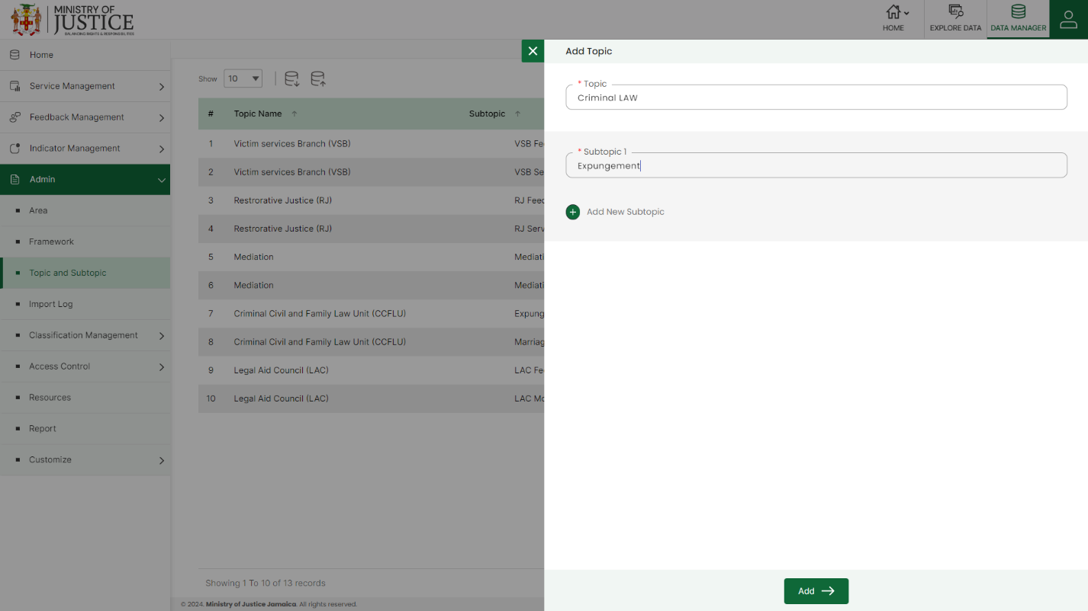Enter **Subtopic** *(If you want to enter more than 1 subtopic, click on Add New Subtopic***)**

Starred details are mandatory to be entered. Click on the **Add** button to save and confirm. You can now view the new topic added to the list.

Select the **Edit** option available in the action dropdown to edit the details of the selected topic. Edit the required detail and click on the update button to save and confirm.

Select the **Enable/Disable** option available in the action dropdown to show or hide the specific element. The hidden topic will not be shown in the overall application.

Select the **Delete** option available in the dropdown under the Action column to delete the selected element. A confirmation popup will appear, click yes to confirm the deletion.

## **7.4 IMPORT LOG**

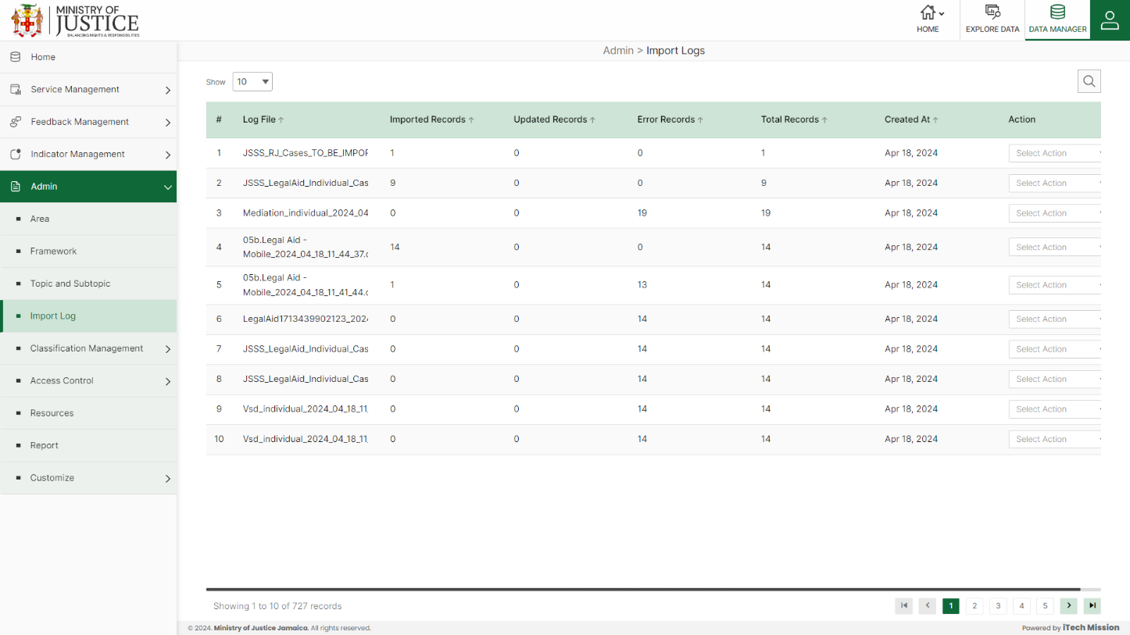Click the **Import** **Log** option in the left panel from the Data menu option to access this module. This module allows the management of the Import Log master list. You will have options to view the list of existing logs, download and view log reports, and delete selected logs (see below figure).

A log will be generated when any data template is imported into the database. A list of import logs is shown on this page where each import log is shown as a row. You can view the file name of each import log along with the log summary that includes: the count of records imported, count of records updated, count of error records, total records available in the import file, and date & time of the import. You also have the option to download the log file to view the reason for error records. The log file will be downloaded in CSV format.

Select **the Download** option available in the action dropdown to download the log file

Select **the Delete** option available in the dropdown under the Action column to delete the selected element. A confirmation popup will appear, click yes to confirm the deletion.

## **7.5 AUDIT TRAIL**

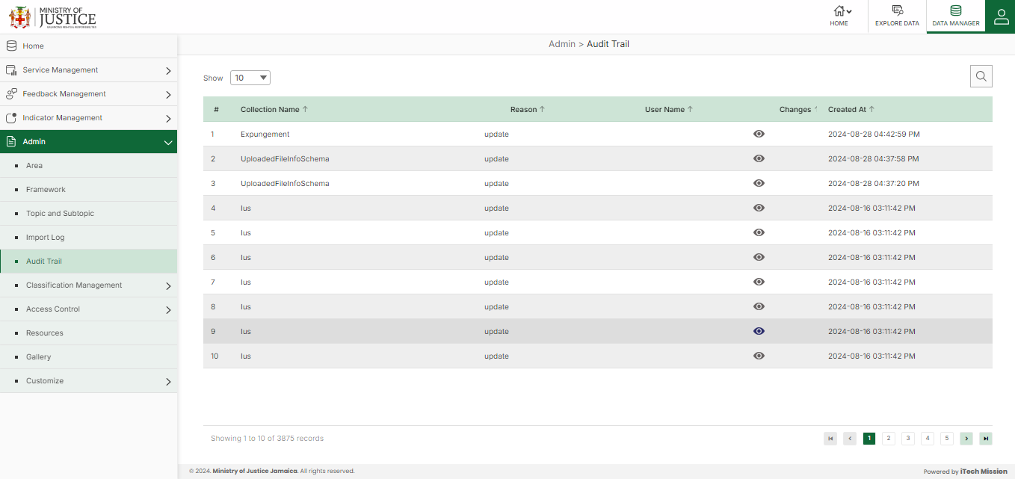Click the **Audit Trail** option in the left panel from the Data menu option to access this module. This module allows the management of a trail of actions performed by various users. You will have options to view the list of existing logs and search the user activity logs (see below figure).

A log will be generated when any action is performed by the user. A list of Audit Trails is shown on this page where each Action is shown as a row. You can view the Audit History of each user along with the log summary that includes the c\Collection name, Reason, User name, and Created At.

## **7.6 CLASSIFICATION MANAGEMENT**

Click on **Classification Management** from the admin menu option on the left panel to access this module. This module has two submodules – Classification Type, and Classification

Let us understand these submodules in detail.

### **7.6.1 CLASSIFICATION TYPE**

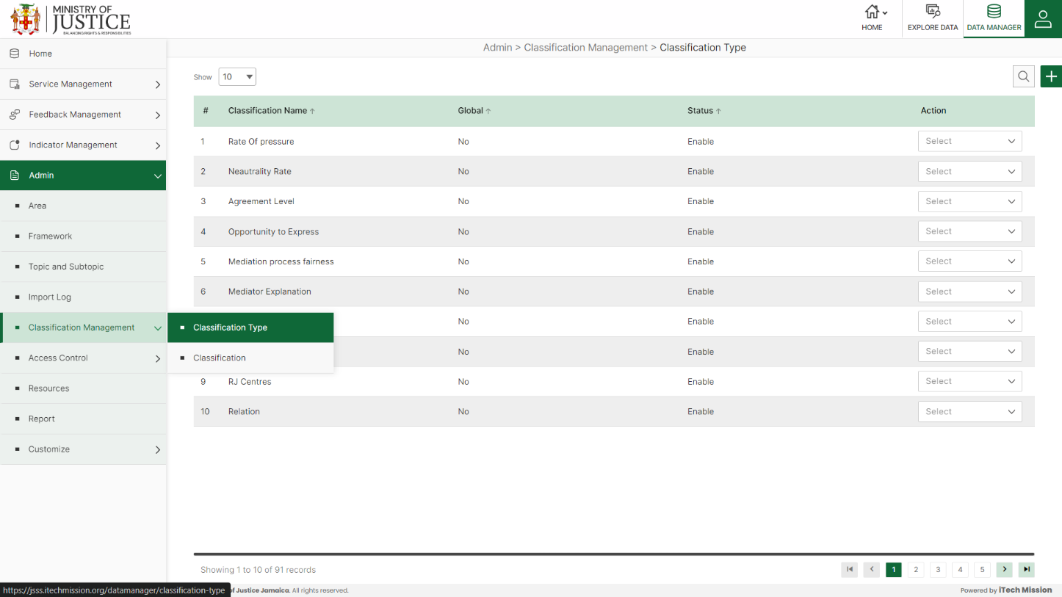Click on **Classification Type** from the classification management menu option available in the left panel to access this module. This module allows the manage the classification type master list. You will have options to add a new classification type, view the list of existing classification types, sort the list, search from the list, edit, delete, and enable/disable existing classification types (see below figure).

****Click on the **Plus** button available at the top right corner and enter the following information to add a new classification type.

* Enter **Classification Type**
* 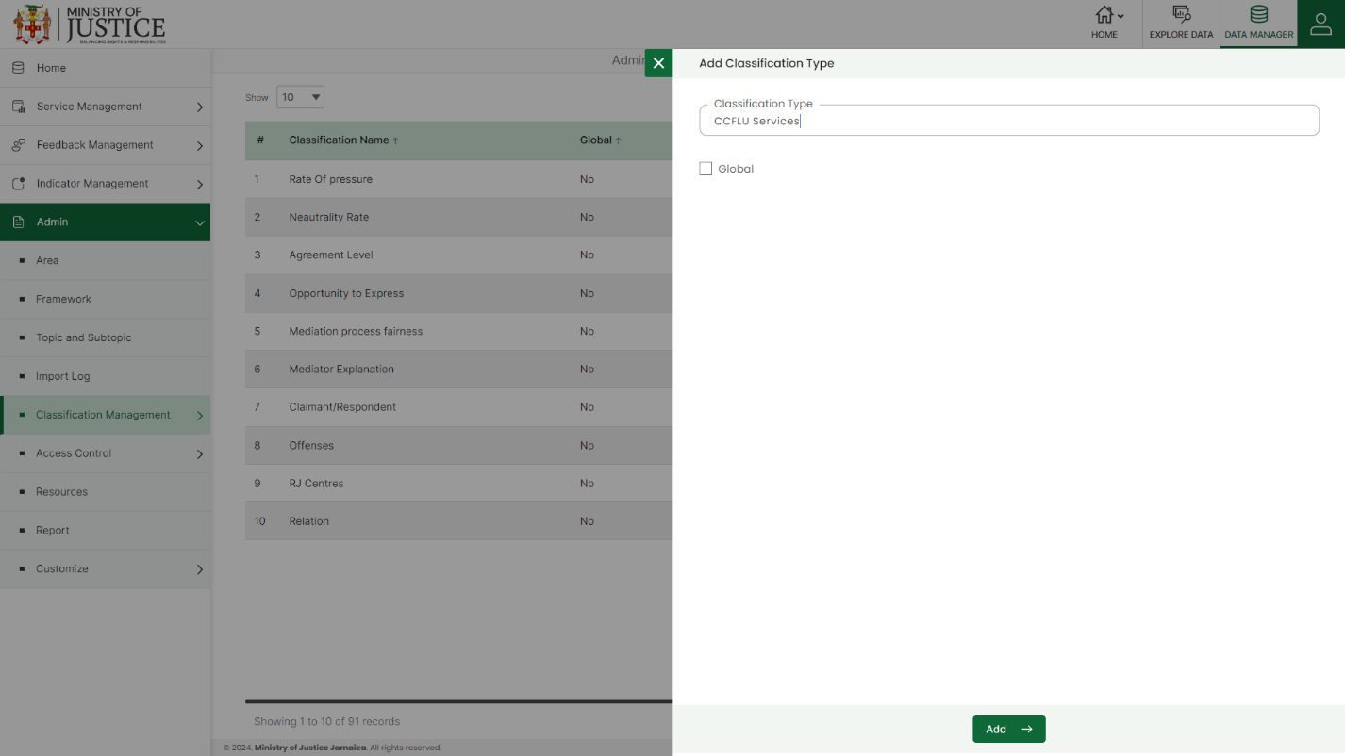Select Global

Starred details are mandatory to be entered. Click on the **Add** button to save and confirm. You can now view the new element added to the list.

Selectthe **Edit** option available in the action dropdown to edit the details of the selected element. Edit the required detail and click on the update button to save and confirm.

Select the **Enable/Disable** option available in the action dropdown to show or hide the specific classification type. The hidden type will not be shown in the overall application.

Selectthe **Delete** option available in the dropdown under the Action column to delete the selected element. A confirmation popup will appear, click yes to confirm the deletion.

### **7.6.2 CLASSIFICATION**

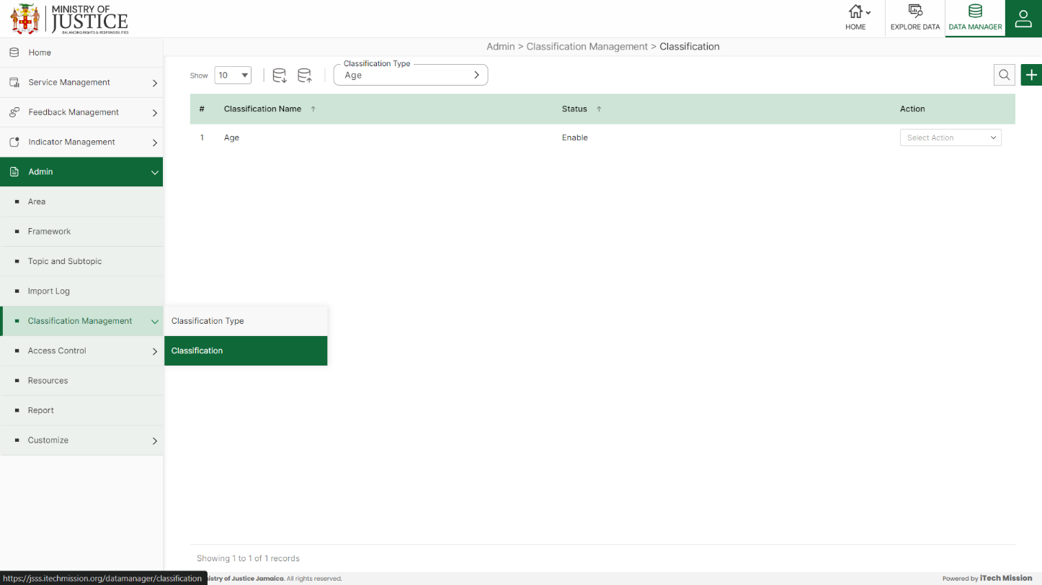Click on **Classification** from the classification management menu option available in the left panel to access this module. This module allows the manage the classification master list. You will have options to export and import, add new classifications, view the list of existing classifications as per the type, sort the list, search from the list, edit, delete, and enable/disable existing classifications (see below figure)

#### **7.6.2.1 EXPORT**

****Click on the **Export** button to download the empty classification template and the classification master list (see below figure).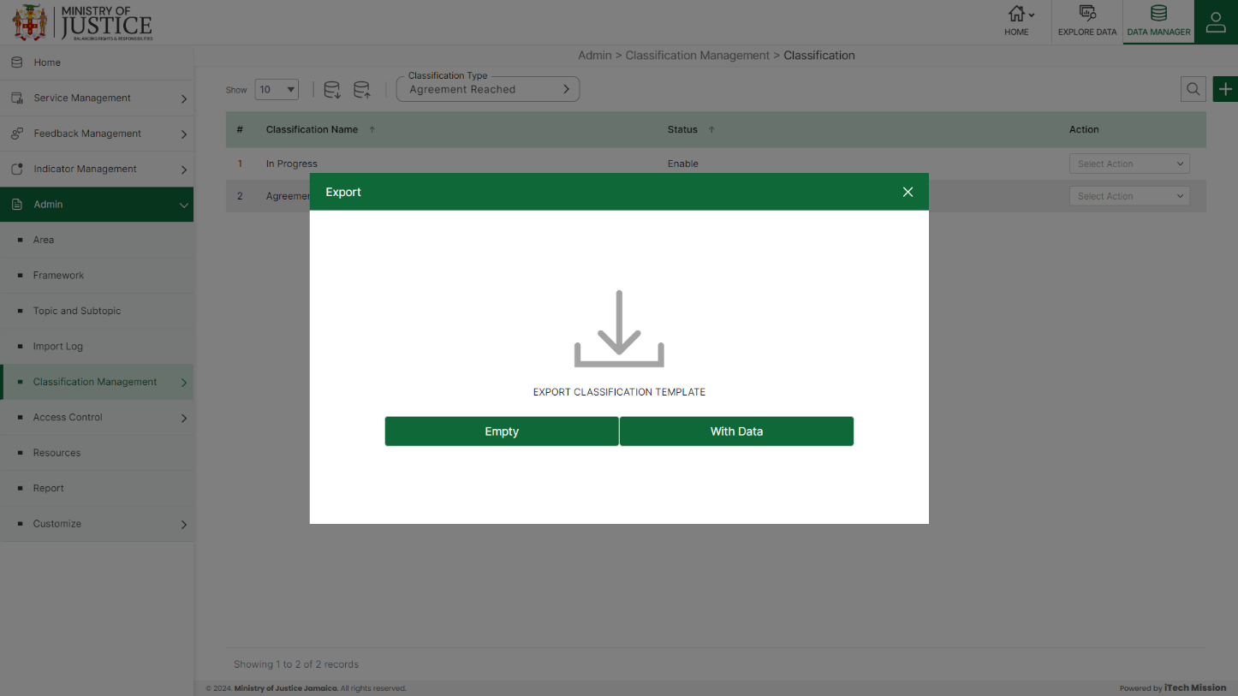

You can use this option to create a classification template structure. Below is the structure that you will find in the classification empty template.

|  |  |
| --- | --- |
| **ClassificationType** | Type of the classification |
| **ClassificationName** | Name of the classification. |
| **Global** | Whether it is a global classification or not. |

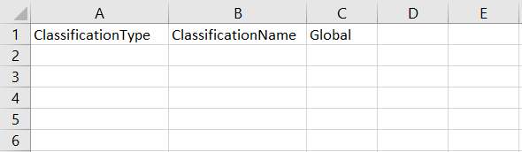Click on the **Empty** option to download an empty area template (see below figure). The classification list is imported and exported in the CSV (Comma Separated Value) file format.

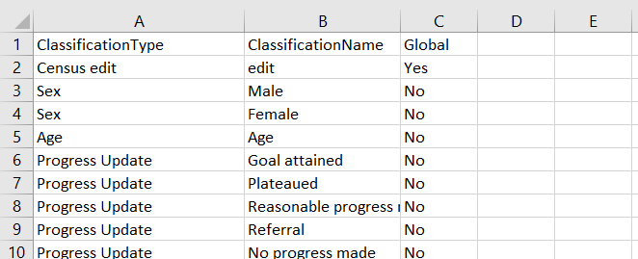Click on the **With Data** option to download the classification master list (see below figure).

#### **7.6.2.2 IMPORT**

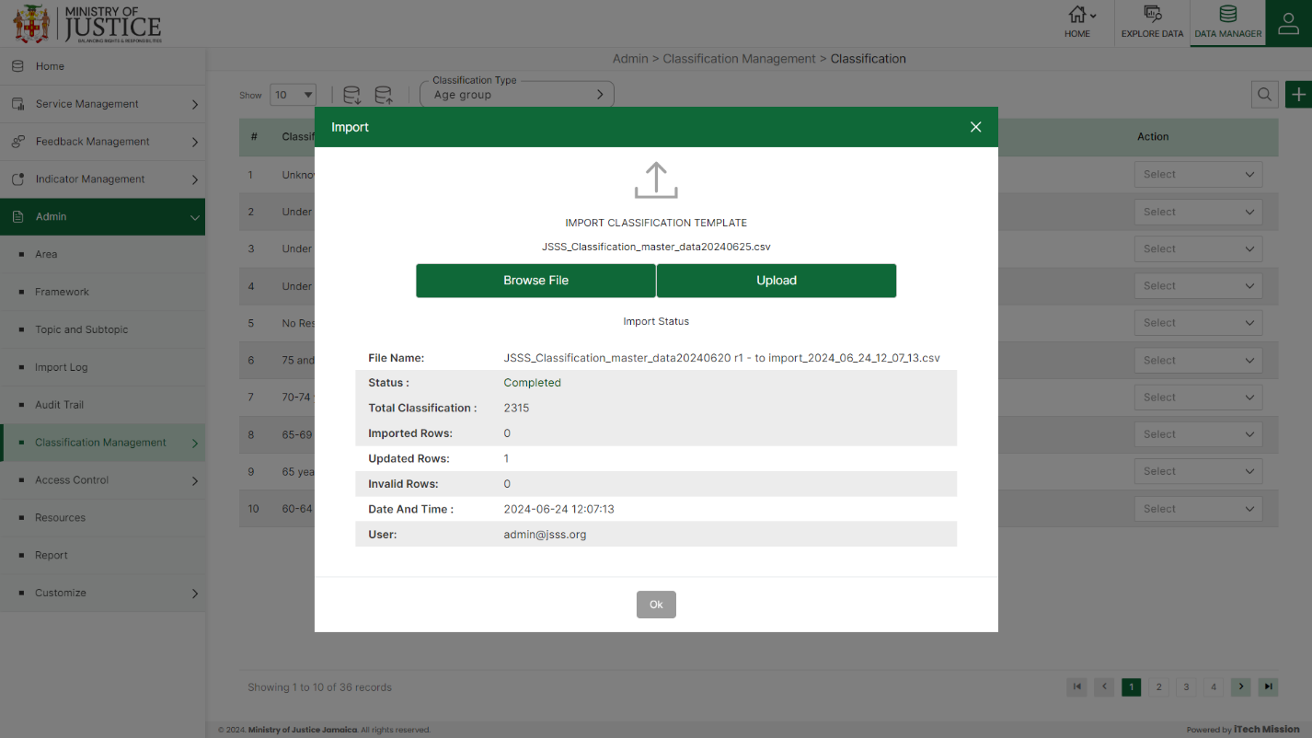Click on the **Import** button to browse the file and upload the classification master list into the database (see below figure).

To upload the classification into the database first enter the structure in the template as explained above and then click on the **Browse File** button to select the template. Now, click on the **Upload** button to start the import process. During the import process, the records that contain blank entries, entries with special characters, and duplicate entries are not imported into the database.

A Last Upload summary will appear after the import process which provides the count of successfully imported records out of the total records. An error log will be generated to report on unsuccessfully imported records which you can access from the **Logs** module.

#### **7.6.2.3 ADD**

****Click on the **Plus** button available at the top right corner and enter the following information to add a new classification.

* Select **Add or Import**
* 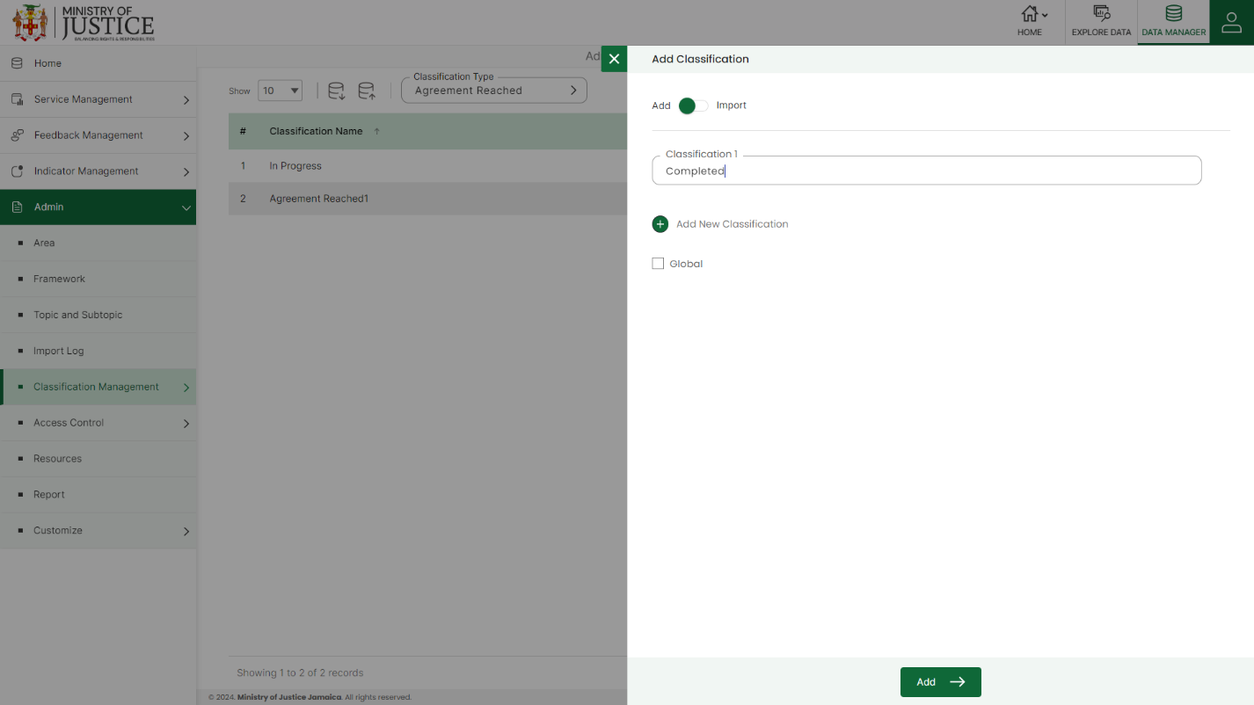Enter **Classification 1** *(If you want to enter more than 1 classification, click on Add New Classification***)**

Green color details are mandatory to be entered. Click on the **Add** button to save and confirm. You can now view the new classification added to the list.

Select **the Edit** option available in the action dropdown to edit the details of the selected classification. Edit the required detail and click on the update button to save and confirm.

Select **the Enable/Disable** option available in the action dropdown to show or hide the specific classification. The hidden classification will not be shown in the overall application.

Select **the Delete** option available in the dropdown under the Action column to delete the selected element. A confirmation popup will appear, click yes to confirm the deletion.

## **7.7 ACCESS CONTROL**

Click the **Access Control** from the admin menu option from the left panel to access this module. This module has two submodules – Role and Permission, User Let us understand these submodules in detail.

### **7.7.1 ROLE AND PERMISSION**

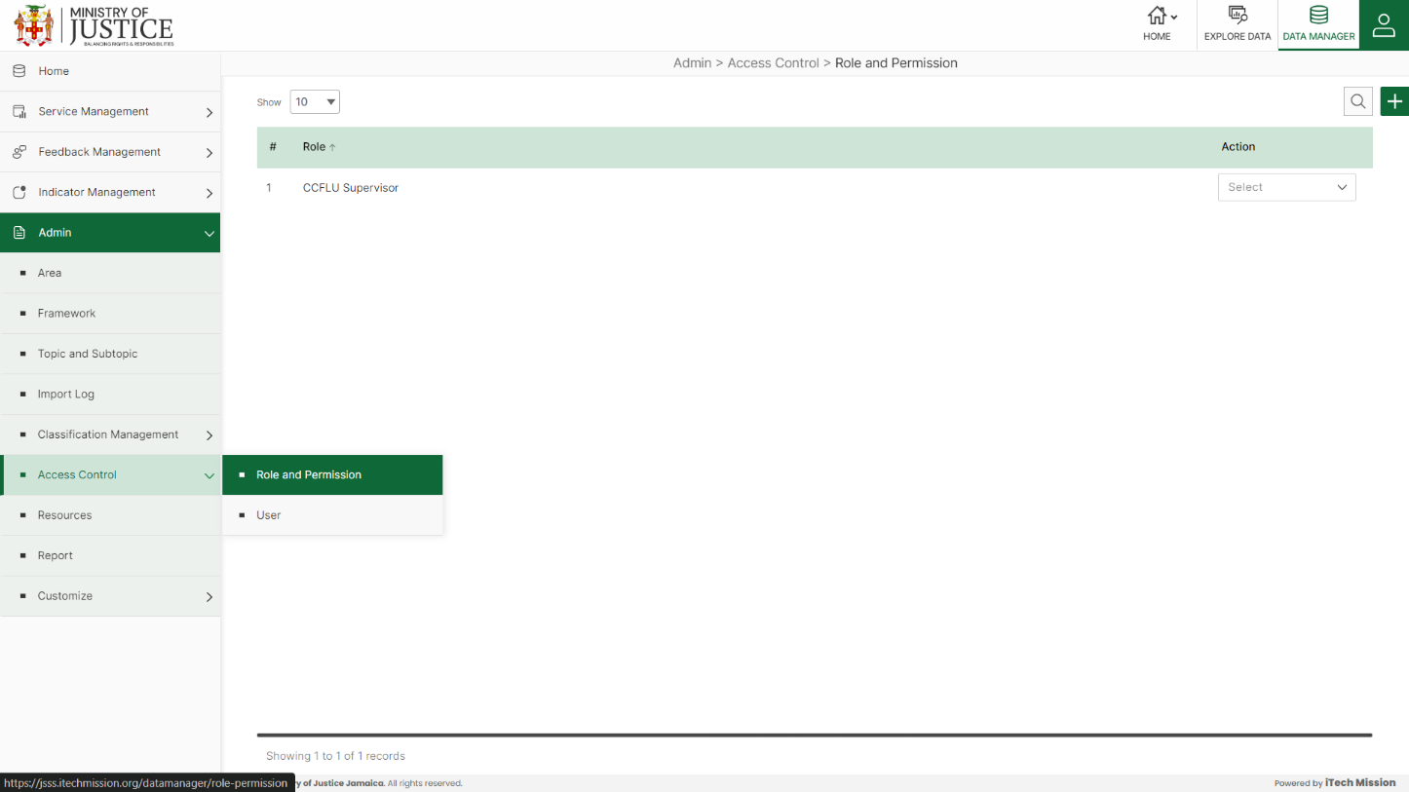Click on **Role and Permission** from the access control menu option available in the left panel to access this module. This module allows to management of the role and permissions. You will have options to add new roles, view the list of existing roles, sort the list, search from the list, edit and delete existing classification types (see below figure)

****Click on the **Plus** button available at the top right corner and enter the following information to add a new role with permissions.

* Enter **Role**
* 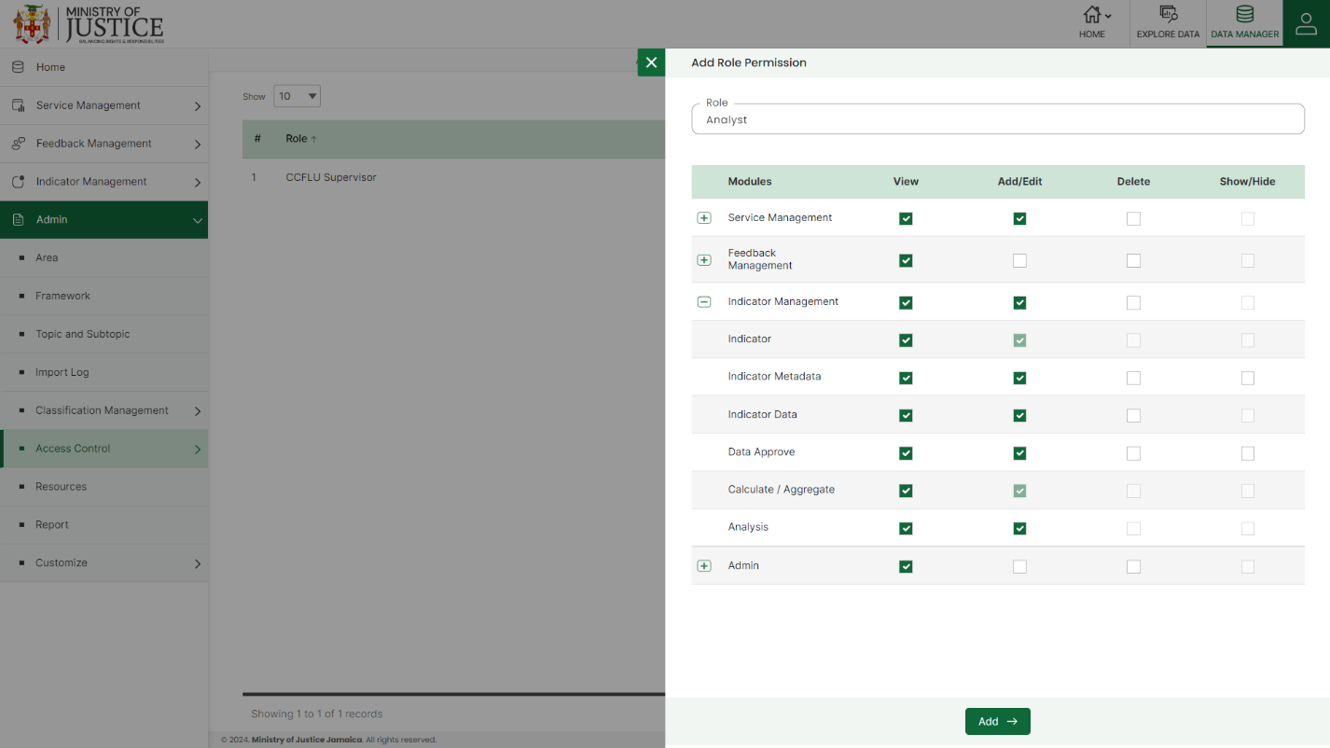Click **View, Add/Edit, Delete, Show/Hide** ()

All the details are mandatory to be entered. Click on the **Add** button to save and confirm. You can now view the new element added to the list.

Select **the Edit** option available in the action dropdown to edit the details of the selected element. Edit the required detail and click on the update button to save and confirm.

Select **the Delete** option available in the dropdown under the Action column to delete the selected element. A confirmation popup will appear, click yes to confirm the deletion.

### **7.7.2 USER**

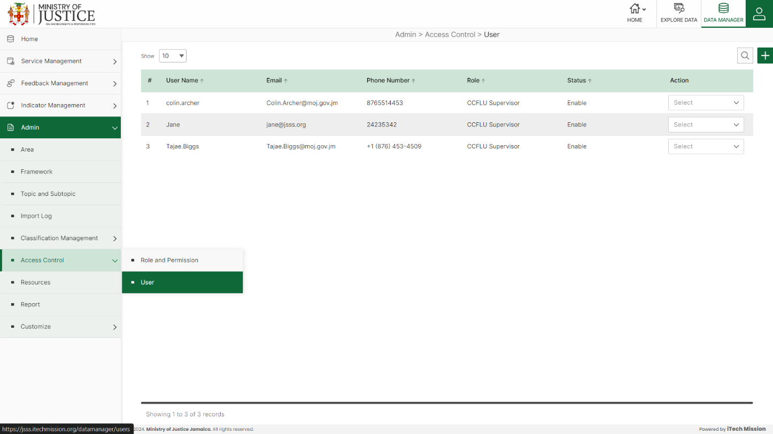Click on **User** from the access control menu option available in the left panel to access this module. This module allows the manage users list. You will have options to add new users, view the list of existing users, search users from the list, edit, and Enable/Disable existing users (see figure below).

****Click on the **Plus** button available at the top right corner and enter the following information to add a new user.

* Enter **User Name**
* Enter **Email**
* Enter **Phone Number**
* Select **Role**
* Set **Password**

All details are mandatory to be entered to add a new user. Click on the **Add** button to save and confirm. You can now view the new user added to the user list.

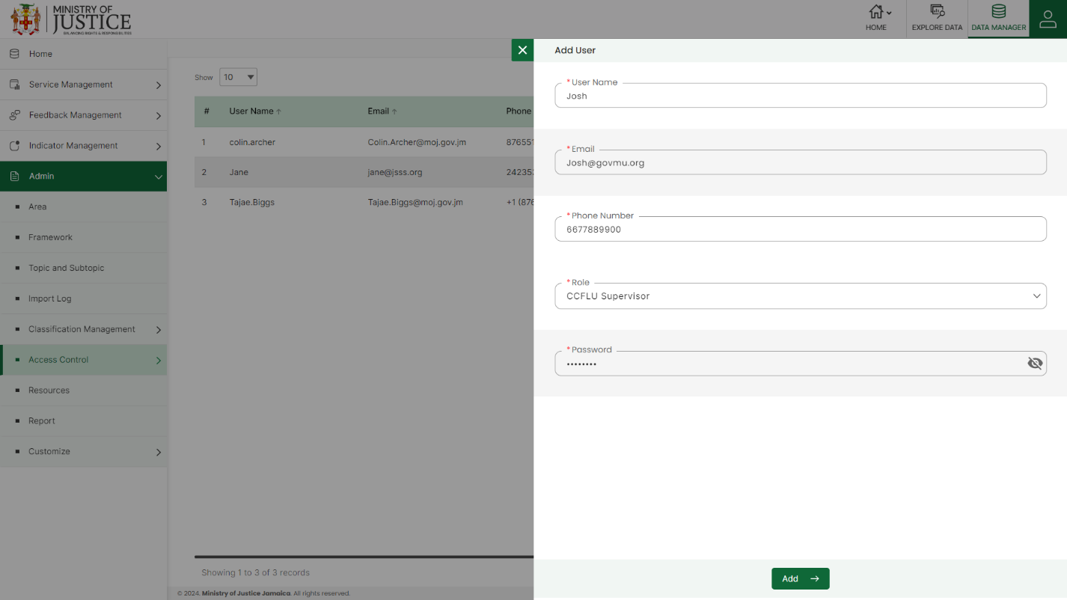 Select **the Edit** option available in the dropdown under the Action column to edit the details of the user. Edit the required detail and click on the update button to save and confirm.

Select **the Delete** option available in the dropdown under the Action column to delete the selected element. A confirmation popup will appear, click yes to confirm the deletion.

Select **the Enable/Disable** option available in the dropdown under the action column to enable or disable the user. The disabled user will not be able to log into the portal.

## **7.8 RESOURCE**

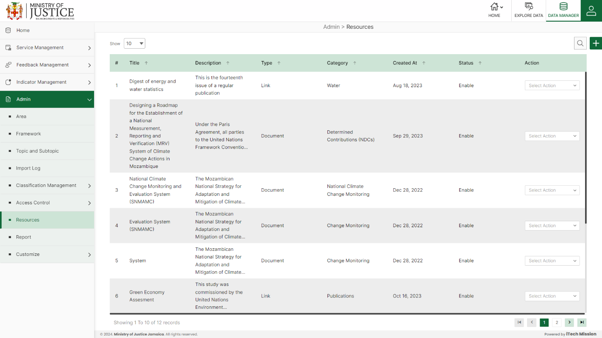Click on the **Resource** option available in the left panel to access this module. This module allows the management resources list. You will have options to add new resources, view the list of existing resources, search resources from the list, edit, delete, and enable/disable existing resources from the list (see below figure).

****Click on the **Plus** button available at the top right corner and enter the following information to add a new resource.

* Enter Resource Name
* Enter Resource Description
* Select Resource Type (Document or Link)
* Upload Document (In case the resource type is Document)
* Enter URL (In case the resource type is URL)
* Enter Category
* Upload Image

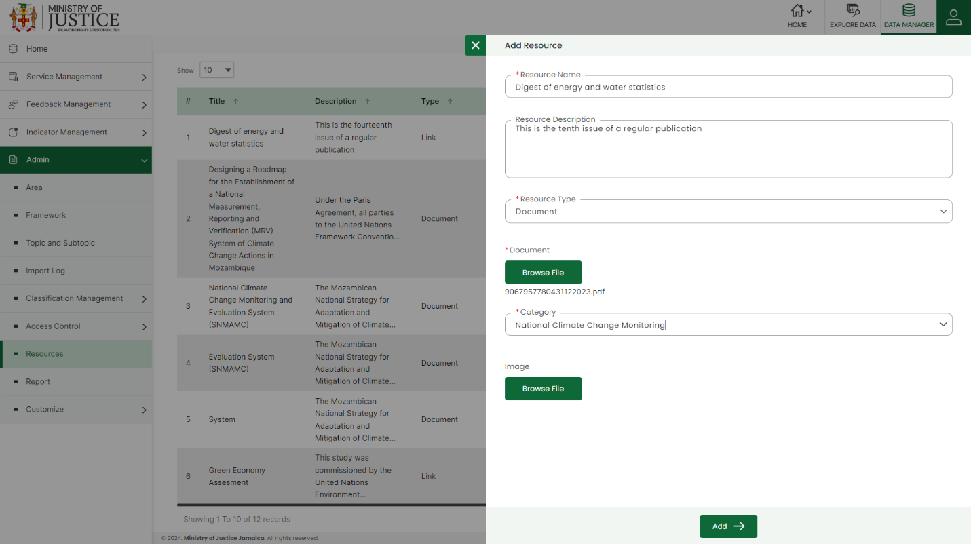Starred details are mandatory to be entered to add a new resource. Click on the **Add** button to save and confirm. You can now view the new resource in the resource list

Select **the Edit** option available in the dropdown under the Action column to edit the details of the resource. Edit the required detail and click on the update button to save and confirm.

Select **the Delete** option available in the dropdown under the Action column to delete the selected element. A confirmation popup will appear, click yes to confirm the deletion.

Select **the Enable/Disable** option available in the dropdown under the action column to enable or disable the resource. The disabled element will not be shown in the user interface application.

## **7.9 GALLERY**

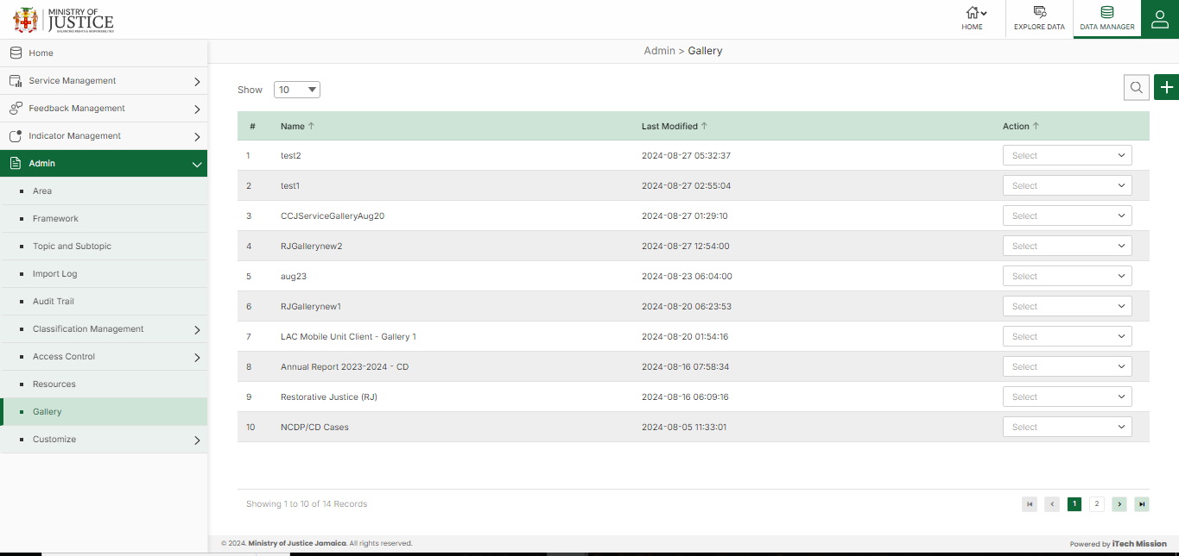Click on the **Gallery** option available in the left panel to access this module. This module allows authorized users to generate charts for a particular indicator, area, and date range You will have options to generate a new gallery, view the list of existing galleries, search from the list, edit, and delete the existing galleries from the list (see below figure). **The gallery** option provides you with a list of saved visualizations that can be used to create a report. Click on the **Gallery** option to view the list of saved visualizations. You can drag & drop the required chart to the empty dashboard and adjust its size & position as per the requirement.

Click on the **Plus** button available on the right side in the header section to add a new gallery. Enter the **Name** of the gallery and click on the **Add** button to save the new gallery. A new empty gallery will be created with options to customize your gallery.

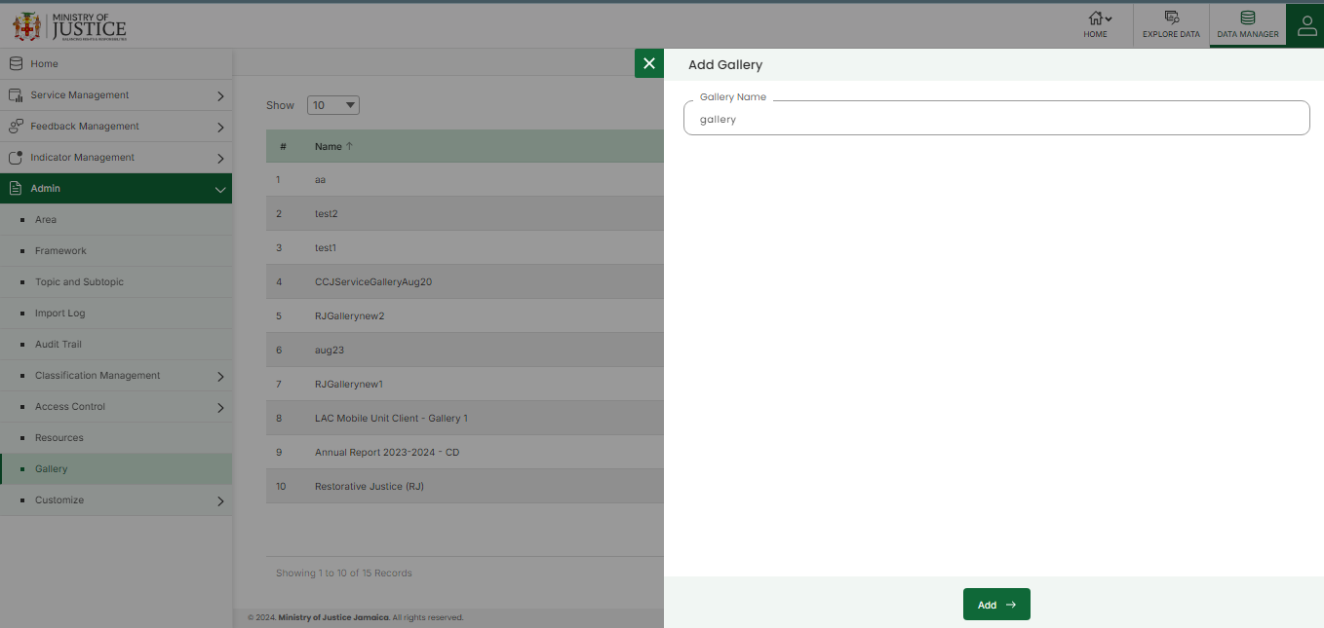Select **the View** option available in the action dropdown to view the charts of the gallery.

Select **the Edit** option available in the action dropdown to edit the details of the gallery(name). Edit the required detail and click on the update button to save and confirm.

Select **the Delete** option available in the action dropdown to delete the selected gallery. A confirmation popup appears, click yes to confirm the deletion of the selected gallery.

Select view and click on **new visualization** to add charts to a particular gallery**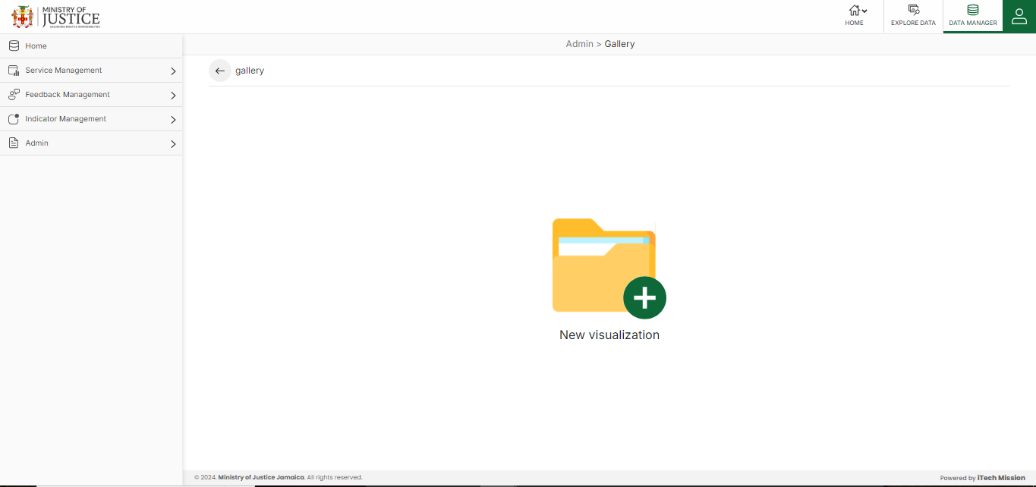.**

To make a chart set the data and modify the settings of the chart:-

* Select **visualization type**
* **Indicator**
* **Area**
* **Time period**
* Adjust Chart **Settings**

Click **Run** to generate the chart and use the **Save button** to save the chart in the gallery. Along 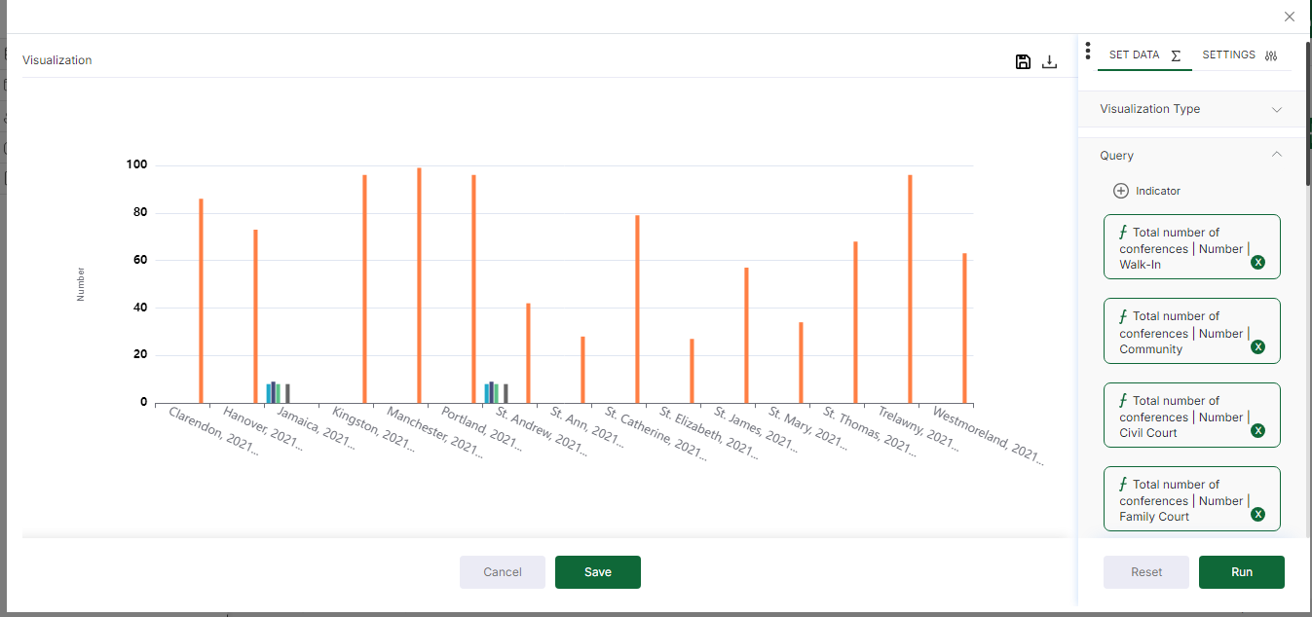with Save, Download the generated chat in 3 formats – JPEG, PNG, and SVG.

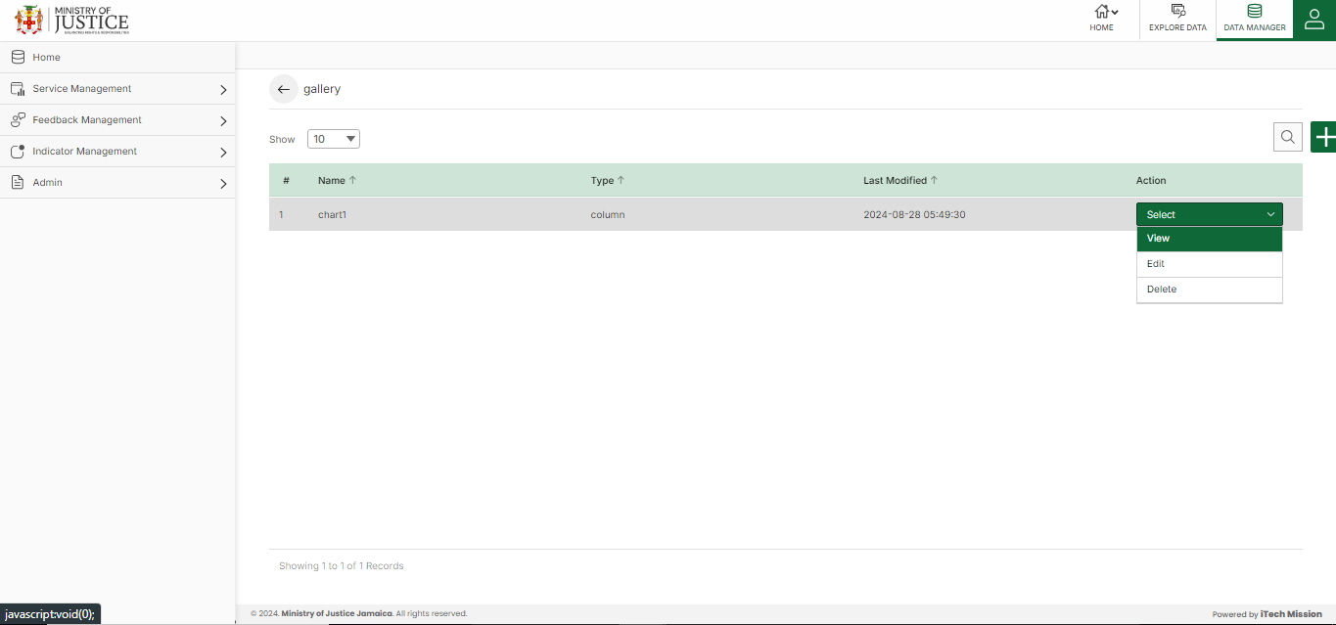 Select **the View** option available in the action dropdown to view elements in the chart

The **Edit** option is available to edit the existing chart.

The **Delete** option is available in the action dropdown to delete the chart.

To remove any **Chart**, click on the **Delete** icon available at the top right corner of the chartand the required chart will be removed from the section.

## **7.10 CUSTOMIZE**

Click on **Customize** from the admin menu option from the left panel to access this module. This module has two submodules – Sliders and Key Facts. Let us understand these submodules in detail.

### **7.10.1 KEY FACTS**

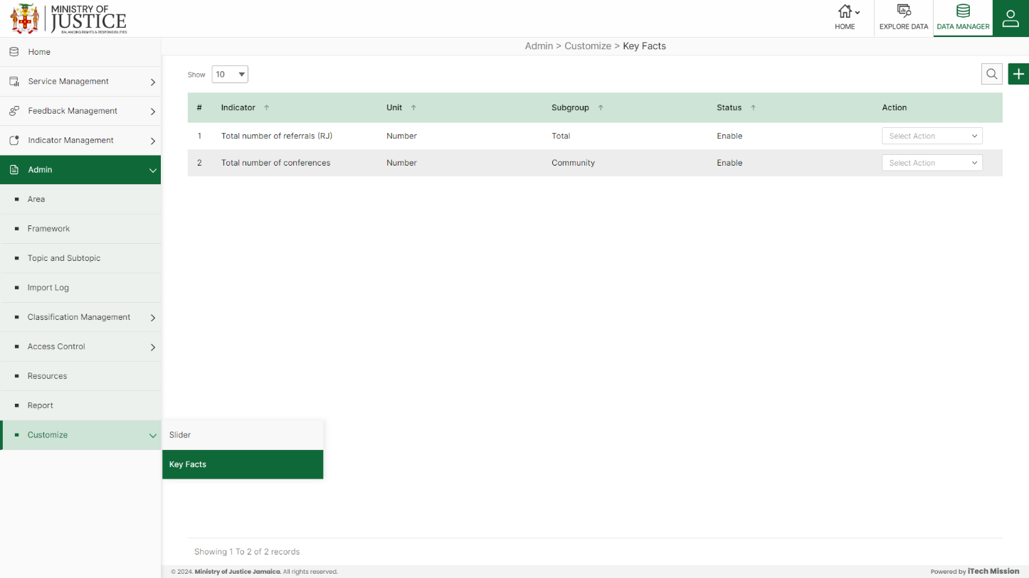Click on **Key Facts** from the Customize menu option available in the left panel to access this module. This module allows you to manage the key facts. You will have options to add new facts, view the list of existing facts, sort the list, search from the list, edit, enable/disable, and delete existing facts (see below figure)

****Click on the **Plus** button available at the top right corner and enter the following information to add a new key fact

* Select **Indicator|Unit**
* 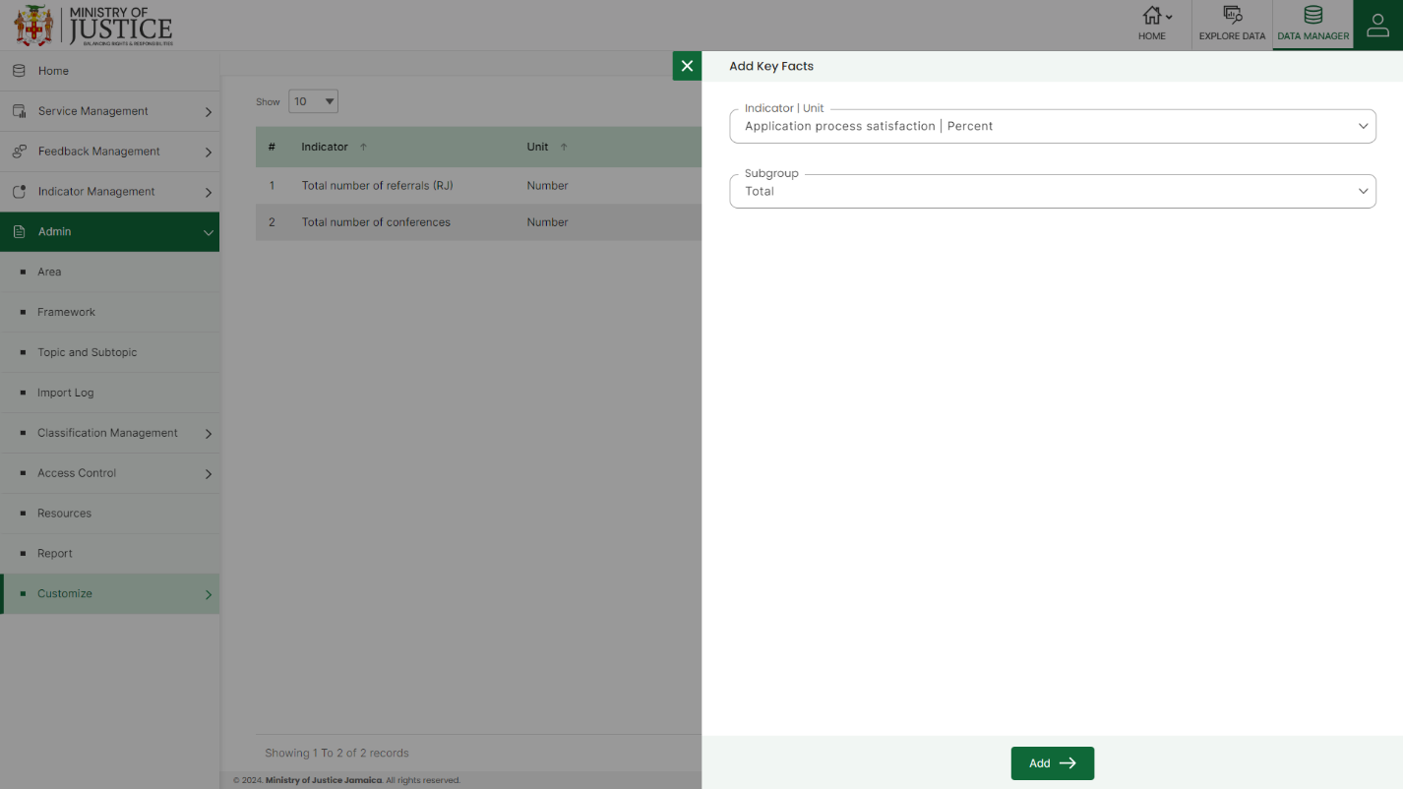Select **Subgroup**

All the details are mandatory to be entered. Click on the **Add** button to save and confirm. You can now view the new element added to the list.

Select **the Edit** option available in the action dropdown to edit the details of the selected element. Edit the required detail and click on the update button to save and confirm.

Select **the Enable/Disable** option available in the action dropdown to show or hide the specific fact. The hidden fact will not be shown in the list of facts in the overall application.

Select **the Delete** option available in the dropdown under the Action column to delete the selected element. A confirmation popup will appear, click yes to confirm the deletion.

***End of the Document***